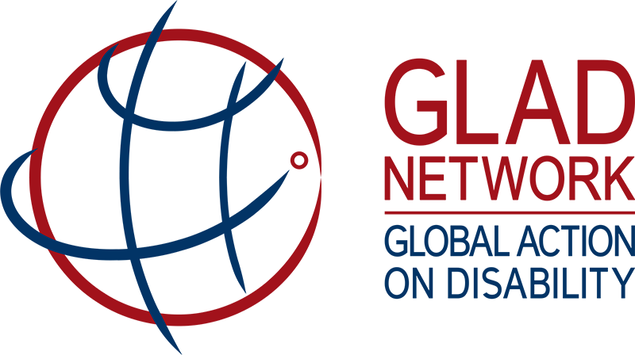

GLOBAL ACTION ON DISABILITY NETWORK MEETING

Aim of meeting: To further develop a firm, coherent and practical commitment to disability-inclusive development and humanitarian action in line with CRPD, through meaningful engagement with Organisations of Persons with Disability (DPOs), and capitalizing on the collective voice, role and resources of GLAD Network members.

Wednesday, 31 January:

9:30 - 10:00 Registration and coffee

10:00 - 10:45 Introduction
Opening: Ministerial and high-level representatives

10:45 - 12:30 Scanning the horizon
Sharing perspectives, knowledge and practices: engagement with organisations of persons with disabilities

12:30 - 14:00 Lunch Break

14:00 - 15:30 Strategic plan towards inclusion (part 1)
Breakout into three groups: States, Multi-lateral and Foundations and selected organisations

15:30 - 16:00 Break

16:00 - 17:30 Strategic plan towards inclusion (part 2)

17:30 - 19:30 Networking reception

Thursday, 1 February:

9:15 - 9:30 Arrival and coffee

9:30 - 10:45 Strategic planning towards inclusion
Presentations from strategic plan groups; defining strategic planning

10:45 – 11:15 Break

11:15 - 12:15 Mobilising our collective purchasing power
Assistive products and accessibility

12:15 - 13:15 Lunch break

13:15 - 16:45 Thematic working groups
Break-out into three groups: Humanitarian action; Education; and Social protection

17:00 - 17:30 Thematic working groups
Presentations on dialogue, action points, recommendation and Q&A

Friday, 2 February:

9:45 - 10:00 Arrival and coffee

10:00 - 11:00 GLAD Updates
GLAD governance, membership, strategy; Secretariat budget; Online knowledge sharing platform

11:00 - 11:30 Break

11:30 - 12:30 Way forward: Next steps and future areas of Focus
End of the meeting and reflections

12:30 - 13:30 Lunch break

13:30 - 16:30 GLAD Steering Committee meeting (for Steering Committee Members only)

