GLOBAL ACTION ON DISABILITY NETWORK MEETING

Communications guide

31 January to 2 February 2017

Get involved!

Help the GLAD Network gain visibility in social media, following these three simple steps:
- Follow @GLAD_Net on Twitter and @GlobalActionDisability on Facebook and get involved in the social media discussions: a selection of tweets and posts will be included in the daily bulletin of the meeting and reported back at the beginning of each day;
- Take a look at the proposed tweets below and start making some noise before and during the event, on Twitter and Facebook;
- Share this document with your colleagues and communications team in your organisation.

Key messages for GLAD’s social media dialogue:

- Overall aim: GLAD Network members are meeting this week to capitalise on their collective voice, role and resources to further develop firm, coherent and practical commitments to disability-inclusive development and humanitarian action which is consistent with CRPD and includes meaningful engagement with people with disabilities and their representative organisations.
- Leadership: The GLAD Network acknowledges the leadership of the Australian Department of Foreign Affairs and Trade (DFAT) and the International Disability Alliance (IDA) in co-chairing the GLAD Network Meeting, and the support of the Foreign Ministry of Finland (FORMIN) and the Abilis Foundation in hosting this important annual meeting of international partners working collaborative together to advance disability inclusive development and humanitarian action. The GLAD Network particularly welcomes ministerial level participation by Finland, Australia and the UK in this meeting.
- DPO engagement: People with disabilities and their representative organisations, known disabled people’s organisations (DPOs), provide unique perspectives, based on their lived experience of disability, to inform effective disability-inclusive development and humanitarian action. The GLAD Network promotes the meaningful engagement of DPOs in development and humanitarian action at community, national and international levels.
- Data disaggregation: The GLAD Network remains seized of the urgent need for better data on the situation of people with disabilities globally and endorses the Washington Group short set of questions and the Washington Group-UNICEF Child Functioning Module for disaggregating data by disability status.
- OECD DAC marker: The GLAD Network supports the introduction of an OECD DAC policy marker for inclusion of persons with disability, which would provide a qualitative measure of Official Development Assistance (ODA) supporting persons with disabilities and better capture support for the SDG goals and targets relevant to persons with disabilities.
- Disability Summit: The GLAD Network welcomes the initiative of the UK’s Department for International Development (DFID) and the International Disability Alliance (IDA) in hosting a Global Disability Summit in July 2018 and commits to working with them to maximise the Summit’s potential to advance the global disability agenda.

A few proposed Tweets:

#GLADnetwork members will meet this week to capitalise on their collective voice, role&resources to further develop firm, coherent&practical commitments to disability-inclusive development and humanitarian action, consistent with CRPD & includes DPOs! bit.ly/2BLwbOP

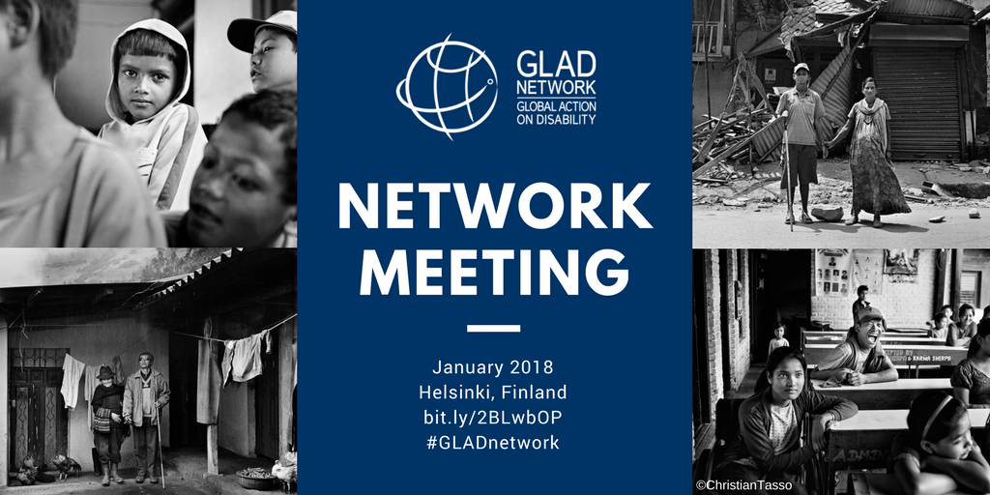

The #GLADnetwork promotes the meaningful engagement of DPOs in development and humanitarian action at community, national and international levels. Read more about the Network @ BIT.LY/2MMS5EZ

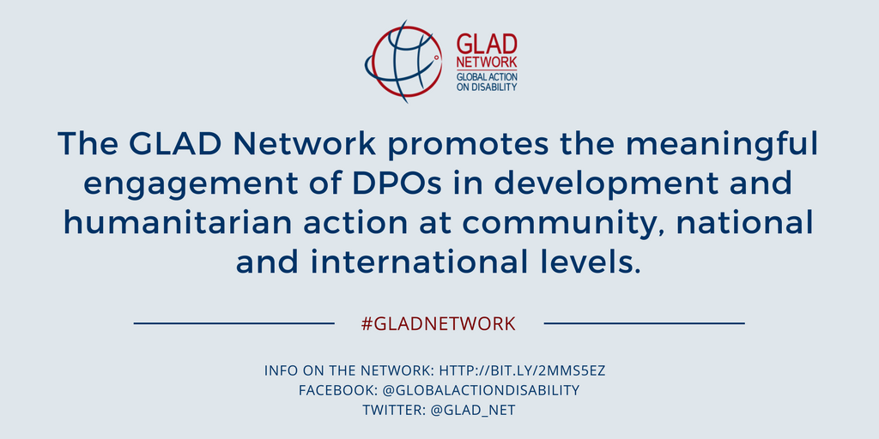

#GLADnetwork welcomes @DFID_UK & @IDA_CRPD_Forum initiative in hosting a Global Disability Summit in July 2018 and commits to working with them to maximise the Summit’s potential to advance the global disability agenda. Read more about the Network @ BIT.LY/2MMS5EZ

