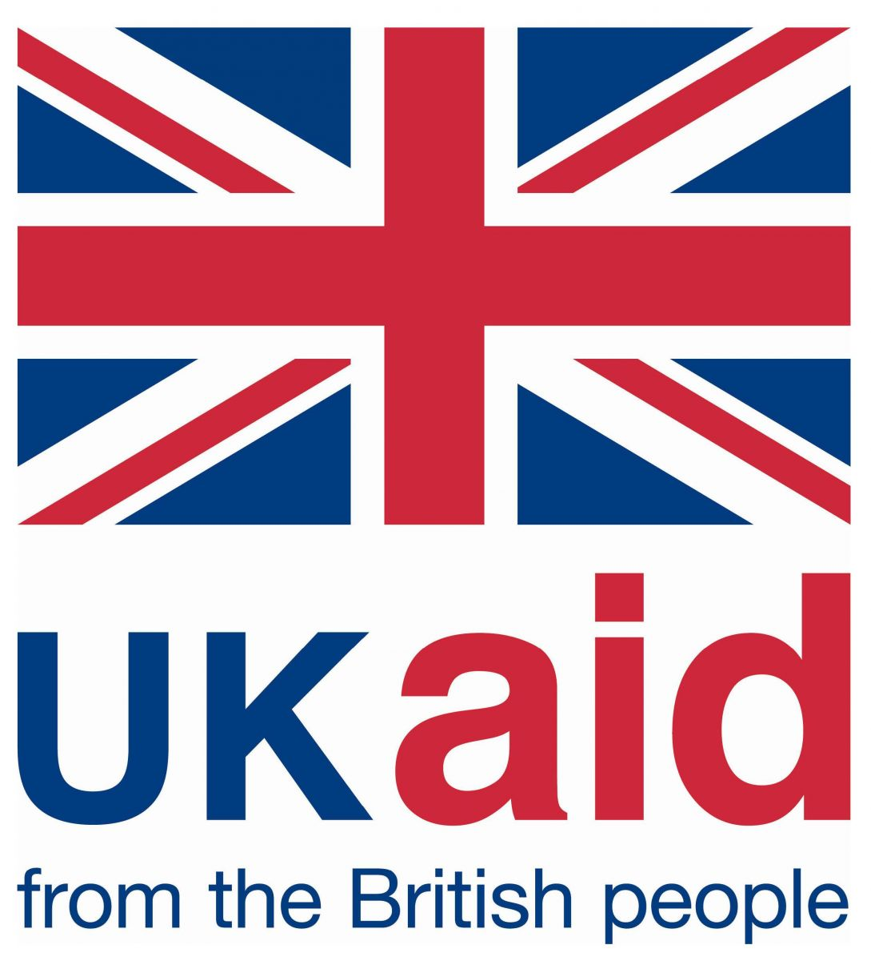
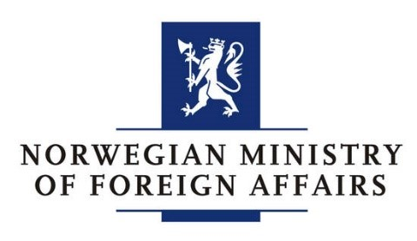
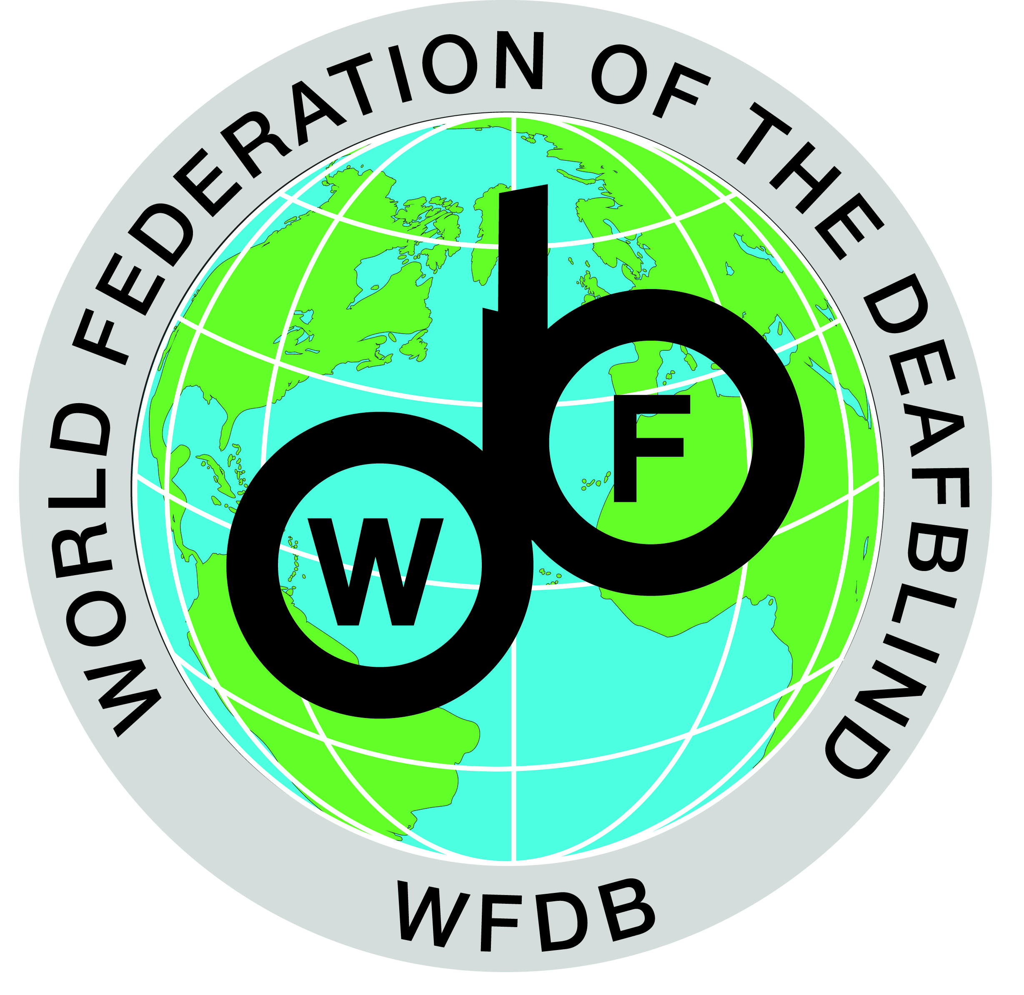
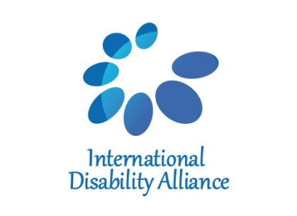

Concept Note
Technical Workshop on Inequality and Persons with Deafblindness: At risk of exclusion from CRPD and SDGs implementation.
Uganda
22 – 23 November 2018

Background
Echoing the changes triggered by the UN Convention on the Rights of Persons with Disabilities (CRPD), the adoption of Agenda 2030 and the Sustainable Development Goals (SDGs) emphasised the importance of inclusive development and leaving no one behind. Worldwide, there is a growing momentum for change based on inclusion, which marks a significant shift from the invisibility and exclusion of persons with disabilities from the Millennium Development Goals (MDGs). However, it is vital to recognise that persons with disabilities are not a homogenous group, and some constituencies, such as persons with deafblindness, remain marginalised and, in many ways, invisible.
The initial WFDB global monitoring report about persons with deafblindness provides evidence of the marginalization and invisibility persons with deafblindness face today.

Combining the largest population-based analysis of persons with deafblindness conducted to date (disaggregation of more than 20 population-based surveys from low, middle and high-income countries), a review of academic literature, two surveys conducted among members and partners of WFDB and Sense International, as well as case studies, the report covers the diversity of persons with deafblindness, their lived experiences, the barriers and inequalities they face.

The evidence says that representing between 0.2% to 2% of the population, persons with deafblindness are a diverse group and are overall more likely to be poor and unemployed, and with lower educational outcomes than other people with disabilities.
They face multiple barriers such as severe lack of access to support services and accessible information, which ultimately make it very difficult to voice their issues.
Moreover, the fact that persons with deafblindness are rarely recognised as distinct disability group has contributed to persistent invisibility leading to lack of support and services.

Ultimately, the report also proposes very concrete recommendations to Members States, development agencies and civil society organizations.

Rationale
Building on the IDA BRIDGE training prior, this technical Workshop on dissemination and utilization of the WFDB Global report as a monitoring and advocacy tool aims to provide DPOs by and for
persons with deafblindness a common foundation for their advocacy.

Initially, the participants will be introduced to the principles of the CRPD and the links between the CRPD and the 2030 Agenda for Sustainable Development with its Sustainable Development Goals (SDGs).
Connected with the evidence provided by the WFDB Global report this workshop will demonstrate how full achievement of the CRPD and the SDGs, and thereby securing full enjoyment of human rights, democracy and equality for persons with deafblindness on equal terms as society in general, is not realistic unless the recommendations in the report are resolved.

Also, the workshop will cover an introduction to the 2030 Agenda and the SDGs and how these frameworks are implemented in line with the CRPD, with the aim to equip organizations of indigenous persons with disabilities to further work connecting with other likeminded organizations/network/alliance in Kenya to mainstream indigenous persons with disabilities issues effectively.

Objectives
To provide initial, or strengthen, understanding of the linkages between the CRPD, SDGs and the WFDB Global report on deafblindness.
Through discussions on argumentative and perspective analysis strengthening the collaboration and network of persons with deafblindness in Uganda and neighbouring countries, to ensure a unified yet locally adapted message on inclusion and what it means for persons with deafblindness.

Expected outcomes
Participants will be able to:
- Understand the linkages between the CRPD, SDGs and the WFDB Global Report
- Understand the concept of the report as an advocacy tool in light of the CRPD and the WFDB Global report.
- Understand how to utilize the WFDB Global report in national and local advocacy.

Participants
The workshop will bring together a diverse group of persons with deafblindness from Uganda and Neighbouring countries.

The workshop will include 5 persons with deafblindness, 1 representative of the WFDB as well as support providers and interpreter-guides. The workshop will be delivered in English, and will be simultaneously interpreted into Sign Language.

We expect participants to understand the core message of the WFDB Global Report and how to connect it with the CRPD and the SDGs.
Through this understanding we expect the participants to be able to meaningfully engage in monitoring processes of national public policies, and thereby create more awareness of deafblindness and as a unique and distinct disability, and its isolating consequences.

To reflect the diversity of the deafblind community, particular consideration will be taken to involve leaders from the following constituencies:
- Youth with deafblindness,
- Women with deafblindness,
- Children With deafblindness
- Persons with deafblindness from rural or remote areas, among others.

A final report will be produced and shared with IDA, AFDB members, WFDB and relevant partners.

Oslo, Norway, 16. October 2018.

