Engagement & Participation Opportunities
during the HLPF

Engagement & Participation Opportunities during the HLPF

Overview of the mandate for MGoS participation

Agenda 21

Since the first United Nations Conference on Environment and Development in Rio de Janeiro, 1992, it was recognized that achieving sustainable development would require the active participation of all sectors of society and all types of people. Agenda 21 drew upon this sentiment and formalized nine sectors of society as the main channels through which broad participation would be facilitated in UN activities related to sustainable development. The Commission on Sustainable Development (CSD) was established by the UN General Assembly in December 1992 to ensure effective follow-up to the United Nations Conference on Environment and Development, also known as the Earth Summit.

The nine channels of society were officially called "Major Groups" and included the following sectors: Women, Children and Youth, Indigenous Peoples, Non-Governmental Organizations, Local Authorities, Workers and Trade Unions, Business and Industry, Scientific and Technological Community, Farmers. To implement this structure, the Major Groups Programme was set up within the Division for Sustainable Development, UN DESA, with the objective of incorporating the views of these sectors of society into intergovernmental processes.

UNGA Resolution 66/288
Two decades after the Earth Summit in 2012, the importance of effectively engaging these nine sectors of society was reaffirmed by the United Nations Conference on Sustainable Development, Rio+20. In addition, governments invited other stakeholders, including local communities, volunteer groups and foundations, migrants and families, as well as older persons and persons with disabilities, were invited to participate in UN processes related to sustainable development.

The outcome document ‘The future we want’ was endorsed by and annexed in UNGA Resolution 66/288. In it, the UN General Assembly dedicated a section to Engaging major groups and other stakeholders. It underscored that broad public participation and access to information and judicial and administrative proceedings are essential to the promotion of sustainable development. It stated that sustainable development requires the meaningful involvement and active participation of regional, national and subnational legislatures and judiciaries, and all major groups.

Governments agreed to work more closely with the major groups and other stakeholders and encouraged their active participation, as appropriate, in processes that contribute to decision-making, planning and implementation of policies and programmes for sustainable development at all levels.

UNGA Resolution 67/290
The Rio+20 Conference in 2012 decided to conclude the Commission for Sustainable Development after its twentieth session and subsequently inaugurate the High-Level Political Forum on Sustainable Development (HLPF) that would build on the practices of the CSD to enhance the engagement of Major Groups and other stakeholders in the follow-up and review of sustainable development commitments. In 2013, the General Assembly adopted Resolution 67/290 outlining the ‘Format and organizational aspects of the high-level political forum on sustainable development’. It stressed the need for the HLPF to promote transparency and implementation by further enhancing the consultative role and participation of the major groups and other relevant stakeholders at the international level in order to make better use of their expertise, while retaining the intergovernmental nature of discussions. Paragraph 15 of the same Resolution further states that representatives of the major groups and other relevant stakeholders shall be allowed:

- To attend all official meetings of the forum;
- To have access to all official information and documents;
- To intervene in official meetings;
- To submit documents and present written and oral contributions;
- To make recommendations;
- To organize side events and round tables, in cooperation with Member States & the Secretariat.

The Resolution encourages major groups and other stakeholders ‘to autonomously establish and maintain effective coordination mechanisms’ for participation in the HLPF.

UNGA Resolution 70/1
In 2015, the UN General Assembly adopted the outcome document titled ‘Transforming our world: the 2030 Agenda for Sustainable Development’ following the UN summit for the adoption of the post-2015 development agenda. The outcome document states that reviews of the implementation of the 2030 Agenda and the SDGs will include developed and developing countries, UN entities and other stakeholders, including civil society and the private sector. The reviews will also provide a platform for partnerships, including through the participation of major groups and other relevant stakeholders. Agenda 2030 reiterates that the HLPF will support participation in follow-up and review processes by the major groups and other relevant stakeholders in line with resolution 67/290 and calls upon those actors to report on their contribution to the implementation of the Agenda.

UNGA Resolution 70/299
Resolution 70/299, ‘Follow-up and review of the 2030 Agenda for Sustainable Development at the global level’ was adopted in 2016. The resolution encourages Member States to involve stakeholders in the national voluntary reviews and reiterates the call to major groups and stakeholders to report on their contribution to the implementation of the 2030 Agenda for Sustainable Development.

UNGA Resolution 72/305
Resolution 72/305 adopted the annexed text concerning the ‘Review of the implementation of General Assembly resolution 68/1 on the strengthening of the Economic and Social Council’. The text stated that the Economic and Social Council should seek to promote the active participation of major groups, non-governmental organizations, the private sector, youth and other relevant stakeholders and regional organizations in the activities of the Council and its functional and regional commissions, in accordance with UNGA Resolution 67/290. In addition, the Economic and Social Council should consider possible ways of applying to other meetings and segments certain aspects of the modalities of engagement of major groups and other stakeholders in the HLPF, while retaining its intergovernmental nature and allowing sufficient time to Member States.

Overview of the MGoS structures for the participation at the HLPF

Since its adoption, MGoS have been actively working towards its implementation, through projects, initiatives, advocacy, knowledge-sharing, and monitoring of the 2030 Agenda. MGoS often work in partnership with other sectors, including governments. At the time of writing in October 2019, there are 9 Major Group and 9 Stakeholder Groups:

Major Groups | Stakeholder Groups
Business & Industry | Ageing
Children & Youth | Asia Pacific Regional CSO Engagement Mechanism
Farmers | Civil Society Financing for Development Group
Indigenous Peoples | Education & Academia
Local Authorities | LGBTI
NGOs | Persons with Disabilities
Scientific & Technological Community | Sendai Stakeholder Mechanism
Women | Together 2030
Workers & Trade Unions | Volunteers & Foundations

MGoS HLPF Coordination Mechanism

The purpose and the structures of the MGoS HLPF Coordination Mechanism are defined in its Terms of Reference (ToR). The ToR outlines the membership, objectives and methods of work MGoS HLPF Coordination Mechanism.

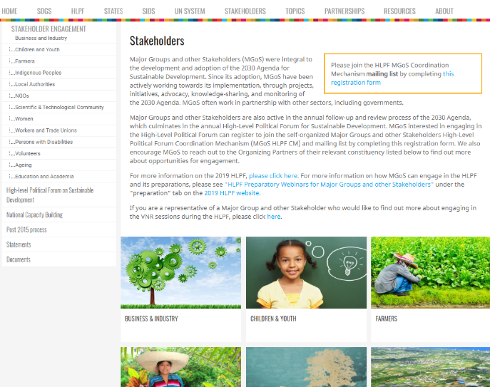
Membership
Membership is open to all representatives of the Major Groups and other relevant stakeholders active in sustainable development. Parties that are interested in engaging in the HLPF can register to join the self-organized MGoS HLPF CM mailing list by completing the registration form found on the ‘Stakeholders’ page of the HLPF website. HLPF participants are encouraged to reach out to the Organizing Partners of their relevant MGoS constituency to find out more about opportunities for engagement.

Objectives
The MGoS HLPF Coordination Mechanism has 4 main objectives:

- Ensure broad, open, transparent and inclusive participation in the HLPF;
- Ensure that the rights of access and inclusive participation of MGoS in the HLPF are protected and upheld as mandated by Resolution 67/2901 and potentially expanded;
- Facilitate the coordination among, and promote the participation of, all stakeholders that are involved in the HLPF process and want to contribute to it, including organizations and groups that are not part of the MGoS HLPF Coordination Mechanism, to ensure the broadest participation possible.
- Convene an annual forum for MGoS at which an annual review of engagement activities is presented, including recommendations for future action.

The Coordination Mechanism consists of 10 Task Groups focused on Coordination; Advocacy; VNR Engagement; MGoS Collective Events & Side Events; Expert Group Meetings & Selection Processes; Webinars; HLPF Planning; HLPF Reform; Terms of Reference. Each task group consists of experienced MGoS representatives who are familiar with the HLPF. Each Task Group is charged with the responsibility of outlining and executing processes which ensure the broad participation of MGoS participants at the HLPF.

MGoS HLPF Steering Group

The MGoS HLPF Coordination Mechanism ToR also outlines the composition and responsibilities of its Steering Group.

Composition
The Steering Group is comprised of one principal and one alternate representative of each of the 18 MGoS constituencies. Typically, these representatives are Organising Partners of the MGoS constituencies. The Steering Group is responsible for facilitating the participation of the MGoS in HLPF related activities. All members of the Steering Group must have clear governance structures, consultative processes, and meaningful accountability mechanisms towards their membership as per DESA and additional jointly agreed requirements, including how these Organising Partners and/or focal points are elected, selected, or appointed, as well as provide some type of governance reporting

Objectives
The objectives of the Steering Group include:

- Facilitating multi-stakeholder inputs into the HLPF programme through DESA/DSD and at meetings with the President of ECOSOC.
- Proposing draft programmes for Expert Group Meetings (EGMs) and other related events that address themes relevant to MGoS and their work in the context of sustainable development.
- Proposing draft guidelines and templates for stakeholder role in national and regional reviews of implementation of the 2030 Agenda.
- Identifying key representatives to be funded and/or non-funded speakers, panelists, and moderators at all stakeholder engagement opportunities in the context of the HLPF.
- Facilitating the integration of broad and diverse perspectives at the HLPF, setting clear, transparent, and inclusive criteria for engagement.
- Facilitating dialogue and, whenever possible, identifying consensus on core issues regarding the participation of MGoS in the HLPF.
- Mobilizing actions and concrete outputs that will strengthen the overall credibility, visibility, and influence of MGoS in the HLPF.
- Facilitating the production of position papers on the theme of HLPF meetings as needed.
- Developing and promoting communication and outreach strategies that supports public awareness and increased understanding of the HLPF.
- Organizing meetings of the MGoS HLPF Coordination Mechanism and propose the agenda.
- Maintaining the mailing list of the MGoS HLPF Coordination Mechanism.
- Considering issues related to fundraising, including administration of a trust fund that may be established.

Although the members of the Steering Group are located all over the world, they hold regular meetings via online conference platforms to collectively decide the issues at hand.

Entry Points for HLPF participation

Registration
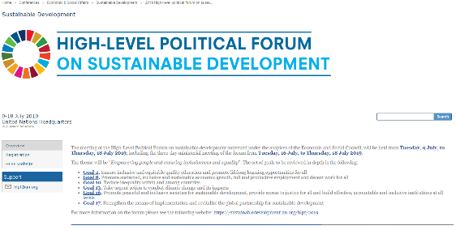
HLPF registration is organised through an event management system called Indico. UN DESA is responsible for managing the registration process. Key dates, such as when the registration process opens and closes, are publicised on the HLPF website and via the MGoS Coordination Mechanism mailing list. You can also find technical information about using Indico including step-by-step guides on the HLPF website.
There are three categories of Civil Society Organizations that can register for the HLPF:
- Organisations accredited with ECOSOC consultative status
The Economic and Social Council is the main entry point into the UN system for NGOs. ECOSOC is the central mechanism for coordination of the activities of the United Nations system and its specialized agencies and supervision of subsidiary bodies in the economic, social, environmental and related fields. It is the principal body for the coordination, policy review, policy dialogue and recommendations on issues of economic and social development and for implementation of the international development goals agreed at the major United Nations conferences and summits, including the Sustainable development Goals. The consultative relationship with ECOSOC is governed by Resolution 1996/31. Further information can be found

The vast majority of organisations attending the HLPF will be accredited with ECOSOC consultative status. Each Organisation accredited with ECOSOC consultative status can request up to 9 temporary grounds passes at a time, in addition to 7 annual grounds passes. In order to attend the HLPF, members of these organisations must have an annual or temporary UN Grounds Pass along with an approved registration application via Indico.

- Organisations on the CSD Roster
In 1992 a list of organisations that were not accredited with ECOSOC consultative status were drawn up and place on the CSD Roster. The purpose was to permit these organisations to attend and participate in the work of the Commission on Sustainable Development without the necessity of obtaining ECOSOC consultative status. No new organisations have been added to the CSD Roster since its creation and so very few organisations use this process as a means of registering for HLPF.

- Organisations affiliated with the MGoS (+41)
In a process that is similar to the CSD Roster above, UN DESA provides each of the 18 MGoS constituencies with 41 additional temporary UN Grounds Passes which cover the dates of the HLPF. These additional passes are granted to what’s known as an ‘Umbrella Organisation’ within each MGoS constituency. These Umbrella Organisations are Organisations accredited with ECOSOC consultative status. The purpose of the additional passes is to provide opportunities to civil society representatives that are engaged in the implementation of Agenda 2030 and the SDGs, who would not usually have an opportunity to engage and participate in the HLPF.

Each of the MGoS constituencies conduct their own selection and nomination process to identify which members of their constituency will receive the 41 additional temporary UN Grounds Passes. The nominations are submitted to UN DESA for review and approval.

Participation in Official Meetings
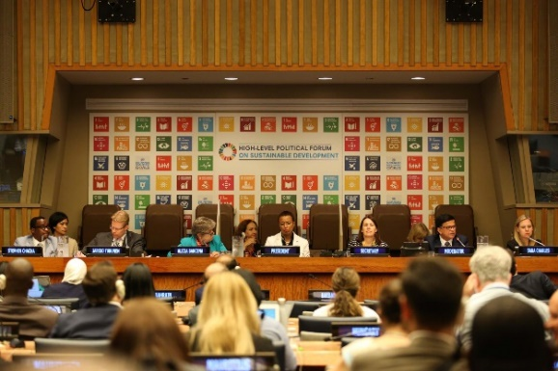
Participants who have had their registration approved will have access to all official meetings of the HLPF. This is of course subject to room capacity. The Department of Safety and Security operates a first-come-first served policy for participants wishing to attend the official sessions of the HLPF. The same applies to side events and special events, the doors are closed when they reach capacity.

The opening session of the Ministerial Segment of the HLPF in the General Assembly Hall required a Secondary Ticket in 2019. These Secondary Tickets were distributed on a first-come-first-served basis from the General Assembly Lobby on the ground-floor.
Photos by IISD/ENB | Kiara Worth http://enb.iisd.org/hlpf/2019/

Funding
UN DESA provides funding to a limited number of participants to attend and participate in the HLPF each year. Funding is provided to MGoS representatives who are nominated as Lead Discussants to speak during the official sessions. Only participants from developing countries receive funding. Each of the MGoS constituencies hold internal processes to put forward a slate of nominees to be approved by the President of ECOSOC.
Written Advocacy Opportunities in preparation for the HLPF

Sectoral Position Papers
In accordance with paragraph 15 of General Assembly resolution 67/290, which outlines the format and organizational aspects of the HLPF, ‘major groups and other relevant stakeholders shall be allowed to submit documents and present written and oral contribution’. Every year, each of the major groups and other stakeholders are invited to submit their coordinated sectoral position papers related to the theme of the High-Level Political Forum. These sectoral papers outline key messages, challenges, opportunities, good practices and policy recommendations for implementing the 2030 Agenda, as well as other sustainable development frameworks. The deadline for these reports concludes shortly before the HLFP each year. The reports are then placed on the ‘Inputs to the HLPF’ online review platform.

Paragraph 89 Reports
In addition to the sectoral position papers, paragraph 89 of the 2030 Agenda states that the HLPF ‘will support participation in follow-up and review processes by the major groups and other relevant stakeholders in line with resolution 67/290. We call upon those actors to report on their contribution to the implementation of the Agenda.’ This provides an opportunity for individual organizations or organizations in partnership to submit reports on specific themes relating to the implementation of the 2030 Agenda and the SDGs. The deadline for these reports concludes shortly before the HLFP each year. The reports are then placed on the ‘Inputs to the HLPF’ online review platform.

The HLPF Programme
The coloured boxes below correspond to the official sessions of the HLPF Programme to easily identify the nature of each session:

Preparatory Meetings
In preparation for the HLPF, UN DESA and the Steering Group share information on how to engage and participate through the MGoS Coordination Mechanism mailing list. To sign-up, participants simply needs to complete the short survey found on Stakeholders page of the HLPF website. Instructions on how to engage and participate in the HLPF as noted below will be distributed via the mailing list and will be placed on the website. UN DESA also holds regular conference calls and webinars to provide MGoS representatives with opportunities to ask questions and find out more information.
The MGoS Coordination Mechanism holds a full-day Preparatory Meeting shortly before the HLPF commences. In previous years this has happened during the weekend before the Forum, in 2019 it was held on Monday, one day before the Forum began on Tuesday. The meeting is facilitated by UN DESA and takes place within the United Nations Headquarters. The meeting provides MGoS representatives with an opportunity to share information, to network and to strategise.
UN DESA and the Steering Group will also moderate a Daily Morning Meeting from 8 – 9am, every morning, throughout the HLPF. The purpose of the meeting is for the Steering Group Co-Chairs and UN DESA to highlight, for example, any amendments to the schedule, additional engagement and participation opportunities or security issues. The MGoS representatives present also use the meeting to discuss substantive issues of the HLPF and to publicise events taking place that day to the group.

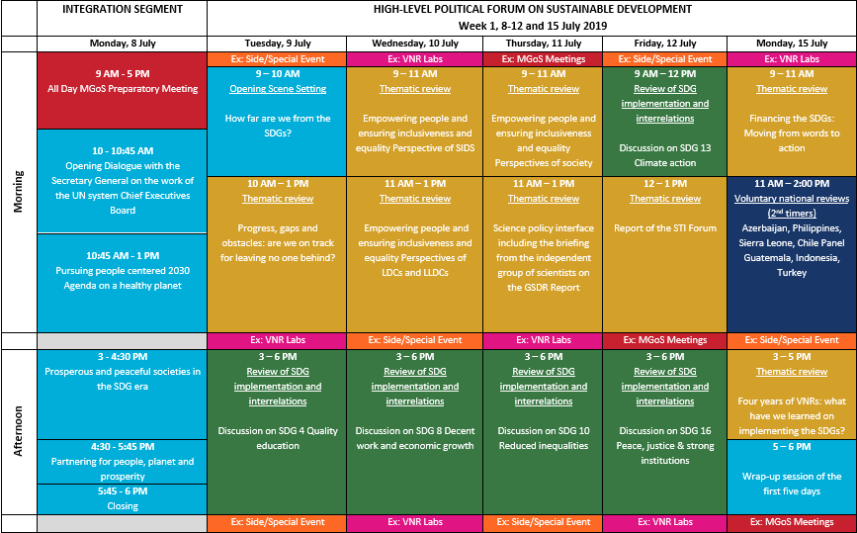
HLPF Programme 2019, Visual Aid 1

Thematic Review Discussions
General Assembly Resolution 70/299 was adopted in 2016. It determined that, for the purposes of the thematic reviews of progress on the 2030 Agenda for Sustainable Development at the HLPF, the sequence of themes for each four-year cycle of the forum shall reflect the integrated, indivisible and interlinked nature of the SDGs. The General Assembly decided upon the following themes for the current cycle of the HLPF under the auspices of ECOSOC:
- 2017: Eradicating poverty and promoting prosperity in a changing world
- 2018: Transformation towards sustainable and resilient societies
- 2019: Empowering people and ensuring inclusiveness and equality
The theme for the next HLPF will be:
- 2020: Accelerated action and transformative pathways: realizing the decade of action and delivery for sustainable development
The thematic reviews take place during the first and the second week of the HLPF. As outlined in the visual aid of the HLPF programme above, the sessions include:
- Thematic Reviews, such as Progress, gaps, and obstacles: are we on track for leaving no one behind; Four years of VNRs: what have we learned on implementing the SDGs; Lessons learned from the first cycle of the HLPF.
- Countries in Special Situations, such as the Perspectives of Small Island Developing States (SIDS), Least Developed Countries and Landlocked Developing Countries. As well as sessions titled What are the regions telling us about implementation of the 2030 Agenda and the SDGs
- Science-Policy Interface, such as sessions about the Report of the Science, Technology & Innovation Forum; Briefing on the Global Sustainable Development Report; Financing the SDGs: moving from words to action
- Emerging Issues, such as sessions titled Where are we heading? Visions and projections for the future of the SDGs; Empowering people and ensuring inclusiveness and equality, long term trends and scenarios.
And of course, the official session focusing on the Perspectives of Multi-Stakeholders which is organised in collaboration with the Major Groups and other Stakeholders’ Coordination Mechanism (see below).
Each Thematic Review Discussion is held for approximately 3 hours. The panel is typically comprised of a Chair Person, a Keynote Speaker, a Moderator, along with 4 – 6 Resource Persons and 1 – 3 Lead Discussants. By way of occupational background, the Resource Persons and Lead Discussants are either eminent practitioners or experts in their field. They are tasked with sharing key insights on the theme of the session and the proposed guiding questions outlined in the HLPF Annotated Programme. In order to make the discussion interactive, submissions by these participants and the interventions from the floor are brief.
Representatives of the Major Group and other Stakeholder are invited to participate in the interactive discussion as Lead Discussants. In preparation for the HLPF, UN DESA will request nominations for these speaking slots. In collaboration with the Steering Group of the MGoS Coordination Mechanism, the Lead Discussants for each official session will be submitted to the President of ECOSOC for approval. All parties seek to ensure that there is an equitable balance of geographical location, age, gender, as well as thematic interest between the nominees.
The interactive discussion is opened to the floor at the end of these official sessions. There are opportunities for representatives of the MGoS to deliver very short submissions or to ask questions of the panel. These advocacy opportunities are very brief, less than 1 minute, and so are typically reserved for questions to be asked of the participants above. Funding is available to all Lead Discussants from developing countries to attend the UNHQ to participate.

SDG Review Discussions
General Assembly Resolution 70/299 also determined that the three dimensions of sustainable development, including cross-cutting issues as well as new and emerging issues, and will serve as the framework for reviewing all 17 Goals. It decided that sets of SDGs shall be reviewed in depth each year. It is important to note that SDG 17 is reviewed every year:
2017: Goals 1, 2, 3, 5, 9 and 14
2018: Goals 6, 7, 11, 12 and 15
2019: Goals 4, 8, 10, 13 and 16
The format, logistics, composition and style of the SDG Review Discussions broadly follow similar principles as the Thematic Review Discussions above. The advocacy and funding opportunities follow a similar process as well.

Voluntary National Review - Presentation Sessions
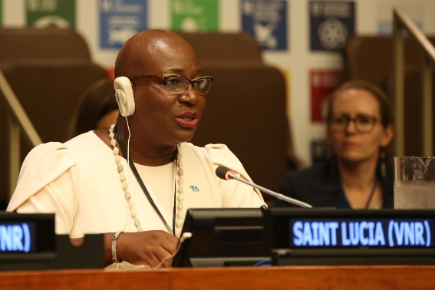
Voluntary National Reviews are part of the follow‐up and review of the 2030 Agenda for Sustainable Development. Such reviews are carried out by the HLPF under the auspices of the Economic and Social Council (ECOSOC). They are to be voluntary, state‐led, undertaken by both developed and developing countries, and provide a platform for partnerships, including through the participation of Major Groups and other stakeholders. VNRs allow the sharing of experiences, including successes, challenges and lessons learned, with a view to accelerating the implementation of the 2030 Agenda.
During the ministerial segment of the HLPF in July, Member States will utilize either a panel or individual format to present their VNR reports. In the panel format, between two and four countries per session each make a presentation. Once all countries in the session have presented, questions are posed to the presenting countries. In the individual format, a single country presents, followed by questions from countries in the audience, as well as from the Major Groups and other Stakeholders. Further information on the background of the VNR Reports can be found in the Introduction to the HLPF document.
Photos by IISD/ENB | Kiara Worth http://enb.iisd.org/hlpf/2019/
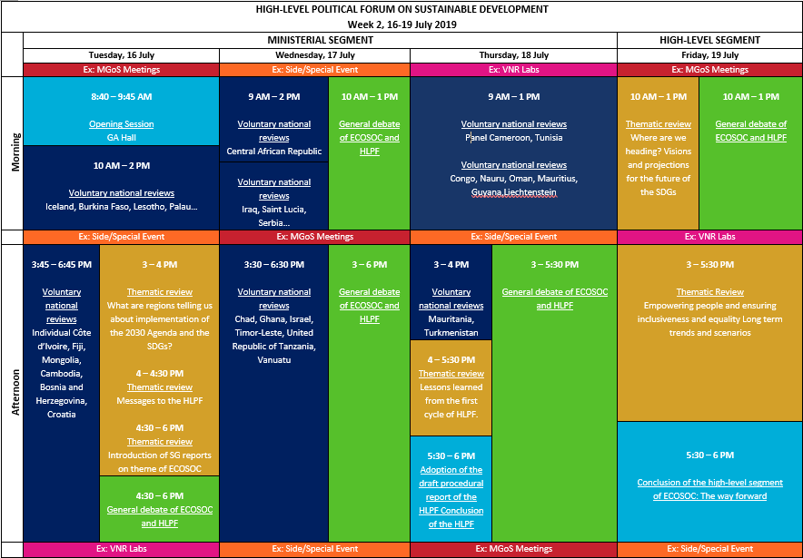
HLPF Programme 2019, Visual Aid 2

Voluntary National Review - Labs
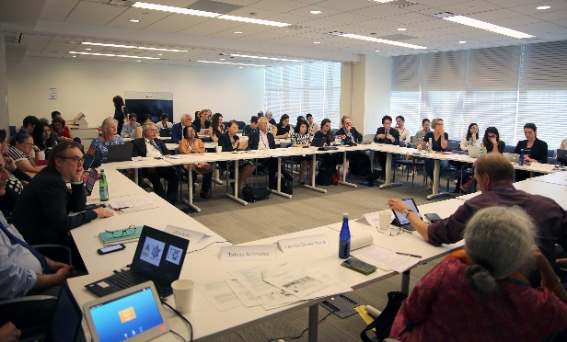
The VNR Labs provide an informal platform to share best practices and to reflect on the experience so far with the Voluntary National Reviews, as well as to identify future improvements. They focus on cross-cutting themes and country experiences. The VNR Labs take place in small to medium size conference rooms and last approximately an hour-and-a-half. They take place under Chatham House Rule, meaning that participants are free to use the information received, but neither the identity nor the affiliation of the speakers nor that of any other participant, may be revealed. These elements are conducive to creating an interactive dialogue between its participants.
In 2019, UN DESA organized 17 VNR Labs in collaboration with other partners. They are open to Member States, UN entities and representatives of the Major Groups and other Stakeholders by RSVP. Each Lab session has a moderator and a rapporteur. The rapporteurs with UN DESA produce brief summaries of each Lab. Some examples of the 2019 VNR Lab themes include Making progress visible - SDG data visualization platforms; From presentation to implementation: Regional support to the follow-up on the VNR process; How can science, technology and innovation advance national implementation; Strengthening the thematic reviews during the next cycle; Storytelling and communication strategies for the SDGs; and Mauritius – national experience of the VNR process.
Photos by IISD/ENB | Kiara Worth http://enb.iisd.org/hlpf/2019/

Official Session dedicated to Multi-Stakeholder Perspectives
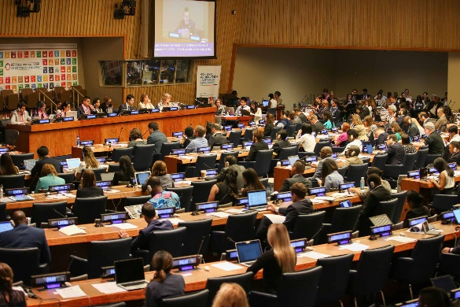
At every HLPF from 2016 to 2019 an official session has been dedicated to the perspectives of society. The 3-hour session, which tends to follow the theme of the Forum that year, is organised by UN DESA in collaboration with the MGoS Coordination Mechanism. The session focuses on the recommendations of MGoS around the implementation, follow-up, and review of the 2030 Agenda. Representatives from the MGoS work with UN DESA to determine the objectives, the guiding questions, invitees and the format of the session.
The traditional layout for official sessions is followed whereby Member State representatives sit at desk on the floor of the conference room. UN entities and MGoS representatives sit at desk in the Observer Section. These desks have illuminated panels to identify affiliation and microphones so that interventions can be made. The gallery, as with all other official sessions, is open to all HLPF registered participants. The session is chaired by a senior member of UN Staff and experienced MGoS practitioners moderate the dialogue. In order to guide the interactive dialogue, only a limited number of participants are pre-determined to allow for others to freely interact in the dialogue. Guiding Questions at the 2019 HLPF included:
Photos by IISD/ENB | Kiara Worth http://enb.iisd.org/hlpf/2019/

- Which should be the principles to guide the strengthening of the follow-up and review process of the 2030 Agenda, including the HLPF Reform?
- How to best integrate the contribution of other cross-cutting/thematic processes, such as the Financing for Development follow-up, the Science Technology and Innovation process, the Committee on World Food Security process and the Sendai process?
- How to strengthen the interplay between the global and the regional processes, including the role of the Regional Sustainable Development Forums?
- How to ensure vibrant participation and effective dialogue in the context of the VNR process at national and global levels?
The session is translated concurrently into all six official languages of the United Nations. UN Web TV broadcasts the session live and stores previous sessions to watch back at a later date. CART captioning services are provided.

Side & Special Events
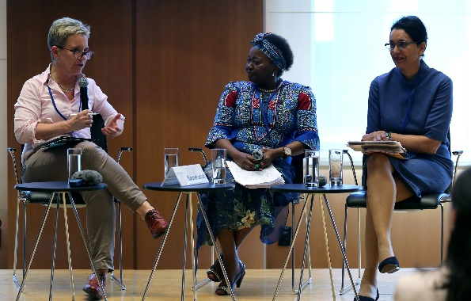
Side events and Special events are organized at the margins of the 2019 HLPF, meaning that they fall outside the official programme and that the outcomes and reports of these events do not feature in the official documentation of the HLPF. The events do however, provide greater opportunities to discuss specific subjects concerning the implementation of Agenda 2030 and the SDGs in greater detail and in a more interactive setting. As a result of the focused topics under discussion, these events are more conducive to finding networking opportunities with peers. Side Events and Special Events typically take place prior to, between or after the Official Sessions in the early mornings, lunch breaks and early evenings. The events are sponsored by Member States, the UN system and other Intergovernmental Organizations, as well as Major Groups and other Stakeholders. In 2019, several Major Groups and Stakeholder Groups held side events in addition to a collective side event titled What do the Major Groups and other Stakeholder Groups want out of the HLPF Review?
Photos by IISD/ENB | Kiara Worth http://enb.iisd.org/hlpf/2019/

High-Level Segment of the Economic and Social Council
Held on an annual basis, the High-level Segment represents the culmination of ECOSOC's annual cycle of work and convenes a diverse group of high-level representatives from Government, the private sector, civil society and academia. There are two aspects to the High-Level Segment. First, the General Debate provides an opportunity for all Member States, United Nations entities and civil society organizations to make statements at the parallel meetings on the annual theme of the ECOSOC cycle. The NGO Branch of the Office of Intergovernmental Support and Coordination of UN DESA submits a request to ECOSOC accredited organisations to submit an oral statement. The major groups and other stakeholders are also invited to submit statements. In 2019, these two-to-three minute statements were delivered from the lectern at the podium of the Trusteeship Council Chamber.
Secondly, it was decided that the final day of the 2019 High-level Segment of ECOSOC, would ‘focus on future trends and scenarios related to the Council theme, the long-term impact of current trends, such as the contribution of new technologies, in the economic, social and environmental areas on the realization of the Sustainable Development Goals, based on the work of the United Nations and other regional and international organizations and bodies as well as other stakeholders’. Interventions by civil society organization representatives from the floor were also welcomed during this session.

