|  |
| --- |
|  |

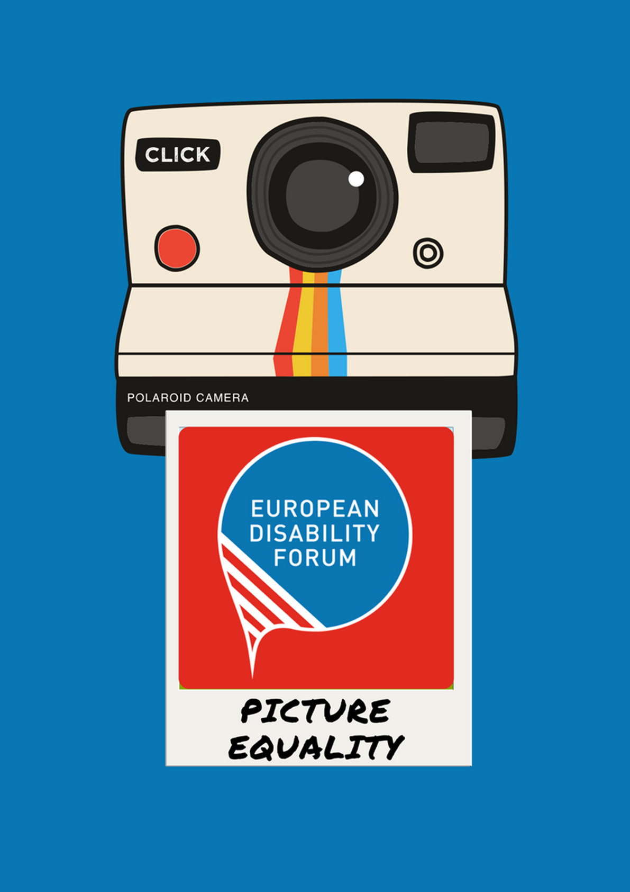

# **European Disability Forum**

# Photo Competition Rules, Terms and Conditions

## **Theme**

The theme of the competition is Equality and Inclusion of persons with disabilities. According to the UN Convention on the Rights of Persons with Disabilities, all persons with disabilities have the right to live where and with whom they want, go to a mainstream inclusive school and have a regular job, vote in the elections and go to the movies or sport club as anyone else. Persons with disabilities should not be discriminated against because of their disability. They should receive the support they need to participate in all aspects of life and society as anyone else.

This theme must be implemented into the photo submissions. Feel free to be creative and unique. However, do not stray away from the goal of the theme. Photos which are not relevant will not be considered for the competition. We are looking forward to seeing how you visualize this theme in your photography work.

## **How** **to** **enter**

The photo entries and can be submitted by emailing it to:

Lucia D’Arino - <lucia.darino@edf-feph.org>

All submissions are due on the **1st of October 2018**, 23.59 PM CET

## **Eligibility**

The competition is open to everyone and there is no entry fee. For more detailed information see the Terms & Conditions.

All participants must submit, together with their photo, a signed copy of page 6. Two authorisations are needed, one from the person who took the picture and one from the person(s) appearing IN the picture.

## **Entries**

Each participant may submit one entry. Participant should be an individual and not an organization. The photo should represent the theme ‘Equality’. Every photo submission should be accompanied by a short description (*in English*) as well as the author name, place (*city & country*) where the picture was taken.

Entries that are offensive, defamatory or obscene, or that disclose unnecessary personal information, will also be rejected from the competition. Composite images are not eligible.

All photos should be provided in high resolution (high quality picture “300dpi”).

Photos can be edited and filters applied, however, entries must comprise one image only. Photos that contain more than one image shot separately are not allowed. Entries comprised of photo collages or images with additional elements (watermarks, text, etc.) will be rejected. Photos shot using various methods (i.e. long exposure, stacking) and camera built-in effects are accepted.

## **Copyright**

All entries must be original work and the participant must either be the sole owner or the transferee of the copyright.

By entering the competition, participants retain full copyright of their images. However, participants also agree to be bound by Facebook legal terms (**https://www.facebook.com/legal/terms**). Participants also grant the European Disability Forum the right to publish and exhibit uploaded photographs.

Participants must obtain and provide written consent from any adult who are identifiable in a photograph. Participants taking a photograph of children, ensure that they obtain and provide us with the written consent of that child’s parents/guardian.

## **Selection & Control**

All photos are checked to make sure that they meet the competition rules before being accepted and shortlisted. Once a photo has been reviewed, participants will receive an email with notification of whether it has been accepted or rejected. All pictures will be included in a special album on EDF’s Facebook page.

## **Jury**

The jury will be composed by two members of the EDF Board, EDF Director, communication officer and human rights officer, and by two photographers.

## **Selection of winners**

There will be a selection of 20 finalists, based on the following criteria: quality of the picture, innovation, creativity and relevance to the competition theme. All 20 final photos, including the three winners, will be exhibited during various events and in other European countries as well, including the [European Day of Persons with Disabilities](http://ec.europa.eu/social/main.jsp?catId=88&eventsId=1264&furtherEvents=yes&langId=en) and Brussels Photo Exhibit.

The jury’s decision is final and no correspondence will be entered in on its decision. At the end of the jury selection period, the 20 finalists will be notified by email.

## Out of the 20 finalists, the Jury will select the 3 final nominees. These 3 final nominees will be invited to Brussels to take part in the European Day of Persons with Disabilities organised by the European Commission on 4-5 December in Brussels.

## The winner’s name will be revealed on the 2nd of November.

## **Cheating**

Fairness and respect are the basis of the competition. Any participant reasonably suspected of cheating, including but not limited to the unfair acquisition of votes, will be disqualified from the competition and their entries removed. No correspondence will be entered in on this matter.

## **Prizes**

The three final nominees will receive:

1st place award: 500 euros

2nd place award: 300 euros

3rd place award: 200 euros

## **Acceptance of Competition Rules**

By entering the competition, the participants agree to be bound by the Competition Rules, including acceptance of granting copyright to EDF.

# **Terms & Conditions**

## 2018 Photo Competition ‘Picture Equality’

**1.** The promoter and host of this Competition is the European Disability Forum based in Brussels, Belgium.

**2.** There is no participation fee to enter this competition.

**3.** No correspondence will be entered into regarding this Competition, including but not limited to the vote, selection and results.

**4.** Employees and immediate relatives of employees of the promoter are excluded from participation.

**5.** The promoter retains the right to disqualify any participant suspected of cheating in any form and remove their entries from the competition. No correspondence will be entered into on this matter.

**6.** The promoter reserves the right to select an alternative winner in the event that the promoter has reasonable grounds for believing that a participant has contravened any of these terms and conditions.

**7.** All participants are required to provide a written acknowledgement of acceptance of all terms and conditions and sign a separate release form as provided by the Promoter. You can find the statement of release here.

**8.** All participants are responsible for any costs or expenses incurred by them as a result of participation in the Competition (including without limitation costs for accessing the Internet or sending the material).

**9.** A participant is responsible for any costs, taxes, duties or levies incurred as a result of participating in or winning the Competition.

**10.** No responsibility will be accepted for entries lost, delayed, misdirected, damaged, or undelivered, whether due to technical difficulties affecting electronic communication or else.

**11.** The prizes are as stated and are non-transferable and cannot be exchanged. No cash or credit alternatives will be offered. If due to circumstances beyond the promoter’s control the promoter is unable to provide the stated prize (s), the promoter reserves the right to award as substitute a prize of equal or higher value. All prizes are subject to the terms and conditions of the supplier of the relevant service included in the prize.

**12.** Participants and winners agree that they may be required to take part in publicity or other promotional activities without further consent or payment as later determined by promoter. Such publicity may include their names, images and/or likenesses as well as any contributions in the online Competition. The participant hereby grants the promoter any and all rights necessary for distribution and public display of any submitted text, image, or other intellectual property rights that may arise from participation in this Competition, the prizes or related publicity, and hereby grants the promoter the perpetual right to exclusively, royalty-free and without limitation use, edit, copy, reproduce, distribute, translate, and publicly display or publish any such intellectual property rights, for whatever purpose, in any form or medium, either on this web-site or elsewhere, for promotional activities or events arranged by promoter, whether locally or world-wide.

**13.** Any personal information, including, without limitation, the participant’s name, age, address (including postcode), mobile phone number and/or email address will be used solely in connection

with this Competition and will not be disclosed to any third party except for the purpose of the Competition (including subsequent promotions as stated in these terms and conditions).

**14.** By accessing this competition, the participant agrees to be bound by these terms and conditions, which may be amended or varied at any time by the promoter.

**15.** The promoter will not be responsible for any failed connection by the participant’s attempt to access the competition, via email or via Facebook whatever reason.

**16.** The promoter will under no circumstance whatsoever irrespective of the cause therefore, be liable for any loss, damage or personal injury to the winner nor to property or else caused or suffered in connection with this Competition or any prize (s) awarded in connection herewith.

**17.** The promoter will under no circumstance whatsoever be liable for any delays, changes, disruptions, cancellations, diversions or substitutions, unavailability of the prize (s) due to local public holidays or other conditions affecting availability or enjoyment of the prize (s), nor any act or omission whatsoever by any form of transportation and/or accommodation included in the prize (s). The promoter shall not be liable in respect of any non-performance of its obligations by reason of any force majeure, civil war or strife, hostilities, act of foreign enemy, invasion, war, satellite failure, legal enactment, governmental order or regulation or any other cause beyond its control.

**18.** The EDF web-site and Facebook Page may contain links to other web-sites, resources and advertisers. The promoter shall not be responsible for the availability of these external sites nor does promoter endorse or agree to be responsible for the contents, advertising, products or other materials made available on or through such external sites. Under no circumstances shall the promoter be held responsible or liable, directly or indirectly, for any loss or damage caused or alleged to have been caused to a user in connection with the use of or reliance on any content, goods or services available on such external site. Participants should direct any concerns directly to such external site’s administrator or webmaster.

**19.** The sending of entries through Facebook or email shall be used for lawful purposes only. Entries shall not contain any material and/or statement which violates or infringes in any way upon the rights of others which is unlawful, threatening, abusive, defamatory, invasive of privacy or publicity rights, vulgar, obscene, profane, indecent or otherwise objectionable, which encourages conduct or is conduct that would constitute a criminal offence, gives rise to civil liability or otherwise violates any applicable law. Entries failing to comply with this provision will be disqualified without prior notification. The Promoter reserves the right to remove any entries it deems to be inappropriate. The decision of Promoter in this matter will be final.

**20.** The promoter reserves the right at any time and from time to time without any liability whatsoever, to modify or discontinue, temporarily all the material of the Contest, with or without prior notice to Participants.

# ***Picture Equality*** Photo Competition 2018

## 1. Rights Authorization: copyright owner

I, the undersigned (*First name + Last name*): ………………………………………………………..……………………………

Living at (*full address: street + postcode + town + country*): ……………………………………………………………….………………………………………………………………………………………………………………………………………………………… hereby authorize the European Disability Forum (EDF) the perpetual right to use, royalty-free and without limitation, for a period of 20 years starting at the date of signature, in the whole world, the material submitted for the ***Picture Equality* Photo Competition 2018,** including to edit, copy, print, reproduce, distribute, translate, and publicly display or publish any such intellectual property rights, for whatever purpose, in any form or medium, either on this web-site or elsewhere, for promotional activities or events arranged by the EDF, whether locally or world-wide.

Drawn up in one original copy and executed in ……………………………….., on ………………….. (dd/mm/year)

***(Signature preceded by “read and approved”)***

Signature: ……………………………………………………………

## 2. Rights Authorization: featured individual

I, the undersigned (*First name + Last name*): ………………………………………………………..……………………………

Living at (*full address: street + postcode + town + country*): ……………………………………………………………….………………………………………………………………………………………………………………………………………………………… hereby authorize the European Disability Forum (EDF), royalty-free and without limitation, for a period of 20 years starting at the date of signature, in the whole world, the material submitted for the ***Picture Equality* Photo Competition 2018** where I, myself or my children that I duly represent, appear, including to edit, copy, print, reproduce, distribute, translate, and publicly display or publish any such intellectual property rights, for whatever purpose, in any form or medium, either on this web-site or elsewhere, for promotional activities or events arranged by the EDF, whether locally or world-wide.

Drawn up in one original copy and executed in ……………………………….. , on ………………….. (dd/mm/year)

***(Signature preceded by “read and approved”)***

Signature: ……………………………………………………………