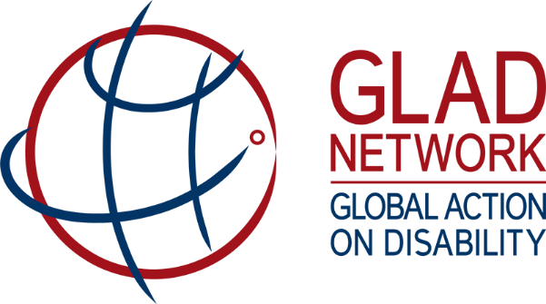

Possible advocacy messages on inclusion of persons with disabilities in humanitarian action

The following high-level points on disability inclusion have been compiled by Australia, as current co-chair of the GLAD Humanitarian Working Group. They offer possible language that members of the GLAD Network may wish to draw on to raise the issue of disability-inclusion during high-level meetings.

Key messages
- We recognise that persons with disabilities are disproportionately affected in situations of risk and humanitarian emergencies, and face multiple barriers in accessing protection and humanitarian assistance.
  - They are also particularly exposed to targeted violence, exploitation and abuse.
- Persons with disabilities and their representative organisations have significant untapped capacity, and are not sufficiently consulted or involved in decision-making concerning their lives, including in crisis preparedness and response.
- As a signatory to the 2016 Charter on Inclusion of Persons with Disabilities in Humanitarian Action (the ‘Disability Charter’), [xx organisation] has indicated a willingness to place persons with disabilities at the centre of its humanitarian response.
- As a signatory, [xx organisation] made several commitments, including:
  - to guarantee protection and equal access to assistance for all persons with disabilities
  - to promote the involvement of persons with disabilities and their representative organisations in decision-making and planning across the programming cycle, including in design, implementation, reporting and evaluation
  - to adopt policies and processes to improve quantitative and qualitative data collection on persons with disabilities, disaggregated by age and sex.
- As a signatory, [xx organisation] also recognised the need to strengthen and systematise existing policies, procedures and practices on the inclusion of persons with disabilities in humanitarian programs.
- To meet these needs and commitments, [our state/organisation] calls on [xx organisation] to:
  - involve persons with disabilities and their representative organisations in decision-making and planning across all stages of humanitarian action, including in design, implementation, reporting and evaluation
  - use the Washington Group Short Set of Questions as the tool to disaggregate data by disability
  - incorporate the needs and leadership capacities of persons with disabilities and their representative organisations into its strategic plans and reporting frameworks, and prepare a dedicated policy on the inclusion of persons with disabilities
  - establish a focal point on persons with disabilities.
- As a fellow signatory to the Disability Charter, [our state/organisation] is keen to work with you to promote stronger cooperation and coordination among humanitarian actors, governments and representative organisations of persons with disabilities, to support our mutual learning and sharing of resources.

Background
According to the World Health Organisation, 15 per cent of people in any population are estimated to be living with a disability. Disasters and conflict can increase the prevalence of disability.

Persons with disabilities, as defined in the Disability Charter, include those who have long-term physical, psychosocial, intellectual or sensory impairments, which in interaction with various barriers may hinder their full and effective participation in, and access to, humanitarian programmes.

The full text of the Disability Charter and a list of its signatories can be found at http://humanitariandisabilitycharter.org/.

The Global Action on Disability (GLAD) Network – comprising bilateral and multilateral donors and organisations, the private sector and foundations – is one group promoting the Disability Charter.

