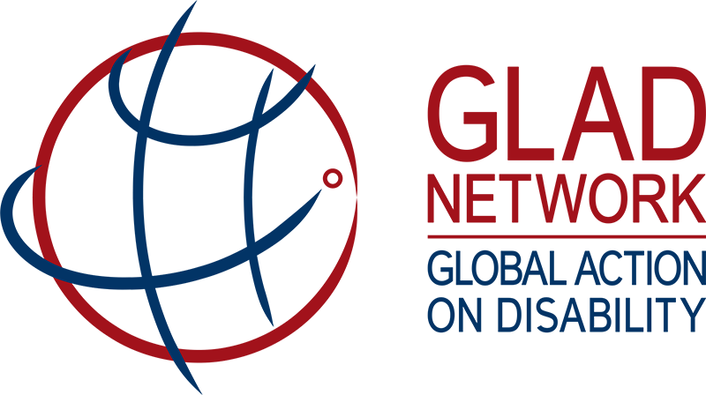

Humanitarian action: entry points for advocacy
These are some examples of humanitarian meetings and events in 2018 that may offer entry points through which GLAD members could cooperatively advocate for disability inclusion.

Meeting/Event | Date | Location
Formal consultations on the Global Compact on Refugees | Monthly, Feb to Jul | Geneva
From Disaster Management to Disaster Risk Reduction – Sendai Framework Implementation | 26 February | Berlin
Consultations on the Sphere Project – Humanitarian Charter and Minimum Standards in Humanitarian Response | 1 March | Europe
UN Children’s Fund (UNICEF) Executive Board Meeting | 11 June | New York
World Food Programme (WFP) Executive Board meeting | 18 June | Rome
UN Economic and Social Council (ECOSOC) Humanitarian Affairs Segment | 19 June | Geneva
International Committee of the Red Cross (ICRC) Donor Support Group | 24 June | Ottawa
UN Office for the Coordination of Humanitarian Affairs (OCHA) Donor Support Group High Level Meeting | 25 June | Bern
Global Disability Summit | 24 July | London
World Humanitarian Day | 19 August | Global
UN Refugee Agency (UNHCR) Executive Committee Meetings | 1 October | Geneva
International Day of People with Disabilities | 3 December | Global

