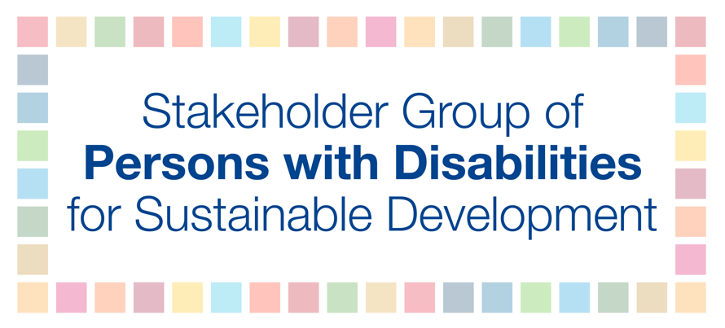
HLPF 2018
10 July
3-6 PM
ALZOUMA MAIGA IDRISS
SDG 7 – Ensure access to affordable, reliable, sustainable and modern energy for all
Most persons with disabilities and their families live in poverty and face a heightened risk of fuel poverty. Most persons with disabilities live in poor quality housing and encounter have limits on how to spend money, for example, choosing between energy consumption and other basic needs, such as food. At the same time, very often persons with disabilities have additional living costs from having a disability, including essential extra fuel cost. Related, the groups most likely to experience particularly negative health impacts from fuel poverty include older persons, infants, persons with disabilities and those living with long-term illness. Additionally, access to electricity is important for persons with chronical illness who use medical equipment and persons with disabilities who use electrically-powered communication tools. Accordingly, Article 28 of the UN Convention on the Rights of Persons with Disabilities calls for recognition of persons with disabilities’ right to social protection, access to poverty reduction programmes and States’ assistance with disability-related expenses including adequate training, counselling, financial assistance and respite care.
Consequently, we recommend that States must ensure universal access to affordable, reliable and efficient energy services for persons with disabilities, including the use of alternative energy facilities where warranted, limiting the frequency of power cuts.

