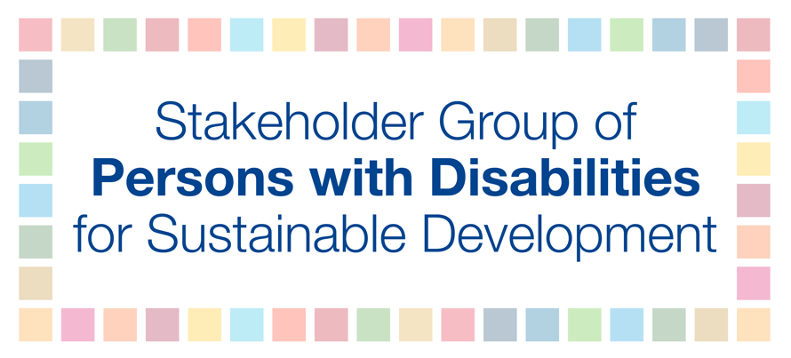
HLPF 2018
9 July
10 AM – 1 PM
ALZOUMA MAIGA IDRISS
Discussion among policy makers and with statisticians and other stakeholders on the report and data and statistics

The global indicator framework was adopted by the General Assembly in 2017, and it contains 11 disability inclusive indicators, and an additional recommendation to further disaggregate by disability. Data disaggregation by disability has been further requested by numerous UN resolutions, including the Ministerial Declaration of the HLPF 2016 and 2017 and by the QCPR. Despite these facts, we do not see data on disability at the global level. If we are not counted, we do not count and will be left behind. Further we are gravely concerned that the Secretary-General’s Progress Report on SDG implementation, which is based on data, contained 12 references to persons with disabilities in 2016 while in 2018 there are only two references. Despite recommendations to States and other stakeholders to take advantage of internationally comparable measures developed, including a short set of questions for censuses and surveys developed by the Washington Group on Disability Statistics (WG-6), the child disability questions developed by UNICEF and the Washington Group, lack of data persist. We therefore recommend States to invest in high quality, timely, reliable and disaggregated data for reporting on the SDGs, and to foster global partnerships on data such as Together we count to be counted, to ensure evidence-based policy making.

