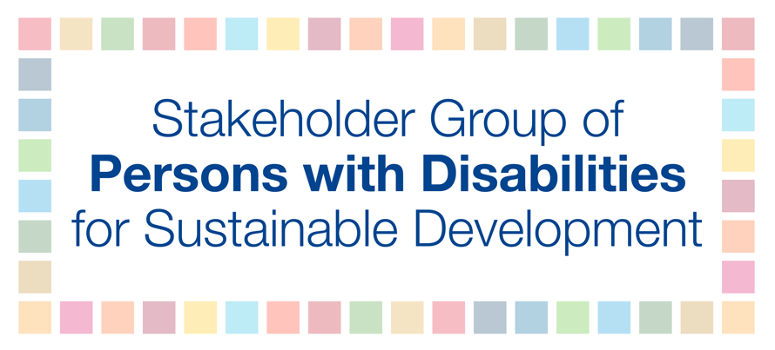
HLPF 2018
11 July
3-6pm
Ana Paleaz

SDG 11 – Make cities and human settlements inclusive, safe, resilient and sustainable
For persons with disabilities, Goal 11 means removing barriers to access the built environment, information, and communication, including information and communication technologies. These barriers deny persons with disabilities access to basic urban services, including housing, roads, public spaces, transportation, sanitation and water, health, education, emergency and disaster response. Furthermore, safe and inclusive mobility is central for guaranteeing persons with disabilities’ participation to the life of their communities and access to economic, social, cultural and political spheres of society. For example, in Asia and Africa, it has been shown that there are linkages between safe mobility and road safety; safe mobility and inclusive education; safe mobility and socio-economic insertion.
Persons with disabilities are vulnerable road users, along with older persons, children, or pregnant women. Since accessibility is a precondition for persons with disabilities to live independently, to be included in the community, and to participate fully and equally in society, the denial of access to the physical environment, transportation, information and communication technologies, facilities and services open to the public should be viewed in the context of discrimination. The increasing frequency and severity of hurricanes, floods, droughts and extreme temperatures further disproportionately affect persons with disabilities who encounter constraints in accessing early warning of disasters, information on how to cope, transportation and emergency shelters. Consequently, studies have indicated that persons with disabilities are four times more likely to die when a disaster strikes than those without disabilities. Therefore, universal design principles need to be applied to truly make cities and human settlements inclusive, safe, resilient and sustainable, we must ensure that all people are included, diversity is celebrated, and everyone has support to live in cities and human settlements.

