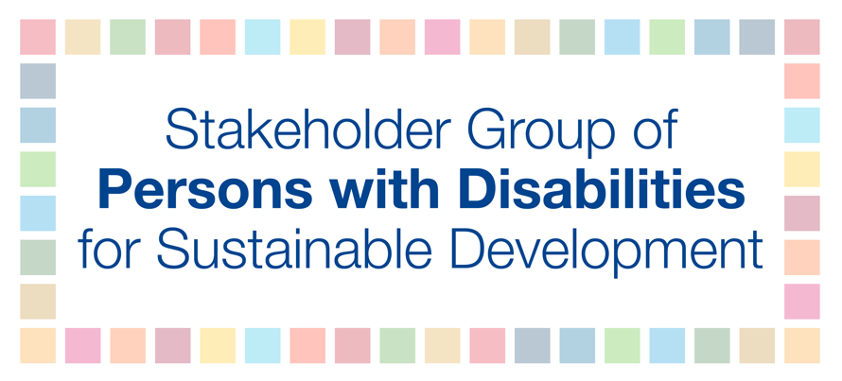
HLPF 2018
12 July
11am-1pm
Ana Paleaz

Perspectives of society: Session organized with major groups and other stakeholders

To truly make cities and human settlements inclusive, safe, resilient and sustainable, we must ensure that all people are included, diversity is celebrated, and all have support to live and be included in cities and human settlements. Approximately 177 million persons with disabilities are adversely affected and without access to clean water and sanitation. Additionally, more than half of all persons with disabilities lives in towns and cities that are rarely accessible, and this number is estimated to grow to between 750,000 and 1 billion by 2030. However, due to barriers in accessing the built environment, information, and communication, persons with disabilities are denied access to basic urban services, including housing, roads, public spaces, transportation, sanitation and water, health, education, emergency and disaster response. Yet it is generally feasible to meet accessibility requirements at one percent of the total cost.
Inclusive, safe, sustainable and resilient societies cannot be defined only by bricks and mortar, neither only by physical access. Inclusive societies must be built on the principles secured in Article 3 of the UN Convention of the Rights of Persons with Disabilities by respect for inherent dignity, individual autonomy including the freedom to make one’s own choices, and independence of persons; non-discrimination; full and effective participation and inclusion in society; respect for differences and acceptance of persons with disabilities as part of human diversity and humanity; equality of opportunity; accessibility; equality between men and women; respect for the evolving capacities of children with disabilities and respect for the right of children with disabilities to preserve their identities. To realize this inclusion for persons with disabilities, policymakers must be informed by collecting evidence-based data that are disaggregated by disability using the short set of questions developed by the Washington Group and by properly consulting persons with disabilities and their representative organizations on the design, implementation and monitoring of SDG plans.

