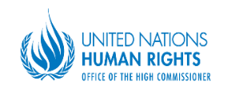
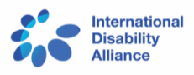
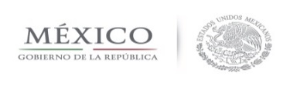
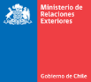

INVITATION SIDE EVENT

MANDATE OF THE SPECIAL ENVOY OF THE SECRETARY GENERAL ON DISABILITY AND ACCESSIBILITY

Synergies among Universal Human Rights System in the framework of Agenda 2030

Co-organized by: The Special Envoy of the Secretary General on Disability and Accessibility, the Permanent Mission of Chile, the Permanent Mission of México, the United Nations Office of the High Commissioner for Human Rights and International Disability Alliance,
Geneva, 7th March 2018
Palais des Nations, Room XXIV, 11:30 - 1:00

This event aims to present the mandate of the special envoy on disability and accessibility and discuss about synergies among the universal mechanisms of Human Rights, in the framework of Agenda 2030 and the full implementation of the CRPD.
Opening remarks and moderator
H.E. Socorro Flores, Permanent Representative of México

Panelists:
Ms. María Soledad Cisternas, Special Envoy of SG on Disability and Accessibility.
Mr. Facundo Chávez, Representative of Office the High Commissioner of HR.
Ms. Catalina Devandas, Special Rapporteur on the Rights of Persons with Disability.
Ms. Silvia Quan, International Disability Alliance.
