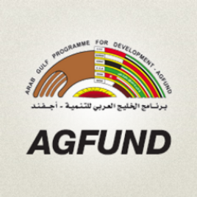
AGFUND Arab Organization of Persons with Disabilities (AOPD)

The Third Regional Conference of
The Arab Forum of Women with Disabilities (AFOWD):
Collaborating for a Safe and Barrier-Free World
28, 29th of April 2018, Conrad Hotel,Cairo,Egypt

Please fill this form, in case you are planning to participate in the conference, and send it to us no later than the 27th of March, 2018.

Name:………………………………………………………………………………………………………………….

Organization: ………………………………………………………………………………………………………

Post:……………………………………………………………………………………………………………………..

Kind of disability:……………………………………………………………………………………………….…

Mailing Address:……………………………………………………………………………………………….…

Country…………………………………………………………………………………………………………....

Tel:………………………………………………………………………...................................................

Fax:……………………………………………………………………………………………………………………....

Email:…………………………………………………………………………………………………………………...

Mobile:………………………………………………………………………………………….

