Brussels,9 April 2019 - IMMEDIATE RELEASE

EU elections lead candidate Weber supports European disability Movement
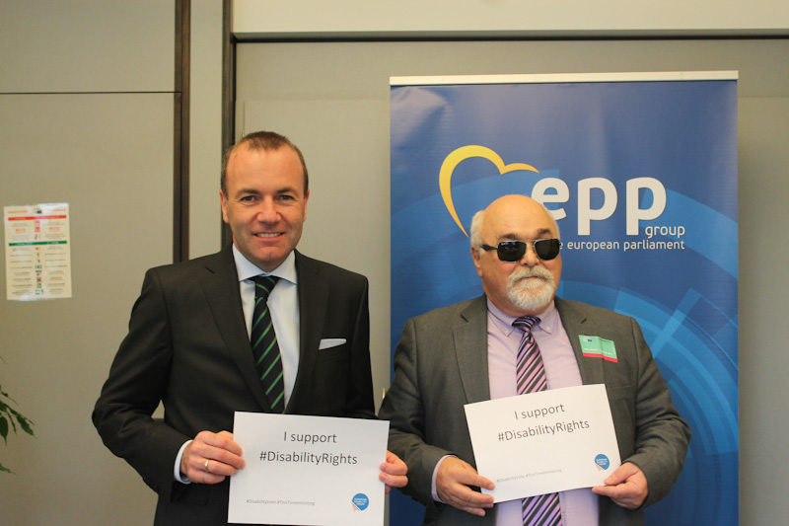
Mr Manfred Weber, lead candidate of the European People's Party and Mr Yannis Vardakastanis, President of the European Disability Forum
The President of the European Disability Forum, Mr Yannis Vardakastanis, met with Manfred Weber, the European People’s Party lead candidate for the European Parliament Elections.
The EDF delegation, led by Yannis Vardakastanis, presented 5 key demands from the disability movement:
- Legislation and support to assure that persons with disabilities can be employed in an equal basis with others.
- An ambitious European Disability Strategy 2020-2030, that involves persons with disabilities in all its phases and with a significant budget allocated. The strategy should be followed by all EU institutions, bodies and agencies.
- The next EU budget, post 2020 needs to fully comply with the UN Convention on the Rights of Persons with Disabilities.
- An accessible Europe: implementing existing accessibility legislation, assuring all new EU initiatives consider accessibility for persons with disabilities and guarantee that EU Commission makes sure all its web tools and infrastructure is accessible.
Mr Yannis Vardakastanis, President of the European Disability Forum stated: “It is estimated that next year there will be over 120 million persons with disabilities living in the European Union. However, much remains to be done. People’s lives are not improving and this is feeding the populist agenda in Europe. We need more social investment, we need innovation, we need forward looking initiatives. We need strong leaders that ensure the rights of persons with disabilities.”
Mr Manfred Weber, lead candidate for the European People’s Party said: “In the European Union we make many statements about the fight against discrimination and about democracy. Yet millions of people with disabilities will not be able to vote at the next European elections and decide about the future of our continent. This is unacceptable!
We need to guarantee that persons with disabilities fully enjoy all the opportunities our societies offer without any discrimination, starting with their basic democratic rights. No one should be left behind.
This is why I fully support the campaign launched by the European Disability Forum. As the EPP candidate for the presidency of the European Commission I will commit to a EU that defends Disability Rights.”

Related Information
- Press Release in Word | Press Release in PDF

Notes to editors

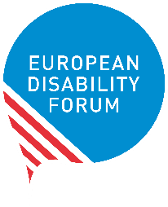
The European Disability Forum is an an umbrella organisation of persons with disabilities that defends the interests of 80 million Europeans with disabilities. EDF is a unique platform which brings together representative organisations of persons with disabilities from across Europe. It is run by persons with disabilities and their families. EDF is a strong, united voice of persons with disabilities in Europe

For more information, please contact
André Félix
External Communications Officer
European Disability Forum
tel +32 2 282 46 04 | Mobile +32 483 18 71 80
andre.felix@edf-feph.org

