Brussels, 13 March 2019 - IMMEDIATE RELEASE

European Accessibility Act: a big step forward on a long journey

European Parliament's approval of the Act is positive – we call for better and effective legislation
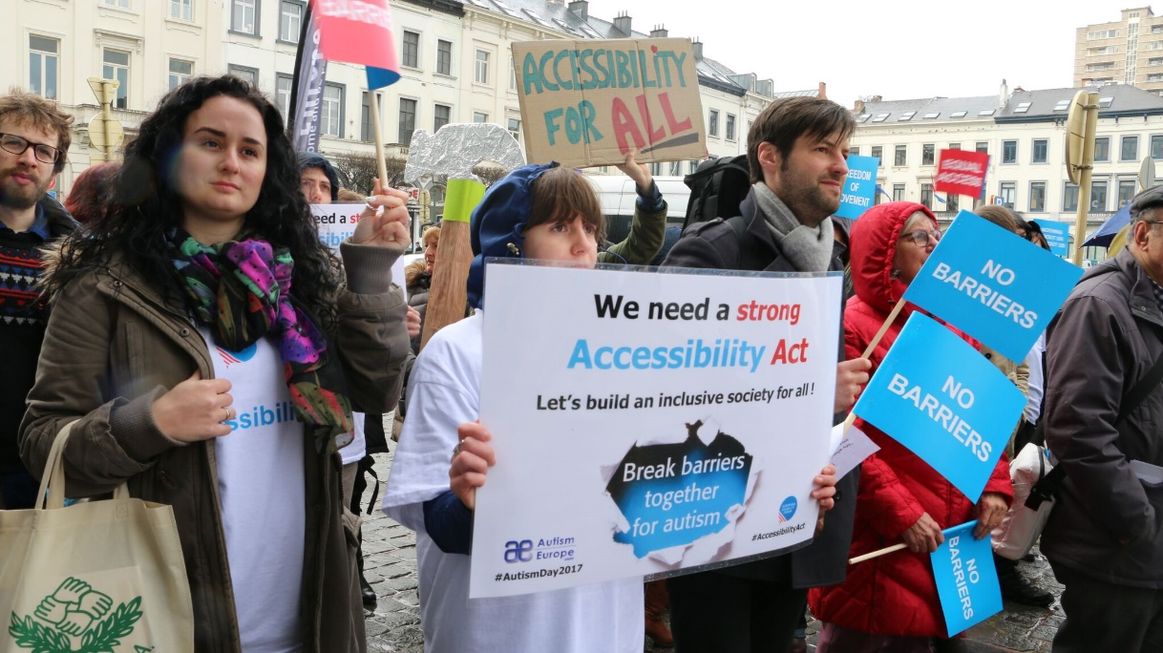
Demonstration for a strong Accessibility Act outside the European Parliament in Brussels, in 2017. Credits: David Hay/European Union of the Deaf
The European Accessibility Act is a landmark agreement. However, while it will ensure that many products and services are more accessible for persons with disabilities, it will not make the EU (institutions and single market) fully accessible. It still excludes many essential areas such as transport, built environment and household appliances.
The new accessibility Directive is an important step, but the EU’s work is far from being complete: we need legislation that ensures equal access in all areas of life.

Improvement in some areas
The Directive will improve the accessibility of a set of products and services for persons with disabilities, such as computers, smartphones, tablets, TV sets, banking ATM and services, payment terminals, e-books and e-readers, e-commerce websites and mobile apps and ticketing machines. It will also ensure that national market surveillance authorities have the competence to hold private entities accountable.
The European Accessibility Act also fulfilled two important demands from the disability movement: electronic telecommunications and the 112-emergency number will become accessible to everyone throughout the EU.
The requirements of the Act will also support the public procurement rules for accessible products and services, so public authorities do not anymore use tax payers’ money in products, services and facilities that are discriminatory of persons with disabilities.

Built environment and transport – a flaw in the Act
However, the Act still does not satisfy our key demands. It is misleading to say that the Act will ensure full accessibility of buildings and means of transport, which were at the heart of our campaign. This means that millions of persons living in the EU will still face daily struggles to leave their homes.
The Act does not include household appliances (such as washing machines or microwaves). This means that millions of persons with disabilities will still face daily difficulties to use these appliances and live in their own homes.
Finally, we regret that microenterprises providing services are exempt from complying with the requirements of the Act. This exemption will significantly reduce the Act’s impact.

Our campaign continues
The European Disability Forum thanks its members and allies for their commitment to making the Act become a reality, and it not being ignored and shelved, as it happened to other equality initiatives.
Yannis Vardakastanis, President of the European Disability Forum stated “It is shameful how Member States managed to reduce the scope of the Act. Governments now must redeem themselves and be very ambitious when incorporating the Act in national legislation.”
After today’s approval, two steps remain to be made: the Council of the EU needs to give its formal approval and the Act has to be published in the EU’s Official Journal. Member States will then have 3 years to transpose the Directive (translate the Directive into national legislation). We will continue fighting to ensure that the EU becomes a worldwide example of full accessibility for persons with disabilities.

Related information
- “Accessibility? Act!” campaign page

Notes to editors

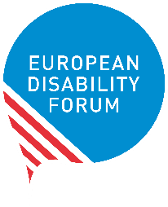
The European Disability Forum is an umbrella organisation of persons with disabilities that defends the interests of 80 million Europeans with disabilities. EDF is a unique platform which brings together representative organisations of persons with disabilities from across Europe. It is run by persons with disabilities and their families. EDF is a strong, united voice of persons with disabilities in Europe

