Brussels, 8 November 2018 - IMMEDIATE RELEASE

Disappointing compromise on EU Accessibility Act

We have political agreement on the European Accessibility Act. It doesn't live up to its name.
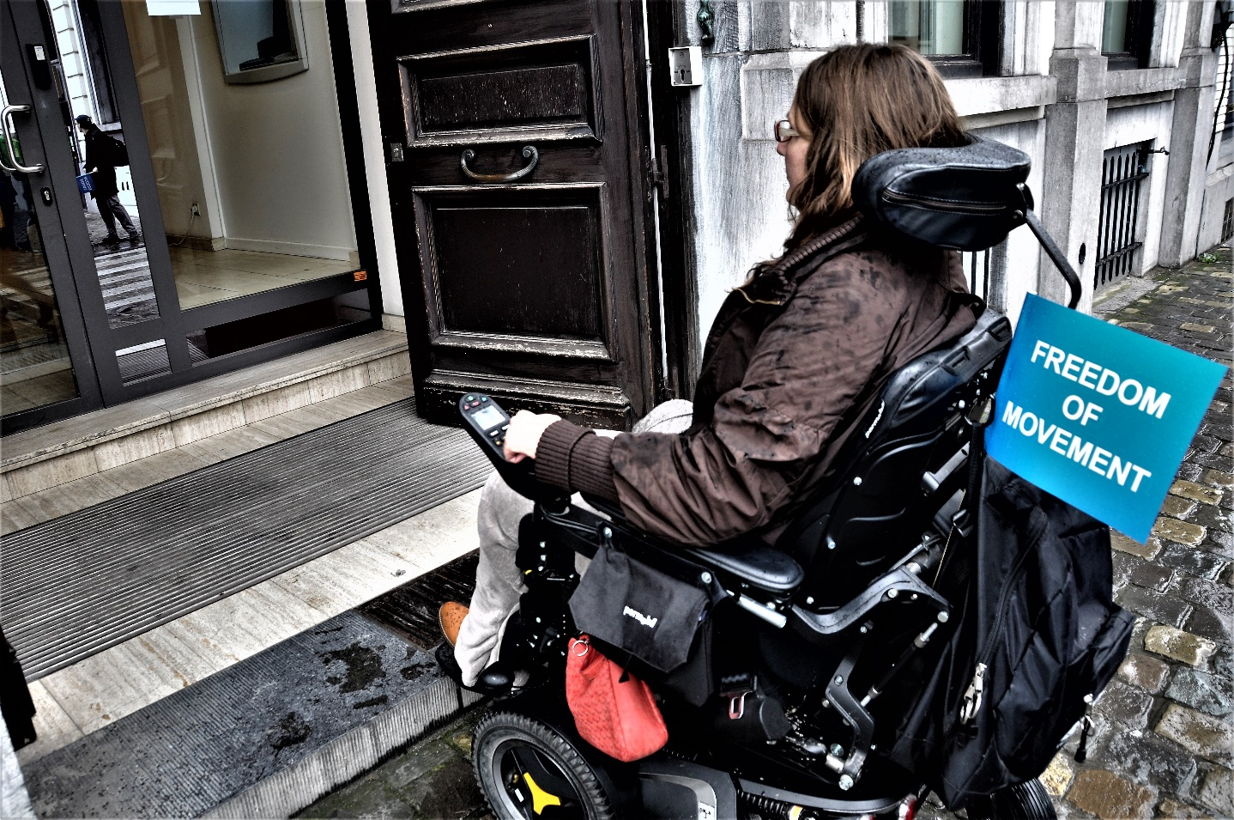
Many products and services will remain inaccessible to persons with disabilities. Credits: Benni de Muelder

A provisional agreement on the European Accessibility Act was reached today by the EU Institutions. The Act failed persons with disabilities. It only covers digital accessibility and leaves out the real world environment where persons with disabilities live.

The European Accessibility Act will add new EU-wide minimum requirements on accessibility on a limited range of products and services. It was proposed by the European Commission in 2015, following more than 10 years of campaigning by the disability movement.
A range of products and services will need to be accessible to and usable by millions of persons with disabilities in the EU; such as computers, smartphones, TVs, ATMs, payment terminals, e-books, e-readers, websites and mobile applications of private companies and ticket machines. The 112-emergency number and telephony services will also have to be accessible to all Europeans.

Expectations not met

Despite these, the Act lacks essential aspects. It excludes transport. It excludes microenterprises that provide services. It excludes household appliances. It excludes any obligation on accessible buildings and infrastructure. It excludes the real environment where people spend most of their time.

Yannis Vardakastanis, President of the European Disability Forum stated “EU Member States failed its citizens with disabilities. It seems more like a European Union of businesses than a European Union of people."

He added "EU Member States need to go above and beyond the scope of the Act if they want it to make a difference. They need to assure that persons with disabilities must have the same access to places, products and services as everybody else.”

The European Disability Forum will now analyse this agreement and issue a statement on the next steps of the campaign.

The institutions will now finalise the technical details of the text and will vote to ratify today’s agreement.

Notes to editors
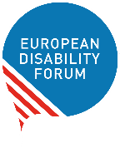
The European Disability Forum is an independent NGO that defends the interests of 80 million Europeans with disabilities. EDF is a unique platform which brings together representative organisations of persons with disabilities from across Europe. It is run by persons with disabilities and their families. EDF is a strong, united voice of persons with disabilities in Europe

Related information
- European Accessibility Act Campaign page
- Illustrative photos
- Press Release in Word | PDF

For more information, please contact
André Félix
External Communications Officer
European Disability Forum
tel +32 2 282 46 04 | Mobile +32 4 831 18 71 80
andre.felix@edf-feph.org

