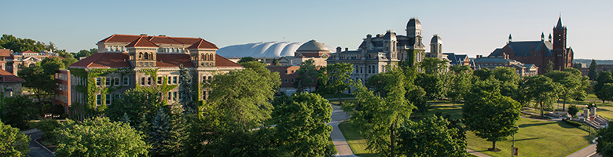

Call for Applications
The J&K Wonderland Foundation and Syracuse University College of Law are partnering to offer full scholarship awards to qualified candidates seeking to pursue a Master of Laws (LL.M.) degree with a concentration in international, comparative, and domestic disability law.

Eligibility Criteria:

Preference will be given to qualified hearing-impaired candidates from China and Taiwan. Applicants should have an outstanding academic record (a Bachelor’s in law or other law degree), professional aptitude, leadership potential, English proficiency, and a demonstrated commitment to advancing the rights of persons with disabilities. It is the policy of Syracuse University not to discriminate on the basis of race, creed, color, sex, national origin, religion, marital status, age, disability, sexual orientation, status as a disabled veteran, or as a veteran of the Vietnam Era in its educational programs, admissions policies, employment practices, and other University-administered programs.

Funding Details:

The scholarship provides funding for:
- Tuition
- fees; and
- student health insurance.

The scholarship does not provide funding for:
- personal expenses (visa fees, books, housing, meals, local transportation, personal allowance, etc.);
- academic study in fields other than law;
- funding for dependent family members; and
- funding for employees of Syracuse University involved in the administration of scholarships and admissions.

Application Instructions:

Interested candidates should submit an application with supporting materials online through our web-based application system [link]. An ADA-accessible application form can be found here [link]. Complete applications are due no later than April 15, 2019. All LL.M. candidates should plan to participate in an admissions interview via Skype or telephone.

Contact Andrew S. Horsfall, Assistant Dean of International Programs, with questions at ashorsfa@syr.edu.

