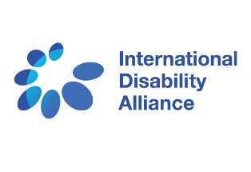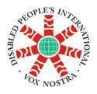

On the Occasion of the 10th Session of the Conference of States Parties to the CRPD & Co - Sponsored by DESA (TBC)

& International Disability Alliance (IDA)

**The Arab Organization of Persons with Disabilities (AOPD)**

**Economic and Social Commission for Western Asia (ESCWA)**

**Disabled Peoples’ International (DPI)**

***Invite you to attend the side event on:***

**The Safety of Persons with Disabilities in Situations of Conflict and Excessive Violence**

**Thursday June 15, 2017 from 10.00 - 11.30 am**

**Conference Room E**

Persons with disabilities in four Arab countries are facing all kinds of violence without any immediate relief. They are hardly to get any kind of services that might support them and help them to cope with such kind of circumstances. They are more than prisoners, they can’t escape but they are also abandoned and injured.

Based on these facts, the discussion will focus on the current situation and challenges, besides steps and measures must be taken.

**Moderated by:**

**Ms. Kirstin Lange,** Senior Disability Advisor, UNHCR(TBC)

**Speakers**

* **Mrs. Gisela Nauk,** Social Policy Section, Chief (ESCWA)
* **Hon. Dr Heba Hagrass,** Member of the Egyptian Parliament& the National Council for Women in Egypt
* **Mr. Jean Luc Simon**, DPI Europe Chairperson
* **Mr. Abdelmajid Makni,** Member of the National Council of Human Rights of Morocco
* **Mr. Ibrahim Abdallah,** AOPD President, Lebanon