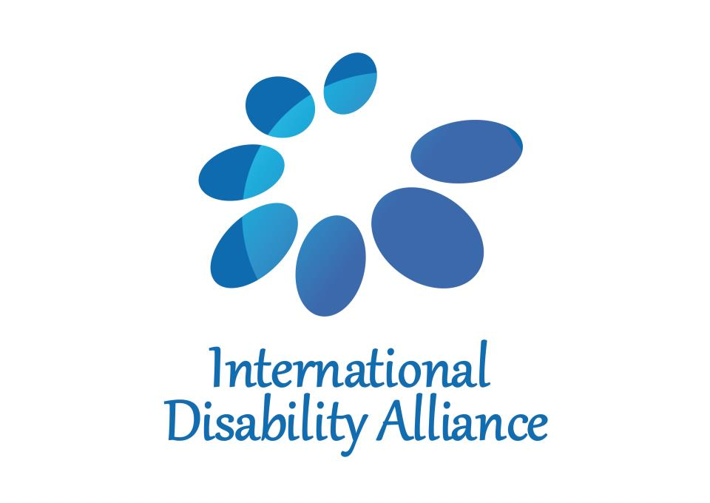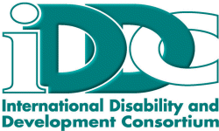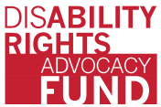
BRIDGE CRPD-SDG training INITIATIVE

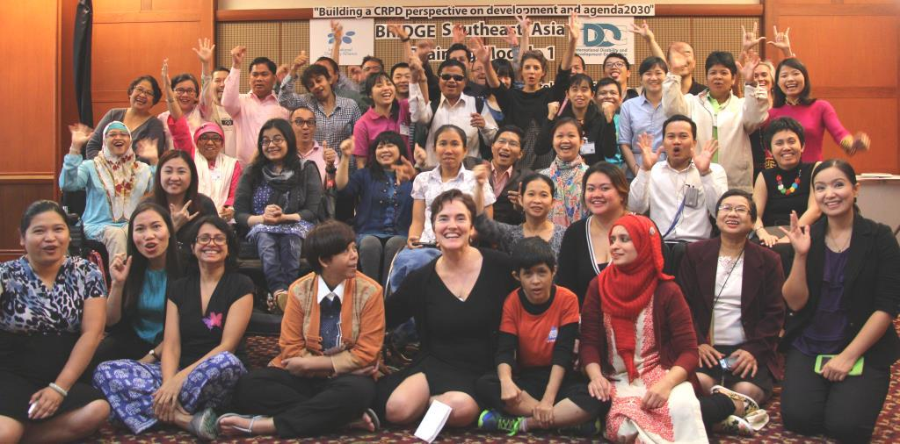
Caption: Group picture of BRIDGE CRPD-SDG South East Asia trainees,
Module 1, Bangkok, October 2015. © Abed Al Jubeh

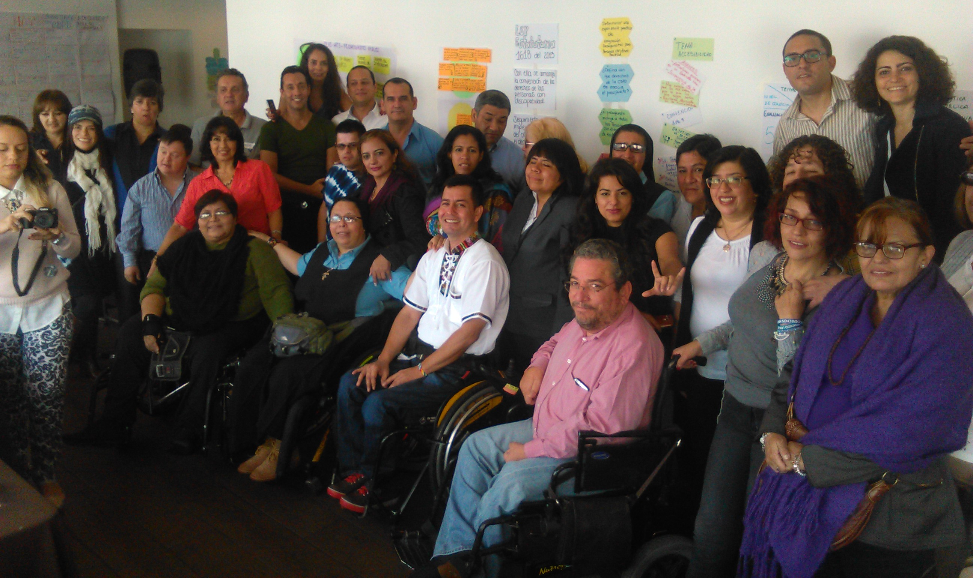
Caption: Group picture of BRIDGE CRPD-SDG Latin America,
Module 2, Lima, June/July 2016.

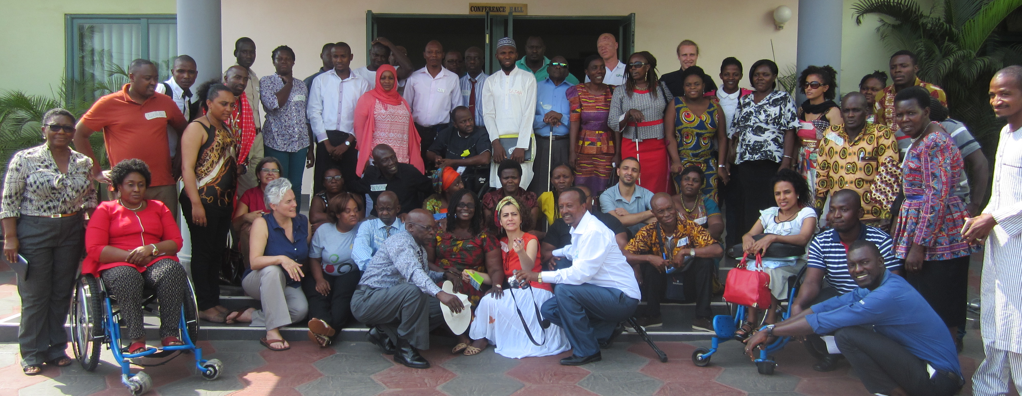
Caption: Group picture of BRIDGE CRPD-SDG East & West Africa, Module 1, Ghana, Nov 2016.

BRIDGE CRPD-SDG
training programme

Table of content

1. INTRODUCTION 3
2. rationale ….. 4
3. Background 5
4. BRIDGE CRPD-SDG ObjectiveS 7
5. DEVELOPMENT OF BRIDGE CRPD-SDG TRAINING PROGRAMME 8
6. BRIDGE CRPD-SDG TRAINING approach 9
7. BRIDGE CRPD-SDG CURRICULUM STRUCTURE 18
8. BRIDGE CRPD-SDG training of trainers 17
9. HOW TO ENGAGE IN BRIDGE CRPD-SDG? 218

Annex 1 - BRIDGE CRPD-SDG Module 1

Annex 2 - BRIDGE assignment between Module 1 and 2

Annex 3 - BRIDGE CRPD-SDG Module 2

Annex 4 – List of contributors

- INTRODUCTION
BRIDGE CRPD-SDG is an intensive training programme that aims to support DPO and disability rights advocates to develop an inclusive (all persons with disabilities) and comprehensive (all human rights) CRPD perspective on development, including the post-2015 agenda and Sustainable Development Goals (SDGs), to reinforce their advocacy for inclusion and realisation of rights of persons with disabilities.
BRIDGE CRPD-SDG is a joint initiative by the International Disability Alliance (IDA) and the International Disability and Development Consortium (IDDC), and is supported by the Disability Rights Fund (DRF).
BRIDGE CRPD-SDG was devised to respond to increasing demands for trainings on the implementation of the Convention on the Rights of Persons with Disabilities (CRPD) and inclusive development, and how this links to achieving Agenda 2030 and the SDGs. It is a coordinated training investment, drawing from the resources and experiences of the IDA and IDDC networks and their members.
BRIDGE CRPD-SDG adopts an integrated approach to bridge the gap between human rights and inclusive development perspectives. It aims to support organisations of persons with disabilities (DPOs) to translate the highest aspirations, norms and standards to full and effective participation and inclusion of all, in the reality of resource-constrained environments, inadequate governance, competing agendas, and politics at both national and local levels. The curriculum is also built to support DPOs to make the most of the SDG momentum, to further implement the CRPD and use the CRPD to frame implementation of the SDGs.

It was developed to set standards on CRPD and SDGs trainings, and ensure consistency across the regions, with the principles and provisions of the CRPD as well as with the evolving jurisprudence of the CRPD committee and key learning from the implementation of the CRPD and SDGs.
This document presents the BRIDGE CRPD-SDG training initiative as a work in progress, about two year after its start.

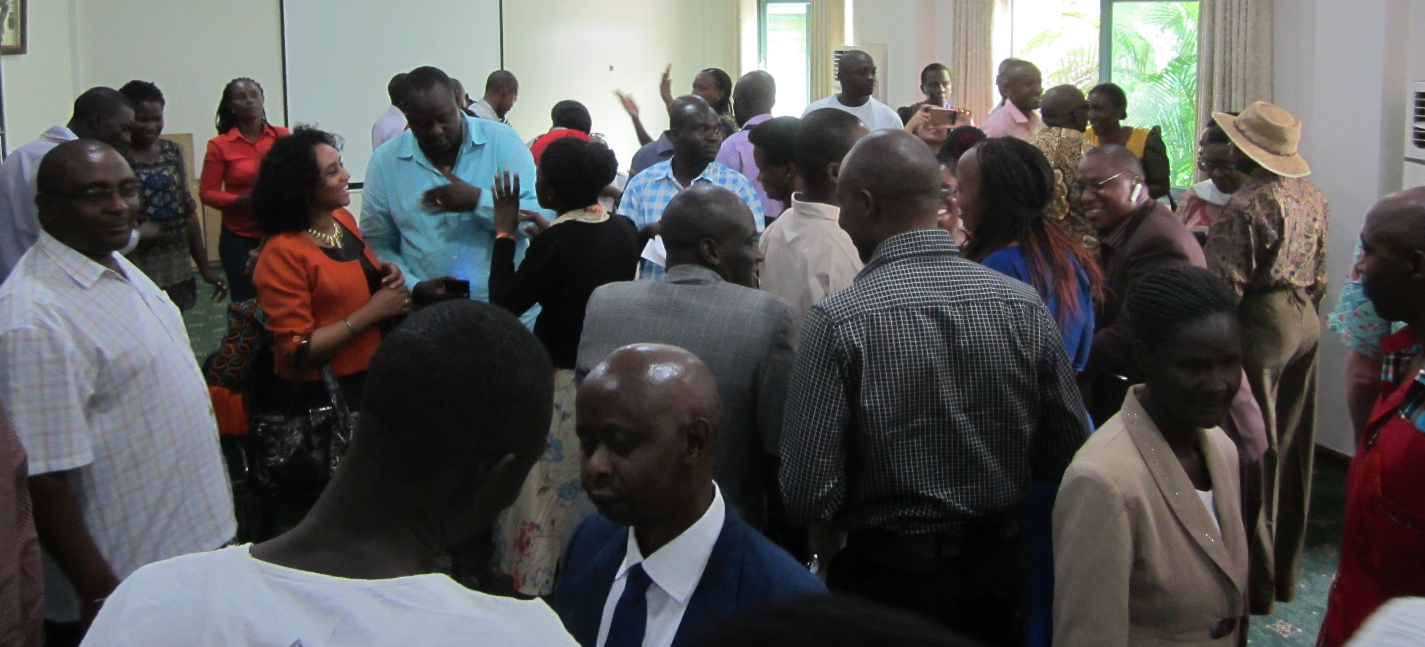
Caption: Picture of BRIDGE CRPD-SDG East West Africa –
Participants during Module 1, doing a ‘Speed dating’ activity.
- rationale

Discrimination of persons with disabilities is widespread - BRIDGE CRPD-SDG training results from common observations that despite great achievements to raise awareness about the rights of persons with disabilities through global advocacy, inclusive societies are still far from the reality experienced by persons with disabilities, especially those living in low and middle income countries. Compelling evidence can be found in a number of reports and analyses, as well as from consultations with persons with disabilities themselves, such as those held to develop the SDGs.

Advocating for ‘all human rights for all persons with disabilities’ is urgent yet also complex - The CRPD sets high standards and obligations to ensure the effective realisation of all human rights (i.e. covering all sectors and dimensions of life) for all persons with disabilities (acknowledging diversity of gender, age, culture, impairments, ethnic origin, etc.). However, its implications are rarely addressed equally for the diversity of groups that form the disability movement. The CRPD is also a fairly complex Convention (e.g. introducing notions such as reasonable accommodation), and translating its provisions in different contexts is equally complex.

DPO advocates were often left out of the system and denied access to education and therefore may lack the skills to engage in action to challenge large scale systemic discrimination - Persons with disabilities and their representative organisations (DPOs) have usually had limited access to advanced educational opportunities, and seek to build capacity to influence policies and legislation; to challenge unjust systems; to advocate for systemic change, including about budget allocation; and to hold governments to account. Significant efforts are therefore required to increase the numbers of skilled DPO advocates and leaders who can take action and challenge the status quo, especially in low and middle income countries where the majority of persons with disabilities live.

Building a critical mass of skilled DPO advocates representing the diversity of constituencies in all regions requires coordinated efforts - The scope of work requires coordination of efforts drawing from different sources of expertise (e.g. in-depth understanding of the CRPD and its enforcement, inclusive facilitation skills, inclusive policies and governance). It requires drawing from the resources of diverse constituencies. It also needs a clear strategy for roll-out, replication across the regions, and coaching to build a critical mass of DPO advocates and trainers to accelerate changes at national and regional levels, building on the momentum created by the SDGs.

- Background

To address this situation, the BRIDGE CRPD-SDG training aims to develop capacities of DPOs advocates, in particular persons with disabilities themselves, from low and middle income countries to improve the effectiveness of their advocacy, by developing a sound understanding of the CRPD as a tool to analyse development, and by identifying different avenues to propose policy reform to translate the treaty into effective social change at all levels (all human rights), for all groups (all persons with disabilities).
BRIDGE CRPD-SDG significantly draws from two experiences, the Training of Trainers, Advocates and Leaders (ToTAL) developed by IDA and the Training of Trainers on Inclusive Facilitation (ToTIF) developed by IDDC.

ToTAL (Training of Trainers, Advocates and Leaders)
ToTAL is a training curriculum developed by IDA in response to the need to create a joint training curriculum to provide guidance to DPOs on advocacy for implementation of the CRPD in low and middle income countries. This training was piloted in three regions:
- West Africa, in partnership with the West Africa Federation of DPOs (WAFOD) and Handicap International (in French)
- South Asia, covering Nepal, India and the Philippines, in partnership with Disabled Peoples’ Organisations Denmark (DPOD)
- The Pacific, in partnership with the Pacific Disability Forum (PDF) and with AusAID funding
ToTAL was adapted to various contexts, and comprised at the minimum of two modules. Module 1 (10 days) focused on ensuring that participants developed a comprehensive and inclusive understanding of the CRPD, followed by an assignment. Module 2 (7 days) was organised six months later focusing on policy analysis and review. Pacific and West Africa undertook a Module 3 for consolidation and review of post-training assignments. Altogether 68 participants took part in ToTAL trainings over 3 years.

ToTIF (Training of Trainers on Inclusive Facilitation)
ToTIF was developed through dialogue amongst members of the IDDC Facilitators’ Forum over the course of a year in 2014. The rationale for ToTIF was the importance to ‘walk the talk’ and ensure training on inclusive development is being delivered in an inclusive manner, showing inclusion by example. ToTIF was led 100% by persons with disabilities for a participant group that was 100% composed of people with disabilities from low and middle income countries in Africa and Asia. This resulted in a 5-day curriculum aimed at building the capacity of trainers with a disability to gain confidence in inclusive training and facilitation skills, as a core foundation in promoting greater awareness on disability inclusive development. ToTIF was piloted for 8 participants from Thailand, the Philippines, Uganda, Kenya, Tanzania and Indonesia in November 2014 and integrated in a post ToTAL training for French-speaking Africa in 2015.
BRIDGE CRPD-SDG builds on the analysis of lessons learned from these two experiences, as well as observations from IDA’s work to support the monitoring of the CRPD and work on supporting DPOs to monitor, engage with, and hold governments to account on public policy and budget allocations.
The analysis includes, inter alia:
A disconnect between human rights and inclusive development
- The need to take into consideration international cooperation without undermining the role and duties of the States (Articles 4 and 32);
- The need to address concurrently CRPD provisions and policy reform (including through inclusive development and the SDGs) to avoid a disconnect between human rights standards, and the mechanics required to translate them into local realities;
- The over-reliance on laws and/or NGOs and the lack of critical analysis about issues related to public policy implementation especially public budget.

Capacity gaps and the need of complementary efforts to address these gaps
- A disconnect between the obligations set by the CRPD and how DPOs perceive and experience the reality at national and local levels;
- Huge gaps in DPOs’ capacities to understand the complexity of the public policy reform and to influence what States should and can do;
- The importance of substantial training to ensure sufficient time for people to challenge their own perceptions and understand the implications of the CRPD for their own practice in terms of promoting and realising all rights for all persons with disabilities;
- Practical participatory methods to build the skills and confidence for DPOs themselves to practice inclusive cross disability capacity development;
- Highly technical topics such as legal harmonisation, strategic litigation, budget advocacy should be further explored as a separate “specialisation” module;
- While ongoing training investment and capacity development of DPOs by IDA is essential, IDDC through its members has a stronger capacity to replicate training and engage with and support DPOs in advocacy for inclusive development.

Inclusion of all persons with disabilities needs to be addressed
- The underrepresentation of some issues and of the voices of groups such as persons with intellectual disabilities, persons with psychosocial disabilities and deaf-blind people;
- The importance of inclusive methods in advocacy, training, awareness-raising so that persons with disabilities are equipped not only with the content but also the skills to convey their message in an efficient and inclusive way;
- The importance of building a training curriculum using practical examples from the diversity of low and middle income contexts (be concrete and context-sensitive).

- BRIDGE CRPD-SDG ObjectiveS

BRIDGE CRPD-SDG is a training programme of 2 modules which is part of a broader training initiative.
- BRIDGE CRPD-SDG training cycles
Objective: To develop the capacities of DPOs advocates from low and middle income countries to engage and take action in the promotion of an inclusive (all persons with disabilities) and comprehensive (all human rights) CRPD perspective on development
Expected outcomes:
Participants will be able to meaningfully:
- Engage in policy debates link to CRPD implementation and SDGs implementation including legal harmonisation, public budget, policy reforms
- Engage with other civil society actors to ensure mainstreaming of rights of persons with disabilities
- Engage in monitoring of CRPD and SDGs
- Engage in further capacity development of DPOs - using inclusive methodology for cross disability movement building and joint advocacy

- The broader BRIDGE CRPD-SDG training initiative
Objective: To initiate, promote and ensure technical and coordination support for the effective and quality implementation of BRIDGE CRPD-SDG training modules for DPO advocates.
Based on the experience and work in progress of running the BRIDGE CRPD-SDG training in different regions, IDA and IDDC have engaged a broader reflection on the broader support required to ensure the smooth and quality delivery of BRIDGE CRPD-SDG modules in different regions.
A steering committee will provide guidance for BRIDGE CRPD-SDG, promote it and secure the means required for quality and sustainability, such as the creation of a pool of accredited BRIDGE CRPD-SDG trainers, and a help-desk to support the coordination of training programmes or defining modalities of engagement in BRIDGE CRPD-SDG.
This part is a work in progress, which is also reflected in Section 7 on BRIDGE CRPD-SDG training approach.

DEVELOPMENT OF BRIDGE CRPD-SDG TRAINING PROGRAMME
Steps in developing the BRIDGE training:
2010-2013 | The first training exchanges between IDA and IDDC were started through ToTAL, which was piloted in partnership with members of IDDC.
2013-2014 | The experience of ToTAL was shared by IDA with IDDC’s DPO Partnership Task Group (Dec 2013), and the IDDC Facilitators’ Forum (April 2014).
Nov 2014 | ToTIF pilot training
April 2015 | A 2-day dialogue was organised between members of IDA and IDDC (including representatives of DPOs from different regions) to engage in the development of a joint curriculum. After reviewing existing training experiences, participants discussed the opportunity of a joint training initiative, agreed on an overall training strategy and programme (including modules, assignments, coaching) and developed a draft outline for Module 1.
July 2015 | The curriculum outline was then further reviewed and enriched by several contributors, including IDA, IDDC and former ToTAL and/or ToTIF trainees. A first attempt to merge focus on CRPD and SDGs was attempted with a French speaking ToT for DPOs from Maghreb & West Africa that took place in Morocco for former ToTAL trainees.
Aug 2015 | A preparatory meeting was convened to build on the draft curriculum and further develop the objectives and training plan for Module 1, in view of pilot BRIDGE modules 1 in South East Asia and Latin America.
Oct 2015 | Pilot BRIDGE Module 1 in South East Asia (9 days, 10 countries, 30 participants) and in Latin America (7 days, 11 countries, 17 participants)
Nov 2015 | Pilot BRIDGE Module 1 in Indonesia (7 days, 2 countries, 28 participants)
Dec 2015 | Pilot BRIDGE Module 1 in Rwanda (6 days, 4 countries, 14 participants) facilitated by 3 WAFOD trainers
Jan 2016 | IDA and IDDC facilitators reviewed pilot Module 1 experiences, defined Module 2 and started sketching a roll-out strategy to ensure quality, promote the initiative and optimize the impact of the training.
Feb-Mar 2016 | IDA and IDDC Boards agreed to set up a BRIDGE steering committee to take the BRIDGE initiative forward, including quality assurance, promotion and mobilisation of trainers.  Pilot Module 2 South East Asia (same participants, 7 days)
May 2016 | Pilot BRIDGE Module 1 in Pacific (7 days, 11 countries, 22 participants) facilitated by IDA, PDF, WFD, CBM and DRF trainers.
June-July 2016 | Pilot BRIDGE Module 2 Latin America (6 days) and Indonesia (6 days)
Nov 2016 | Pilot BRIDGE Module 1 East & West Africa (7 days)
Nov 2016 | Pilot BRIDGE Module 2 in Rwanda (6 days, 4 countries and 15 participants)
May 2017 | Pilot BRIDGE Module 2 East & West Africa (7 days, 10 countries and 30 participants) Nairobi, Kenya
June 2017 | Technical meeting was convened in Geneva among IDA, IDDC Chair and CBM lead trainer at Pilot BRIDGE East & West Africa, with BRIDGE CRPD-SDG team
October 2017 | BRIDGE CRPD-SDG Steering Committee meeting, Athens.
- BRIDGE CRPD-SDG TRAINING approach
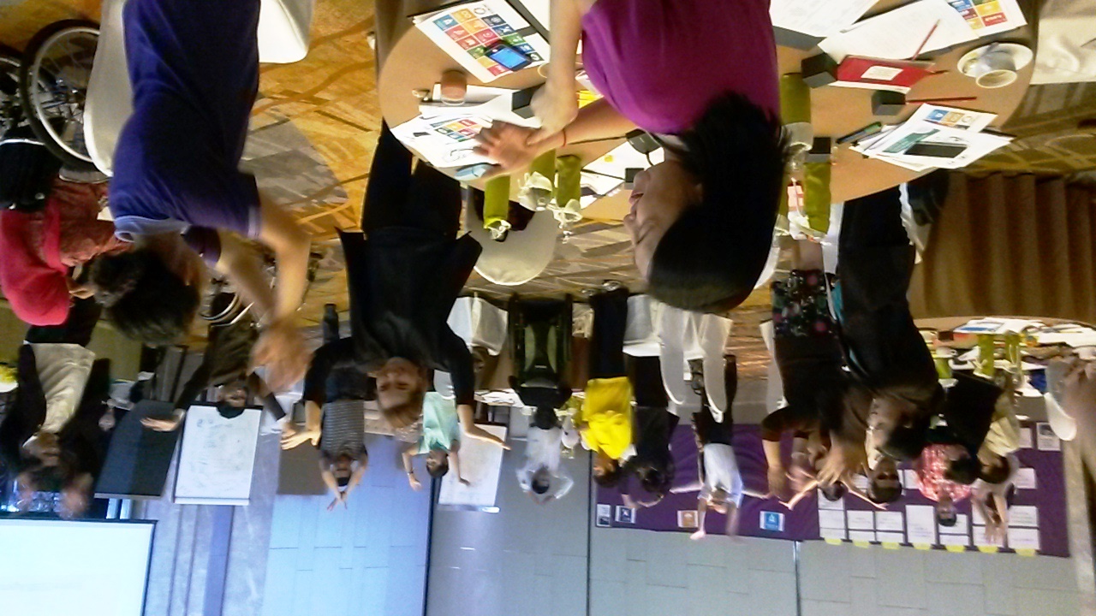
Caption: Picture of BRIDGE CRPD-SDG South East Asia participants during Module 2, doing an energiser proposed by one of the participants. ©Priscille Geiser

Key principles of BRIDGE CRPD-SDG
BRIDGE CRPD-SDG strives to enact the general principles of the CRPD throughout its training objectives, content, and teaching methods:
- By, for and with persons with disabilities - Targeting DPO advocates as the primary audience of the training course, it aims to equip self-advocates with the skills required to participate and influence decisions that affect their lives, in line with the motto of the disability movement “nothing about us without us” and the objective of full and effective participation. BRIDGE CRPD-SDG also seeks to increasingly engage persons with disabilities, especially from low and middle income countries, as BRIDGE CRPD-SDG trainers and co-facilitators, also acknowledging the contributions of allies.
- Ensuring and promoting diversity - Attention is paid to ensure the optimum representation of the diversity of the disability movement among participants, including gender balance, representation of people with different types of impairments, and/or other characteristics such as indigenous persons with disabilities.
- Participatory methods - BRIDGE CRPD-SDG is based on mobilisation of participants’ knowledge, and is very practical and participatory. It places emphasis on inclusiveness and strives to ensure inclusive facilitation for all groups and participants. Each participant is selected in relation to their experience, knowledge and active contribution to the promotion of rights of persons with disabilities, and they are expected to actively contribute to the content of the training.
- Inclusiveness in practice - This implies significant attention to accessibility, reasonable accommodation needs, different learning styles and rhythms, different ways of engaging and communicating, and the use of diverse tools and methods to get feedback from participants and optimise participation and learning.
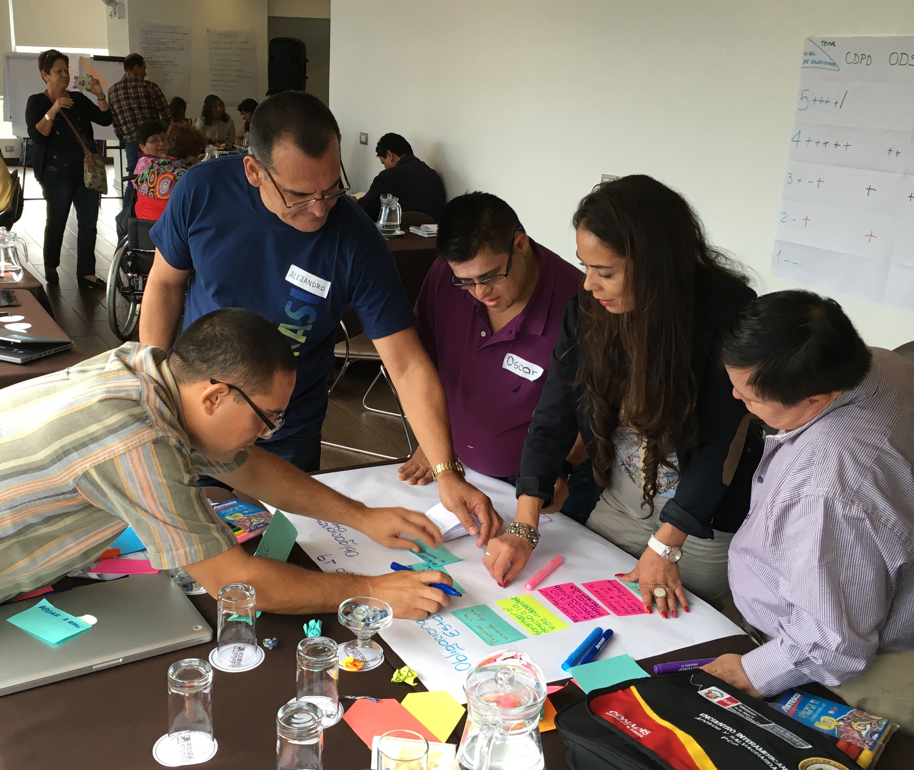
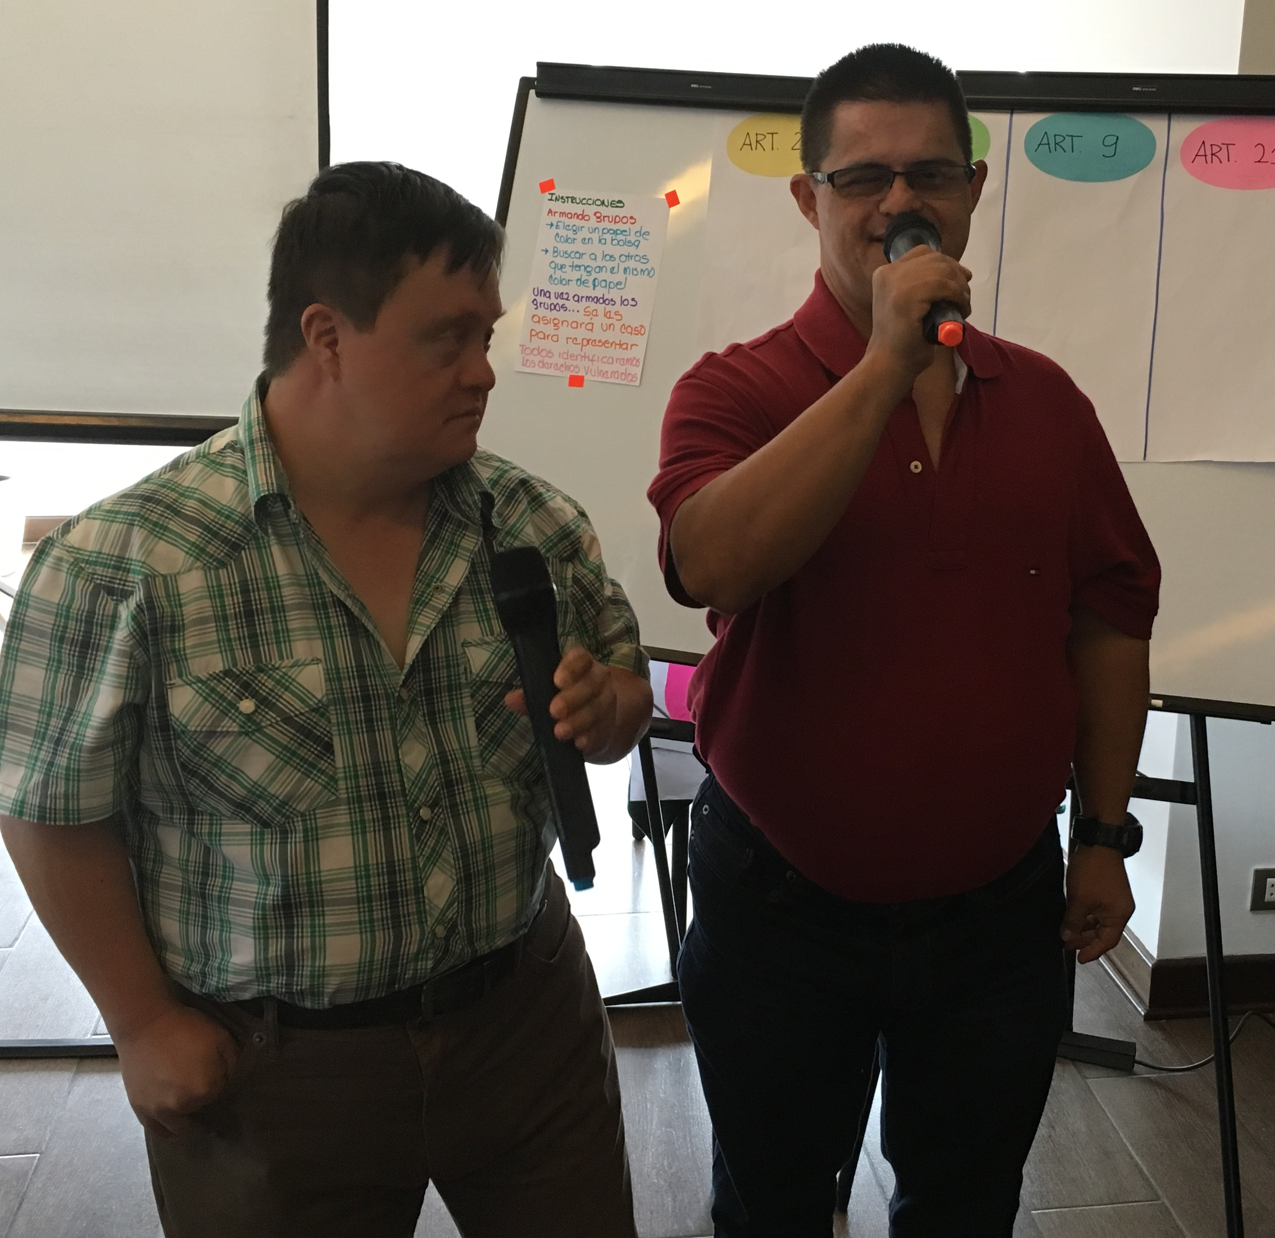

Caption: On the left, a group creating a presentation. On the right, two participants presenting a session on self-advocacy and their rights. Both moments were during BRIDGE CRPD-SDG Latin America.
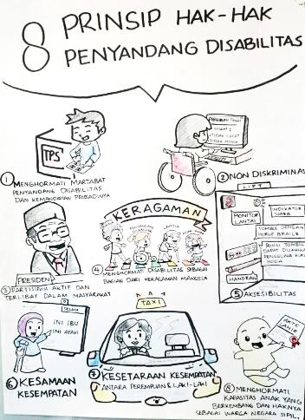
Caption: On the left, illustration of Article 29 drawn during South East Asia Module 1 training sessions by cartoonist Anan Prapaso. On the right, illustrations of CRPD principles drawn during Indonesia-East Timor Module 1 training session by Mr. Rotinsulu to support explanation of key messages to self-advocates.

7. BRIDGE CRPD-SDG CURRICULUM STRUCTURE

Overall training structure
The training is composed of 2 core modules with a set of assignments to complete which complement the learning and put the theory into practice:

Module 1 focuses on the development of knowledge and skills to UNDERSTAND the CRPD and start to ANALYSE development from a CRPD perspective.

Module 2 builds on this understanding and analysis to further develop knowledge and capacities to TAKE ACTION towards the full and effective participation of persons with disabilities, through different key advocacy routes (legal harmonisation, budgetary advocacy, inclusive programming, influencing for good disability data and evidence, etc.).

Module 2 also provides practical application of advocacy skills learned by engaging with government, donor or UN agencies.

Between Module 1 and Module 2 participants have to develop a draft policy brief on analysing a development issue in their own country from a CRPD perspective. The policy paper should be finalised after the Module 2 to receive the certificate.

Additional optional modules are foreseen for participants who wish to go further:
- A Training of Trainers to support participants to disseminate the learning of the first two modules, with a focus on inclusive facilitation
- A training to develop a more in-depth understanding of the CRPD (drawing from the CRPD advanced training developed by IDA)
- Additional modules on inclusive policy and governance including legal harmonisation, budget advocacy, inclusive programming or disability data.

Fig. A – Structure of BRIDGE CRPD-SDG training

As a work in progress, the BRIDGE CRPD-SDG training is enriched with the learning from each BRIDGE CRPD-SDG cycle being delivered in different regions. The overall process can be described in different steps as follows:

Step | What is expected from participants | Support IDDC and IDA can bring
Prerequisite and selection of participants | To have a basic understanding of the CRPD and to have acquired basic skills, for example through Empowerment or Disability Rights and Equality Training (DRET); this may vary for different groups | Prior to the BRIDGE CRPD-SDG training, IDA and IDDC members may provide preparatory training (which is not considered as part of BRIDGE)  Criteria for selection of participants (see the Selection criteria), ensuring diversity
Pre-training preparation | Ensure preparatory reading of the information shared in advance | Share key preparation documents and guidance; webinars might be considered in the future
Module 1 (6-7 days) | Engage actively in the training | Collaborative organisation; joint facilitation of sessions, mobilisation of trainers with disabilities from the region
First assignment | In their respective country, participants should analyse CRPD compliance of one policy | Provide remote guidance/mentoring to support participants with their assignments
Module 2 (7 days) | Engage actively in the training and the practical advocacy exercise  Account for their assignment | Collaborative organisation; joint facilitation of sessions, mobilisation of trainers with disabilities from the region
Completion of assignment | Complete the policy paper | Provide of remote guidance/mentoring to support participants with their assignments; certification

Prerequisite
In preparation for Module 1, all participants need to carefully read:
- The Convention on the Rights of Persons with Disabilities (CRPD) from Preamble to Article 33
- The Sustainable Development Goals (SDGs) and targets
- General Comments from the CRPD Committee and thematic reports of the Special Rapporteur on the Rights of Persons with Disabilities

Module 1
Learning objectives:
After the training, participants should:
- Be familiar with all CRPD articles
- Have confidence in the CRPD principles and selected areas
- Be familiar with the SDGs and have confidence in recognising the linkages between the CRPD and the SDGs, applied to their development contexts / have an understanding of how the CRPD can support disability inclusion in the SDGs
- Have been exposed to practice inclusive facilitation skills

Module 1 is focused on understanding the CRPD and its links to post-2015 and the SDGs.
The length of Module 1 varied from 6 days (Big Lakes Africa and Latin America) to 9 days (South East Asia). A draft of the proposed revised content and sessions for Module 1 drawing from lessons learned of the pilot Module 1 in 2015 and 2016 is presented in the Annex 1.

Module 2
Learning objectives:
After the training, participants should:
- Be able to identify core CRPD articles and link them to specific SDGs
- Familiar with the laws in their country and with their national development plan
- Understand public policy and able to identify main blockages and issues in its implementation
- Be aware of differences between cultural beliefs, social roles and responsibilities considering gender equality
- Develop skills on how to influence development actors nationally and regionally for inclusion of persons with disabilities

Module 2 is focused on applying this understanding and analysis via the diverse advocacy routes (legal harmonisation, budgetary advocacy, litigation, awareness campaign…). It also promotes a privileged space to bilateral meetings with development actors in different regions.
The length of Module 2 varied from 6 to 7 days. A draft of the proposed revised content and sessions for Module 2 drawing from lessons learned of the pilot Module 2 in 2015 and 2016 is presented below in the Annex 3.
An agreed curriculum is being finalised and will be published by September 2017.

BRIDGE CRPD-SDG TRAINING OF TRAINERS

BRIDGE CRPD-SDG trainers
BRIDGE CRPD-SDG was started by an initial group of trainers and co-facilitators from very diverse backgrounds (see the list of contributors in Appendix 6). BRIDGE CRPD-SDG modules mobilised trainers with and without disabilities, from high as well as low and middle income countries. Diversity still needs to be strengthened through developing a pool of BRIDGE CRPD-SDG trainers.

The experience from different regions where the BRIDGE CRPD-SDG modules have been piloted is being regularly reviewed. From this it has emerged that three ranges of core skills are required for a successful BRIDGE CRPD-SDG facilitation, they cover advanced CRPD skills, inclusive governance and policies, and inclusive facilitation.

Fig. B –Core skills for BRIDGE CRPD-SDG trainers and co-facilitators

Caption: The above slide represents 3 intersecting circles of CRPD, governance and policy, and inclusive facilitation.

BRIDGE CRPD-SDG is a demanding experience which requires at least one lead trainer and two co-facilitators with complementary skills and expertise. BRIDGE CRPD-SDG lead trainers are expected to have core expertise in one of the three areas as well as a confirmed level in the other two areas.
The process of accrediting trainers is defined with support of the BRIDGE CRPD-SDG steering committee.

BRIDGE CRPD-SDG in the landscape of disability trainings
BRIDGE CRPD-SDG does not intend to replace the diversity of training modules of various lengths or focus that exist around CRPD and disability-inclusive development (e.g. Community Based Rehabilitation (CBR), Disability-Inclusive Development, Inclusive Disaster Risk Reduction (DRR), Disability Equality Training, Inclusive Education, etc). Rather, it aims to develop a common understanding of key messages and skills for experienced DPO advocates to engage more efficiently in CRPD promotion and monitoring.

BRIDGE CRPD-SDG explores what ‘all human rights for all people with disabilities’ means, and does this through experiencing the diversity of the disability movement and practicing inclusion as an integral component of the training. It is meant to be preceded by empowerment training, and to be enriched by a variety of other modules (such as CBR, Disability-Inclusive Development, legal harmonisation, inclusive DRR, etc.), depending on participants’ roles and aspirations. The expectation is that those participating in BRIDGE CRPD-SDG are already active and empowered advocates within their own constituencies. BRIDGE CRPD-SDG builds on this and helps to strengthen opportunity for greater cross disability advocacy, network and movement building.

Fig. C – BRIDGE CRPD-SDG in the landscape of disability-related training initiatives
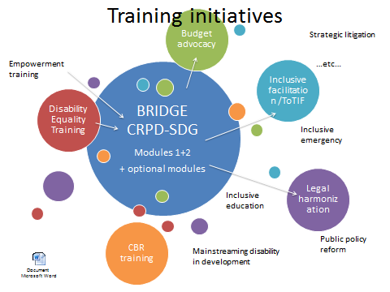
Caption: this slide shows bubbles of different sizes and colours to depict the variety of training initiatives that exist on the topics of disability rights and disability-inclusive development. It shows how the BRIDGE CRPD-SDG bubble in the middle can be a way to develop common messages and a common cross-disability perspective to promote all human rights for all persons with disabilities. It is meant to complement other training initiatives such as inclusive facilitation training, budget advocacy training, CBR training, inclusive education training etc.

The curriculum of the training of trainers (ToT) was developed by IDA, with direct engagement from IDA and IDDC members as well as DRAF, in order to respond to the increased demand on highly qualified trainers on a diverse curriculum covering in-depth issues related to the Convention on the Rights of Persons with Disabilities’ (CRPD) and the Sustainable Development Goals’ implementation.

The strengthening of capacity of these trainers will foster guidance to organisations of persons with disabilities (DPOs) on advocacy for inclusive implementation of the CRPD and the SDGs in low and middle income countries, with meaningful inclusion of underrepresented groups of persons with disabilities.

Core ToT modules
BRIDGE CRPD-SDG Training of Trainers is composed of 2 core modules:
- Module A focuses on understanding the CRPD and inclusive development as well as analysing some key development issues from a CRPD perspective. It historically takes place in Geneva, later February early March, concomitantly to the March session of the CRPD Committee, to allow great exposure of trainers to the committee’s work, and meetings with relevant UN mechanisms, such as special rapporteurs, as well as UN agency officers, Geneva-based;

- Module B focuses on public policy, CRPD and SDGs implementation in different country contexts; applying this understanding and analysis via the diverse advocacy routes (legal harmonisation, budgetary advocacy, litigation, awareness campaign, among others. It takes place in October each year, wherever relevant to the curriculum, including in Washington.

In addition, trainers also:
- Participate as co facilitator in full cycle of BRIDGE CRPD SDGs (2X 7 days)
- Write a policy paper on a key CRPD-SDGs topic
- Get active involvement in submission for treaty bodies, UPR or HLPF country review
- Provide distance support on technical mentoring for 18 month

The ToT process is tailored to ensure that by the end of the process each trainee is in position to be a BRIDGE CRPD-SDG co-trainer. This is an intensive process needed to develop the comprehensiveness and depth required for delivering trainings like BRIDGE CRPD-SDG. Any certified BRIDGE CRPD-SDG trainer will be in position to deliver multiple level of CRPD and SDGs related training of different lengths to different audience.

Inclusive facilitation
BRIDGE CRPD-SDG is a fairly intensive program that puts emphasis on inclusiveness and will strive to ensure gender equality as well as full and effective participation and inclusion of all groups and participants reflecting the CRPD purpose and principles - all human rights for all persons with disabilities - and the agenda 2030 commitment to leave no one behind, which demands from the facilitation team to gather all the skills required to deliver the content of the curriculum with great inclusive facilitation ensuring optimal participation of all trainees.

This resulted in a 3-day curriculum aimed at building the capacity of trainers with disabilities and development actors to gain confidence in inclusive training and facilitation skills, as a core foundation in promoting greater awareness on disability inclusive development.

The BRIDGE CRDP-SDG Training of Trainer is based on mobilization of trainees’ knowledge and is meant to be very participative. Indeed, each trainer is valued in relation to her/his experience, knowledge and active contribution to the promotion of the rights of persons with disabilities and is expected to actively contribute to the content of the training.

9. HOW TO ENGAGE IN BRIDGE CRPD-SDG?

The scope and ambition of BRIDGE CRPD-SDG, as well as the way it was conceived requires a collaborative approach, and therefore contributions and further support are needed. BRIDGE CRPD-SDG was started by a group of committed disability trainers, advocates and development workers, who all undertook this experience alongside their main occupation and commitments. To sustain the initiative, both coordination and institutional support is required. BRIDGE CRPD-SDG is intended to be open for use by a wide range of stakeholders who agree and commit to the BRIDGE CRPD-SDG objectives, values and principles.

Support is required at various levels, for example:
- Co-funding the BRIDGE CRPD-SDG modules in different regions
- Facilitation of BRIDGE CRPD-SDG training modules
- Support to the development of the pool of BRIDGE CRPD-SDG trainers
Modalities of engaging as a BRIDGE CRPD-SDG partner is defined in the Task Team Partnership Protocol.

Costs of BRIDGE CRPD-SDG training
Average costs of the BRIDGE CRPD-SDG training (1 cycle of 2 modules):
- Per participant: 6,000 EUR (including travel, accommodation, food, reasonable accommodation), with variations depending on the region
- Per cycle of 2 modules with 25 participants: 150,000 EUR

Co-funding of BRIDGE CRPD-SDG modules till date:
BRIDGE CRPD-SDG training | Co-facilitation | Co-funding
BRIDGE CRPD-SDG South East Asia | IDA, WNUSP, CBM, HI, Inclusion International, Life Haven, Deaf Resources Philippines, Bapu Trust India | IDA Core (DFAT, Finland Ministry of Foreign Affairs, SIDA), ADD International, Atlas Alliance, CBM, DPOD, HI, Light For the World, DRAF
BRIDGE CRPD-SDG Latin America | IDA, HI, RIADIS, WNUSP, Inclusion International | IDA Core (Finland), HI, RIADIS and CBM
BRIDGE CRPD-SDG Indonesia and East Timor | IDA, DRF, Konas Difabel Indonesia | DRF, IDA Core (DFAT) & HI
BRIDGE CRPD-SDG Pacific | PDF, IDA, World Federation of the Deaf, DRF | DRAF, PDF (DFAT) & IDA Core (DFID & DFAT)
BRIDGE CRPD-SDG EWA | IDA, CBM, ADF, SS, DPOD, II, WNUSP, HI | IDA (DFAT, SIDA, DFID & Finland), CBM, SS, HI, DPOD, LFTW, DRAF (indigenous), UNFPA (youth), OSF (co-leader salary)

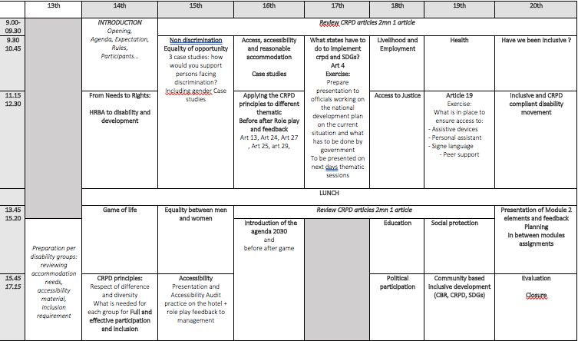
Annex 1 - BRIDGE CRPD-SDG Module 1

Annex 2 - BRIDGE assignment between Module 1 and 2

Post Module 1 assignments
After Module 1 all participants will have to complete an assignment which is a condition of their continued participation in Module 2:

A policy paper assignment: All participants have 5 months to develop a short policy paper (6 pages) on analysing a development issue from a CRPD perspective and the implementation of a key provision of the CRPD in her/his country, including
- Short description of the development issue (e.g. access to health, education, justice….) for the general population as well as in terms of the impact/restriction of social participation of persons with disabilities, preferably by using existing available statistical data and other type of evidence
- Identification of key issues with regards to the compliance (or not) of the legal framework with the CRPD
- Identification of bottlenecks in policy implementation (e.g. budget, human resources…).
- Formulation of recommendations

The policy paper should be sent to the BRIDGE co-facilitators one month before Module 2.

Note: Written assignments are not academic assignments but rather practitioners’ one and will be assessed as such. Moreover, as English is not the mother tongue of most participants, assessment of assignments will focus on the content, in particular assessing the adequate understanding and use of the CRPD in analysis and quality of information and references provided. Assignments can also be submitted in sign language multimedia file and alternative format.

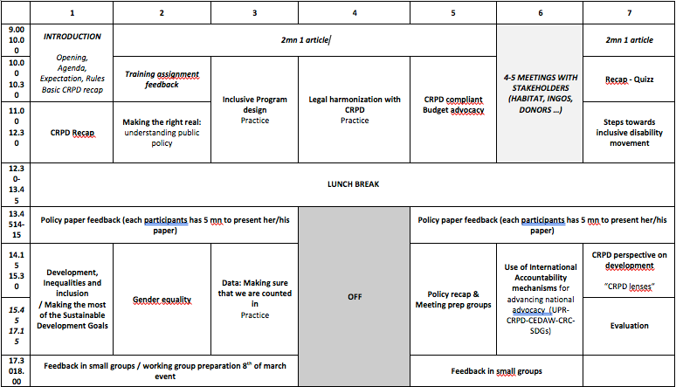
Annex 3 - BRIDGE CRPD-SDG Module 2

Annex 4 – List of contributors to Pilot BRIDGE CRPD-SDG

People listed below have contributed to the development of BRIDGE CRPD-SDG training modules and/or facilitation of session(s) in different regions.

Name | Organisation | Country
Abner Manlapaz | Life Haven | Philippines
Alex Cote | International Disability Alliance (IDA) | France
Alexandre Mapurunga | Latin American Network of NGOs of Persons with Disabilities and their Families (RIADIS) | Brazil
Anderson Henao | Handicap International | Colombia
Angeline Chand | Pacific Disability Forum (PDF) | Fiji
Anna MacQuarrie | Inclusion International | Canada
Ansofie Leenknecht | European Disability Forum (EDF) | Belgium
Berhanu Tefera | African Disability Forum | Ethiopia
Bhargavi Davar | Bapu Trust | India
Brianna Wilson | CBM Australia | Australia
Carolyn Dagani | National Federation of the Deaf | Philippines
Carlos Rios | Former member CRPD Committee | Mexico
Christina Parasyn | Disability Rights Fund (DRF) | Australia
David Corner | Inclusion International | New Zealand
Dwi Ariyani | Disability Rights Fund (DRF) | Indonesia
Eeva Tupi | World Federation of the Deaf (WFD) | Finland
Elena Down | CBM | Australia
Fatma Wangari | Inclusion International | Kenya
Gabor Gombos | World Network of Users and Survivors of Psychiatry (WNUSP) | Hungary
Getty Fefoame | Sightsavers | Ghana
Imed Ouertani | BRIDGE CRPD-SDG Fellow | Tunisia
Kathy Al Jubeh | CBM | Ireland
Liza Martinez | Deaf Resources Philippines | Philippines
Louise Carroll | International Federation of Hard of Hearing (IFHOH) | New Zealand
Madezha Cepeda | CBM | Peru
Mamadou Sissoko | West Africa Federation of DPOs (WAFOD) | Mali
Meenakshi Balasubramanian | Equals | India
Michael Njenga | World Network of Users and Survivors of Psychiatry | Kenya
Monica Cortes | Inclusion International | Ecuador
Nagase Osamu | Inclusion International | Japan
Priscille Geiser | Handicap International, International Disability and Development Consortium (IDDC) | France
 | Pacific Disability Forum Resource team | Pacific
Rebeca Alamo | Handicap International | Mexico
Risna Utami | Konas Difabel | Indonesia
Rose Diakite | WAFOD | Mali
Salam Gomez | Fundamental, WNUSP | Colombia
Shitaye Astawes | African Disability Forum | Ethiopia
Signe Højsteen | Disabled People’s Organisations Denmark | Denmark
Siddo Nouhou Oumarou | WAFOD | Niger
Stefan Lorenzkowski | Handicap International | Germany
Sylvie Cordier | ADD International | France
Tamara Jolly | CBM Australia | Australia
Tchaurea Fleury | IDA | Brazil
Ulrike Last | Handicap International | Germany
Ximena Serpa | RIADIS | Colombia

ToT on how to improve facilitation on CRPD and public policies analysis (with participants from WAFOD and DPOs from Maghreb) 17 participants.
Participants included representatives of IDA and IDDC and some of their members, including: the World Network of Users and Survivors of Psychiatry (WNUSP), the Latin American Network of non-governmental Organizations of Persons with Disabilities and their Families (RIADIS), the International Federation of Hard of Hearing (IFHOH), the European Disability Forum (EDF), Inclusion International, the World Federation of the Deaf, the Pacific Disability Forum, Handicap International, ADD International.
Contributions vary from contribution to core budget, sponsoring participants/ trainers. Attention is paid to enable participation of trainees with higher reasonable accommodation costs.

