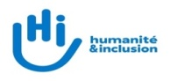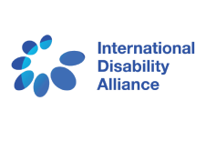**/Users/Tchaurea/Downloads/IDDC_LOGO_Full_Color_png_@2x.png**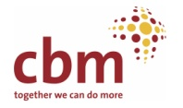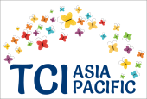

**CALL FOR APPLICATION**

**Bridge CRPD-SDGs Training Initiative - Multi Asian countries**

Dear members and partners,

# Background

In 2015, the International Disability Alliance (IDA) and the International Disability and Development Consortium (IDDC) developed the [Bridge CRPD-SDGs training initiative](http://www.internationaldisabilityalliance.org/content/bridge-crpd-sdgs-training-initiative) to support representative of organizations of people with disabilities to advocate for inclusion and realization of all human rights for all persons with disabilities in resource-constrained environments at national and local levels.

The intensive Bridge CRPD-SDGs program focuses on an inclusive and comprehensive understanding of the Convention on the Rights of Persons with Disabilities (CRPD) as well as generating a CRPD perspective on development in general and the Sustainable Development Goals (SDGs) in particular.

As an outcome of the training program, advocates would have stronger skills and knowledge to make the most of both SDGs and the CRPD to ensure the realization of all human rights for all persons with disabilities.

*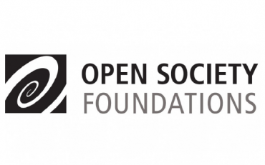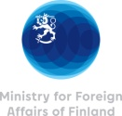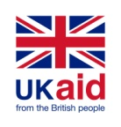Implemented by IDA, DPOD, TCI-Asia Pacific, CBM and HI, with financial support from DPOD, CBM, MOFA Finland, DFID (through the Disability Inclusive Development - DID Programme)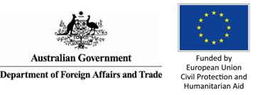 and the Open Society Foundations.*

# Bridge Asian multi-countries cycle – Module 1 December 2019 and Module 2 August 2020

IDA and its members, together with IDDC and its members (in particular the Disabled People’s Organization Denmark -DPOD, CBM and HI), along with Transforming Communities for Inclusion (TCI) Asia-Pacific, have the pleasure to launch this open call for participation in the **Bridge CRPD-SDGs Asian multi-countries cycle**. Module 1 will take place in Nepal between the **28th of November and 5th of December, 2019**.

This training invites applications from persons and organizations from **Bangladesh, India, Laos, Nepal, Pakistan and Sri Lanka.**

In case you or your organisation is interested to apply, make sure you fulfil the following criteria:

* Be an active member in the disability movement, being a DPO, member of a DPO federation, member of [IDA members](http://www.internationaldisabilityalliance.org/content/ida-members), be supported by any [IDDC members](https://iddcconsortium.net/sites/default/files/pages/files/20180627_iddc_member_organisations_listed_by_country.pdf), or be from a group of persons with disabilities who have been traditionally excluded,
* Be committed to learn, exchange and support other disability activists within their own group and beyond: be this at a local, national or regional level,
* Present a working awareness of the CRPD and a commitment to learning more about how to apply human rights concepts approaches, including using other human rights treaties, and the SDGs to advocate for disability-inclusive public policy at national and local levels,
* Demonstrate experience, interest and aptitude to engage in influencing development processes and public policy, be this at a local, national or regional level,
* Be able to fully attend both modules and to undertake given assignments (a full missed day, may disqualify the participant from being certified as having completed the BRIDGE training)

# Language

The training will be delivered in English. Participants may require simultaneous interpretation into their national/ local language. Individual requests will be considered and will be approved depending on available budget. Sign language interpretation or any alternative modes and formats of communication would also be available and supported.

# Most marginalised groups

The selection of candidates will be an open process based on fair representation of gender, age and different types of disabilities and background such as people from rural and remote areas, indigenous people and ethnic minorities. Deaf people, persons with deafblindness, persons with intellectual disabilities, persons with psychosocial disabilities, persons with autism and persons affected by leprosy are strongly encouraged to apply. The emphasis of the programme is on inclusion, and inclusive facilitation ensures that no one is left behind in the training methodology.

You do not need a certification of disability in order to apply. If selected, your supports would be discussed and reasonable accommodation would be facilitated. You can read about the different ways in which past training cycles have ensured inclusion on the [webpage on Bridge CRPD-SDGs training initiative](http://www.internationaldisabilityalliance.org/content/bridge-crpd-sdgs-training-initiative).

# Fees

**Participation in the Bridge CRPD-SDGs training does not require payment of fees**, neither to the trainee nor to their organisations. For that reason, each and all Bridge CRPD-SDGs participants commit themselves in disseminating the knowledge and experiences acquired through the training to their organisations and networks, as well as to the broad disability movement. All logistical costs related to the training will be borne by the organizers including travel, accommodation and hospitality.

# Application process

Interested persons are invited to provide us with the following documents:

1) A letter of expression of interest stating experience and commitment to the whole process (one-page maximum). This could be done via recorded oral or video presentation, including in sign language or other alternate forms of communication;

2) An updated CV in English;

3) A letter of recommendation on letterhead from a member DPO of a national, sub-regional or continental DPO, or from IDA or IDDC members, or other allies, in English.

Applications, including the required attachments mentioned above, must be submitted by e-mail to the following address: [bridge-regional-fellow@ida-secretariat.org](mailto:bridge-regional-fellow@ida-secretariat.org) no later than **31 October 2019**.

Very best regards,

The Bridge team for the Asian multi-countries cycle