EULOGY - Elena Down
Colin Allen, WFD President and IDA Chair
31 March 2017
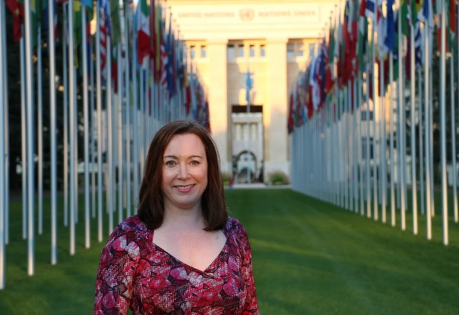
As has just been mentioned by her parents, I want to start by saying that while Elena may have been short in stature, her impact was momentous; she was really powerful particularly in terms of the work she undertook with persons with disabilities.

It is truly an honour to be here as an Australian and as the President of two global organisations, the World Federation of the Deaf (WFD) and the International Disability Alliance (IDA) to deliver this tribute in memory of our dear Elena.

To put this into perspective, the WFD has 133 members representing 70 million deaf people and IDA comprises 14 members who work on behalf of their members, numbering more than 1,100 across five continents, meaning one billion persons with disabilities (PWD).

As a deaf woman, Elena’s remarkable career involved working with a number of organisations including the Australian Attorney General, the Australian Human Rights Commission, AusAID within the Department of Foreign Affairs and Trade (DFAT), CBM Australia, WFD and IDA.

She played a significant role during her term with the Australian Human Rights Commission when she was the Principal Legal Officer, responsible for processes related to Australia’s negotiations in relation to the United Nations Convention of the Rights of Persons with Disabilities (UN CRPD) which led to the Australian Government becoming a signatory and ratifying the UN CRPD in 2007.

Another achievement in her career was whilst working with AusAID when she assisted in the development of Australia's first Disability Inclusive Development Policy - ‘Development for All’. This resulted in AusAID’s first funding agreement with the Pacific Disability Forum and involved working closely with CBM Australia.

Her absolute passion was working with the Deaf and PWD Communities in the Asian and Pacific Region during her term with AusAID and CBM Australia. In 2003, she undertook a two year volunteer aid role with the disability sector in China. It was only recently that I learnt that she enrolled in a language course to study Mandarin which as we know is a very challenging language to learn – this was in addition to her also learning Chinese Sign Language!

She worked with many groups in the Pacific region with her most recent trip being to Samoa to support the Pacific Disability Forum, which is one of IDA's regional members, during their regional conference. At this event, she organised a panel session with members of the Deaf Community from various Pacific countries (Samoa, Solomon Island, Fiji, New Zealand and Australia) with the goal being for them to gather together to facilitate the establishment of a national deaf association with the intention of them being able to 'voice' their deaf human rights.

Elena’s friends in Timor Leste are devastated by her passing. Elena was very committed to supporting the Disability Community in this nation to empower themselves. Although there was a plan for me to accompany Elena to Timor Leste later in the year, sadly this obviously will not occur however I do still hope to go there in memory of her work.

The first time I met Elena in person was in Sydney during the 3rd International Conference of WFD with her work colleague, Philip Waters. During our conversation, she indicated how her dream was to work with the Deaf Community in the Pacific Region to support them in fulfilling their human rights. She also said how much she wanted to work with the World Federation of the Deaf and do you know what, she did it, she accomplished both goals! WFD was fortunate to collaborate with Elena's employer - CBM Australia who agreed to her being seconded on a part time basis to WFD as a Human Rights Officer for approximately 11 months last year.

During her term with WFD, Elena wrote a number of submissions and statements related to the Deaf Community and Deaf People who use the sign language for the CRPD Committee. She wrote a particularly challenging position paper addressing how significant it is for deaf children to learn sign language which included extensive references to international research. This position paper was launched last September as the ‘WFD Position Paper on the Language Rights of Deaf Children’.

IDA established a training program, known as BRIDGE Training to provide the opportunity for trainers to become skilled in the field of the Human Rights for Persons with Disabilities through greater understanding of the UN CRPD and the 2030 Agenda - Sustainability Development Goals with the aim of empowering the PWD Community including deaf people thereby ensuring that individuals human rights would be ‘heard’. Elena was nominated by WFD to attend this training program with the objective of her being able to share her wealth of experience about the Deaf Community and Sign Language Users with other trainers.

Many many people including both board and staff members from the World Federation of the Deaf and the International Disability Alliance treasure the memories they have of Elena and really miss her so very much however there is no doubt that the legacy of her work in many countries around the world will continue.

Vale Elena and thank you.

Finally, I would like to conclude my eulogy with an honour specific to Elena with the intention that this amazing woman will continue to live on in our memories.

You may be aware that almost all members of the Deaf Community have a sign name, a name in sign language. Elena had a sign name which is unique and beautiful [SHOW SIGN NAME] – I would like everyone here to imitate me as I teach you her SIGN NAME – please copy me – ‘ELENA’.

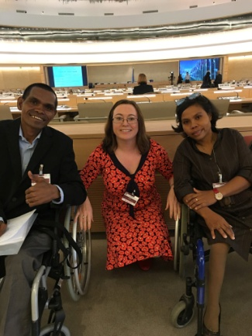
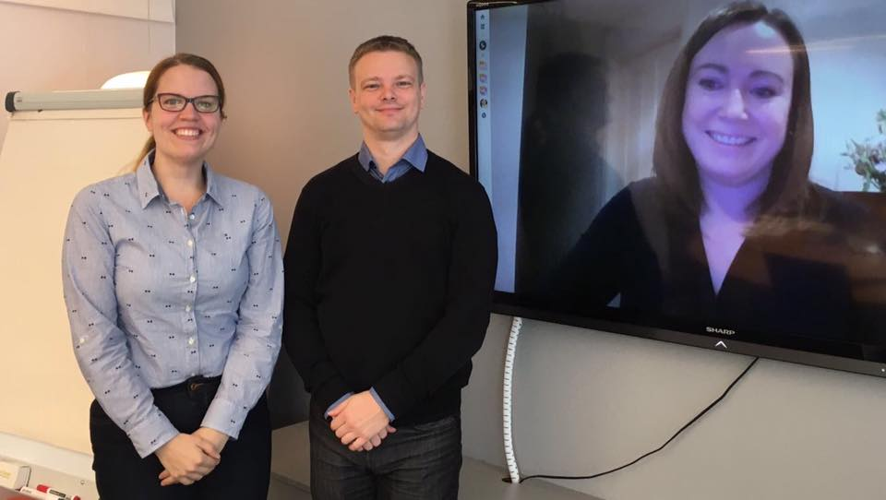
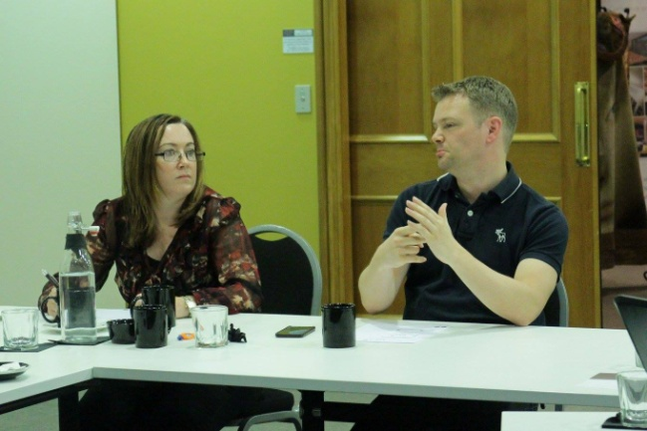
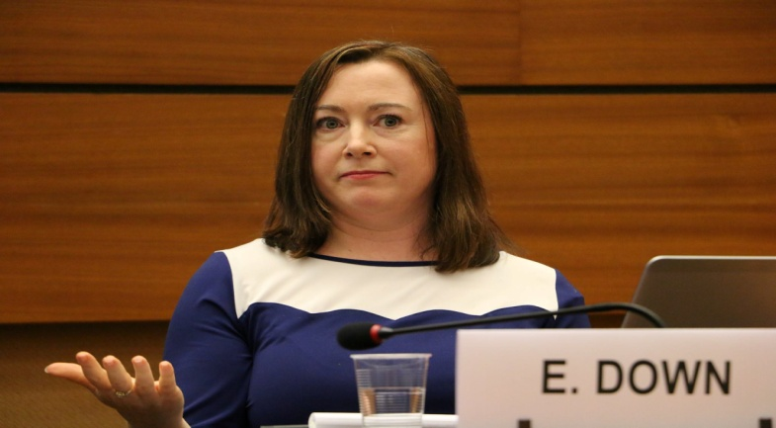
From my understanding, ELENA’s English name means ‘Light of the Sun’. As you can see, there is a connection between her sign name and the meaning of her name so as we go forward, when you look towards the light of the sun on any given day, associate this with Elena and recall her sign name and the impact that she made on the world.
