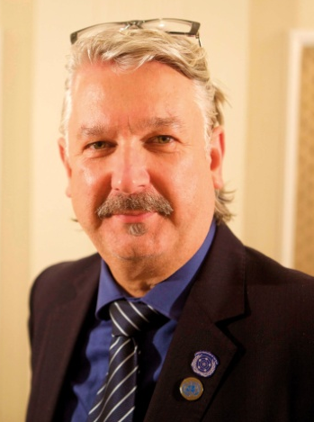
Mr Colin Allen
Biography
(July, 2016)

As a deaf person who has used Australian Sign Language (Auslan) since birth, Colin has actively participated in the Deaf Community throughout his life and has advanced the human rights of deaf people and more broadly people with disabilities for over 35 years.

Commencing in 1975 at a local level, he was involved in Deaf Community groups including Theatre of the Deaf, NSW Association of the Deaf, the Deaf Society and Australian Gay and Lesbian Association of the Deaf. Colin served as a Board member of Australian Association of the Deaf (now Deaf Australia) from 1987- 1999, serving as President for nine years. During Colin’s leadership, the organisation achieved:

- Inaugural Government funding (1992)
- Establishment of the National Relay Service (with Deaf Australia spearheading the campaign) (1995)
- Hosting XIII World Congress of the World Federation of the Deaf (WFD), Brisbane (1999)

Between September 2000 and May 2007, Colin worked for the Finnish Association of the Deaf on capacity building projects for the Deaf Community in Albania, Cambodia and Kosovo as well as conducting a situational analysis project of the Deaf Community in Macedonia, Serbia, Montenegro, Bosnia and Herzegovina, and Turkey. From 2007 to 2009, he was International Project Co-ordinator for the Global Education Pre-Planning Project on the Human Rights of Deaf People conducting regional survey work about deaf people in Eastern Europe, Middle Asia, Asia and the Pacific, South America, Mexico, Central America, the Caribbean, Eastern and Southern Africa, Western and Central Africa and Arabian States.

Upon his return to Sydney, Australia in late 2009, Colin worked as Director of Services and Community Engagement with the Deaf Society until June 2013, a position responsible for the delivery of services across Community Services, Adult Education, Employment, Sign Language Interpreting and Advocacy & Community Development. He was Access and Community Engagement Consultant with the Deaf Society from July 2013 to February 2016 which involved advocating to Government departments for information to be provided in Auslan.
In 2003, Colin was elected as a board member of the World Federation of the Deaf (WFD) and in July 2011 became President, the first Australian to occupy this role. In July 2015, he was re-elected for a second term until 2019.
In the human rights arena, Colin has represented WFD in international forums, most particularly the United Nations meetings relevant to the Convention of the Rights of Persons with Disabilities (CRPD).
In 2011, Colin became a board member of the International Disability Alliance (IDA) and in 2013, he became Second Vice Chair. In 2015, he was elected as First Vice Chair and is currently the Chair, a position which he will occupy for a two year term (July 2016 - June 2018). His commitment to human rights was exemplified through representing WFD and IDA at the CRPD Committee Session Meetings in Geneva, at Annual State Parties' Conferences of CRPD, United Nations High Level Meeting on Disability and Development in New York, and 22nd APEC High Level Forum on Disability in Beijing, China.

Colin is responsible for guiding and representing IDA's engagement with the UN System and other international human rights and international development organisations. He is closely engaged with the implementation of the 2030 Agenda for persons with disabilities worldwide including leading IDA's strategic planning to ensure awareness raising, capacity building, and participation of persons with disabilities in the preparatory processes towards national reviews. Under his leadership, IDA's mission is to ensure that the UN upholds the essential, unifying principle of the disability movement: 'nothing about us without us'. This includes implementing standards on full inclusion and participation of persons with disabilities, notably ensuring accessibility of decision-making spaces and documentation, meaningful participation in follow-up and review processes, and universal design throughout programme implementation.
The WFD and IDA roles are honorary positions with all work undertaken on a voluntary basis.

