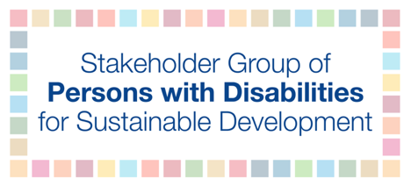

It is an indivisible and interdependent human right to ensure inclusion and equality for all persons with disabilities, which is embodied in the UN Convention on the Rights of Persons with Disabilities (CRPD) and enshrined in the 2030 Agenda. In the implementation of the 2030 Agenda, the Goals on education, employment, reducing inequalities, climate change, and peaceful and inclusive societies, in particular, must be guided by the CRPD. There are a number of principles and rights enshrined in the CRPD that could potentially apply to most, if not all, Sustainable Development Goals (SDGs) and targets.

Persons with disabilities are incredibly diverse in their identities, and those who experience other and intersecting forms of discrimination are at further risk of being excluded from society. All persons with disabilities, and particularly those from underrepresented groups, in rural and urban areas, including persons with psychosocial, intellectual and developmental disabilities, as well as children, women, older persons, indigenous peoples and others with disabilities must have equal opportunities to contribute to sustainable development to truly achieve the SDGs.

In many places, the socio-economic gap between persons with and without disabilities is increasing, because persons with disabilities experience low level of education, higher rates of unemployment and economic inactivity and a lack of social protection in comparison to their peers without disabilities. Moreover, persons with disabilities encounter barriers due to lack of or reduced access to healthcare and other services; an increased risk of violence and abuse; lack of access to justice; minimal participation in political and public life; discriminatory attitudes in sexual health, reproductive rights and the right to family life; lack of birth registration and encounter the effects of increasing risks and vulnerability that climate change is creating.

Consequently, a system-wide reform is required to strengthen national policies and legal systems to ensure that all persons with disabilities can access quality education, employment, disaster risk reduction programs, justice systems and other processes ensuring that the policies do not exacerbate discrimination, but rather promote access to mainstream and inclusive programs. To measure these policies, programmes and activities, indicators such as the OECD-DAC policy marker on the inclusion and empowerment of persons with disabilities should be administered.

Both the 2030 Agenda and CRPD require the collection of high-quality, accessible, timely and reliable data disaggregated by disability. Despite this, limited disability data are available at the global level. Yet, the Washington Group on Disability Statistics short set of questions and the UNICEF/Washington Group Child Functioning Module are sustainable, internationally comparable and suitable for disaggregating by disability status and monitoring progress in attaining the SDGs on an ongoing basis. Delays in using these tools could have detrimental consequences to the implementation of the SDGs, which subsequently will leave persons with disabilities uncounted and behind. Further, it is critical to foster partnerships between statisticians, policymakers and organizations of persons with disabilities to address policy gaps to achieve the SDGs and CRPD.

The ultimate objective of both the CRPD and 2030 Agenda is that every person with a disability is recognized as an equal citizen in every country with full rights on an equal basis with others, with dignity, respect and freedom. We, as persons with disabilities have as much of an obligation to achieve this goal as we expect from others. We must ask, isn’t it better, as persons with disabilities to begin taking steps toward this goal by embodying the spirit of the global agenda, by being proactive and visible advocates and partners of transformative change? We all know inclusion is a two-way process, and we must ask ourselves, are we applying the principles for which we advocate?

