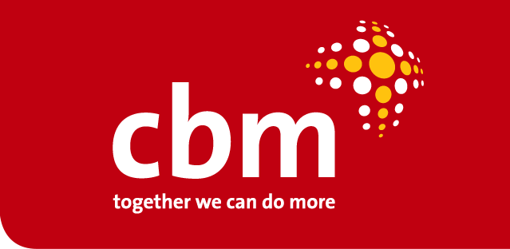

COVID19 Resource
  - Key advocacy messages, questions to ask on inclusion and signpost to resources to learn more
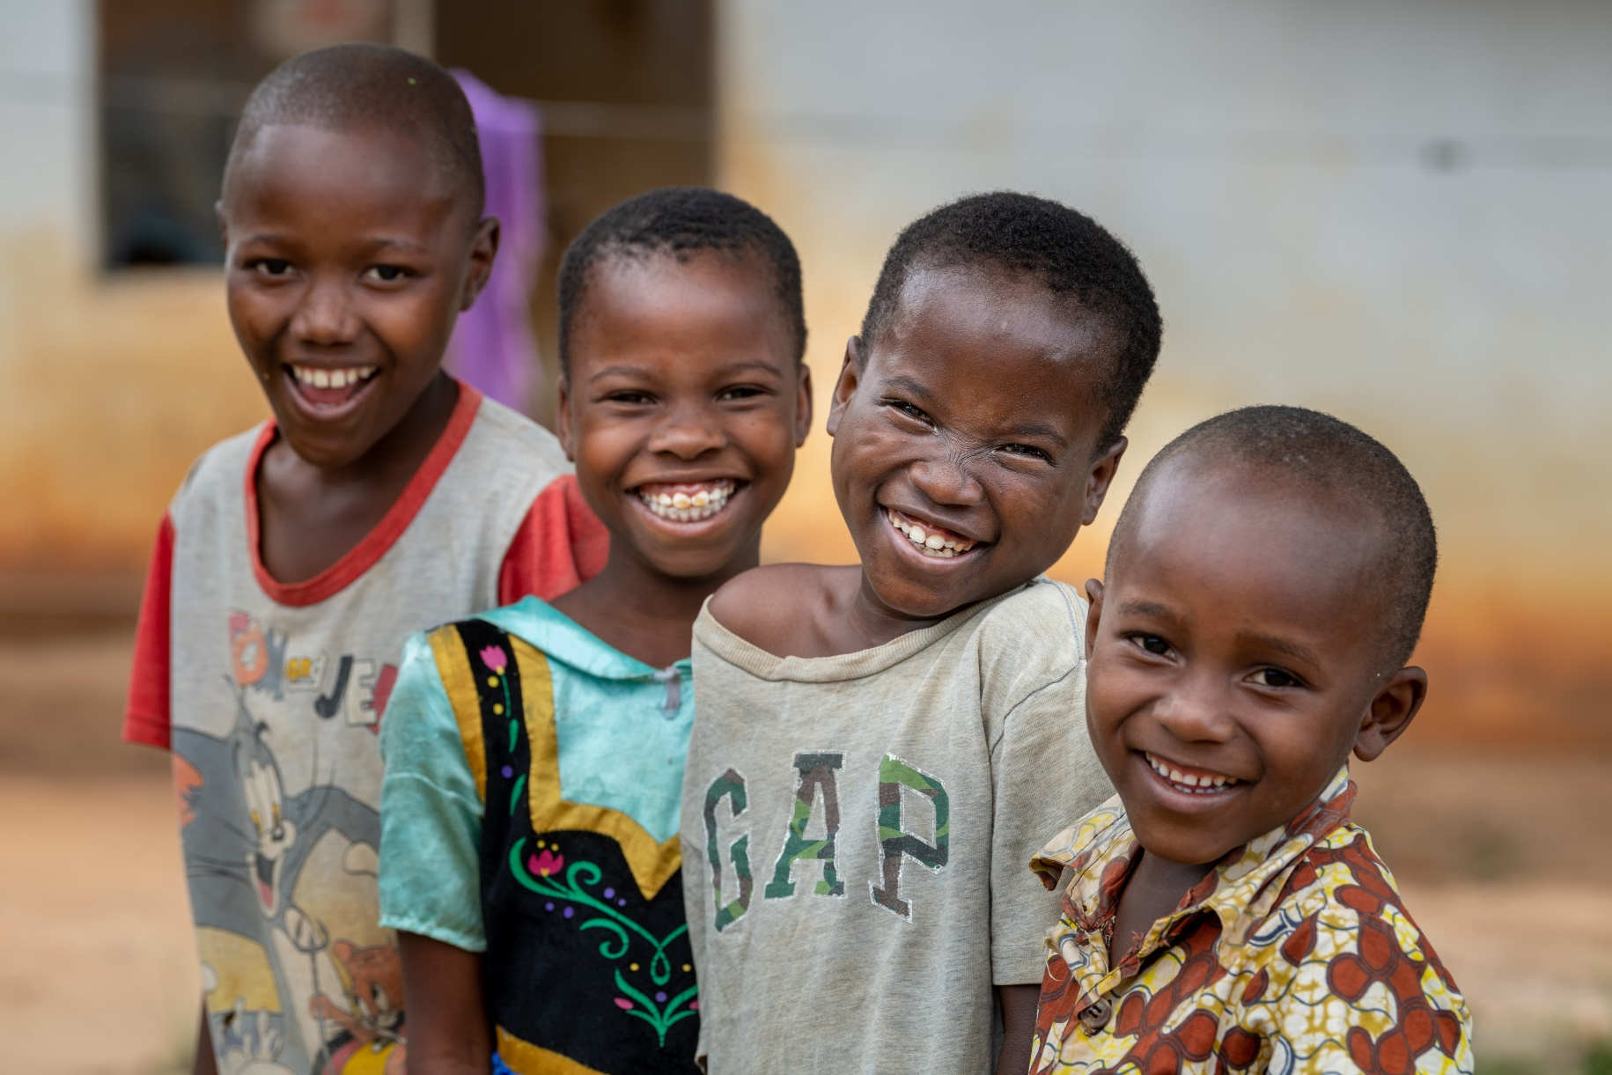
CBM Global Disability Inclusion
www.cbm-global.org Dr.-Werner-Freybergstr. 769514 Laudenbach, Germany
Editha seeks treatment for obstetric fistula at CCBRT hospital in Tanzania

As the COVID pandemic continues to escalate across the world, this document has been prepared to;
- provide some top-line advocacy messages that can be used for advocacy and communications
- give you 2/3 questions example you can ask yourself/or other stakeholders to check how people with disabilities are being included
- provide key resources for further reading.
We recognise the importance of safe, evidence-based messages, and stand by the advice of the World Health Organisation on health-related issues, of the Inter-Agency Standing Committee on international coordination, and of the International Disability Alliance on inclusion of people with disabilities in the COVID-19 response.
This document is consistent with this advice, and seeks to ensure its application for all.

- People with disabilities on an equal basis with others must be given access to healthcare and lifesaving measures. Decision-making regarding allocation of scarce health resources must not discriminate against people with disabilities.

Questions you could ask your Ministry of Health/Health officials?
- What measures are you taking to ensure equal access to messaging, equal access to care as needed, and continuing access to supports during COVID19 pandemic?
- What protocols have you put in place to ensure people with disabilities get the right support if in quarantine?

Read more about what the UN Special Rapporteur on the Rights of Persons with Disabilities, Catalina Devandas advises during this period - Who is protecting the people with disabilities?

- Organisations representing people with disabilities (OPDs) should play a key role in raising awareness of people with disabilities and their families on COVID-19 and also in advocating for disability-inclusive response to COVID-19 crisis

Questions you could ask your government officials, UN agencies, NGOs and OPDs?
- As you roll out your response to COVID-19, how have you ensured OPDs have been involved in the planning?
- What measures have you put in place to ensure on-going engagement with OPDs during the crisis?

Read more about the recommendations the International Disability Alliance provide for a disability inclusive COVID response. International Disability Alliance Key Recommendations toward a Disability-Inclusive COVID19 Response

- Information on COVID-19 should be available through all media channels and on all platforms in accessible formats. Accessible formats means, the use of sign languages, Easy Read, plain language, captioned media, Braille, augmentative and alternative communication.
Questions you could ask your government officials, UN agencies, NGOs and OPDs?

- What policy or plan do they have for producing material in different accessible formats?
- What channels do you plan to disseminate the information? Have you thought about how to reach those who are usually left behind?

Read more from organisations representing the different representing people with disabilities who are best placed to provide advice and guidance on this. Learn more from the World Federation of the Deaf: Guidelines on Providing Access to Public Health Information in National Sign Languages during the Coronavirus Pandemic and from the World Blind Union: WBU calls for accessible and inclusive services on Corona Virus

- Any COVID-19 programme response must be inclusive of people with disabilities and ensure equal access to programmes for all people with disabilities, recognising that women and girls with disabilities are often left behind.

Questions you could ask your government officials, UN agencies, NGOs and OPDs?

- What measures are you taking to ensure that in your programme response, you are including all people with disabilities?
- How do you plan to make sure your disability inclusion response is inclusive of people with disabilities across different age ranges and gender identities? How will you ensure disability disaggregated data

Read more from UNICEF on considerations for children and adults with disabilities, to learn more on an inclusive approach on protection, gender and inclusion, read key messages from the International federation of red Cross and red crescent societies.

- A global pandemic can increase anxiety levels among the general population and particularly those who are worried about their existing support they rely on, breaking down.

Read more about ways to reduce anxiety here, and how governments and other agencies can provide mental health and psychosocial support during the COVID-19 outbreak here.

Questions you could ask your government officials, UN agencies, NGOs and OPDs?
- What measures are you taking to ensure that in your programme response, people with disabilities can receive clear information about their circumstances, and be assured of their support not being compromised?
- What measures are you taking to promote mental health and wellbeing? Such as community public health messaging that provides practical ways of staying healthy and managing stress.

- During time of crisis and emergency, people of all ages who are not living in family residences, be these children or adults living in care homes, homeless persons, displaced persons, refugee camps or asylum/detention centres, urban slums, informal settlements are more at risk and can be left behind.
Questions you could ask your government officials, UN agencies, NGOs and OPDs?
- Do you have a list of all facilities, traditional/informal places where people receive care and/or reside? Have you ensured that these facilities can continue to operate in a safe and dignified manner, and no one has been left behind or is unable to leave?
- How do you plan to make sure that all people living in different types of setting, institutions of all kinds, including children, adults and older adults with disabilities, continue to receive the same standards of support and access to basic rights like food and health care and remain in contact with their families and supporters, even while workers’ availability may be reduced?

- In times of crisis, communities are always the front line of defense. For COVID-19, community response needs to be inclusive of people with disabilities and their families and access to local support services where practicable is critical.

Questions to ask community-based organisations?
- What steps are you taking to ensure people with disabilities are fully included in community level response
- What measures are you putting in place to ensure people with disabilities do not experience social isolation during this crisis?
Read more about inclusive community based engagement and inclusive community responses from World Health Organisation, International federation of red Cross and red crescent societies and the United Nations Office for the Coordination of Humanitarian Affairs.

Additional Resources for further information
- IDA, COVID19
- WHO, Disability considerations during the COVID-19 outbreak
- Inclusion International: Easy to read information on COVID19
- European Disability Forum: Open letter to leaders at the EU and in EU countries: COVID-19 – Disability-inclusive response
- International Disability and Development Consortium Health Group
- 5 Things To Know About Coronavirus And People With Disabilities by Andrew Pulrang in Forbes
- Important information in International Sign from Mill Neck Family of Organizations
- Disability Debrief - news on coronavirus from Peter Fremlin
- Inclusion Europe: Easy-to-read information about Coronavirus available in many languages
- European Disability Forum: comprehensive report on COVID-19 and the disability movement
- UN and COVID19
- UN System and COVID19
- World Institute on Disability: Recommendations for Immediate Action Regarding: The Rights & Needs of People with Disabilities Who Use Personal Assistance Services & Supports Throughout COVID-19 Planning & Response

About CBM Global
In 2019, the CBM International Federation agreed to make changes to allow different parts of the Federation to focus on their priorities and areas of expertise. Following a transition period ending by December 2021, CBM will implement its programmes through two legal entities, which will continue to collaborate closely, sharing programme standards and drawing on each other’s resources and expertise. CBM Global will combine field programming, advocacy and external advisory work on inclusion, to build an inclusive world in which all people with disabilities enjoy their human rights and achieve their full potential. It includes CBM Australia, CBM Ireland, CBM Kenya, CBM New Zealand, CBM South Africa, CBM Switzerland and CBM UK.
CBM Global will continue to work closely with a range of strategic partners worldwide to bring change at an individual level, challenge systemic discrimination and support the voice and power of people with disabilities as agents of change in both development and humanitarian action. Drawing on our Christian values, we will work with the most marginalised in society, irrespective of race, gender or religion, to challenge injustice, promote rights and build an inclusive world.
CBM Global will continue to deliver four key areas of work in an integrated way:
- Disability Inclusion, spanning community based inclusive development, national and global advocacy
- Inclusive Eye Health
- Community Mental health
- Inclusive Humanitarian Action.

For more information about CBM Global, please email hello@cbm-global.org or phone the CBM UK media team on +44 1223 484700 (out of hours: +44 7833 618699).
CBM Global Disability Inclusion

hello@cbm-global.org
+49 (0)1522 4493606
Dr.-Werner-Freybergstr. 769514 Laudenbach, Germany

Augmentative and alternative communication, are various methods of communication that can help people who are unable to use verbal speech to communicate.

