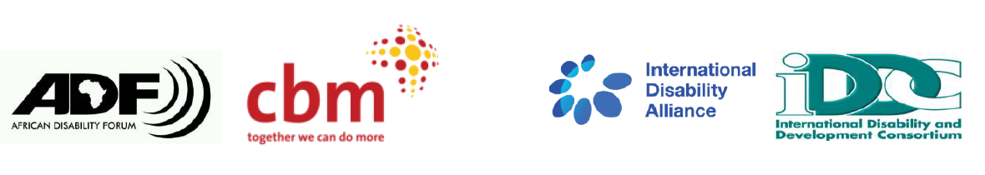

BRIDGE CRPD - SDGS Tanzania
NARRATIVE REPORT – MODULE 1

22nd – 29th July 2018

Day 1: 22nd July 2019: Workshop summary

Welcome remark
Day 1, 9:00am. Participants, facilitators, documenters and interpreters had taken their places in eagerness for the 8-day Bridge module 1. The layout of the room was already set for inclusive facilitation.

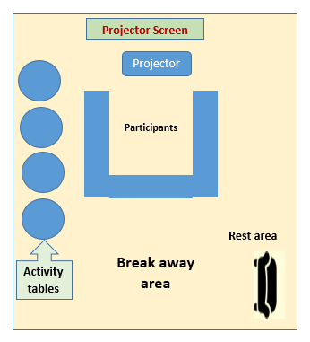
Picture showing the layout of the inclusive facilitation room. The projector table and screen in front. participant’s desks in the middle, activity labels on the right hand side and the rest area to the left.
Speeches:
Fatma Wangare one of the facilitators welcomed all to the training and invited several personalities to make introductory speeches.
Jonas Lubago CEO SHIVYAWATA: He Appreciated the organizers and funders of the Bridge Module 1 Tanzania. He challenged participants to learn and use the knowledge on CRPD and SDGs for better inclusion of persons with disabilities in Tanzania.
David Shaba (Deafblind) Board member of SHIVYAWATA was among the first person in Tanzania to receive Bridge training. David challenged the participants to be good ambassadors of the Bridge initiative by advocating for rights of persons with disabilities in Tanzania. He noted the impossibility of advocating for your rights without knowing these rights. He testified that Bridge training has benefited him by being a key political figure in campaigning for parliamentary post in his region of origin.
Ummy Nderianaga (Chairperson SHIVYAWATA): She was welcomed by a song praising her that persons with disabilities have confidence in her leadership in SHIVYAWATA. Challenged all to use the learnings in this workshop to better their advocacy practices.
Nesia Mahenge: CBM Country Director, Tanzania: Nesia noted that the training shall be instrumental in advancing the advocacy for rights of persons with disabilities in Tanzania. She also appreciated various sponsors (IDA, IDDC and National Lottery Community Fund) and the facilitators who have taken lead in the funding and organisations of this workshop. She also appreciated all participants form both Zanzibar and Tanzania Mainland and welcomed all to the training. She informed that CBM is an international organisation committed to the improving the rights of persons with disabilities in Tanzania, CBM has worked for over 50 years in Tanzania. She challenged participants to use the Bridge training to bridge to advocate for rights of persons with disabilities.
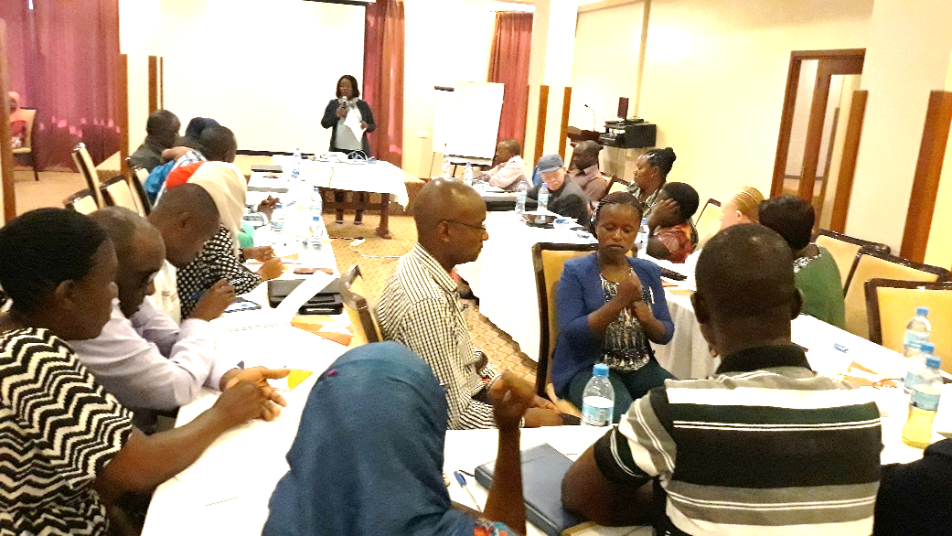
Picture showing Nesia Mahenge, Country Director CBM Tanzania, delivering her speech
Michael Njenga: Facilitator and Board Member of African Disability Forum (ADF). ADF was started in 2014, first AGM was held in 2015 in Nairobi. It was registered in 2017 in Ethiopia. Membership of ADF is continental organisations representing persons with disabilities and their families, Sub-regional DPOs and National organisations. Purpose of ADF is twofold: to amplify voices of persons with disabilities, capacity building of DPOs and families of persons with disabilities. Michael wished all participants a fruitful engagement in the training.

Introductions: Knowing each other:
The methodology used for participants to know each other was speed dating Members did 3 rounds of speed dating each lasting 2 minutes. Afterwards, all present in the room introduced themselves by name, organisation and their positions.
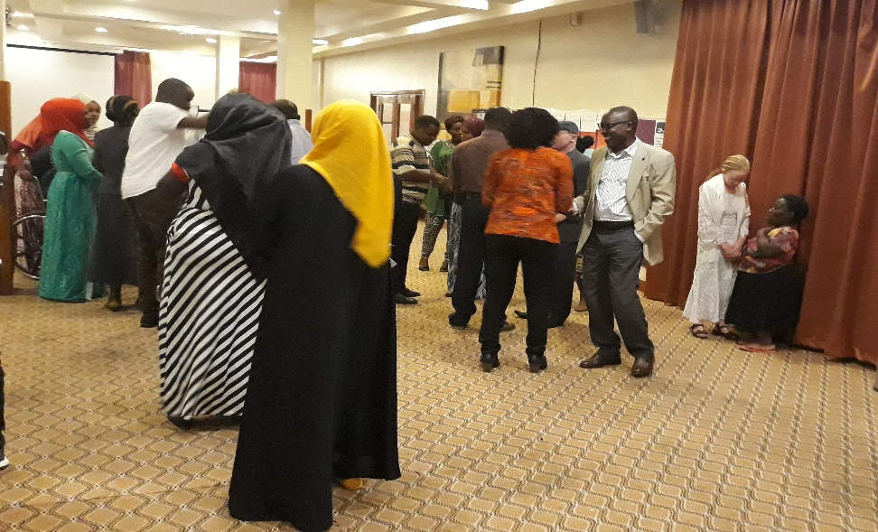
Picture showing participants interacting with each other at the back of the room in order to know each other.
Ground rules: participants agreed that phones should be on silent or vibration mode, have name tags, be silent and avoid side talks, and respect for each other opinions.

General schedule (Betty Najiemba): Start for each day 9am. Tea Break Lunch 12:30-1:45 Ending at 6pm.

Documentation and feedback mechanisms:
Traffic lights: green for something you are enjoying, red for something not well understood or confusing, yellow for anything that you need clarification.
Moodometer: will be used to evaluate the feelings for the day, high to low.
Parking lot: for issues you feel have not been addressed well.
Daily Review teams: working with the facilitators team, feedback and comments on facilitation methods. 3 people will be giving feedback on a daily learnings for each day.
Rest area: Sofas for short time resting for participants with disabilities.

From Needs to Rights: HRBA to disability and development (Key learnings).
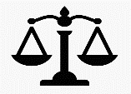Human rights are fundamental rights and freedoms that belongs to all of us as human beings. They are not given to us by anyone but they are inherent in us by virtue of being humans. Human rights are: universal, indivisible (all human rights are equal), interdependent and interrelated.

Bridge empowers DPOs for advocacy. It is fully inclusive of persons with disabilities, gender age and geographical spread. Module 1 is about understanding CRPD and SDGs and how to link both. Module 2: is about applying module 1 principles in advocacy in - country. Bridge is an experiential learning and inclusive for both facilitators and participants.

Duty bearer: State is primary duty bearer, which has 3 obligations: duty to respect, obligation to protect by non-state actors and duty to fulfil. Right holder: we are entitled to claim our rights. You can’t claim them if you don’t know them. Entitled to hold duty bearer to account. Rights comes with responsibilities.

HRBA therefore recognizes that we have certain needs in life and that we need to translate these into human rights.

CRPD and other conventions

The purpose of the CRPD is to promote, protect and ensure the full and equal enjoyment of all human rights and fundamental freedoms by all persons with disabilities, and to promote respect for their inherent dignity.

CRPD should not be looked at or implemented in isolation, but rather alongside many other international treaties such as the Universal declaration of Human rights, Convention on the rights of the child (CRC) and Convention on the elimination of all forms of discrimination against women (CEDAW).

In comparison to other conventions and treaties the CRPD gives us the following which is new:
- A clear articulation of reasonable accommodation; including the denial of reasonable accommodation as a ground for discrimination on the basis of disability (Article 2)
- The right to use support – and have supported decision making to enjoy being able to exercise legal capacity (Article 12)
- The right to live in the community and not to be excluded (article 19)
- The CRPD preamble does not define disability but articulates disability differently: as an evolving concept- an interaction between impairment and barrier.

Participants discussed at length the challenges faced by persons with disabilities in Tanzania. These barriers include stigma, discrimination, poor access to education, lack of sign language interpretation in the local media and also challenges of fully and meaningfully engaging in reporting processes to the CRPD committee. Eventually, it was agreed that all organisations and persons with disabilities have to work together so as to achieve positive outcomes of their advocacy initiatives.

Game of life:
Participants were divided into 6 groups whereby each of these produced a character. Each of the groups were given character to discuss about and act out in the Game of life. Statements of the game of life included play, schooling and social political participation. At the end of the persons in the lead were those from wealthy families despite their impairments while those were trailing were from the less privileged families.
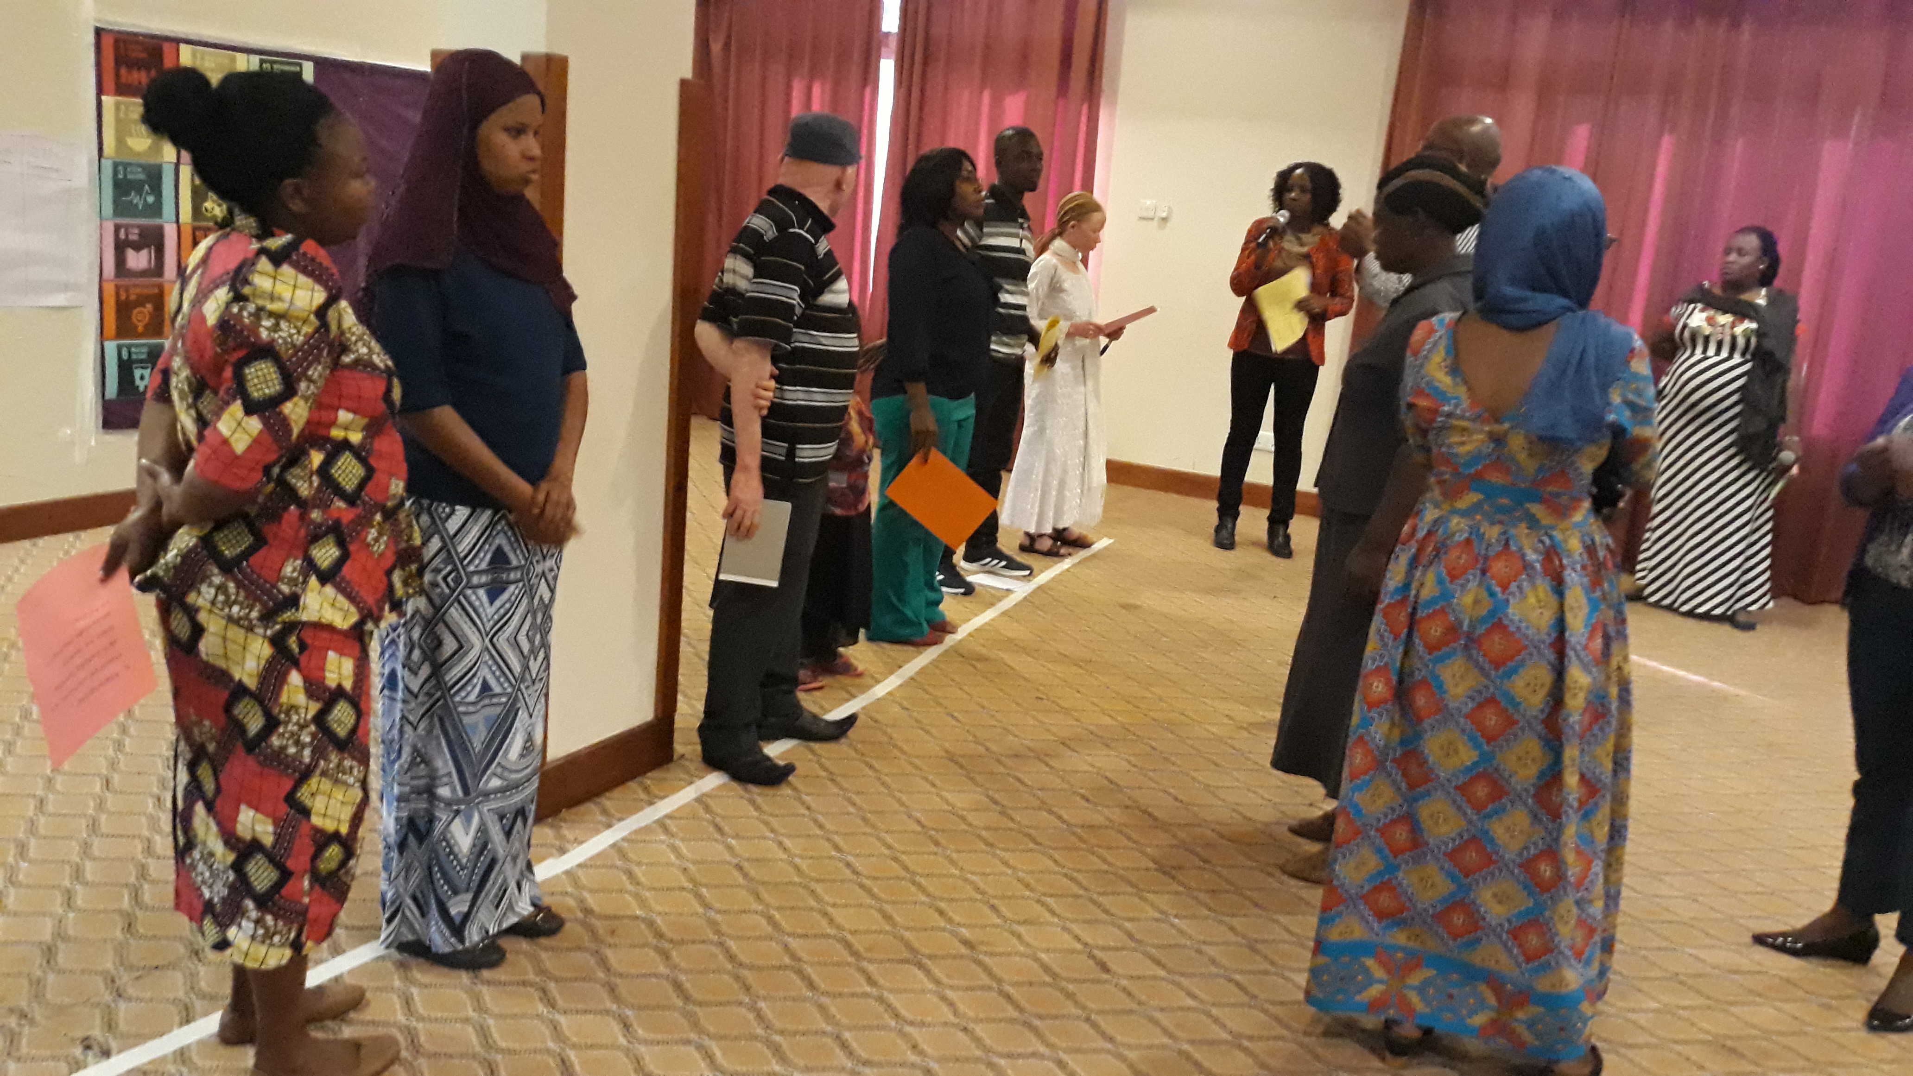
Picture showing all participants at the same level of starting line.

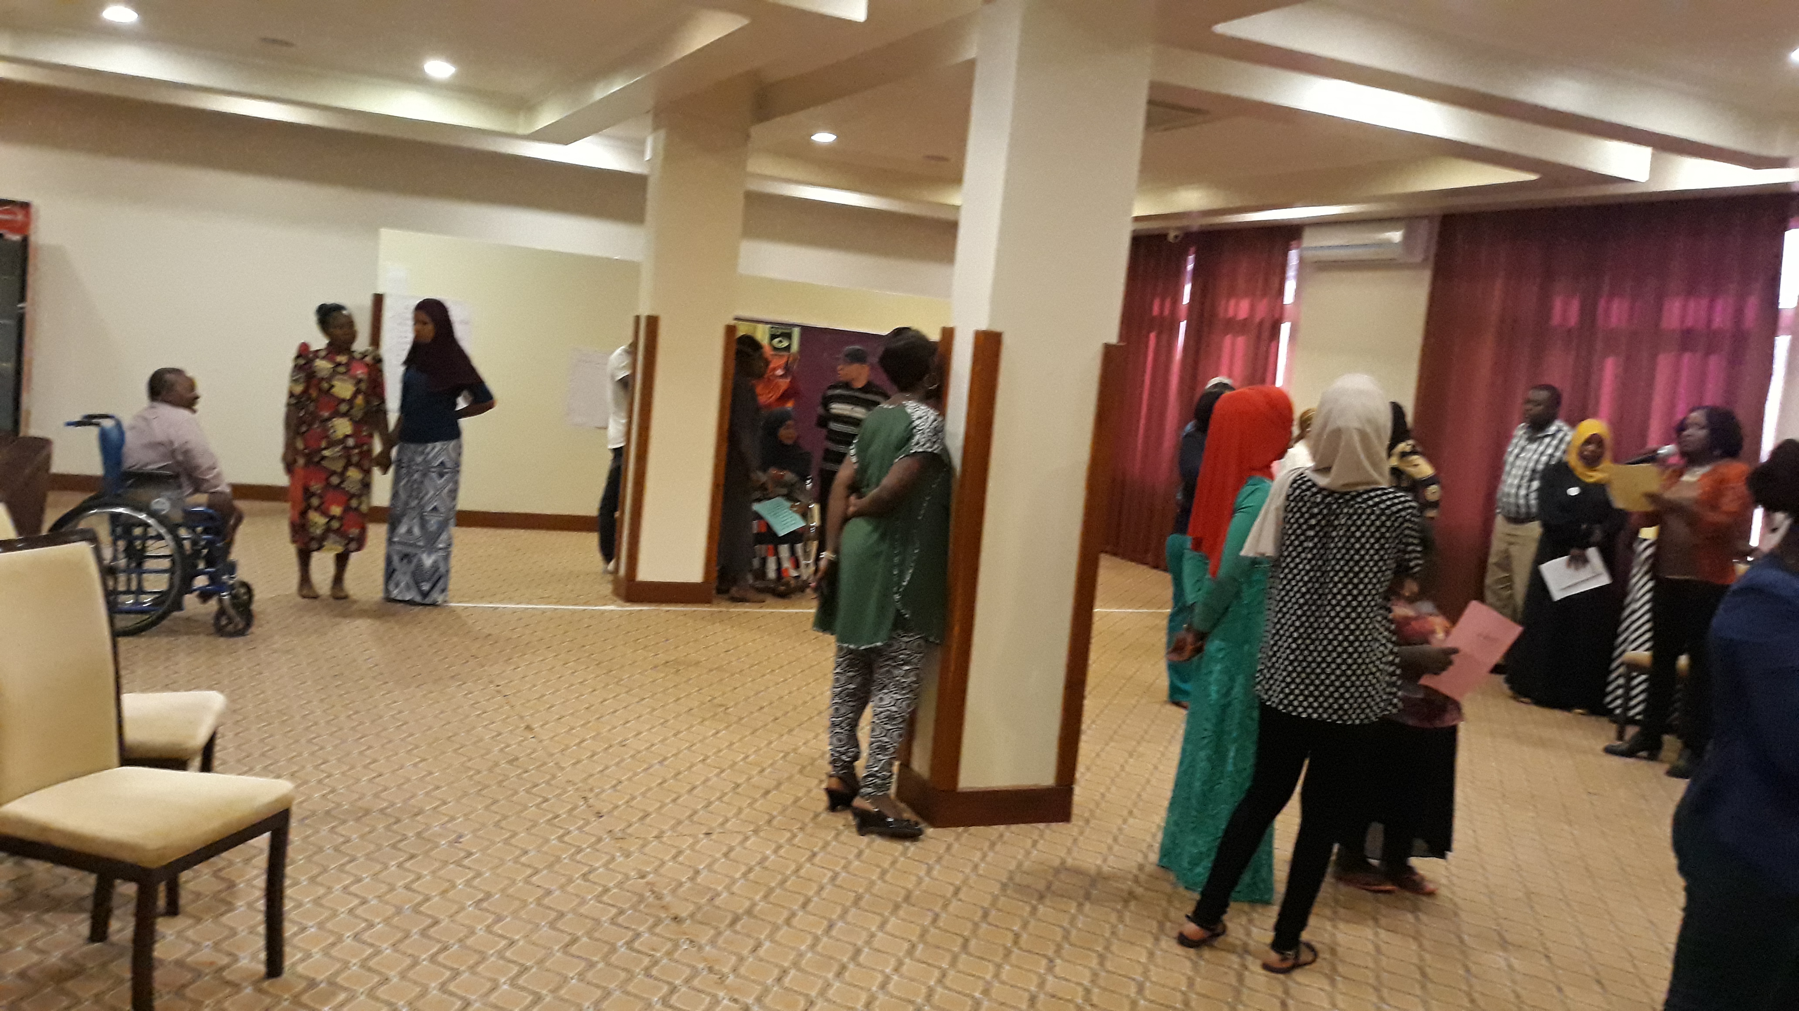Picture showing the end of the inclusion game, everyone at different levels.

Lessons learnt from the game of life game:
- Persons are progressing or retrogressing due to family/environmental conditions.
- Gender differences affect the situation of life of persons with disabilities. Mostly the women are trailing behind men due to negative social attitudes for women in the society.
- Affirmative actions are key to achieving equality and equity.

In conclusion, participants were taken through formal equality, de facto equality and equality of outcomes.

--------------------------------

