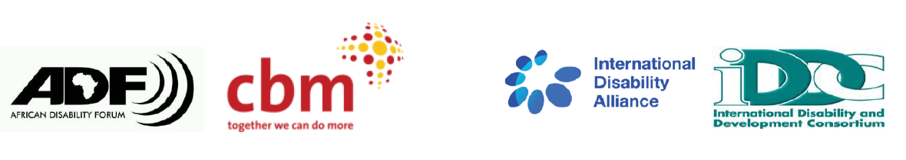

BRIDGE CRPD - SDGS Tanzania
NARRATIVE REPORT – MODULE 1

22nd – 29th July 2018

Day 7: 28th July 2019: Summary

Being the last day of Bridge Module 1Tanzania, the day was dedicated to making reflections on the whole week; with the first session being on collective reflections on how inclusive the workshop was, and secondly, an activity session on ensuring an inclusive and CRPD compliant disability movement in Tanzania. This session was to guide the participants to understand the importance of inclusiveness in the disability movement in addition to discussions on key elements to ensure inclusion of different groups of persons with disabilities.

The facilitator posed the following question to the participants: Have we been inclusive? Reflections included the following:
- The participants noted that having all of them in the training, the different impairment groups was very positive and a clear example of ensuring inclusion and also a best practice for them in their advocacy.
- The participants noted that facilitators made individual follow up on members to ensure that they were fully participating, which was applauded in ensuring that all were included in the training.
- Participants also noted that prior to the training, each of them had been asked to state their reasonable accommodations and support services requirements which they said was a good way that ensured their inclusion right from the very beginning.
- They applauded that resources were in accessible formats for different impairment groups including in Braille, use of sign language interpretation, and easy read materials which ensured that everyone participated fully and effectively.
- The participants stated that the whole week had been for them, a session on inclusive facilitation, a practice that they highly applauded indicating that it would support them in their work as activists.
- The participants indicated that the concepts introduced throughout the week were key for them in their work and they said this was also a way to ensure that they are inclusive in their work.
- They also appreciated that the training had presented to them a comprehensive approach at all rights for persons with disabilities which had also supported in their confidence as most areas were covered to give them insights on what it means to ensure all human rights for all persons with disabilities.
- That participants were drawn from different regions in Tanzania was also applauded as a way to make stronger the movement in the country.

The facilitator then sought to know how the participants would use the new learning in their organizations. They stated the following:
- ‘Through the umbrella organization, as a start I will seek to further let others know what we learnt so far, on rights, on issues of non-discrimination.’
- ‘These past few days have enriched my training skills, I have a session with refugees in a camp soon and I will use these learning to also share with them on the CRPD and SDGs.’
- ‘This is a unique opportunity, a way to change our outlook on how we work with all groups of persons with disabilities, also how we expand our networks in Zanzibar and how we continue in our advocacy on the realizing of all human rights for all persons with disabilities.’
- ‘Acknowledging the leadership challenges that may exist within different organizations, these training is opening to us and showing us new ways of addressing such challenges and also to work together as the movement.’
- ‘To link the CRPD and the SDGs was new to me and it gave me new ideas in my advocacy and soon am going to meet development stakeholders and it supports me in new ways of engagement with them.’

Afterwards, the participants chose one of them to be in charge of their WhatsApp group that they will use as a common means of communication and learning in the lead up to Module 2

Building the straw tower:
Activity session on ensuring an inclusive and CRPD compliant disability movement.

The participants were given straws and adhesive roll with the task being to build the highest straw tower possible. They had to work together to ensure that their straw tower stood as the tallest among the rest.

The whole activity was applauded by the participants as a practical way of what it means to work together and to include all persons with disabilities in advocacy. In their feedback, the participants spoke of how it was key to have a strong foundation at the start so that the tower could stand on its own. One group made their straw tower by linking the adhesive roll to the table, something that the facilitators told them was not in the ground rules, and even as the participants laughed at the fact that the straw tower could not stand on its own, the participants agreed that the foundation of the tower was not strong and however much they had put up a fancy tower that could not hold, there had not been strategic thinking and planning around how the tower could stand on its own.

Other participants spoke of how consulting among themselves worked very well in ensuring the tower stood tall, others stated that the wide foundation was a representation of different impairment groups.

In reinforcing the key messages from the activity, the facilitator stated that from the activity, it was practical to see the ingredients of an inclusive disability movement such as ensuring that all persons with disabilities are included, always advocating within the framework of all human rights for all persons with disabilities, and also that by being compliant with the CRPD, it gives the movement more legitimacy.

It was also emphasized that to ensure everyone is on board requires active steps, that being inclusive makes the movement stronger and also that building an inclusive disability movement requires strategic thinking and planning.

Next steps, evaluation and closure

Bridge Module 1 Tanzania ended with the participants going through the elements of Module 2 that shall happen after six months. The policy paper assignment that they shall work on during that time frame was also explained, after which each participant was assigned a mentor from the facilitation team, to work with the participants in realizing the policy paper.

The participants then took time to make written evaluation of the whole week and after which the workshop came to a close by a word from the SHIVYAWATA leadership.

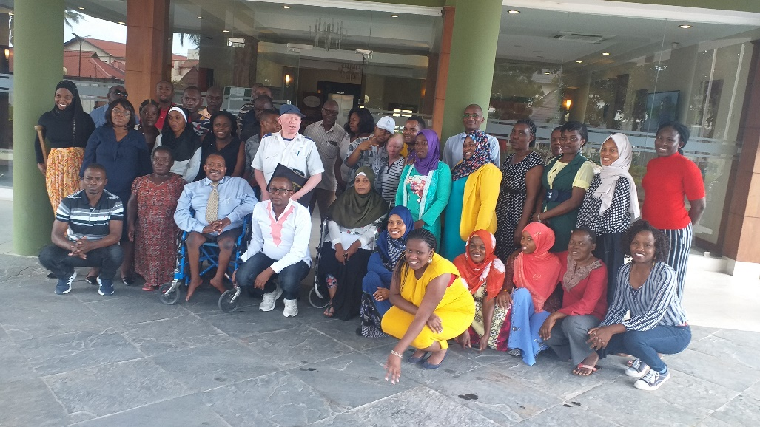A group photo of all participants

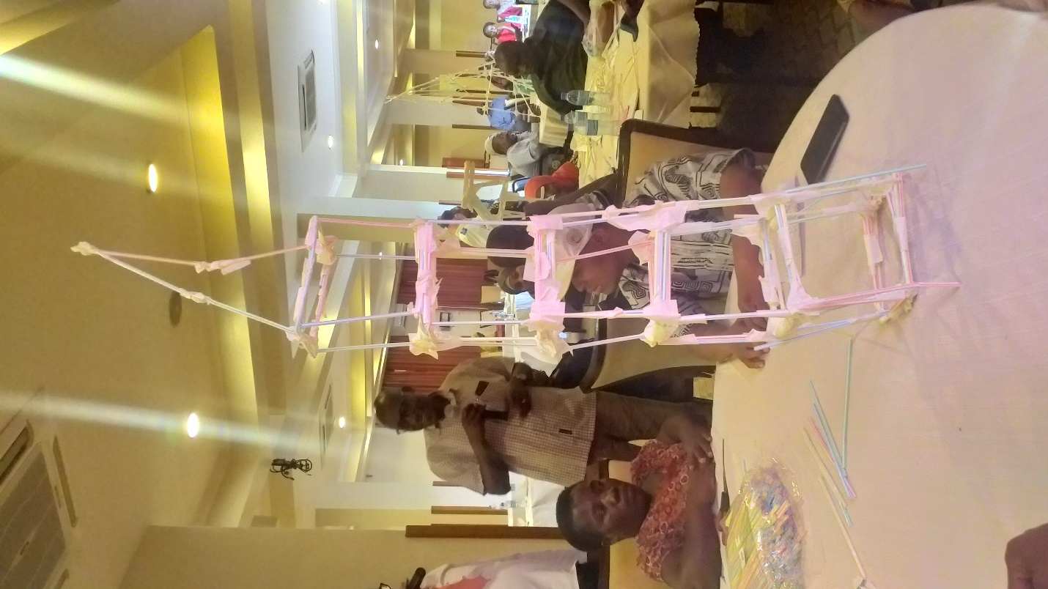One of the groups during building the straw tower

…ends.

