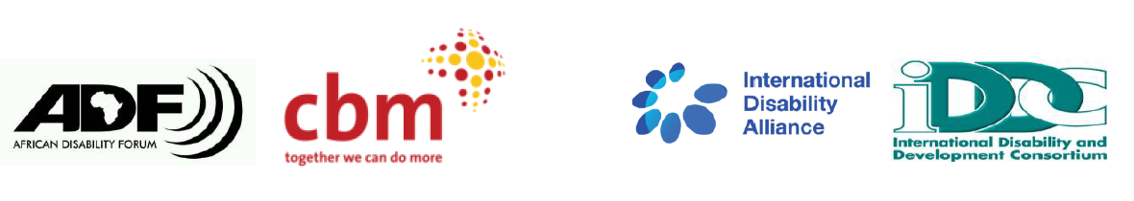
BRIDGE CRPD - SDGS Tanzania
NARRATIVE REPORT – MODULE 1

22nd – 29th July 2018

Day 3: 24th July 2019: Summary

Day 2 highlights feedback
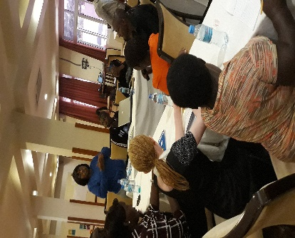
Picture of Day 2 Review presentation by a participant

The review group for feedback gave a summary of the day’s activities and events appreciating the improvement in time management; more time was requested for group discussions.
Participants were asked to describe one striking thing they learnt the previous day. They loved the mock accessibility audit exercises, discussions on gender equality and disability language and non-discrimination whereby denial of reasonable accommodation is discrimination. The case study on the person who is blind who applied for a firefighting job was also striking event for day 2.

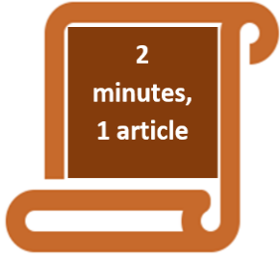 Article 24 education: Education has to be inclusive. It should lead to non-discrimination and offer independence and not dependence to persons with disabilities. Inclusive education should not be discriminatory to persons with disability but should promote participation.

Article 13: Access to Justice: Gender based violence was said to be rampant and more so affecting persons with disabilities. This incudes but not limited to the ritual sacrifice of persons with albinism in Tanzania and Africa. This article should therefore be read alongside Article 12, Equal recognition before the law. Article 9: Accessibility is key to achieving both article 12 and article 13. This is what DPOs should advocate for.

Article 25: Health: This was presented in form a Kiswahili poem. Health services should be available and accessible. National insurance should also be available for persons with disabilities. Medical personnel should be trained on the access requirements for persons with disabilities. The facilitators added that health should be looked at more comprehensively. E.g mental and maternal health and not just physical well-being.

Article 31: Statistics and data collection: This is one of the articles that speaks to monitoring and implementation of the CRPD. One of the ways which this is done is by disaggregating data by disability gender and age alongside other indicators. Disaggregation of data is not an end in itself but barriers faced by diverse persons with disabilities should also be considered. The Washington set of short questions is an important tool for data disaggregation.

Article 23: Respect for home and the family. Persons with disabilities have the right to marry and start families when they attain the marriage age. Families have the obligations to support persons with disabilities in their family life and the choices that they make in their family life.
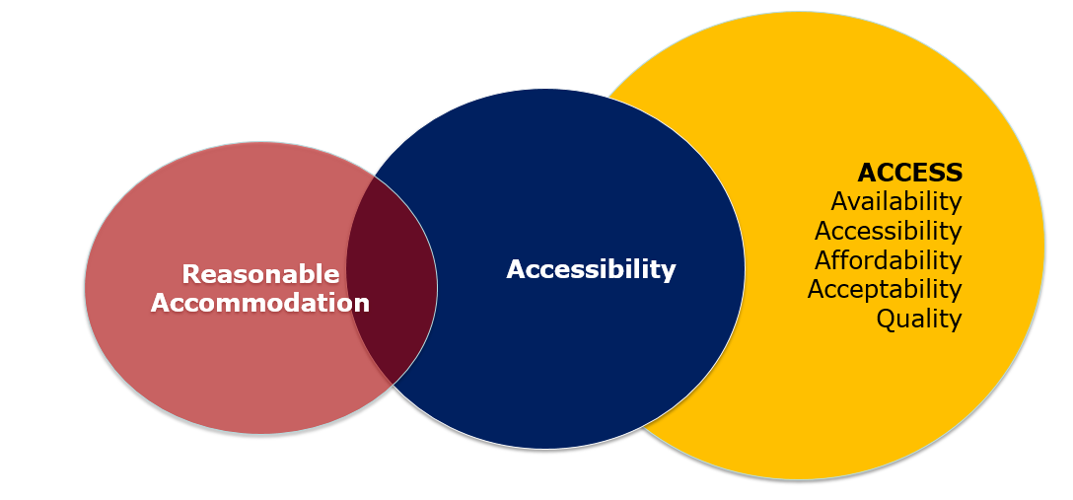

Session:

Access:
The session started with a presentation of access and accessibility situation in the country. The government as the duty bearer should ensure access to services. Service delivery especially health services is not accessible. There is a discrepancy between policy and practice in service delivery. Banking, transportation and other services are not accessible to persons to persons with disabilities. Does that then mean that a person who is Deaf is admitted or jailed, the sign language interpreter should also be jailed or admitted?

Access to services has the following elements under the acronym 4As&Q
- Availability: existence, geographic distribution, sustainability
- Affordability: services should be affordable or free to persons with disabilities.
- Accessibility: of transport, infrastructure, communication and information. Acceptability; does the community accept the service or cultural sensitivity hinders its acceptability?
- Quality: are the services responsive to users’ needs and desired outcomes?

Accessibility and reasonable accommodation
Participants were taken through a differentiation between accessibility and reasonable accommodation. They were also informed that reasonable accommodation is defined in article 2 of the CRPD and accessibility is explained in detail in Article 9 of the CRPD.

A discussion between reasonable accommodation and accessibility was concluded thus: reasonable accommodation is specific to an individual while accessibility is for everyone. Reasonable accommodation is temporary but accessibility is permanent. Lastly reasonable accommodation is on request and immediate while accessibility is systemic and progressive respectively. A group exercise on various scenarios of accessibility and reasonable accommodation that followed this presentation was evidence enough that the two concepts were well understood by the participants.

Session: Self-determination, respect for inherent dignity and personal autonomy.
The context where persons with disabilities are not allowed to make their own decisions on big decisions such as property ownership, political processes and also other small decisions like which clothes to wear laid the foundation to the session. Understanding article 3 of the CRPD (General principles is very important as most UNCRPD concepts are built upon it. The participants read through the principles and were therefore asked to internalize them.

The presenter presented a case study of Zuena who was subjected to Electro convulsive therapy treatment by her family without her consent.

The facilitator asked if this action was correct. For those who said that this action was wrong, they gave the reason that Zuena is a human being, her impairment notwithstanding. Therefore, she should have been consulted about the decision to take her to hospital.

Participants who said that it was okay to take Zuena to hospital without her consent implored upon the rest to think about the outcome of the intervention she received, which was positive. A facilitator challenged this group to think of a situation whereby one is punished before being given a job. He challenged the participants whether this was right. At the end it was agreed that the forceful taking of Zuena to the hospital was not right.

The facilitator posed another question to the participants about which other rights of Zuena was violated. The participants singled out Article 16: Freedom from exploitation violence and abuse as well as Article 19: Living independently and being included in the community (Zuena was translocated from her family).

Asked the questions about what could be done differently, participants responded that family members would have considered Zuena as a human being and not as a sick person due to her impairment. This way, they could have interacted with her better and offer her support in assisted decision making.

Further learnings from this case study;

Article 12: Equal recognition before the law.
Participants were asked to reflect on how their life would be if they were not able to make any decisions. Responses to this question were as follows:
- I would not feel equal with others.
- I would not have attended this training.
- I would be like Zuena in the case study.
- If I did not decide to come to the city to work after my parents could not afford to educate me, I would have stayed the village, age and die in poverty.

The facilitator noted that we take decision making for granted because if we are not able to make decisions in our life we are the same as dead. Article 12 is about making big and small, formal and informal decisions. In some instances, just like is the same with other people, persons with disabilities may at time require support. Therefore, when this support is needed, this should be provided.

Article 12 directs that in relation to decision making:
- Respect the will of that persons with disability.
- In providing support, one may abuse this opportunity. The state should thus put in place mechanisms to mitigate this possibility.
- Persons with disabilities have the right to own property.

Article 12 is closely related to related to Article 19: living independently and being included in the community. Living in the community is not geographical issue. It is that ensuring all services for persons with disabilities are provided within the community e.g. health and education services. Persons with disabilities should live in the community and have equal choices on an equal basis with others. Institutionalization of persons with disabilities therefore goes against this. Lastly it is about supporting persons with disabilities to live in the communities.

In relation to the context of choices, a participant gave an example whereby persons with disabilities are offered employment but then posted to work only in areas or organisations for persons with disabilities which does not ensure that persons with disabilities have choice to work in all other areas or organizations not specifically working only with persons with disabilities.

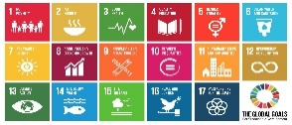Session: Agenda 2030 and SDGs
Agenda 2030 builds up on the millennium development goals (MDGS). The former is a result of intense negotiations among different stakeholders. They were adapted in 2015 and will go till 2030. 5Ps were presented to the participants to show what Agenda 2030 covers.
- People: SDGs are about US.
- Prosperity: able to build a prosperous society for all.
- Peace: Ensure we are building just and inclusive societies for all.
- Partnerships: SDGs are for all countries and encourage partnership between developing and developed countries.
- Planet: take measures to ensure sustainability in our climate and the environment. This is necessary to achieve the rest.

SDGs are a political commitment but they are not legally binding. This is one of the differences between CRPD and SDGs. SDGs also apply universally but the SDGs are implemented through national development frameworks. Another difference is that MDGs did not mention persons with disabilities but the SDGs do. The overacting principle of the SDGs is “Nothing about us without us”. Whenever the word vulnerable is used in SDGS, we are referring to persons with disabilities. SDGs use a very inclusive language e.g. education for all.

Participants read through the SDGs from the first one to the last one.
GOAL 1: No Poverty
GOAL 2: Zero Hunger
GOAL 3: Good Health and Well-being
GOAL 4: Quality Education
GOAL 5: Gender Equality
GOAL 6: Clean Water and Sanitation
GOAL 7: Affordable and Clean Energy
GOAL 8: Decent Work and Economic Growth
GOAL 9: Industry, Innovation and Infrastructure
GOAL 10: Reduced Inequality

GOAL 11: Sustainable Cities and Communities
GOAL 12: Responsible Consumption and Production
GOAL 13: Climate Action
GOAL 14: Life Below Water
GOAL 15: Life on Land
GOAL 16: Peace and Justice Strong Institutions
GOAL 17: Partnerships to achieve the Goal

The facilitator issued each participant with several CRPD articles and asked them to match each of them against the SDGs. Observations after this matching exercise were as follows:
- A participant who had opposed that there is a relationship between SDGs and CRPD now realized that there was actually a relationship between the two (light bulb moment).
- There are some of the SDGs that were easy to match but others were not easy. Specific examples were not given.
- It was noted that participants did not match SDGs numbers 1, 2 and 6 with any CRPD articles, something that was challenged by the facilitators where for example participants were shown and had brief discussions on SDG 6 with CRPD article 28: Adequate standard of living and social protection.

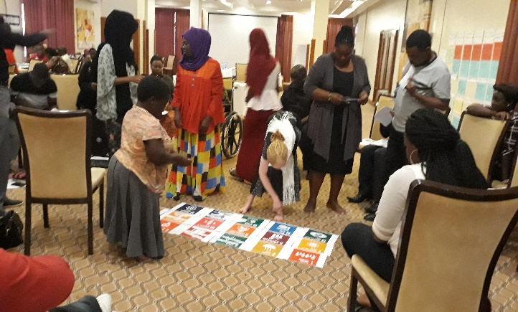
Picture showing participants matching CRPD to SDGS

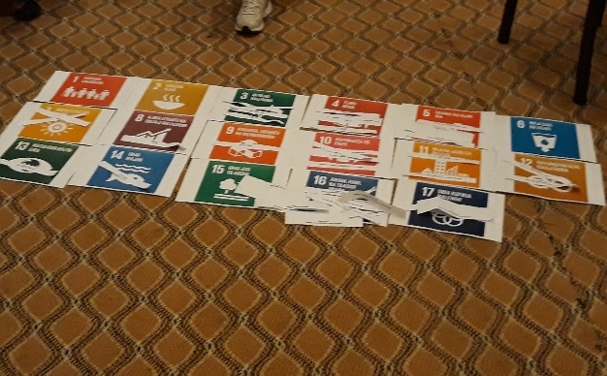
Outcome of the exercise of matching the SDGs and CRPD articles to show how important it is always that in implementation of SDGs, it is done within the framework of the CRPD and vice versa.

