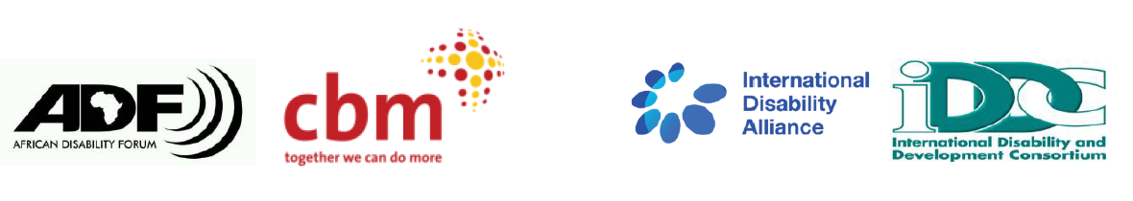
BRIDGE CRPD - SDGS Tanzania
NARRATIVE REPORT – MODULE 1

22nd – 29th July 2018

Day 4: 25th July 2019: Summary

Day 3 highlights feedback
The review team indicated that they had conversations with their colleagues so as to give a comprehensive feedback. They reported that day 3 had gone on well and was also well concluded. To ensure full and effective participation of everyone, participants indicated the need to give more time to discuss their views on various topics. To have energizers that included everyone was also proposed. Participants were also encouraged to maintain keenness and to be attentive throughout all sessions.

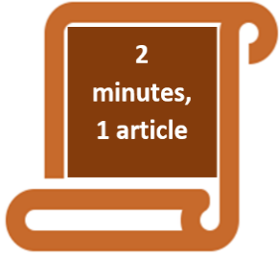 Article 27 employment: On the reflection about this article, it was noted that barriers to inclusive employment for persons with should be mitigated. It was emphasized that persons with disabilities should be paid wages on an equal basis with others. Need for an inclusive work environment was also emphasized. Reasonable accommodation should also be provided at the workplace.

Article 29: Participation in political and public life: Discussions indicated the fact that there is a reality where participation in political life comes down to people’s financial abilities which may be a disadvantage for most persons with disabilities. hat politics is a game of money and not policy. Therefore, reflection was made on the need for advocacy on representation of persons with disabilities in the political sphere.

Article 32: International cooperation: The article emphasizes that a developing country like Tanzania should cooperate with other nations and vice versa so as to achieve inclusion and empowerment of persons with disabilities.

Article 5: Equality and non-discrimination. A participant with a physical disability narrated a personal case of how a conference for 200 youths was organized. Despite the organsiers being aware that some of the participants had disabilities, they went ahead to organize the workshop without taking into consideration accessibility requirements. In the end, the conference was organized without sign language interpretation, in addition to holding it in a place that was physically inaccessible. This was shown as a discrimination case and all participants encouraged to be aware of both discrimination in law and in practice and being able to challenge it.

Article 21: Freedom of expression and opinion and access to information: This article marries very well with general principles of the CRPD (Article 3) and article 9: Accessibility. Accessibility is not just about physical accessibility but also information and communications. For article 12 (equal recognition before the law), it was emphasized that you cannot make decision without information.

Session: Article 4 (General obligations)
Participants were asked what the government should do to ensure that persons with disabilities are included. Answers given to this question was that the government should develop policies on inclusion and raise awareness on these policies. In summary the government has the obligation to respect, protect and fulfill the rights of persons with disabilities.

The Government of Tanzania has made strides in disability inclusion as follows:
- Policy development on inclusion:
- Constitution 2010
- Disability Act (2012)
- Signing of CRPD in 2009,
- Directive for employers to be inclusive (3% of persons employed to be persons with disabilities)
- Inclusive education policies.
- Implementing policies:
- Appointments of persons with disabilities into public posts.
- Establishment of disability council,
- Registration of DPOs,
- Resource allocation:
- The national government has a budget code/line for persons with disabilities. The figures allocated are not however clear.
- 2% of local government resources has been allocated for persons with disabilities to get loans.

There is need to keep on advocating for the realization and sustainability of the commitments above by the government especially when it comes to the local government. This is why this Bridge training is important.

As regards the challenges of access to information to persons with disabilities through their organizations, participants suggested the need to have options to ensure that this gap is filled. Co-facilitation team from Kenya and Uganda shared how information among DPOs is shared in their respective countries. Participants agreed that for them to succeed in advocacy, there has to be unity of purpose among the DPOs.

Session: feedback by participants on ensuring their full and effective participation
Halfway in the training, the participants indicated a meeting of their expectations, and appreciating the inclusive facilitation methods used by the facilitators in the training.

Facilitation direction for the next 2 days:
Participants were divided into five groups and informed that for the remaining 2 days of the training, they would take roles as facilitators. Each of the groups was given a CRPD article to facilitate on. The groups were urged to observe inclusive facilitation methodologies, identify key messages in the CRPD article they are working on and how the article relates to the SDGs. The participants were also urged to relate the implementation of the article to the real situation in Tanzania. Lastly, they were urged to be creative and use various methodologies to present their content.

The participants were grouped as follows:

Group 1: Article 27: Work and employment
Group 2: Article 13: Access to Justice
Group 3: Article 24: Education
Group 4: Articles 25: Health
Group 5: Article 19: Living independently and being included in the community:

This being half working day, the participants were wished a restful afternoon.
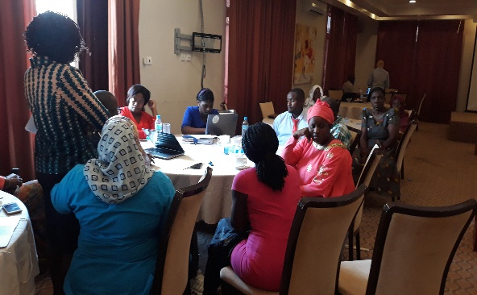
Picture of facilitators consulting on day 5 activities.

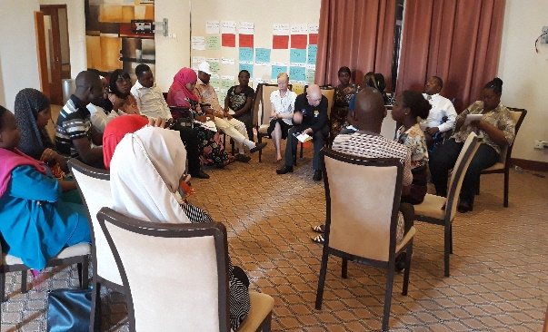
Picture of participants preparing feedback to the facilitators.

