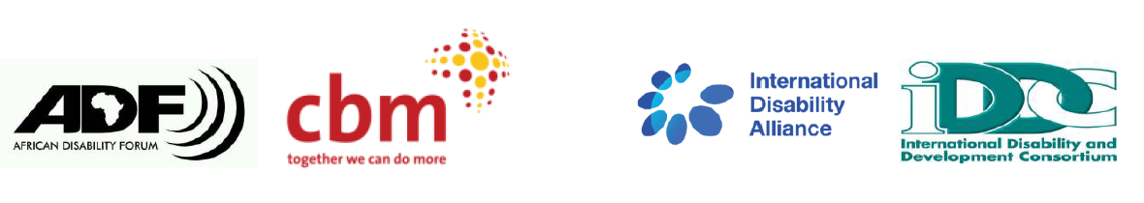
BRIDGE CRPD - SDGS Tanzania
NARRATIVE REPORT – MODULE 1

22nd – 29th July 2018

Day 5: 26th July 2019: Summary

Day 4 highlights feedback
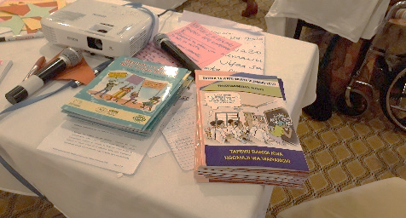
Picture of copies of materials presented by CCBRT

The facilitator for this session appreciated CCBRT for delivering copies of Easy read CRPD and the Tanzanian Disability Act 2010. This was possible through the efforts of one of the participants.

Participants were asked to reflect and share the learnings of the previous day. They cited the topic on government obligations, access to information and constant communication within themselves by use of available accessible technologies. Participants noted that there was a detailed discussion of inclusive education and how it can be implemented in the country.
Preparatory session on presentation of CRPD Articles by participants
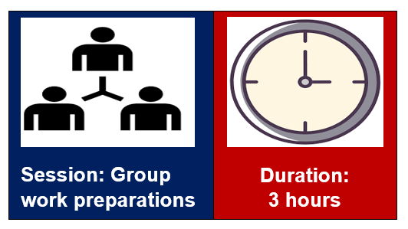
Group presentations:
Group 1
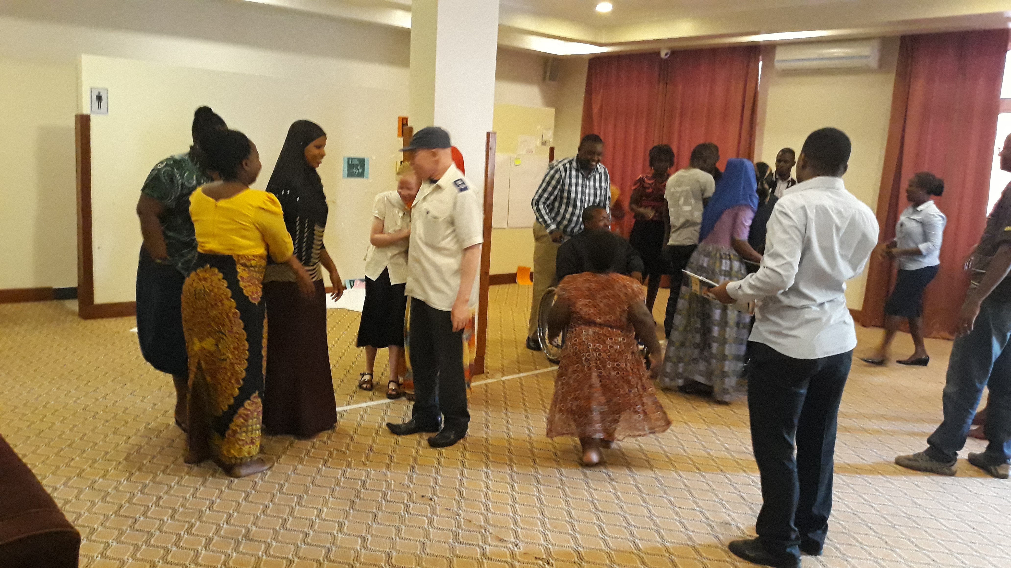
Group 1, on Article 13 introductory activity.

Article 13: Access to Justice
Methodologies used
- Introductory activity: All persons in one line. Instructions given were that ‘ensure you are not sandwiched between 2 people’ so participants kept on moving.
- Statements on SDGs to gauge whether each of them require a legal intervention.
- Lecture.
- Question and answer.
Content of the session:
Interpretation of the sandwich activity:
- The exercise demonstrates how rights holders on one side and service providers on the other side abdicate their responsibilities of persons with disabilities. The team indicated that this was the current situation that persons with disabilities find themselves in.

Relating article 13 to SDGs
The facilitating team read out various contextualized statements, which showed the situation of potential discrimination, and asked the participants if the particular case scenario needed a legal intervention. The team made a conclusion where they stated that in implementing any of the sustainable goals and where discrimination occurs, access to justice frameworks should be available to all.

Legal orientation in Tanzania in relation to article 13:
Some of the presentations from the session was that the country has ratified the CRPD. There are policies towards inclusion of persons with disabilities in education and employment. Persons with disabilities have also been nominated into public positions.

Questions and feedback from members:
- In their submissions, fellow participants shared feedback including one where it was said that there are instances where when a person with disability faces disciplinary issues then the community generalizes that this is a problem of persons with disabilities, a fallacy that was challenged as it was said that all people, including people with disabilities make mistakes and it should always be taken as a case by case situation.
- A participant narrated a case study about how she was sacked form a school she was teaching because she had advocated for better living conditions of the students. In an effort to get justice she contacted local authorities as well as civil society organisations to get justice. Eventually, justice was delivered.
- Access to justice is hampered by the negative attitudes people have towards persons with disabilities. A participant with albinism narrated a personal experience which saw perpetrators of a heinous crime punished, however he noted that he had challenges at first in accessing the justice system where he did not feel as though he received adequate support from the beginning as he said he felt that the police officers for example looked down on him, but the participant stated that it a lot of time requires people to be steadfast in seeking justice.

Conclusions on Article 13:
- Persons with disabilities in the context of the continent have immense challenges accessing justice.
- The Justice system should not be looked at only at the level of the courts but rather from the reporting and investigation of the incident by the police.
- Awareness of disability rights in the entire justice system is very low and thus this should be enhanced.

Group 2
Article 24: Education

Methodologies used:
- Blindfolding all the partipants.
- Teaching in a classroom.
- Song.
Materials and equipment used.
- Blindfolds
- Drawings of animals.
Content of the session:
- All the participants were blindfolded then asked how they felt in their situation. They responded that that they felt bad and excluded.
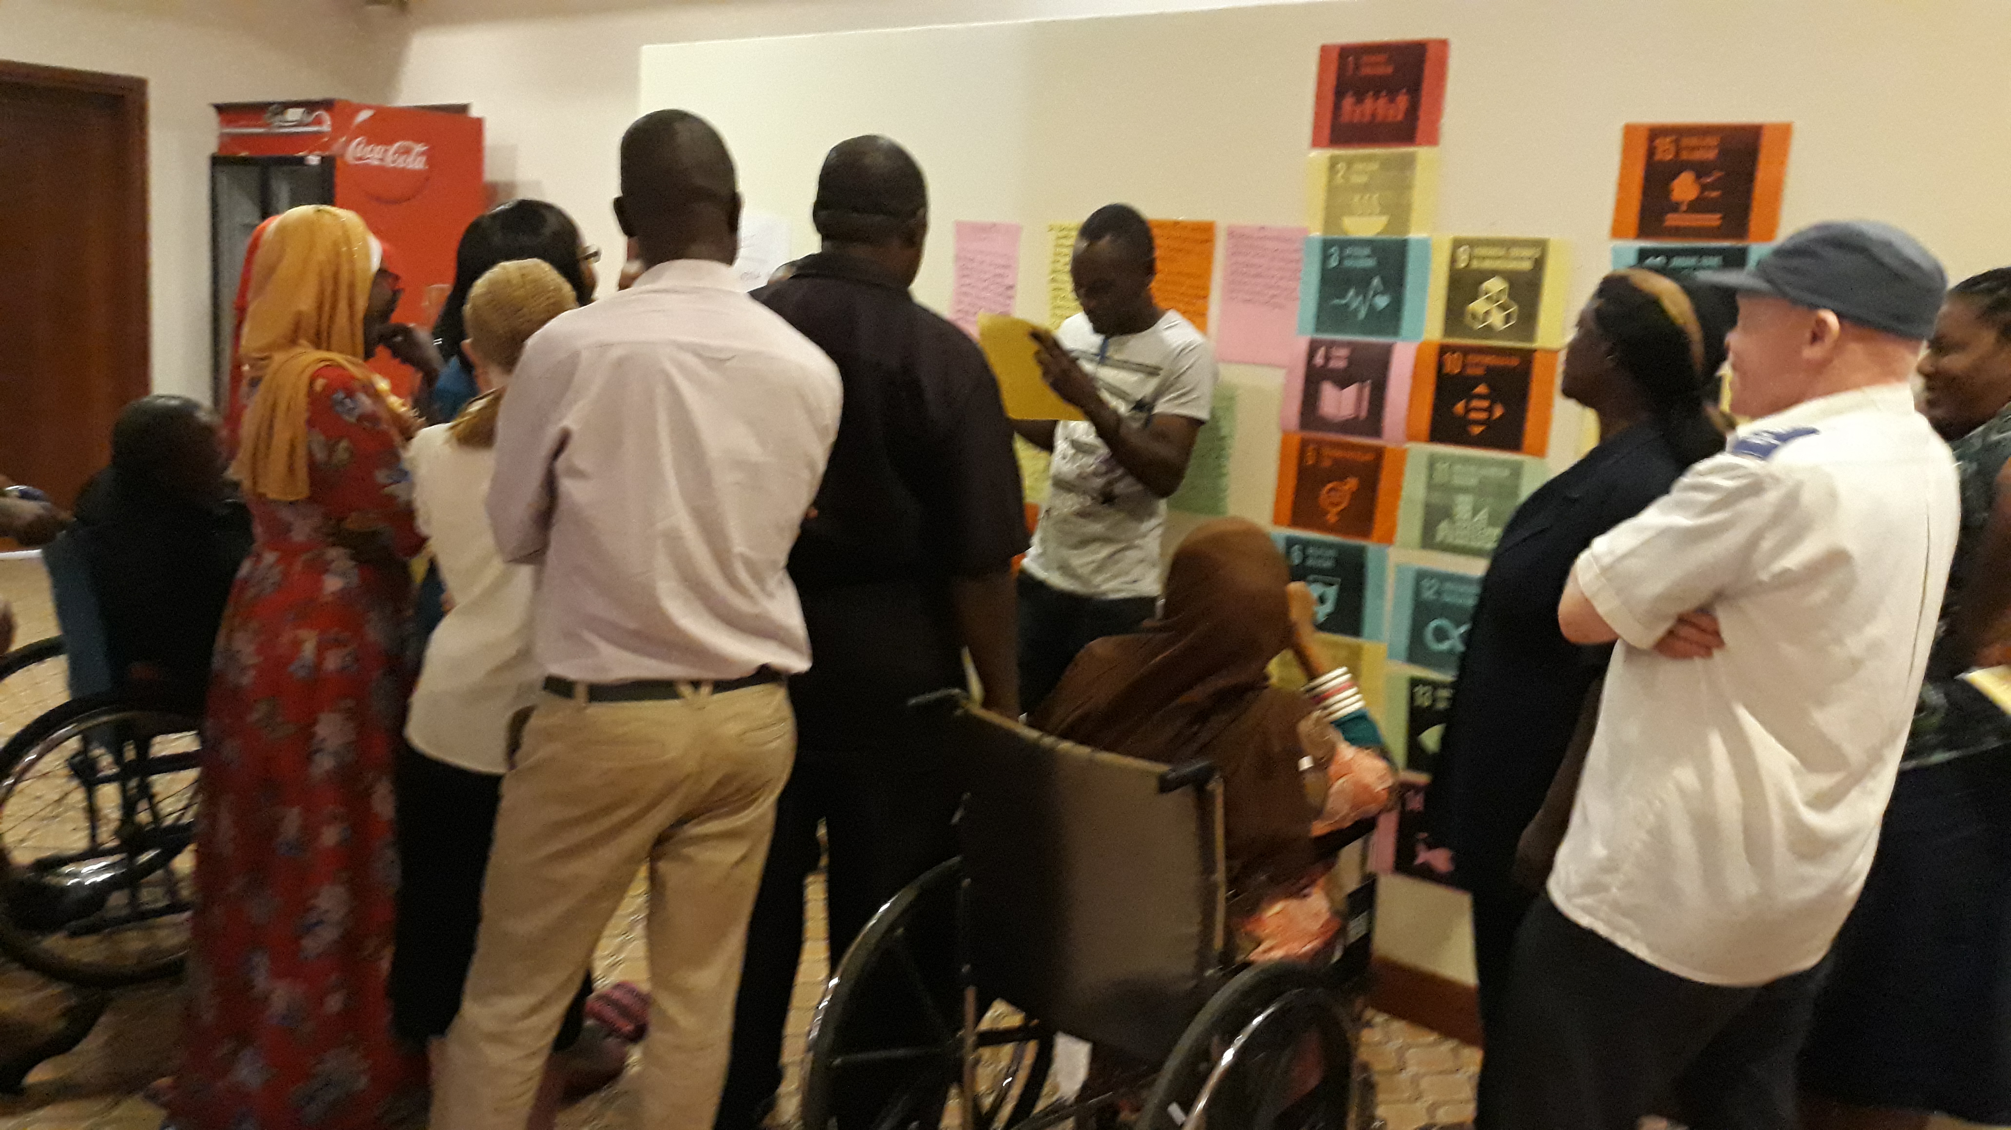
Group 2, concluding the classroom session with a son.

- Next, all the deaf participants were asked, with the help of their sign language interpreters to step out of the room. Some pictures were stuck on the wall and the participants who were now students in the class were asked to explain what they could see. There was not response because all of them were blindfolded. Participants were asked to remove their blindfolds. At this point, the blind participants were also asked to step out.
- This role play presented a reflection of discrimination in education. It was concluded with an enjoyable song on inclusive education.

Article 24 and relationship with SDGs.
SDG no 4 is about education for all. Education should be inclusive and should follow the principles laid out in the CRPD.

Context:
The inclusive education policy in Tanzania was published and this policy state ‘zero rejection’ for children with disabilities in the school system. Education in Tanzania is however generally not inclusive. It is a replica of the role play that has just been concluded. There is need therefore for advocacy in order to include children with disabilities in the school system.

Questions and feedback from members:
It was noted that the facilitation session was well organized, very creative and well executed. However, the facilitators did not take into consideration the needs of their students with diverse/different impairments. Quality education is of essence and this is dedicated to availability of learning materials and instructors who are trained in inclusive education. Parents and families of children with disabilities should be involved in inclusive education.

Group 3
Article 19: Living independently and being included in the community

Methodologies used:
- Skit:
- Questions and answers.

Content of the session:
In the skit, two young girls, one with albinism and the second one without disabilities go to visit the latter’s home. Once they enter the house, the girl’s father calls the guards to arrest the girl with albinism. Her daughter protests and he threatens to withdraw her from the school because it has children with disabilities.

Article 24 and relationship with SDGs.
Persons with disabilities have the right to access services such as Education and Health on an equal basis with others.

Context:
- Most service delivery in the country including transport, access to building especially courts et are not accessible to persons with disabilities. Communication for persons who are deaf has been quite a challenge.
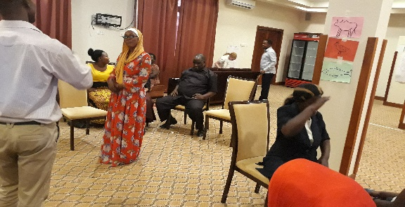
Picture showing the girl with albinism who has been arrested (far right) and the one with the father (front left foreground)

- Most children with disabilities lack proper family support systems. Disability is a major source of family conflicts especially for mothers. A participant challenged her colleagues why is it only the mothers that suffer the wrath of dejection by their spouses when a child with disabilities is born. It was concluded that most marital misunderstandings are not started by the birth of the child with a disability but this birth is only the last straw in an already restrained relationship. Another view was that lack of awareness and education precipitates marital discord when a child with disabilities is born. Awareness raising is therefore key in ensuring that Article 19 of the CRPD is implemented.

Questions and feedback from members:
- The article has 3 areas of consideration. Choice, respect and support.
- Article 19 is a cross cutting across all SDGs and articles of the CRPD. The basic unit of the community is the family, so the family is an important consideration in implementing this article. We therefore need to advocate for informed and inclusive family structures.
- Separation of persons and children with intellectual and psychosocial disabilities in Africa is rampant because families are ashamed of their children with disabilities. The society needs to be informed through live case studies that all persons with disabilities can fully and effectively participate in all activities in the community.

----------------------------------

