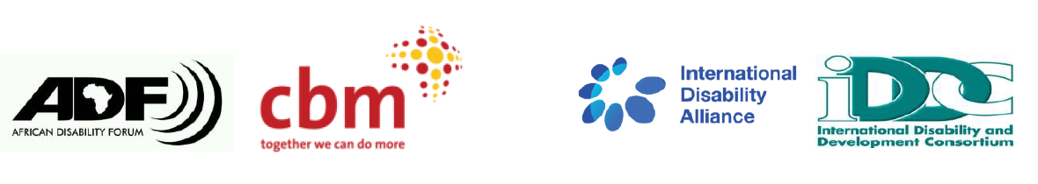
BRIDGE CRPD - SDGS Tanzania
NARRATIVE REPORT – MODULE 1

22nd – 29th July 2018

Day 6: 27^{h} July 2019: Summary

Day 5 highlights feedback
The feedback team reported that the previous day, teams picked ballots papers on the order of presentations. They later detailed how the day rolled on capturing the group preparation sessions and consequent presentations.

Group presentations
Group 4
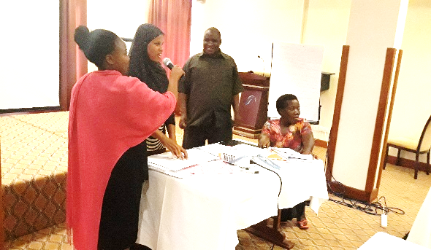
Group 4, presenting article 25 (Health)

As a continuation from the first day, group presentations continued with the main objective being that participants explain and share their understanding of one specific article of the CRPD in an inclusive and participatory way and also where they would receive feedback from their peers in order to improve their own understanding of the article as well as the way that they ensure inclusiveness of a session.

Article 25: Health
Methodologies used:
- Lecture.
- Question and answer.
Content of the session:
- Persons with disabilities have the right to the enjoyment of the highest attainable standard of health without discrimination on the basis of disability.
- Health services should be close to the people and these services should be responsive to their needs.
- The article prohibits discrimination in national health insurance services for persons with disabilities. It also emphasizes on the health education of persons with disabilities.

Group 5
Article 27: Work and employment
Methodologies used:
- Lecture.
- Interview
- Skit.
- Posters for summary.
Materials and equipment used.
Content of the session:
- Persons with disabilities have the right to work in and employment on the same basis with others. The work environment should also be accessible and the wages should be the same as others at the same grade.
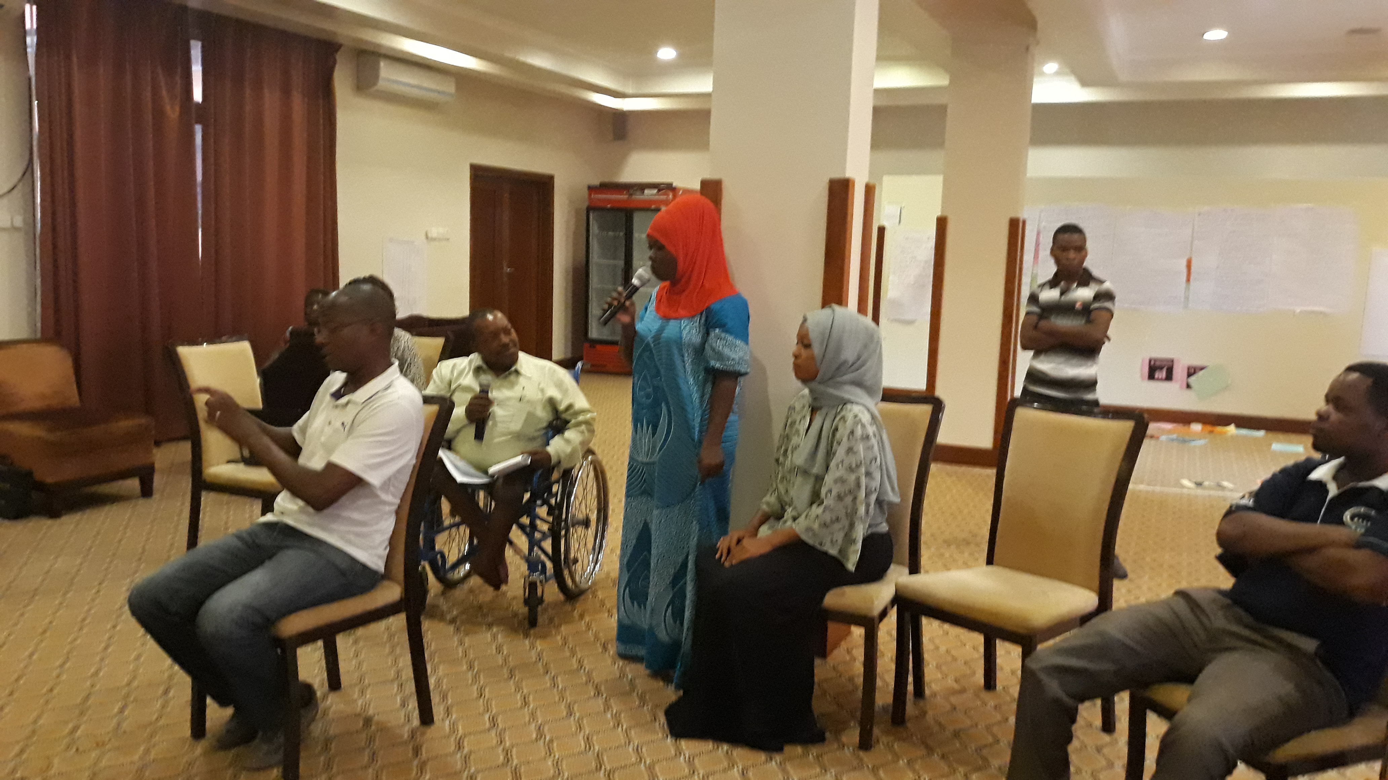
Group 5, Interview session

- In linking the article to the sustainable development goals, the group listed among others SDGs 1, 4, 8,10,16
Discussions
- The government of Tanzania has a policy on employment whereby employers should ensure that 3% of their workforce are persons with disabilities.
- DPOs should sensitize employers on rights of persons with disabilities and also monitor government policies on inclusive employment.
- Low levels of work and employment is a global issue however persons with disabilities face more barriers.

The session was dedicated to looking through the week’s sessions, whereby questions were posed that gave an opportunity for participants to recall the key learnings of the week and also facilitators had a chance to add to the discussions and reinforce on these key learnings. Questions ranged from reflections on the CRPD principles, states obligations, and SDGs and linking to the CRPD.

The three afternoon sessions were dedicated to Participation in political and public life (article 29), Adequate standard of living and social protection (Article 28) and also discussions on reinforcing key concepts in the CRPD by ensuring that we are all using language that respects the inherent dignity of persons with disabilities.

