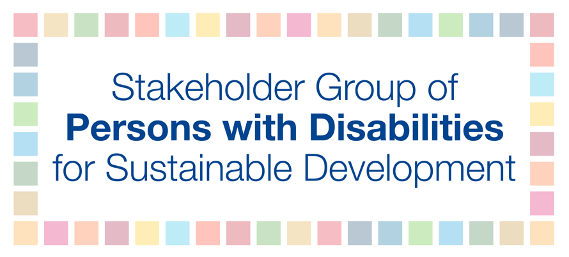
HLPF 2018
13 July
2:30-4:30PM
Deguye
SDG 17 – Strengthening the means of implementation and the global partnership for sustainable development
The global indicator framework was adopted by the General Assembly in 2017, and it contains 11 disability-inclusive indicators with an additional recommendation to further disaggregate by disability. The UN Convention on the Rights of Persons with Disabilities (CRPD) also requires Member States to collect appropriate information, including statistical and research data on persons with disabilities. Regrettably, there is lack of data on the situation of persons with disabilities globally. The lack of rigorous disaggregated data on persons with disabilities exacerbates vulnerabilities by masking the extent of deprivation and disparities. Thus, there is a significant lack of accurate documentation on the discrimination encountered by persons with disabilities. If persons with disabilities are not counted, then they don’t count. As a consequence, planning and budgeting for reasonable accommodations with effective policymaking have suffered and persons with disabilities have largely fallen off the statistical map.
As such, it is of upmost importance that international and national aspirations are linked. Advocacy at the global level for the collection and disaggregation of disability data is not enough unless international-level commitments are translated into national priorities and realities. Stakeholders should take advantage of internationally comparable measures that are developed, including a short set of questions for censuses and surveys developed by the Washington Group on Disability Statistics (WG-6), and the child disability questions developed by UNICEF and the Washington Group to generate consistent and reliable data on disability and development. We therefore recommend that: data should be disaggregated by age, gender and disability to facilitate the adoption of measures to combat discrimination and to promote participation of persons with disabilities at all levels, and States should conduct timely capacity building and ongoing monitoring for persons with disabilities to lead discussions and edit policies towards safe, sustainable and resilient societies in which they play a core role in implementation of the SDGs.

