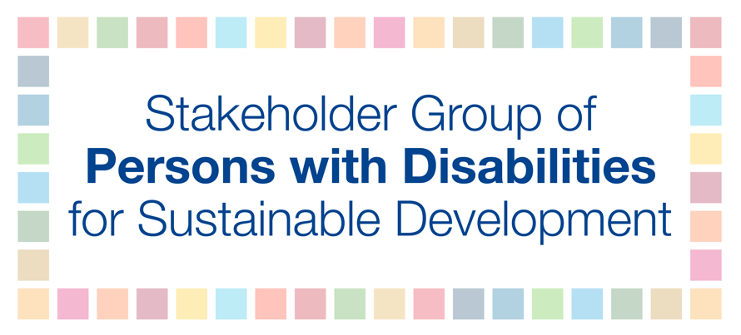
HLPF 2018
9 July
3-6 PM
Deguye
SDG 6 – Ensure availability and sustainable management of water and sanitation for all
Persons with disabilities often encounter physical, institutional, economic, social and/or cultural limitations in accessing water and sanitation. Limitations in access to water and sanitation facilities can gravely compromise the safety and dignity of women and girls with disabilities. And since most of them may have to wait until it is dark to fetch water and defecate in poorly lit and secluded places, they are exposed to a heightened risk of injuries, abuse and exploitation. The lack of clean water can also result in stigma and exclusion of persons with disabilities (e.g., people with spina bifida and spinal cord injury) because of incontinence issues that limits independent living, productivity and participation in their communities. Therefore, we kindly call upon member states to ensure that persons with disabilities have access to clean water and sanitation by following the availability, quality, safety, acceptability, accessibility and affordability criteria followed with non-discrimination, participation, accountability, impact and sustainability and must be guided by universal design and broader scope of CRPD Article 9, including accessibility of information to ensure that all persons with disabilities are included.
We recommend to:
- Ensure equal access for persons with disabilities to clean water and sanitation services, appropriate and affordable services, devices and other assistance for disability-related needs.
- Include specific measures to guarantee that women and girls with disabilities have access to safe, private and accessible WASH.

