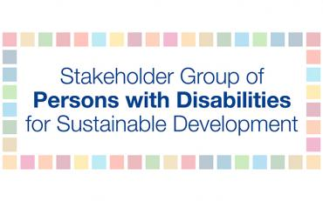
Disability Data Advocacy Working Group Terms of Reference

Objective
The objective of this working group is to provide a global platform for information exchange, learning and dialogue, sharing of good practices, and collaboration on disability data collection, disaggregation, and analysis.

Background
Evidence-based data on persons with disabilities at the national and global levels are instrumental in identifying gaps and challenges that persons with disabilities encounter and then addressing them in policymaking and programing. In July 2017, Member States adopted and called for global SDG indicators to be disaggregated by disability. Despite this, a lack of financial resource allocation remains for carrying out household-level and other relevant surveys with adequate levels of disaggregation, adversely impacting persons with disabilities. As such, global, regional, and national advocacy efforts toward the collection and disaggregation of disability data must be aligned.

To identify barriers, an analysis was conducted in 2018 to assess the availability of disability data at the national level. The main finding was that DPO engagement in data collection and disaggregation efforts is critical and missing. The results also indicated that DPOs are ready to engage, but they need technical support, advocacy guidance, and the opportunity for periodic information exchange and learning. Consequently, the Disability Data Advocacy Working Group has been established to address these gaps.

Membership participation
Membership in the Disability Data Advocacy Working Group is open to:
- All persons with disabilities;
- Organizations of persons with disabilities (DPOs);
- Non-governmental and other organizations working on the rights of persons with disabilities; and
- Non-governmental donors, researchers, and independent consultants working with persons with disabilities.

Working methods
The Disability Data Advocacy Working Group will have its own listserv on disability data and a website hosted by International Disability Alliance. The listserv will be open to all interested in engaging in the disability data dialogue. Information shared will be on webinars, online learning opportunities, and periodical newsletters with data information. Members of the listserv will be encouraged to raise any issues, make suggestions, and to communicate with one another. Depending on funding opportunities, small projects will be developed to support data work at the country level. The Working Group will be led by the main representative of the Stakeholder Group of Persons with Disabilities and the HLPF Secretariat will coordinate logistics. The Working Group will provide open, transparent, and inclusive information for DPOs and all interested in engaging. As for all unregulated matters in this Terms of Reference, the Stakeholder Group of Persons with Disabilities Terms of Reference prevails.

https://sustainabledevelopment.un.org/majorgroups/personswithdisabilities

