DISABILITY PREVENTIVE MEASURES AGAINST COVID-19 - TANZANIA

DOCUMENT DRAFTED FROM CONSULTATION WITH THE DISABILITY IMPLEMENTING PARTNERS IN TANZANIA

This document is based on inputs received from different people living with disabilities, development partners, Health partners and human right partners across the Country aiming to strengthen assist national and local advocacy, to more efficiently address the range of risks faced by persons with disabilities in the Pandemic crisis COVID-19.

In March 2020 the World Health Organization (WHO) declared the outbreak of a novel corona virus disease, COVID-19, to be a pandemic, due to the speed and scale of transmission. WHO and public health authorities around the world are taking action to contain the COVID-19 outbreak. Certain populations, such as those with disability, may be impacted more significantly by COVID-19. This impact can be mitigated if simple actions and protective measures are taken by key stakeholders and our Government.
People with disabilities are among the world’s most marginalized and stigmatized groups even under normal circumstances. Without swift action by government to include people with disabilities in their response to COVID-19, they will remain at serious risk of infection and death as the pandemic spreads.”
Globally, more than 1 billion people – roughly 15 percent of the world’s population – live with some form of disability. People who are older, people with chronic health conditions, or people with disabilities – that, for example, affect their respiratory capacity – may be at particular risk of serious illness or death from COVID-19 infection.
For others, having a disability does not by itself put them in at higher risk of infection, but they are in danger due to discrimination and barriers to information, social services, health care, social inclusion, and education.
In a rapidly evolving pandemic, information is essential for people to make decisions about how to protect themselves and how to access necessities and services during quarantine and self-isolation. Government should be providing accurate, accessible, and timely information about the disease, prevention methods, and services.
To ensure that people with disabilities are not deprived of lifesaving information, communication strategies should include qualified sign language interpretation for televised announcements, websites that are accessible to people with different disabilities and telephone-based services( such as a helpline and bulk messages) that have text capabilities for people who are deaf or hearing impaired. Communications should use plain language simplified versions to maximize understanding.
Governments should also consider the specific needs of people with disabilities when developing prevention strategies. For example, additional guidelines on hand washing should be developed for people with disabilities who are not able to wash their hands frequently or on their own or lack access to sufficient water for hygiene.
COVID-19 spreads rapidly and is especially dangerous to people living in close proximity to others in closed settings
The COVID-19 pandemic is terrifying for many of us, but people with a disability have more reason to worry than most.
People with physical disorders including cerebral palsy and spinal cord injury may not able to follow general safety precautions independently.
People with mental retardation also need special assistance during this period.
Awareness and accurate information are vital parts of the prevention process.
People with deaf blindness and other sensory impairments experience higher risk than most others as, in addition to being in the high-risk group dual sensory impairment; they struggle to cope with both accessing and processing information, as well as resolving daily tasks such as shopping for essentials like basic food and /or medicine, a couple of examples among many issues being faced. The crucial facts is their loss of both vision and hearing strongly impacts on and increases the complexity of their situation, increasing their need for proper services to reduce risk if serious and severe health complications due to COVID-19
In total, people with disabilities despite their susceptibility, are often invisible in vulnerability and must be considered during COVID-19-related decision- and policy-making processes. Ensuring that people with disability and their families have access to information and facilities according to their needs is of great importance.

What should we Do?
1. The following actions are urgently needed to protect people with disabilities as the pandemic progresses:
- The establishment of an expert committee with members who have expertise in the disability and health sectors to advise government, similar team working from well trained TOTs who are PWDs themselves might help to reach out to communities and mitigate the spread of COVID-19 and its related stigma and other social impacts to PWDs. Similar approach was applied to HIVAIDS
- Significant supplies of personal protective equipment (such as masks, gloves and gowns) should be given to protect the supporters/interpreters-Most types of disabilities encourages close proximity and touching of hands with interpreters (supporters) which allows to follow information on the environment surrounding them and translations from spoken-written language.
- Government guarantees of income for care workers who may be sick, have caring responsibilities or have their shifts cancelled
- To obtain data to know people with disabilities who have been infected with COVID-19
- Identify the people with disabilities in quarantine
- The Ministry's announcement on Corona should be in line with the needs of people with disabilities
- All videos created by the ministry should be added to the Interpreter's picture below to keep the translation integrated
- Declaration should come from a special COVID-19 Committee that all the equipments and especially the buckets are friendly to people with disabilities
- Assistance to preventive gears for people with disabilities should be provided in conjunction with capacitating their associations for continuous and sustainable support
- Health officials assigned to educate the community about COVID-19 they have to make sure they use sign language interpreters when providing information
- Reaching out to People with disabilities in rural areas by ensuring ward executive officers, social welfare officers and street chairs are empowered and see how the best they can deliver the information in friendly language formats to people with disabilities about the COVID-19
- There should be strict observance of all safety practice given by responsible authorities to the public including PWDs which must ensure cleaning of assistive devices such as white canes, wheelchairs, crutches etc. This will minimise transmission
- Families and caregivers of the Down Syndrome people should avoid exposure as much as possible through social distancing
- There should be equitable access to healthcare and treat people with down syndrome and other learning disabilities the same as all others
2. Information about COVID-19, in a Diversity of Accessible Formats
- Mass media communication should include captioning, national sign language, high contrast, large print information.
- Digital media should include accessible formats to blind persons and other persons facing restrictions in accessing print.
- All communication should be in plain language.
- In case the public communications are yet to become accessible, alternative phone lines for blind persons and email address for deaf and hard of hearing may be a temporary option.
- Sign language interpreters who work in emergency and health settings should be given the same health and safety protections as other health care workers dealing with COVID-19.
- There may be appropriate alternatives for optimum access, such as interpreters wearing a transparent mask, so that facial expressions and lip movement is still visible,

3. Implementing quarantines or similar restrictive programs may entail disruptions in services vital for many persons with disabilities and undermine basic rights such as food, health care, wash and sanitation, and communications, leading to abandonment, isolation and institutionalization

- Persons with disabilities should not be institutionalized as a consequence of quarantine procedures beyond the minimum necessary to overcome the sickness stage and on an equal basis with others.
- Any disruptions in social services should have the least impact possible on persons with disabilities and should not entail abandonment.
- Support family and social networks, in case of being quarantined, should be replaced by other networks or services.
During Quarantine, Support Services Must be Ensured
- Quarantined persons with disabilities must have access to interpretation and support services, either through externally provided services or through their family and social network;
- Personal assistants, support workers or interpreters shall accompany them in quarantine, upon both parties agreement and subject to adoption of all protective measures;
- Personal assistants, support workers or interpreters should be proactively tested for COVID 19 to minimize the risk of spreading the virus to persons with disabilities

4. When ill with COVID-19, Persons with Disabilities may face additional Barriers in Seeking Health care and also Experience Discrimination and Negligence by Health Care Personnel.

- Public health communication messages must be respectful and non-discriminatory.
- Instructions to health care personnel should highlight equal dignity for people with disabilities and include safeguards against disability-based discrimination.
- While we appreciate that the urgency is to deal with the fast-rising number of people infected and in need of hospitalization, rapid awareness-raising of key medical personnel is essential to ensure that persons with disabilities are not left behind or systematically reprioritized in the response to the crisis.
- Communications about the stage of the disease and any procedures must be to the person themselves and through accessible means and modes of communication.

5. Organizations of Persons with Disabilities (DPOs) should take the following Measures

- Prepare COVID-19 instructions and guidance in various accessible formats in local languages;
- Help establish peer-support networks to facilitate support in case of quarantine;
- Organize trainings on disability inclusion for responders
- Compile an updated list of accessible health care and other essential service providers in each area
- Proactively reach to all related authorities including the health system, the national media, the COVID-19 Committee and Ministry of Health to:
- Sensitize authorities on how the pandemic as well as the response plans may disproportionally impact persons with disabilities;
- Offer tailored practical tips on how to address accessibility barriers or specific measures required by persons with disabilities
- Consider specific needs of women and girls with disabilities (menstrual hygiene, pregnancy care, breastfeeding , etc) during testing, quarantine, confinement and hospitalization
- Support community awareness and accept to receive PWDs who are cured and proved to be free from COVID-19. This will combat stigma which might arise against PWDs formally affected by the disease
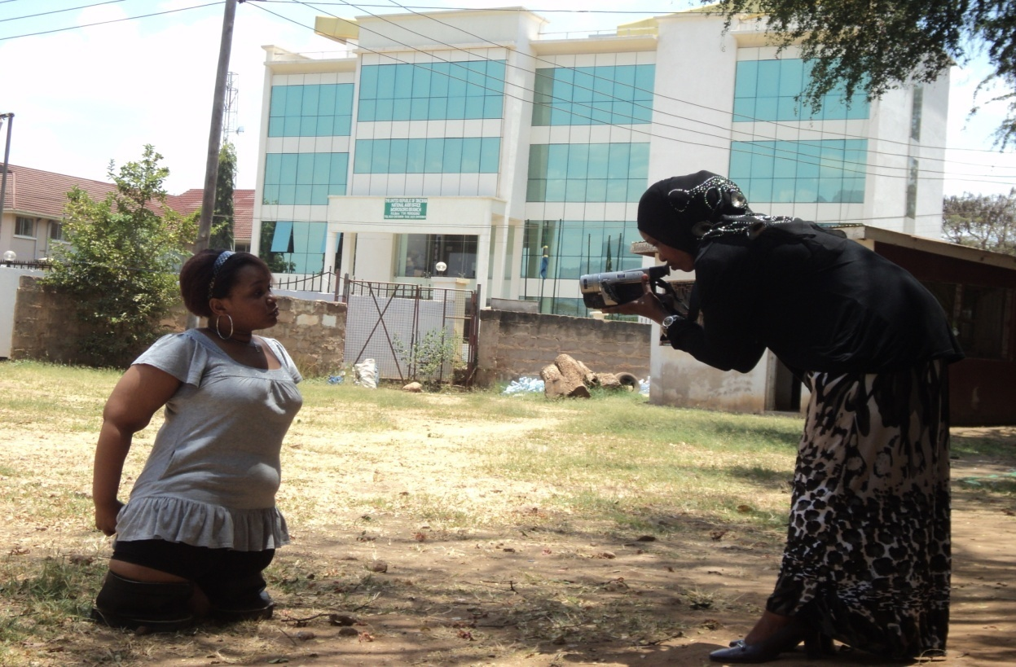
These actions won’t address all the inequities people with disabilities face, but they will be a good start.

