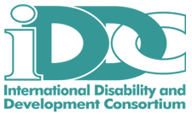
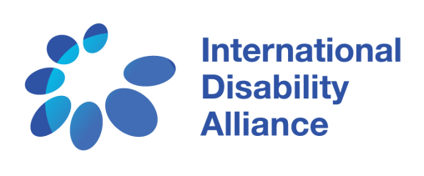

For Immediate Release

Persons with Disabilities Excluded from National Sustainable Development Plans

(15 July 2016, New York) 80% of persons with disabilities live in developing countries and have won a hard-fought role in designing and overseeing the Sustainable Development Goals (SDGs) at the United Nations. But they are still being left out of development policies and programmes by governments within their own countries.

“Persons with disabilities were left out of the Millennium Development Goals. If we are excluded by governments now, the SDGs will leave us behind again.” - Colin Allen, Chair of the International Disability Alliance

Leading disability rights advocates, representing every region of the world, are active participants in this year’s session of the UN’s High-level Political Forum on Sustainable Development (HLPF), July 11th-20th, to review progress towards the SDGs in 22 countries. Yet in each of these countries, persons with disabilities are facing barriers to fully participate in designing, implementing and reviewing national development programmes.

Facing barriers
While organisations of persons of disabilities are looking for opportunities to work with governments, many are being turned away. Public consultations often exclude persons with disabilities themselves and their representative organisations. Even when wider civil society is invited to participate, meetings and documents are not accessible to many persons with disabilities, excluding them from democratic processes.

Countries have committed to inclusion
The Convention on the Rights of Persons with Disabilities (CRPD) is the fastest ratified human rights treaty in history, with now 166 countries adopting it as national law. It requires governments to include representatives of persons with disabilities in all programmes relating to them, reflecting the disability rights movement’s call for ‘nothing about us, without us.’

“Only by utilizing the CRPD as a guiding framework in implementing the SDGs, can we ensure that exclusion and inequality are not created or perpetuated”, says Senior Inclusion Advisor Yetnebersh Nigussie of Light for the World, an IDDC member, adding, “persons with disabilities must be a part of identifying problems, and a part of building their solutions.”

“The real work of implementation over the next 15 years lies ahead, and it is critical that the rights and participation of persons with disabilities are guaranteed every step of the way in all countries” – José Maria Viera, World Blind Union, an IDA Member

The Stakeholder Group of Persons with Disabilities is holding a town-hall style discussion on the Contributions of Persons with Disabilities in the HLPF Voluntary National Reviews on Monday July 18th, at the Ford Foundation in New York, from 1:15 pm to 2:45 pm, with representatives of persons with disabilities from Germany, Morocco, Latin-America, the Philippines and Uganda discussing barriers they have faced in participating in national implementation of the SDGs. Press are welcome. More information about this event is available here.

Members of the Stakeholder Group of Persons with Disabilities are available for comments and interviews in New York:

- Colin Allen, Chair of the International Disability Alliance and President of the World Federation of the Deaf
- Yetnebersh Nigussie, Ethiopia, official representative of the Stakeholder Group of Persons with Disabilities and Senior Advocacy Officer of Light for the World
- Disability rights advocates from Argentina, Germany, Lebanon, Morocco, the Philippines, Uganda, United Kingdom
- Spokespeople from the International Disability and Development Consortium (IDDC) members ADD International, CBM, and Sightsavers and from International Disability Alliance (IDA) members the ASEAN Disability Forum, the European Disability Forum, and the World Blind Union.

Further information:
Position Paper of Persons with Disabilities to the HLPF 2016

Contact for quotes and interview requests:

Jaimie Grant  International Disability Alliance  jgrant@ida-secretariat.org  +19142550669  www.internationaldisabilityalliance.org | Sarah Hull  International Disability and Development Consortium  coordinator@iddcconsortium.net  www.iddcconsortium.net
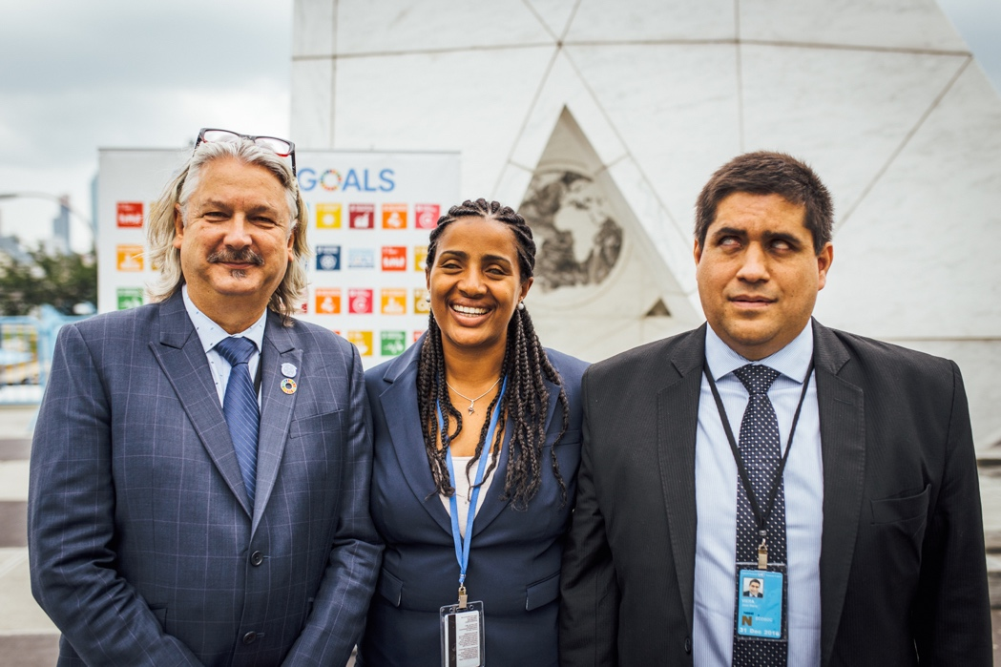

Left to right: Colin Allen, Chair of the International Disability Alliance; Yetnebersh Nigussie, IDDC and Light for the World; José Maria Viera, World Blind Union

Photo: Joel Sheakoski for International Disability Alliance/International Disability and Development Consortium

