— for immediate release —

International Disability Alliance appoints Colin Allen as new Chair

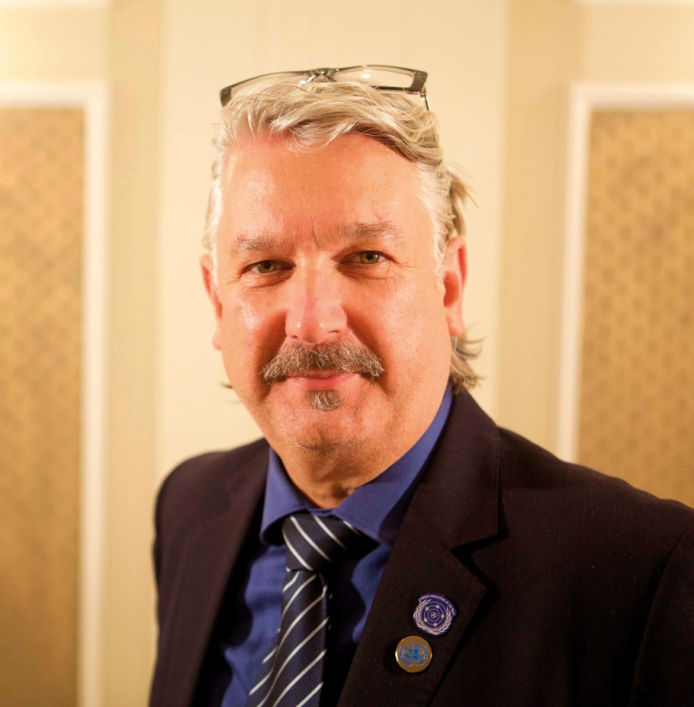
New York, NY, 1 July 2016 — Today Mr. Colin Allen assumes the Chair of the International Disability Alliance (IDA), from Australia; elected by the Alliance’s 13 voting Members in March of this year. Colin Allen is a leading advocate for persons with disabilities globally, including as President of the World Federation of the Deaf since 2011. He is the second deaf person to serve as the Chair of IDA, of which the World Federation of the Deaf is a founding member. Mr. Allen succeeds Ms. Maryanne Diamond, AO, Immediate-Past President of the World Blind Union, and IDA Chair from July 2014 to June 2016.

Joining Mr Allen in the International Disability Alliance’s Executive Committee is First Vice Chair Ms. Ana Lucia Arellano, President of the Latin America Network of Non-Governmental Organizations of Persons with Disabilities and their Families (RIADIS), from Ecuador; Second Vice Chair Dr. Ruth Warick, President of the International Federation of Hard of Hearing People, from Canada; Third Vice Chair Ms. Vanessa Dos Santos, Acting President of Down Syndrome International, from South Africa; Treasurer Mr. Yannis Vardakastanis, President of the European Disability Forum, from Greece; and General Secretary Mr. Klaus Lachwitz, President of Inclusion International, from Germany.

“I feel honoured to walk in the footsteps of my mentor, 2013 UN Human Rights Award Recipient, Dr Liisa Kauppinen, who was the first deaf IDA Chair between 1999 and 2000. During the past five years WFD has seen IDA grow from a loose network of DPOs into a significant, professionally led organisation with paid staff. I am thrilled that I have been given the opportunity to lead the work of IDA in collaboration with my colleagues from other global and regional DPOs as well as with the skilled staff members of the IDA Secretariat.” - Colin Allen.

“I am very pleased that as a deaf sign language user, I will be able to advance IDA goals and promote its vision in my own language - sign language - and perhaps through my international leadership hasten the removal of barriers experienced by other deaf people in the world, thereby pursuing and fulfilling the UN Convention on the Rights of Persons with Disabilities and the Sustainable Development Goals. While I am very concerned about the removal of barriers for the Deaf Community, as Chair of IDA, I am equally keen that current obstacles experienced by all people with disabilities are eradicated as only then will we have a truly inclusive community." - Colin Allen.

Mr. Allen is responsible for guiding and representing IDA's engagement with the UN System and other international human rights and international development organizations. Mr. Allen is closely engaged with the implementation of the 2030 Agenda for persons with disabilities worldwide: he is leading IDA's strategic planning to ensure awareness raising, capacity building, and participation of persons with disabilities in the preparatory processes towards national reviews. Under Mr. Allen's leadership, IDA's mission is to ensure that the UN upholds the essential, unifying principle of the disability movement: 'nothing about us without us'. This includes implementing standards on full inclusion and participation of persons with disabilities, notably ensuring accessibility of decision-making spaces and documentation, meaningful participation in follow-up and review processes, and universal design throughout programme implementation.

Maryanne Diamond, AO was Chair of the International Disability Alliance from July 2014 until June 2016. Ms. Diamond has held a range of positions at community, local, state, national and international boards and committees for more than 30 years. Ms. Diamond is a board member and immediate Past President of the World Blind Union (WBU). Ms. Diamond has spoken on behalf of persons with disabilities and wider civil society at a number of high-level UN Conferences and Forums. Ms. Diamond led the WBU delegation throughout negotiations of the Marrakesh Treaty, which facilitates access to published works for persons who are blind, visually impaired or otherwise print disabled. Ms. Diamond has assumed a new role managing outreach with Australia’s National Disability Insurance Agency.

Enquiries
Jaimie Grant
jgrant@ida-secretariat.org
+1 914 255 0669

