Partnerships for SDGs
Background
The United Nations Conference on Environment and Development (UNCED) of 1992 was the first Conference to explicitly call for the active engagement of various “social groups” in the follow-up of Agenda 21 and identified their roles and responsibilities. Agenda 21 identified in particular nine stakeholder groups that could play a role in developing policy and implementing what was agreed: Women, Children and Youth, Indigenous Peoples, Non-Governmental Organizations, Local Authorities, Trade Unions, Business and Industry, Scientific and Technological Community and Farmers. Ten years after UNCED, these groups were allowed to participate in the preparatory phase of the World Summit on Sustainable Development (WSSD). Suggestions for increasingly decentralized were incorporated and participatory approaches became formally known as Type II partnerships. Type II partnerships (which were meant to complement Type I outcomes or agreements and commitments made by Governments) were characterized as ‘collaborations between national or sub-national governments, private sector actors and civil society actors, who form voluntary transnational agreements in order to meet specific sustainable development goals’. Type II partnerships must meet certain criteria built on the Bali Guidelines. In 2003, these partnership guidelines were updated during 11th Session of the Commission on Sustainable Development. Subsequent to WSSD, there was an emerging consensus that partnerships can play significant roles in helping to implement the outcomes from UN conferences. Since taking office in 2007, the Secretary-General has launched various transformational multi- stakeholder initiatives such as Every Woman Every Child (EWEC), the Zero Hunger Challenge, and the Global Pulse and Sustainable Energy for All (SE4All). For the 2012 United Nations Conference on Sustainable Development (Rio+20) all stakeholders, including government, civil society and the private sector, were invited to make voluntary commitments that deliver concrete results for sustainable development. It is important to highlight that governments invited additional stakeholders, including local communities, volunteer groups and foundations, migrants and families, as well as older persons and persons with disabilities, to participate in UN processes related to sustainable development. By the end of the Conference, over 700 voluntary commitments were announced and compiled into an online platform. The platform initially developed in response to Rio+20 has been improved to better respond to the 2030 Agenda for Sustainable Development in order to inform all stakeholders on initiatives carried out by multi-stakeholder partnerships in support of the SDGs, and for linking progress of those initiatives to various follow-up mechanisms of the 2030 Agenda, in particular to the High-level Political Forum on Sustainable Development.
Multi-stakeholders Partnerships (MSPs)
Partnerships are defined as voluntary and collaborative relationships between various parties, both state and non-state, in which all participants agree to work together to achieve a common purpose or undertake a specific task, and to share risks and responsibilities, resources and benefits. Multi-stakeholder partnerships (MSPs) can range from loose forum-like structures allowing for active debate and the exchange of knowledge and experience, to more formalised structures based on the creation of a legal entity with appropriate governance structures to ensure transparency and accountability. The core theme of MSPs is joint value creation by all the participating members. MSPs are important to bring about policy change and find innovative and synergistic ways to pool resources and talents, based on each participant’s strengths. There are large differences in function, goals, capacity and membership constellations of MSPs. The figure below provides a basic typology of the spectrum of MSPs.
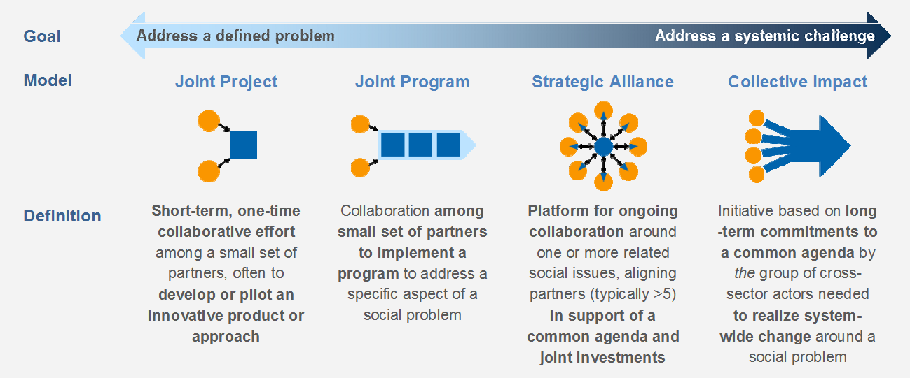
[ALT]Goal: From addressing a defined problem to addressing a systemic challenges; Models: Joint Project: Short-term, one-time collaborative effort among a small set of partners, often to develop or pilot an innovative product or approach; Joint Program: Collaboration among small set of partners to implement a program to address a specific aspect of a social problem; Strategic Alliance: Platform for ongoing collaboration around one or more related social issues, aligning partners (typically >5) in support of a common agenda and joint investments; Collective Impact: Initiative based on long -term commitments to a common agenda by the group of cross- sector actors needed to realize system- wide change around a social problem
Well- designed and adequately-resourced global partnerships can have a number of potential benefits, including:
- Advancing more integrated, comprehensive and scalable approaches to SDG challenges by:
  - Facilitating cross–sector dialogue toward co-creating and aligning around a common agenda for action and advocacy
  - Combining and leveraging the complementary roles and diverse capabilities of a larger set of cross-sector stakeholders and promoting their inclusive participation
  - Facilitating a shift to more programmatic approaches to planning, investment and implementation
  - Providing multi-level platforms or networks for achieving sustainable impact at scale by opening up new opportunities for collaboration; linking action across multiple scales from global to local and local to global; and by facilitating rapid learning and efficient knowledge transfer, both horizontally and vertically
- Advancing more integrated, efficient and effective approaches to financing by:
  - Using pooled financing mechanisms for mobilizing, combining and allocating diverse sources of international and domestic public and private finance
  - Employing blended finance approaches and instruments for the strategic use of public funds to mobilize private finance and catalyze public and private investments for development purposes in partner countries
  - Enhancing efficiency and effectiveness by lowering transaction costs and reducing fragmentation and duplication; more flexible targeting of support to countries, groups and areas most in need; and providing more predictable multi-year funding commitments.
- Providing platforms for global advocacy and mobilization of civil society around priority poverty eradication and sustainable development challenges. Civil society groups can either play an advocacy or campaigning role, or they can become part of the solution, drawing on their knowledge, capacity for innovation and trust of the general public to contribute in partnership to sustainable solutions
DPOs and MSPs
Particularly, DPOs could take the “twin-track approach” to
- mainstream disability through strategically participating in diverse MSPs that constitute strategic alliances or address systemic challenges, and
- convene and lead various partners in order to support disability-specific SDG projects and programs. The projects and programs could be stand-alone or part of bigger efforts

In particular, with regard to mainstreaming disability, DPO participation in MSPs can improve the quality of MSPs initiatives by exercising sensitivity to the disability dimension at the various processes and components of the mainstream projects, programs, and other types of collaborations. Disability inclusive efforts should focus not just on comprehensive initiatives, but also on initiatives for specific sectors such as education, health, transport, food security, social services, employment, and local government. Creating enabling and accessible environments for persons with disabilities is essential to disability inclusive MSPs. Universal design, accessible infrastructure, and universal access are key concepts for the knowledge transfer and technical assistance DPOs could provide to MSPs, among others.

The “business case” for including disability in mainstream MSPs could mention:
- Statistics, particularly the higher prevalence of disability in developing countries
- The unequal and adverse socioeconomic outcomes persons with disabilities experience
- Aspects of the legislative, physical, and social environment that create or maintain barriers to the participation of persons with disabilities in economic, civic, and social life
- The cause-effect linkage between disability and poverty
- Human rights and CRPD
- The increasing number of bilateral donors that have developed disability policies to guide their international aid
- The increasing number of disability discrimination laws and constitutional provisions at national level
- The 2030 Agenda for Sustainable Development which clearly states that disability cannot be a reason or criteria for lack of access to development programming and the realization of human rights
- The SDG framework which includes seven targets which explicitly refer to persons with disabilities and six further targets on persons in vulnerable situations which include persons with disabilities

http://www.un.org/en/ecosoc/newfunct/pdf15/2015partnerships_background_note.pdf
https://sustainabledevelopment.un.org/content/dsd/dsd_aofw_par/par_mand_baliguidprin.shtml
http://www.un.org/esa/sustdev/partnerships/publications/brochure_E.pdf
http://www.un.org/en/ecosoc/newfunct/pdf15/2015partnerships_background_note.pdf
https://sustainabledevelopment.un.org/majorgroups
http://www.un.org/en/ecosoc/newfunct/pdf15/2015partnerships_background_note.pdf
https://sustainabledevelopment.un.org/partnerships/about
UN General Assembly, 60th session, Report of the Secretary General. UN Doc A/60/214
https://www.apc.org/es/system/files/catia_ms_guide_EN-1.pdf
https://icscentre.org/downloads/14_10_02_Multi-Stakeholder_Partnerships.pdf
https://sustainabledevelopment.un.org/content/documents/1738Global%20Multistakeholder.pdf
multi-donor humanitarian financing through rapidly available mechanisms
complementary use of grants (or grant-equivalent instruments) and non-grant financing from private and/or public sources to provide financing on terms that would make projects financially viable and/or financially sustainable
https://sustainabledevelopment.un.org/content/documents/1738Global%20Multistakeholder.pdf
https://www.odi.org/sites/odi.org.uk/files/odi-assets/publications-opinion-files/2117.pdf
http://www.worldbank.org/en/topic/disability/overview#1

