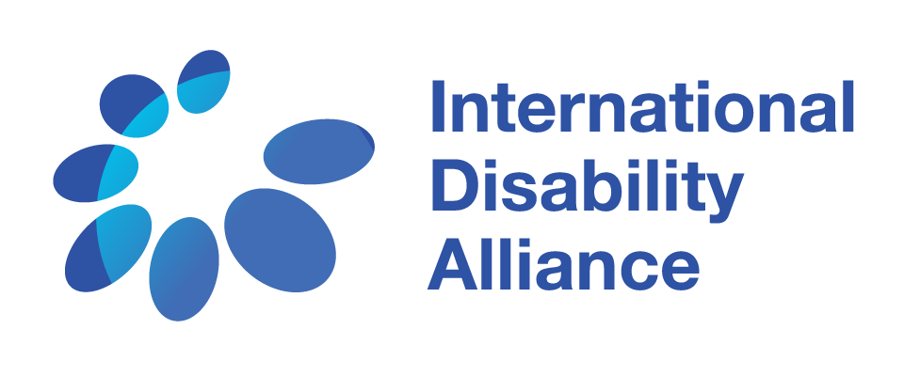

Terms of reference
baseline data collection on status of education of children with disabilities in nepal
and/or facilitation of the second inclusive education technical workshop

Summary:

The International Disability Alliance (IDA) seeks support from experienced researchers to undertake a baseline data collection on the status of inclusive education for children with disabilities in Nepal. This report will support the larger work of IDA in the area of inclusive education, particularly its Inclusive Education Task Team. This Task Team is currently working towards framing the implementation of the Sustainable Development Groups (SDGs) from the perspective of the Convention on the Rights of Persons with Disabilities (CRPD) and disabled people’s organisations (DPOs), while ensuring participation of the most marginalised groups. The overall objective of the Task Team is to develop a DPO-led, evidence-based consensus perspective on how best to achieve SDG4 and CRPD Article 24 for all children with disabilities among other children, by 2030. As part of this objective, the Task Team will undertake a country assessment in Nepal. As part of this assessment, an initial data collection will be conducted specific to the country context which will also inform a workshop of the Task Team in March 2019.

About IDA:

The International Disability Alliance (IDA) was established in 1999 and is a network of eight global—and, six regional organisations of persons with disabilities (DPOs), representing the voice of the estimated one billion persons with disabilities worldwide. IDA is a network representing members that are organisations of persons with disabilities. IDA’s unique composition as a network of international DPOs allows it to act as an authoritative and representative voice of persons with disabilities in the United Nations (UN) system, both in New York and Geneva.
IDA’s mission is “To advance the human rights of persons with disabilities, as a united voice of organizations of persons with disabilities, utilizing the Convention on the Rights of Persons with Disabilities and other human rights instruments”. IDA’s longer-term goal is that “the United Nations framework (the General Assembly, Security and Human Rights Councils, treaty bodies and development agencies), bilateral and multilateral development agencies, regional organizations and human rights instruments contribute to create an enabling environment for DPO advocacy and government capacity to implement the UN CRPD at national level”.

Background:

In the education sector, explicit references to persons with disabilities in the SDGs provide opportunities to explore connections and mutual reinforcements between SDG 4 and CRPD Article 24. The adoption by the Committee on the Rights of Persons with Disabilities of the General Comment on the “right to inclusive education” has been a landmark providing clarity on interpretation of rights and states obligations under Article 24 of the CRPD.

There has been a greater awareness at international level of exclusion and restriction faced by children with disabilities with regards to education with increasing visibility in international organisation reports in the frame of monitoring of Education for All and now SDG 4. At national level, there has been many initiatives led by NGOs and /or governments seeking to make education system more inclusive, albeit too often through pilot projects or local initiatives that are not scaled up or adoption of policies not yet implemented.

According to UNICEF, 1/3 among out-of-school children are children with disabilities. Major initiatives to improve access to education such as the Global Partnership for Education (GPE) still provide limited attention to including children with disabilities.

Despite some progress in international frameworks and progress in the development of more adequate education laws and policies, there is no certainty that any country for that matter is on track to ensure access to quality inclusive education for all children with disabilities by 2030.

There is currently a lack of evidence on what works to achieve SDG 4 on inclusive quality education by 2030 for all children with disabilities, including policy scenarios that comply with the standards of the CRPD for all groups, and adjust to the cultural, social and economic realities of low and middle-income countries. In a context of competing priorities and limited funding, it is essential that DPOs come up with clear messages and recommendations, building on the evidence of what works and looking at mechanisms for taking good practices to scale for broader impact.

To address this, the Education Flagship Initiative aims to develop a DPO-led, evidence-based consensus perspective on how best to achieve SDG 4/ CRPD Article 24 for all children with disabilities by 2030. One of the outcomes is to develop an approach to support national DPOs in their advocacy towards SDG 4/ Article 24 implementation.

The key deliverable of the project is a global report to be produced and disseminated by March 2020 on how to achieve SDG 4 on inclusive quality education by 2030 for all children with disabilities based on the analysis of the current global trends and positions and policy scenarios proposal elaborated with DPOs from 2-3 countries, from IDA members perspective and exchange with key stakeholders (such as UNESCO, GPE, UNICEF). This report would also be a substantial, evidence-based contribution of IDA in 2020 to the SDG baseline.

Purpose and intended use of the baseline data collection

The purpose of the consultancy is to collect, review and analyse the data on the status of education for children with disabilities, produce a base of evidence for later reference and use for further planning and decision making, all within a determined time frame. This data and analysis will be shared with the IDA Inclusive Education Task Team during its second technical workshop in March 2019. During the workshop this work will be used to identify the methodology for developing policy scenarios towards realization of SDG4 in compliance with Article 24 in Nepal by 2030. Once the methodology is developed by the Task Team, a second phase of in-country data collection and consolidation of the analysis will be required after the workshop collect and analyse the missing information and build up the policy scenarios.

Some of the issues that report will address include, but not limited to, are as follows:

- What are the legal frameworks governing education?
- What are the provisions under current education laws and regulations supporting inclusive education?
- Is there an education information system in place (EMIS)?
- Number of out-of-school children (disaggregated by gender, disability).
- Enrollment rate for children with disabilities vis-à-vis the general enrollment rate.
- Transition rate from primary to secondary school (data disaggregated by disability, gender).
- Number of schools – mainstream, residential, and special schools (disaggregated by number of accessible schools).
- Number of children in schools (disaggregated by mainstream schools, residential schools, special schools).
- Teacher pupil ratio across from primary to secondary in the public sector and private sector schools.
- Average number of pupils per class in primary.
- Average salary for both regular and specialized teachers.
- Availability of support services for children with disabilities.
- Education expenditures (public-private) to GDP ratio (disaggregated by budget allotted to special schools; budget allotted inclusive education).

COMPONENT 1 – Data collection (Jan-March 2019)

Consultant tasks:
- Identify the base of evidence available, including but not limited to some of the issues highlighted above, from existing data sources (literature review, including published and grey literature, official data and statistics, administrative data, case studies, etc.)
- Compile and organize the available evidence into a folder of resources to be shared with the Task Team
- Review and analyze the available evidence and identify the missing data/ evidence
- Propose an analysis of the education sector in Nepal and access of (all groups of) children with disabilities to education in Nepal (report), including suggestions of missing data to collect
- Present the report to the Task Team at the 2nd IDA Inclusive Education Flagship Technical workshop which will be held in Kathmandu the week of the 11th March 2019.

Deliverables:
- A short document (1-2 pages max) describing the methodology used for the mission (1 week to 10 days after the start of the mission). This should include a proposed outline of the situational analysis report.
- A database with all evidence collected, organized as agreed at the beginning of the consultancy in the above methodology document
- A narrative report (first draft by 11th Feb, final version by the 20th Feb 2019)
- A power point presentation (to be presented to the project stakeholders) (no later than the 28th Feb 2019)
- Any additional deliverables that are agreed at the beginning of the consultancy (in the above methodology document)

Timeline: This component of the consultancy needs to be realized between January and ending in February. A first draft report should be sent no later than the 11th of February, and the powerpoint presentation should be ready no later than the 28th February. The consultant will be invited to take part in the workshop the week of 11th March.

COMPONENT 2 – Technical workshop facilitation (week of the 11th March 2019, report until 20th April 2019)

Consultant tasks:
- Review the documentation collected by the consultant engaged in Component 1 above
- Prepare the methodology for collective stock-taking on Nepal and identification of a commonly agreed methodology for building policy scenario towards achieving SDG4 in compliance with CRPD Article 24, advise on potential external contributors
- Facilitate the Inclusive Education technical workshop in Kathmandu (March 2019), including potential visits and interactions with stakeholders in Nepal, with support from the IDA Secretariat team

Deliverables:
- A concept note, agenda and methodology for the workshop
- A comprehensive draft report of the workshop

Timeline: The timeline for component 2 needs to match the dates already set by the IDA Inclusive Education task team, i.e. the week of 11th March 2019. The draft workshop report should be sent no later than the 20th of April 2019.

COMPONENT 3 – 2nd phase of data collection to support the Nepal policy scenario (ideally March - April 2019 or later by July 2019)

Consultant tasks:
- Based on the outcomes of the IDA inclusive education technical workshop of March, propose a methodology for collecting the missing data (as collectively identified by the task team)
- Collect and analyze the required date including through in-country visits
- Liaise with the task team and the consultant in charge of component 2 (if a different person is selected) to develop policy scenarios and draw recommendations from the additional data collected.

Deliverables:
- A short document (1-2 pages max) describing the complementary methodology for additional data collection
- An updated database with all additional evidence collected, organized as agreed at the beginning of the consultancy in the above methodology document
- An updated narrative report (consolidating the one produced under component 1), and inputs into the workshop report if undertaken by a different consultant
- The deliverables of component 3 may be reviewed by IDA and the consultant according to developments under components 1 and 2.

Timeline: This component of the consultancy needs to be realized between March and July 2019.

INTERESTED CONSULTANTS CAN SEND A PROPOSITION IN RESPONSE TO (COMPONENT 1 + 3) or TO (COMPONENTS 1 + 2 + 3).

Qualifications:
- Relevant university degree in education, disability studies, public policy
- Strong research experience and knowledge of data management and analysis
- Proven experience and expertise on education sector reform, including education data
- Demonstrated interest and familiarity with the rights of persons with disabilities, especially inclusive education, CRPD article 24 and related jurisprudence
- Familiarity with the systems and context in Nepal would be a strong added value
- Knowledge of English; Nepalese would be a strong added value
- Ability to write a concise and analytical research report in English

Budget:

- Applicants are invited to submit a budget/quotation within their proposal. The expected total budget for the 3 components will range from 20,000 to 25,000 US Dollars.
- Applicants are invited to detail the study trips and additional expenses needed to deliver each component. Those travels and additional expenses will be evaluated by IDA selection committee. All travel costs will be taken care of by IDA as per IDA travel policy.
Contracting and Remuneration:
- A consultancy contract (as per Swiss law) will be signed between the selected consultant(s) and IDA.
- Applicants are invited to submit a copy of their passport and commercial/consultant registration/tax numbers. Only applicants with valid commercial and/or consultant registration and/or tax numbers will be considered.
- Payments will be made in several installments and upon successful completion of the deliverables and submission of invoices.

Please send a letter of interest and a detailed proposal (with budget/quotation) to consultancy@ida-secretariat.org latest by 4 January 2019.
Note: The subject line of the e-mail should be “Application for Nepal Consultancy”.

IDA reserves the right to select different consultants for the two components.

