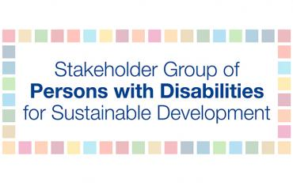
Regional Forum on Sustainable Development in the Latin America and Caribbean Region

The United Nations Regional Forum on Sustainable Development in the Latin America and Caribbean (ECLAC) region took place from 22-26 April 2019 in Santiago, Chile.

The Stakeholder Group of Persons with Disabilities was present at the Forum.

A great achievement of the ECLAC regional forum this year was the final establishment of the Civil Society Coordination Mechanism.
According to the Terms of Reference for the Civil Society Participation Mechanism, each civil society interest group was required to choose a main focal point and an alternative focal point prior to the Forum. Prior to the forum, an online meeting was convened to identify the main and alternate focal points of the Civil Society Participation Mechanism. Rosario Galarza was chosen as the main focal point and Olga Montufar was chosen as the alternate focal point of the Civil Society Participation Mechanism in the Sustainable Development Agenda.
On Monday, April 22nd, all interest group focal points attended a meeting in CEPAL to discuss the Terms of Reference and the principal responsibilities of the focal points. Additionally, the focal points defined their role in the Forum and agreed to compile two civil society statements. The first was a short statement to be presented during the ECLAC forum. The second was a long statement to be presented during the July 2019 High-level Political Forum. The long statement includes one to two paragraphs written by each interest group.
On Tuesday, April 23rd, there was a civil society forum in which the focal points explained to other civil society members the methodology of the Civil Society Participation Mechanism. Each focal point was allotted time to meet with their respective groups. Rosario Galarza, RIADIS, and Elena Dal Bó, Inclusion International, met on behalf of the Stakeholder Group of Persons with Disabilities.
On Wednesday, April 24th, the Stakeholder Group of Persons with Disabilities attended the opening ceremony of the Forum. In the afternoon, the Stakeholder Group of Persons with Disabilities attended a side event hosted by the Major Groups and other Stakeholders. Rosario Galarza delivered a presentation on the engagement of the Stakeholder Group of Persons with Disabilities in the High-level Political Forum during this side event.

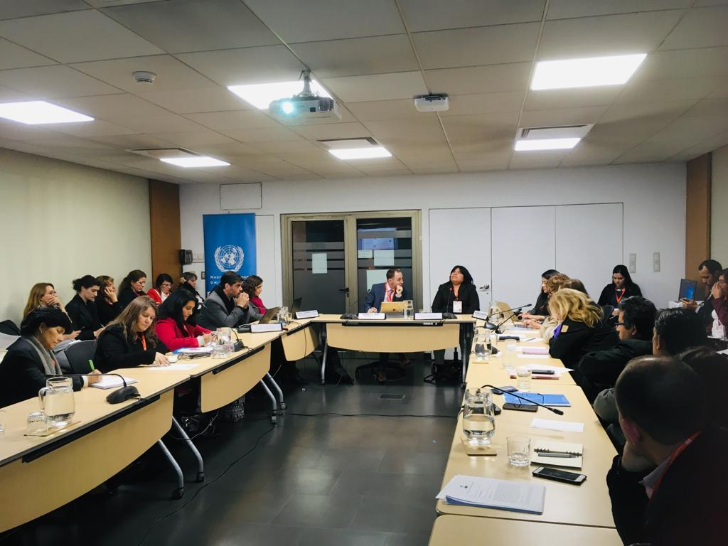
On Thursday, April 25th, a meeting with all focal points of the Civil Society Participation Mechanism was convened in the morning to finalize the short statement to be delivered during the Forum. Ms. Galarza was selected to deliver the statement on behalf of all civil society organizations attending the Forum. She delivered the statement to Member States during the afternoon session of the Forum on April 25th. Click here to read the statement in English.
The civil society focal points met after the delivery of the statement to determine a way forward and the next steps to take. They identified which focal points would lead the civil society groups for one and two years. Ms. Galarza was identified as the focal of the Stakeholder Group of Persons with Disabilities in the ECLAC region for the next two years.
On Friday, April 26th, the Stakeholder Group of Persons with Disabilities attended the closing session of the Forum and met with Alicia Barcena, Executive Secretary of the United Nations Economic Commission for Latin America and the Caribbean (ECLAC). Ms. Galarza requested the support of Ms. Barcena in disseminating the Latin American SDGs Report to all Member States.

