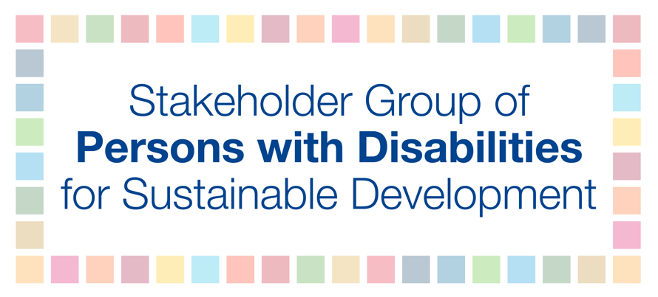

3 November 2017

H.E. Mr. Frederick Musiiwa Makamure Shava
President of ECOSOC at 2017 HLPF
Permanent Mission of the Republic of Zimbabwe to the United Nations
128 East 56th Street
New York, NY 10022

Excellency,
On behalf of the Stakeholder Group of Persons with Disabilities we congratulate and welcome the accessibility arrangements undertaken by the UN for persons with disabilities at the 2017 High-level Political Forum (HLPF). This progress keeps in line with the principle of the 2030 Agenda to ensure that no one is left behind and the UN Convention on the Rights of Persons with Disabilities. Persons with disabilities who attended the HLPF had significantly more access, on an equal basis with others, to the physical environment, information and communication, technology and systems and other facilities throughout the United Nations system versus the HLPF 2016. We particularly would like to thank Mr. Sergey Kochetkov, Chief, Russian Interpretation Section, DGACM and Ms. Lotta Tähtinen, Chief of Outreach and Communications Branch, DESA and their teams for their excellent support and facilitation.
We look forward to a continued, positive collaborative relationship to ensure accessibility for all persons with disabilities at the UN. We strongly recommend that this is systematically included in all future HLPF sessions to ensure that no one is left behind and that persons with disabilities can meaningfully participate in person and remotely.
Yours sincerely,
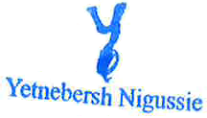
Vladimir Cuk Yetnebersh Nigussie
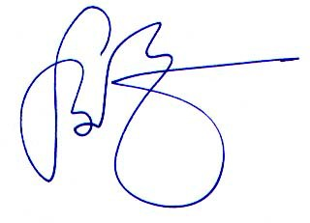
Permanent Representative, Alternative Representative,
Stakeholder Group of Persons with Disabilities Stakeholder Group of Persons with Disabilities

