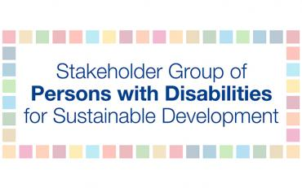
Talking points for FFD Forum Domestic public resources (Action Area A)
Wednesday, 17 April, 10:00-11:30am EST

Lead Discussant: Mr. Jose Viera, Permanent Representative, Stakeholder Group of Persons with Disabilities and CEO of The World Blind Union

Today, I am presenting on behalf of the Stakeholder Group of Persons with Disabilities. There are 1 billion persons with disabilities worldwide that make up some 15 percent of the global population of whom 80 percent lives in the global south.
The quantity and quality of financing to realize the rights of persons with disabilities tells us a lot about whether the global economic system is fit to deliver a more equal world for everyone by 2030. And the current situation confirms that alarm bells should be ringing.
Persons with disabilities experience compounding social, economic and political inequality, which is exacerbated when disability intersects with other forms of discrimination, including on the basis of gender, age, ethnicity, and other factors. We are over-represented among people living in poverty.
Redressing these many inequalities requires dedicated resources. Yet available evidence suggests that in practice, although there have been some pockets of progress, such resources are rarely available. Gaps exist in critical areas, including in inclusive education for children with disabilities; sign language interpretation for deaf people seeking to access health facilities; and essential support services that would enable persons with disabilities to live independently, to name a few examples.
I would like to highlight two key barriers that are preventing these resources from being mobilised and allocated:
First, corporate tax avoidance is costing governments worldwide an estimated US$500 billion every year. This includes some $70-120 billion lost from countries in the global south, where corporate taxation is a particularly important source of revenue. Yet countries in the global south are still not able to participate in decisions on international tax standards on a genuinely equal footing: the OECD tends to act as the chief decision maker, as there is still no intergovernmental tax body under the auspices of the UN. This makes it much harder to put an end to harmful tax practices that currently deprive governments of resources that they urgently need for tackling inequalities.
Second, whatever constraints governments face due to inequalities in the international tax system or other factors, they nevertheless have a duty to align national-level fiscal policies with their human rights obligations, paying particular attention to the rights of marginalized groups. Yet, research finds that the actual practice often falls far short. All taxation and expenditure policies, across all ministries and across both central and local government, should be subject to comprehensive human rights impact assessments, and these assessments should be fully disability-responsive. This in turn requires concerted efforts to enhance transparency, accountability and participation in fiscal policymaking, especially for marginalized groups.
As important first steps toward fitting fiscal systems to tackle inequalities, we call for the following concrete outcome from this year’s FFD Forum:
- We ask the Inter-Agency Task Force on Financing for Development, in its 2020 report, to examine governments’ performance in conducting human rights impact assessment of fiscal policies, with a particular emphasis on responsiveness to the rights of marginalized groups, such as persons with disabilities.
Thank you.

https://www.wider.unu.edu/sites/default/files/wp2017-55.pdf and https://unctad.org/en/PublicationsLibrary/wir2015_en.pdf

