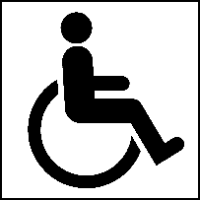
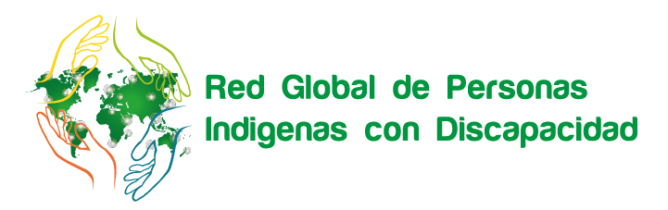
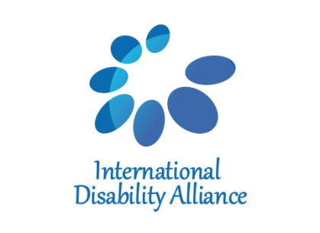
NAROK SOUTH DISABILITY NETWORK
Indigenous Persons with Disabilities Global Network

Technical Workshop on ensuring the rights of Indigenous Persons with Disabilities in line with the UNCRPD,
in connection with the UNDRIP and the Agenda 2030
Bomet, Kenya
20 – 23 August, 2018

Final report

“This is a landmark meeting. UDPK is committed to work with indigenous people with disabilities. This group cannot be left behind.”
Anderson Gitonga, Chief Executive Officer,
United Disabled Persons of Kenya

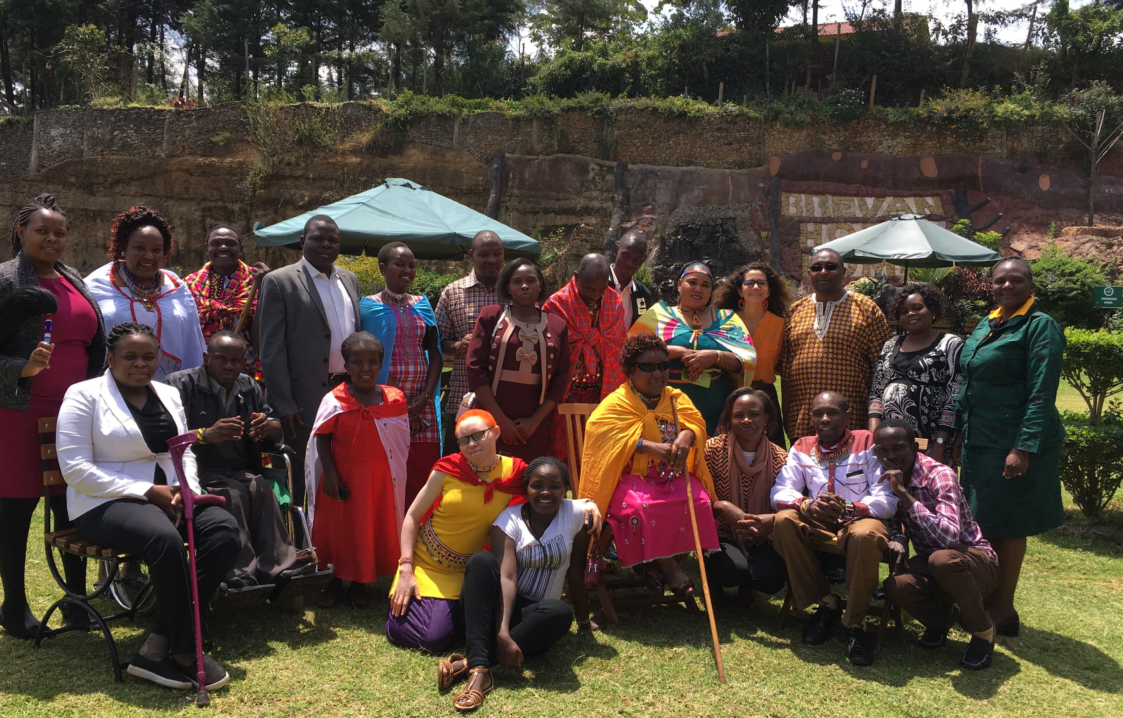

SUMMARY

From the 20th to the 23rd August, the Indigenous Persons with Disabilities Global Network (IPWDGN), the Narok South Disability Network and the International Disability Alliance (IDA) held a Workshop on ensuring the rights of indigenous persons with disabilities in line with the UN CRPD, in connection with the UN Declaration on the Rights of Indigenous People (DRIP) and the Agenda 2030, with support from the Disability Rights Advocacy Fund (DRAF) and MFA Finland.

The workshop was a unique opportunity for indigenous leaders with disabilities (IDPOs) from five different counties (Narok, Kajiado, Baringo, Samburu and Bomet) to meet together to discuss critical issues and violation of their rights. The workshop gathered relevant information about the CRPD, UN DRIP and the SDGs and their relevance to indigenous persons with disabilities. Sessions and discussions were presented and simultaneously interpreted into English, Masai and Swahili to ensure all participants and facilitators were meaningfully included.

A privileged moment was the informal discussion with non-indigenous stakeholders, with representatives from the United Disabled Persons of Kenya (UDPK), IDDC member, Ministry of Labour and Social Protection and Kenyan National Commission on Human Rights (KNCHR). Only UN agencies based in Kenya were not present in the workshop, despite repeated invitation.

All participants shared their customs, traditions, but also challenges and barriers, including in regards to the rights of women and children with disabilities, including on issues related to the right to life, legal recognition before the law, right to participate and access to education, among others. The workshop was also a privileged moment for indigenous leaders with disabilities to expand their understanding on how to use the CRPD, UN DRIP and SDGs to foster their rights and development as well as to better understand how to connect with the Global Network of Indigenous Persons with Disabilities.

The workshop was co-facilitated by Manase Ntutu, African representative of the IPWDGN, Rebecca Opetsi (United Disabled Persons of Kenya, Bridge co-facilitator and former fellow of the International Federation for Spina Bifida and Hydrocephalus), Elizabeth Ombati (Users and Survivors of Psychiatry in Kenya and Bridge Fellow), and Tchaurea Fleury (Bridge CRPD-SDGs Coordinator), forming a diverse group of facilitators bringing different local, national, regional and global perspectives on human rights and development, embracing, at the same time, the diversity of persons with disabilities and indigenous peoples.

Table of content
SUMMARY 2
Table of content 2
First day 3
Second day 4
Third day 5
Fourth day 8
Testimonials 9

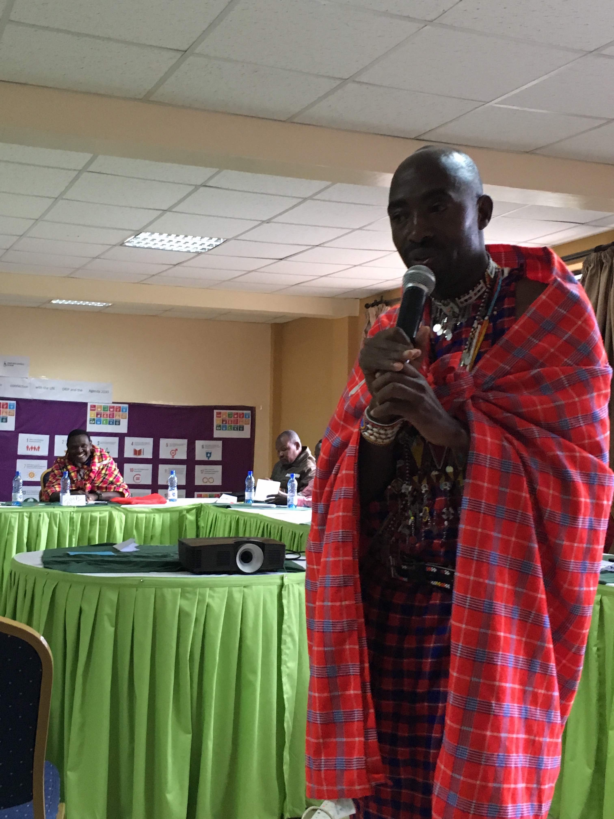
First day
The workshop was launched with a warm welcome by Manase Ntutu, African representative of the Indigenous Persons with Disabilities Global Network, and Tchaurea Fleury, from the International Disability Alliance. After the official opening, the indigenous group discussed their different identities - being at the same time persons with disabilities and indigenous people. All participants shared their customs, traditions, but also challenges and barriers, including in regards to the rights of women and children with disabilities.

Main barriers identified by the leaders are:
- to overcome barriers (attitudinal, physical, communicational, among others),
- actively participate in society,
- access education,
- fear from society,
- comparison with non-disabled women,
- fight to not become dependent from other people and the community,
- need to proof they can also work hard and can contribute to their communities.

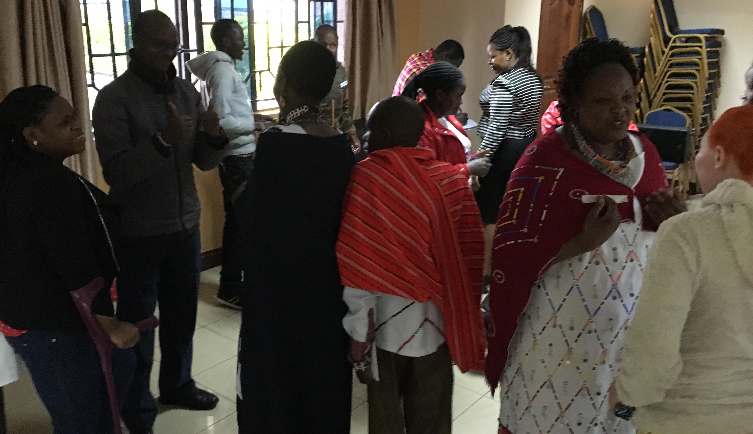
Representatives also shared the work they undertake at their community-based, county-based and national levels representing their different identities both as indigenous people and persons with disabilities, and also as women, entrepreneur, pastors, among others. Participants shared their work representing their community in meetings with stakeholders, participating in different government bodies or working groups, contributing to processes related to data collection, among others.

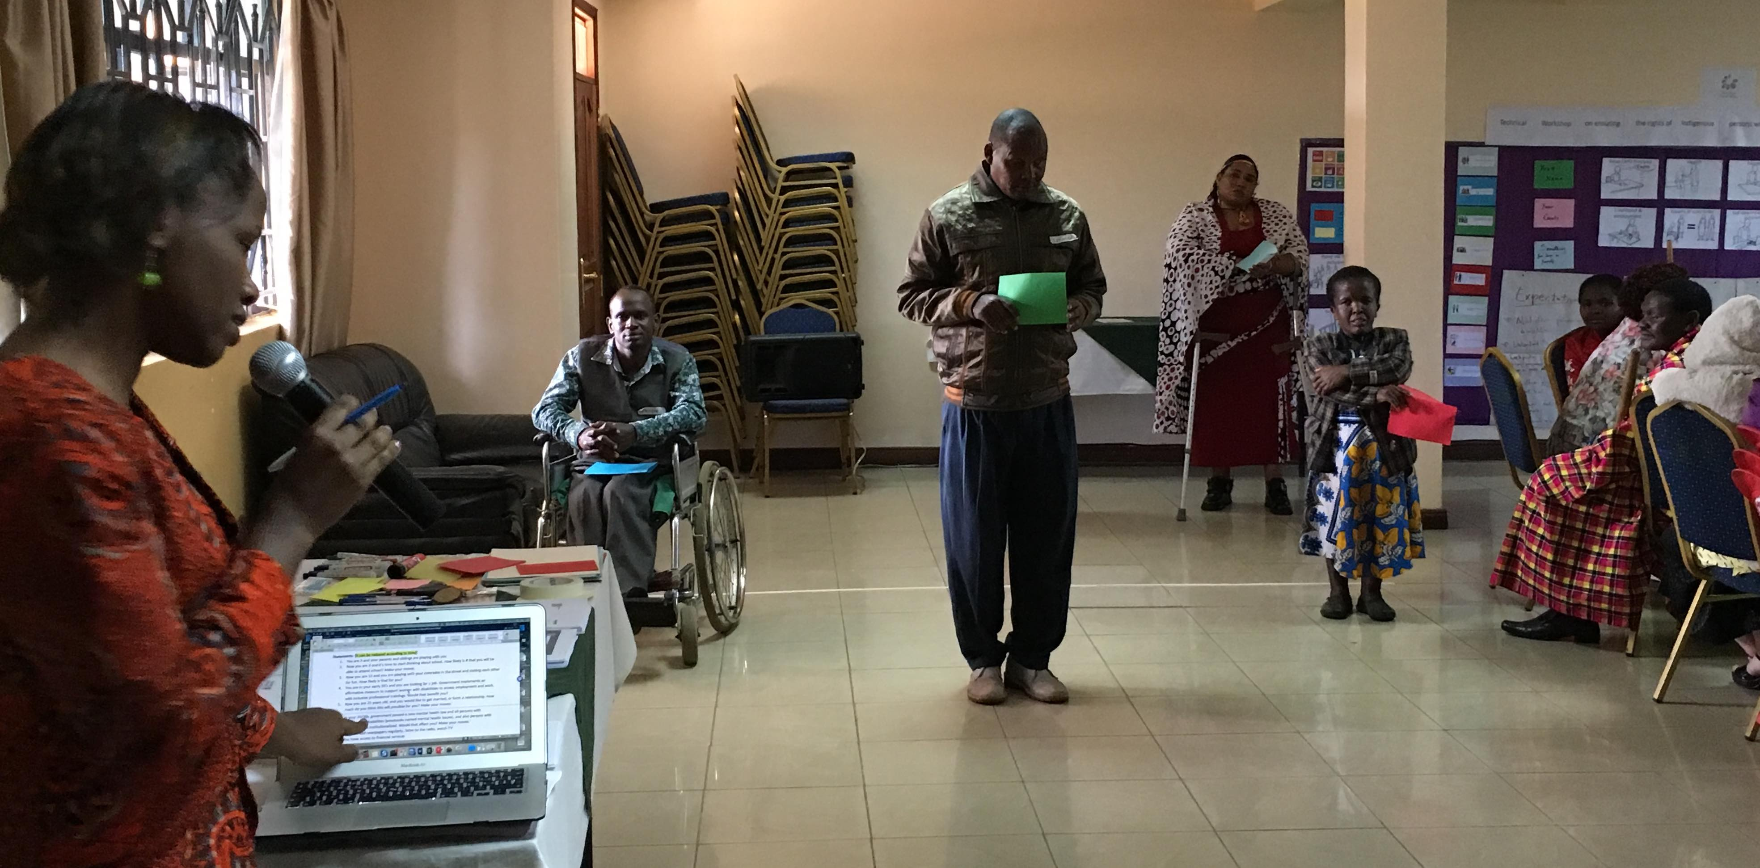
This session was followed by a game of life, where participants discussed about discrimination over the life span and intersecting forms of discrimination as well as on how to overcome those barriers.

The day was concluded by a group exercise on how to shift the discussions from needs to rights, and then about the human rights-based approach to disabilities.

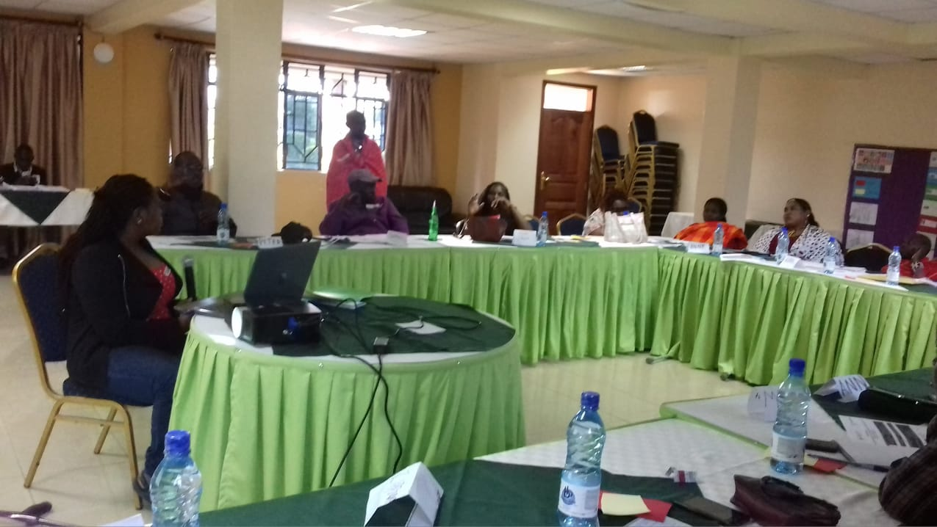
The “moodometer” of the day was very positive with all feedback quite high.
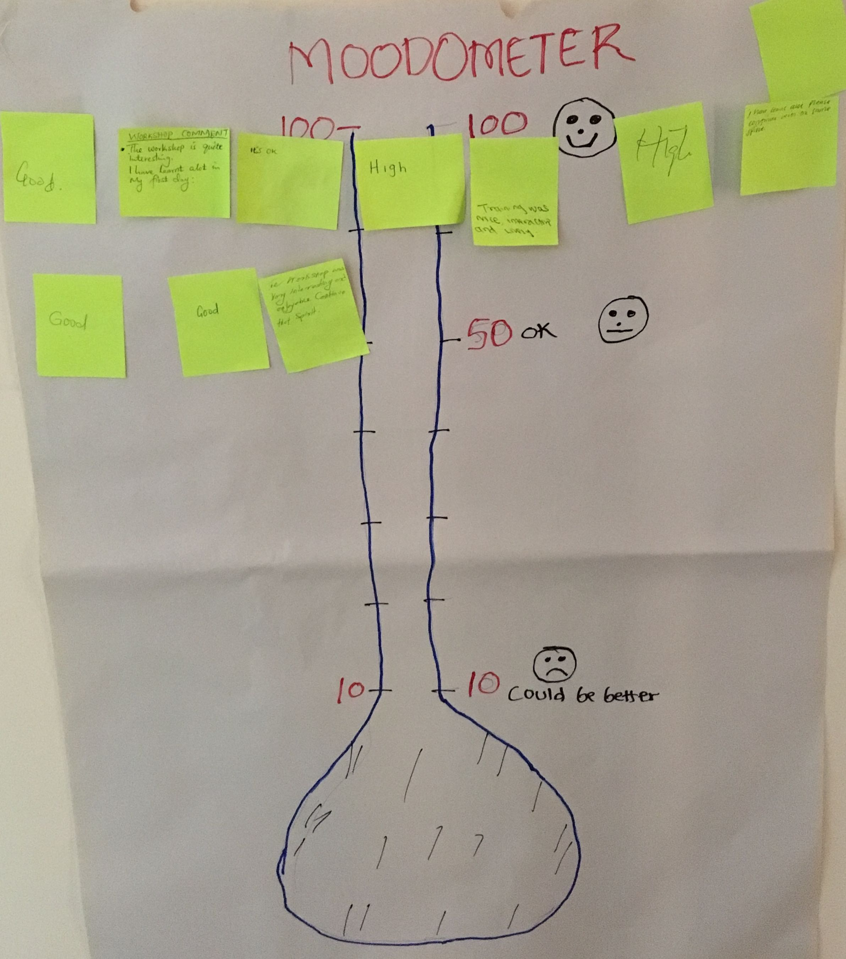

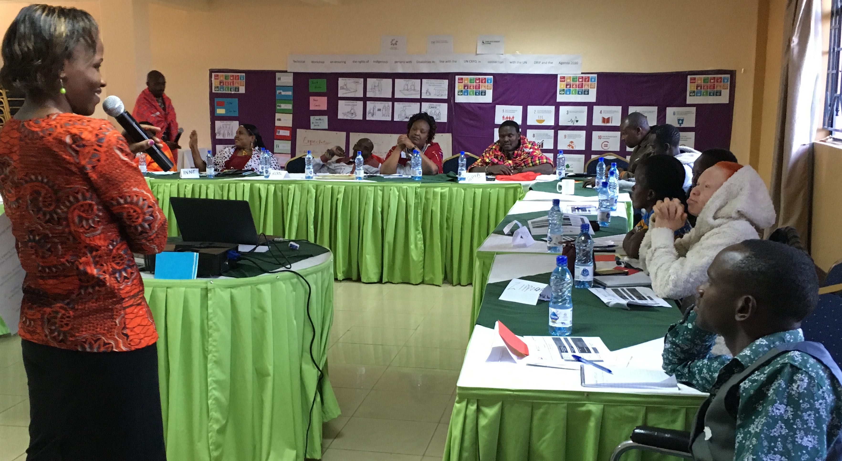
Second day
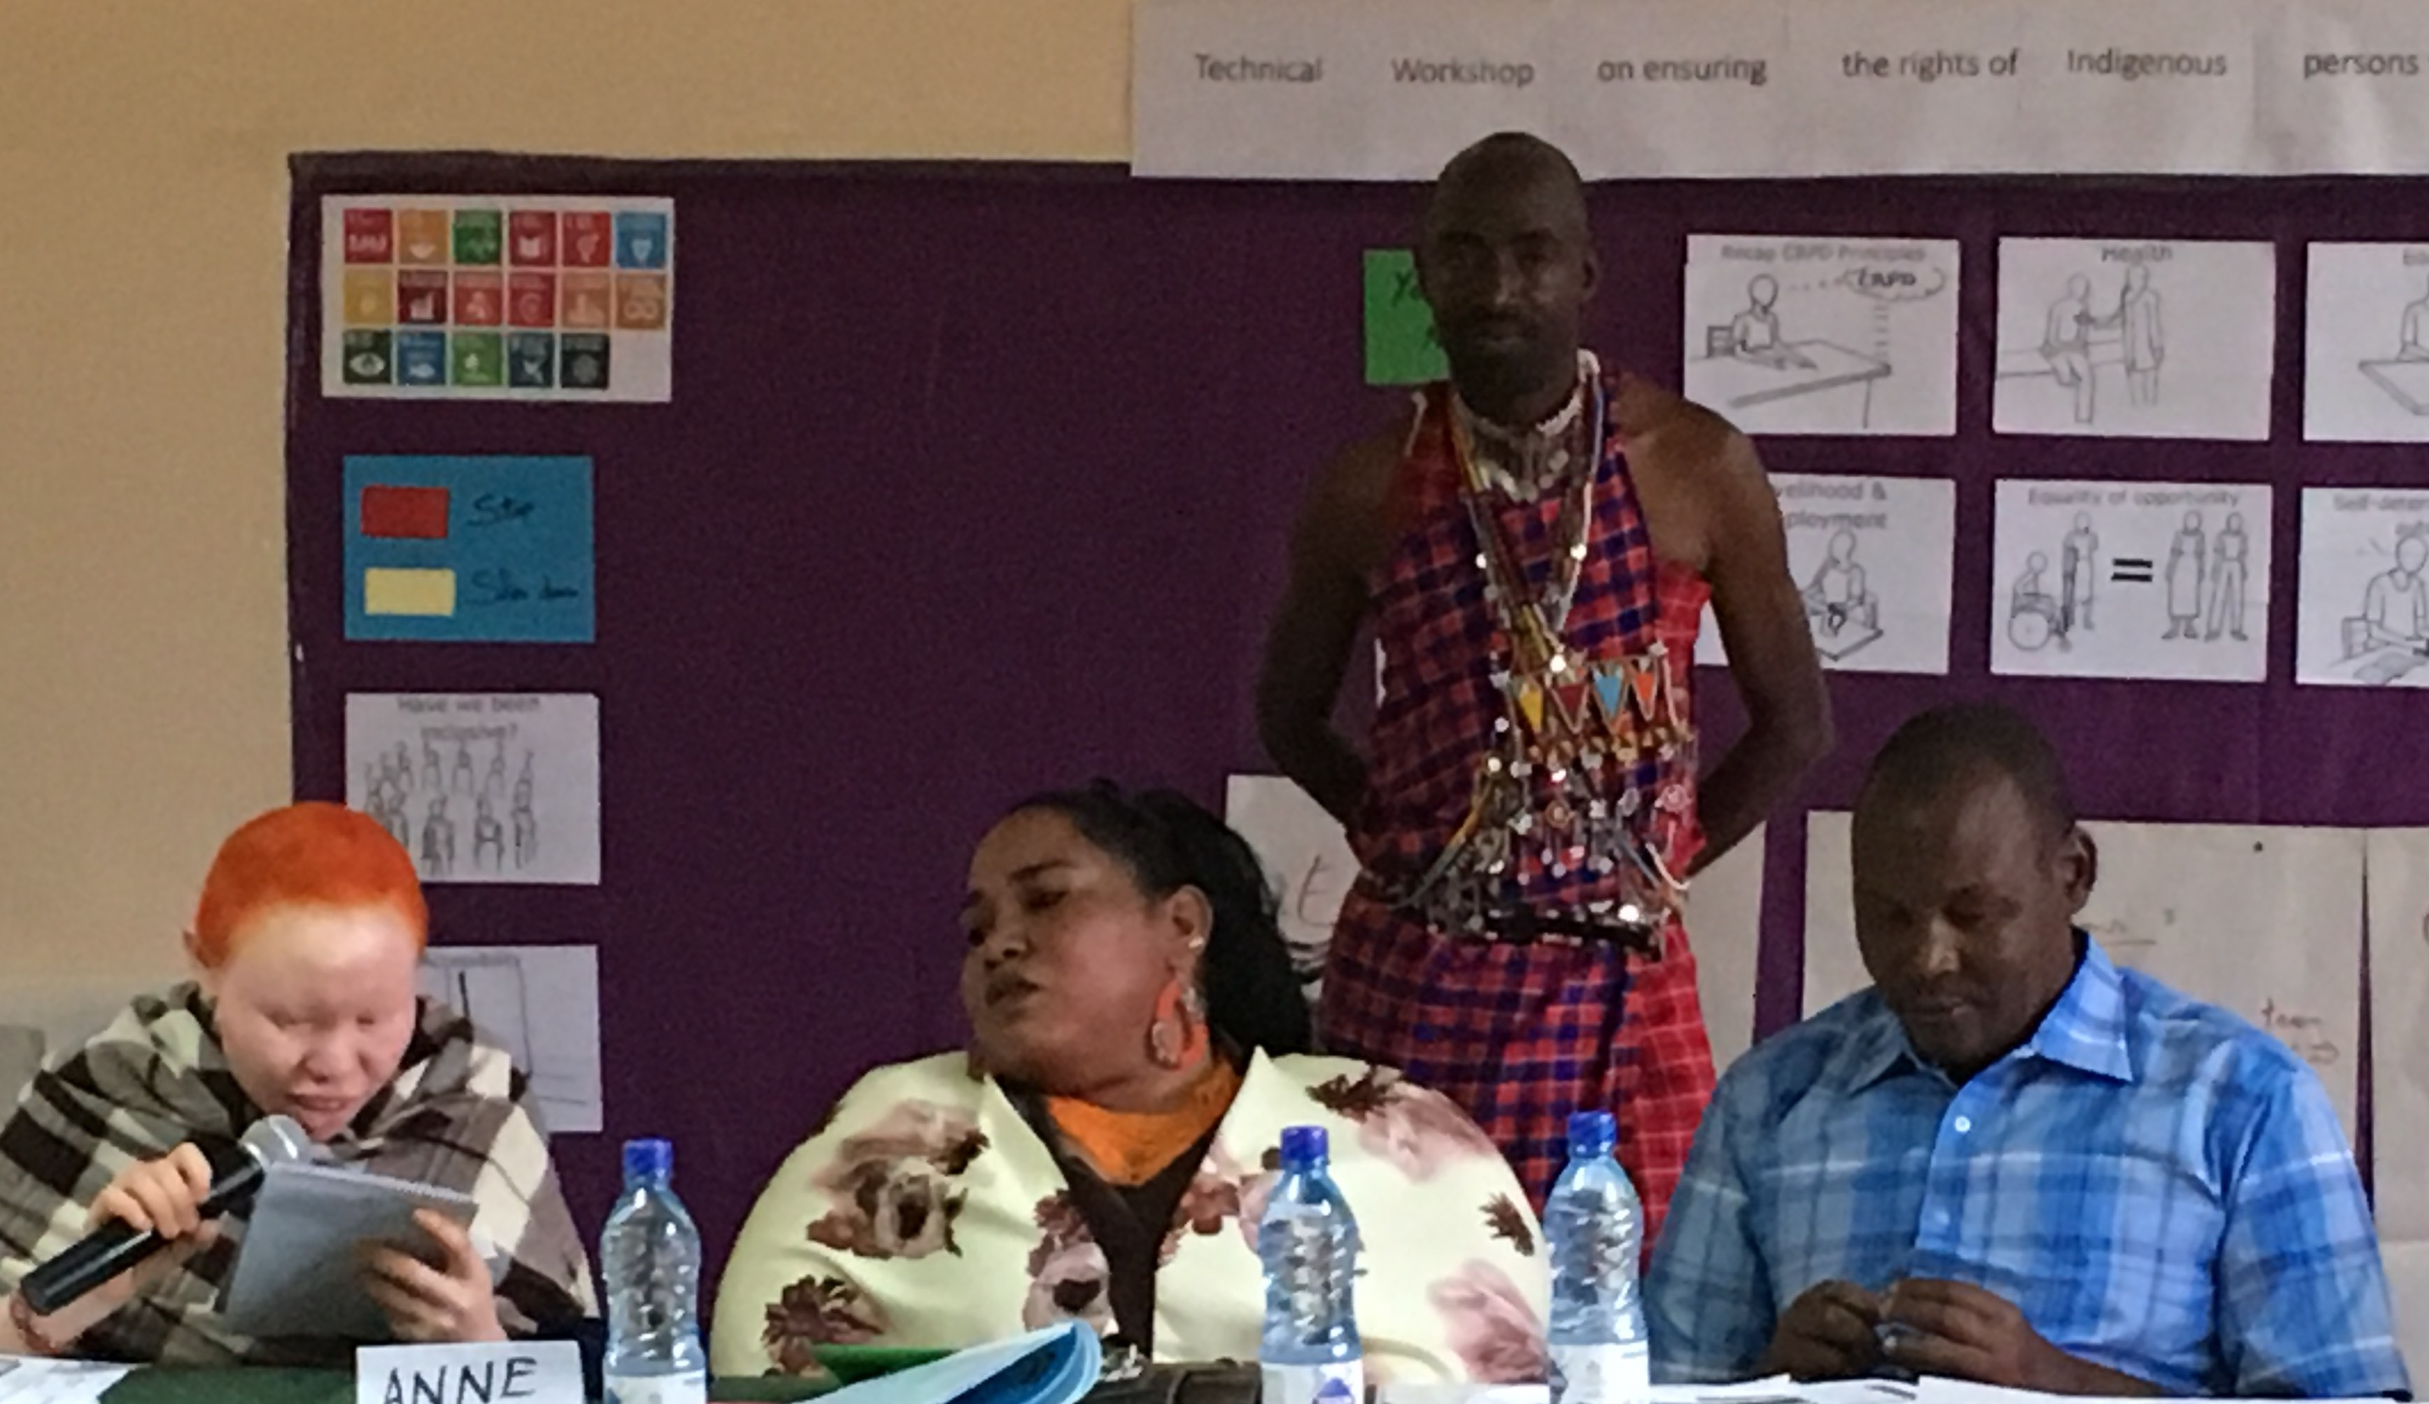
The day started by a recap of the preceding day, followed by a general overview of the CRPD, and a group work on the eight general principles of the Convention. Discussion on terminology regarding persons with disabilities under the Human Rights Based-approach was promoted. The session was followed by an in-depth debate on practical questions regarding the principles of the Convention related to the daily life of indigenous persons with disabilities, including issues related to equality between men and women, respect for evolving capacity of the child, and full and effective participation and inclusion in society.

Subsequently, there was a presentation of the UN Declaration on the Rights of Indigenous Peoples, followed by a round of questions and answers. The session was followed by an introduction to the Agenda 2030 and its Sustainable Development Goals (SDGs), and its evolution from the MDGs.

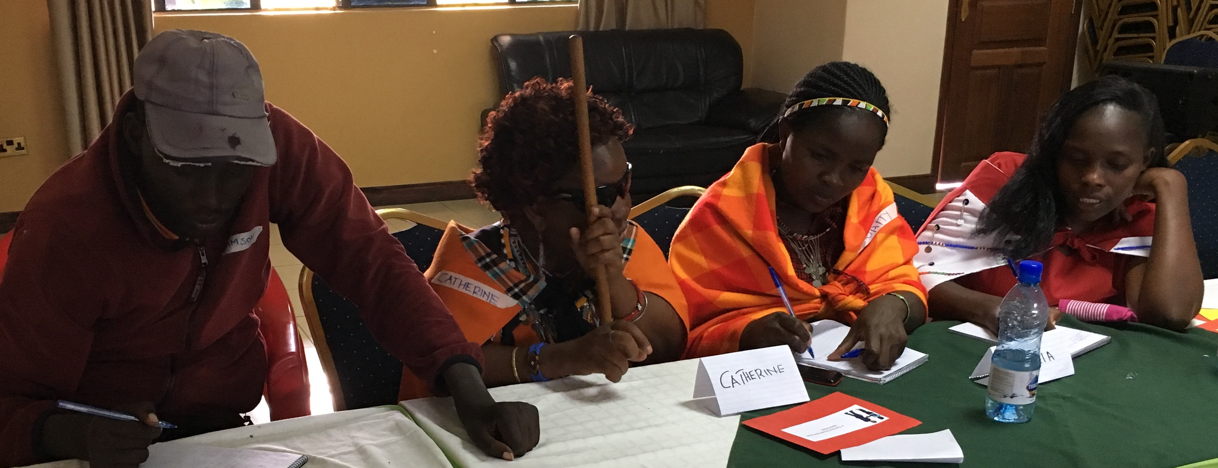
According to participants, indigenous with disabilities were not involved in efforts for the MDGs’ implementation. This introduction was followed by a practical exercise on linking the 17 goals and the CRPD articles. Then, a plenary discussion about the importance to use the CRPD on the implementation of the SDGs, and the SDGs to impulsion of the CRPD’s implementation. The day was concluded by a preparatory exercise to facilitate discussions between the indigenous with disabilities representatives and the stakeholders that opened the third day of the workshop.

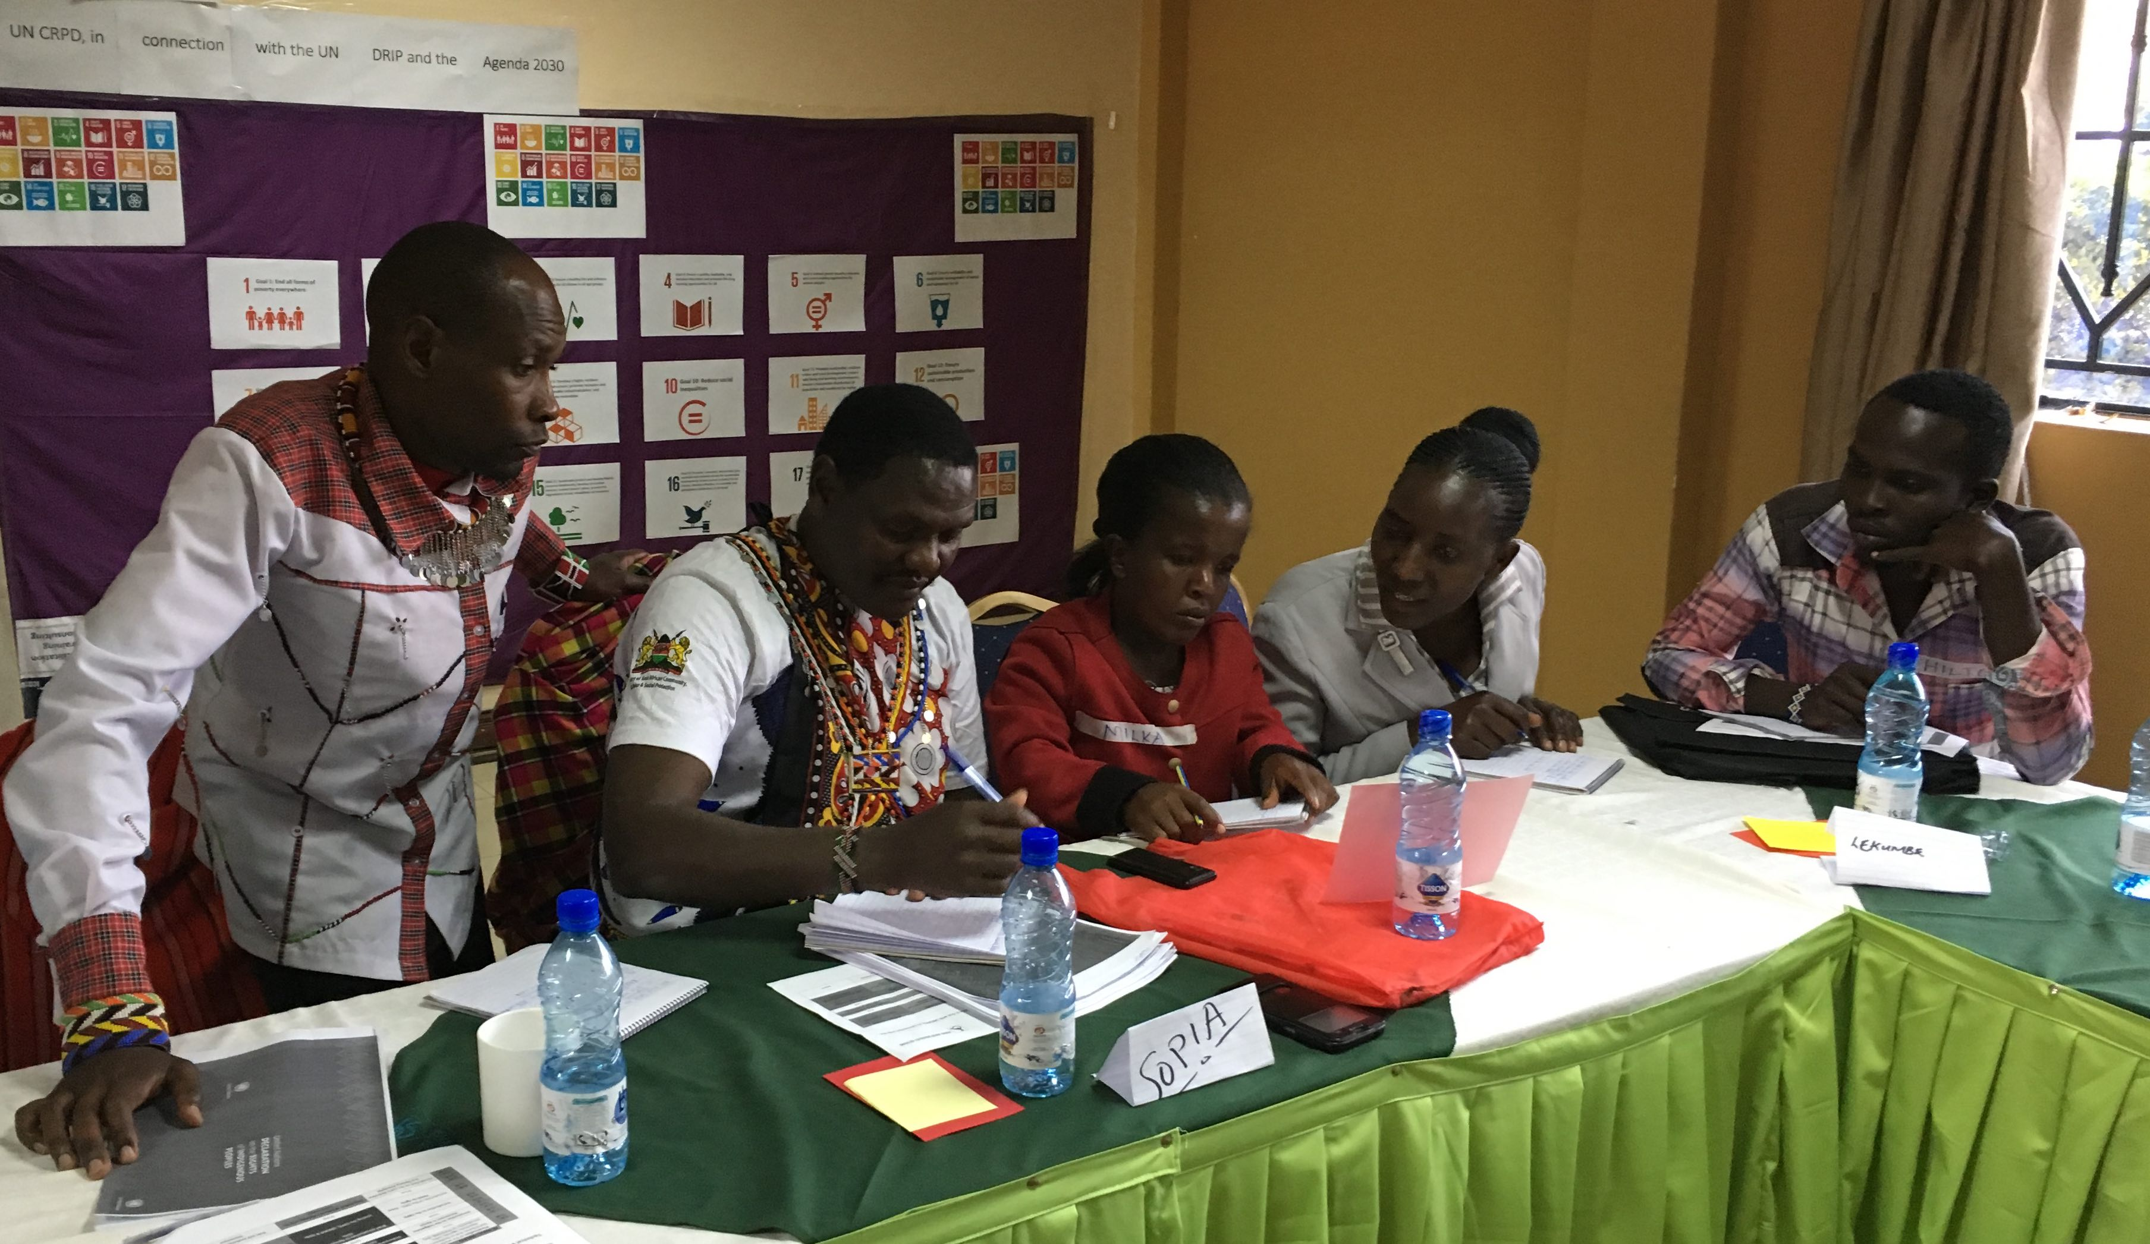
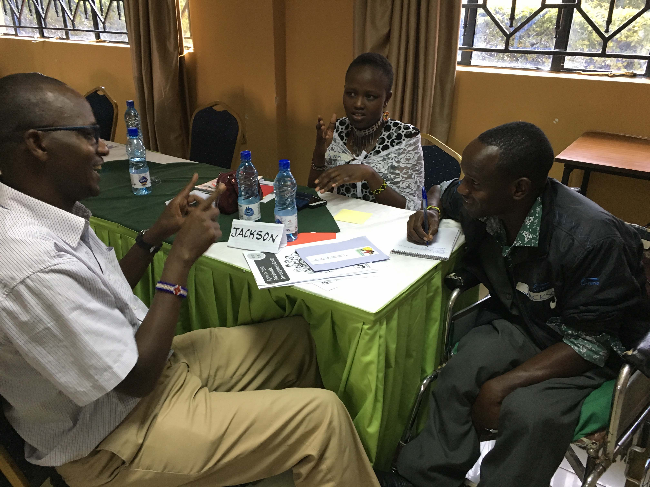

The “moodometer” of the day was again very high with excellent feedback.

Third day
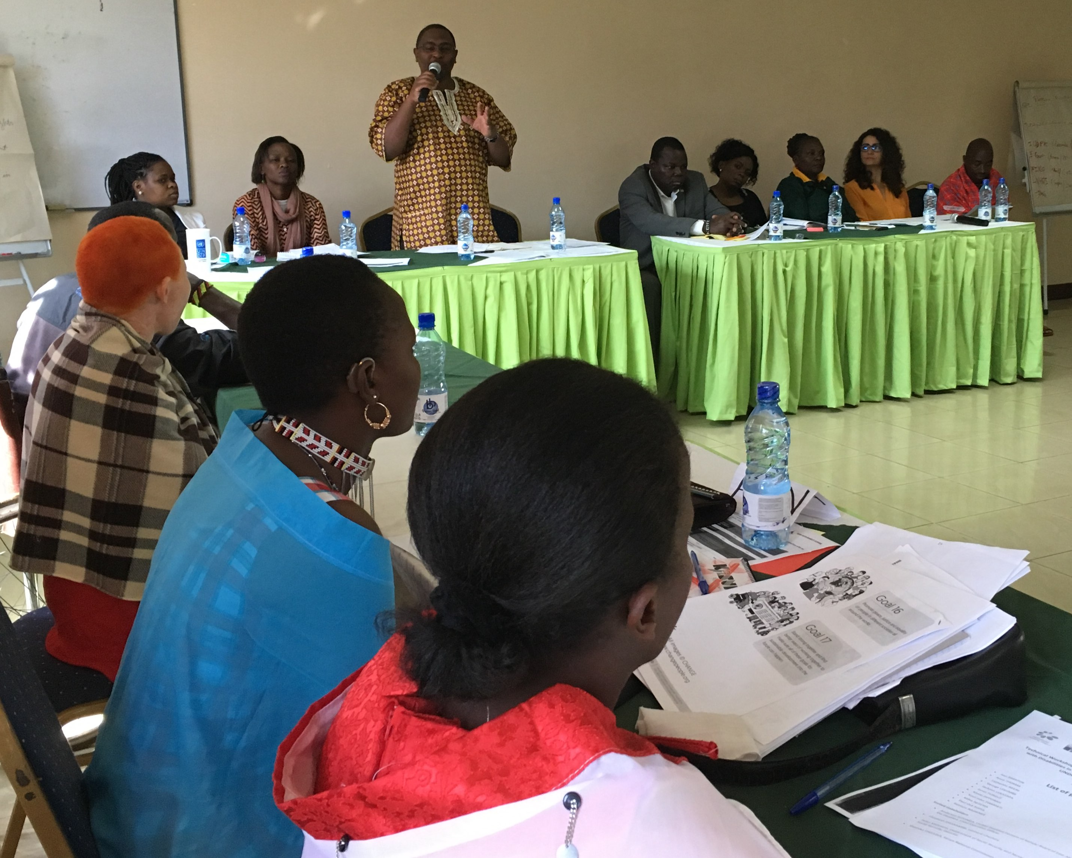
The day was opened by a formal opening remark by Manase Ntutu presenting the history of the Indigenous Persons with Disabilities Global Network (IPWDGN), the different regional representatives and the global work the Network was making over the past years at the global level, including towards the UN agencies. Manase also mentioned the support IDA and DRAF has historically provided to the Network. He concluded referring to the importance of the workshop to the African members of the Network.

These opening remarks were followed by a short presentation by Tchaurea Fleury, introducing IDA and the support presented by IDA and DRAF over the past years to the IPWDGN. Tchaurea also presented an overview of the IPWDGN work in advocating towards UN mechanisms, both in Geneva and in New York.
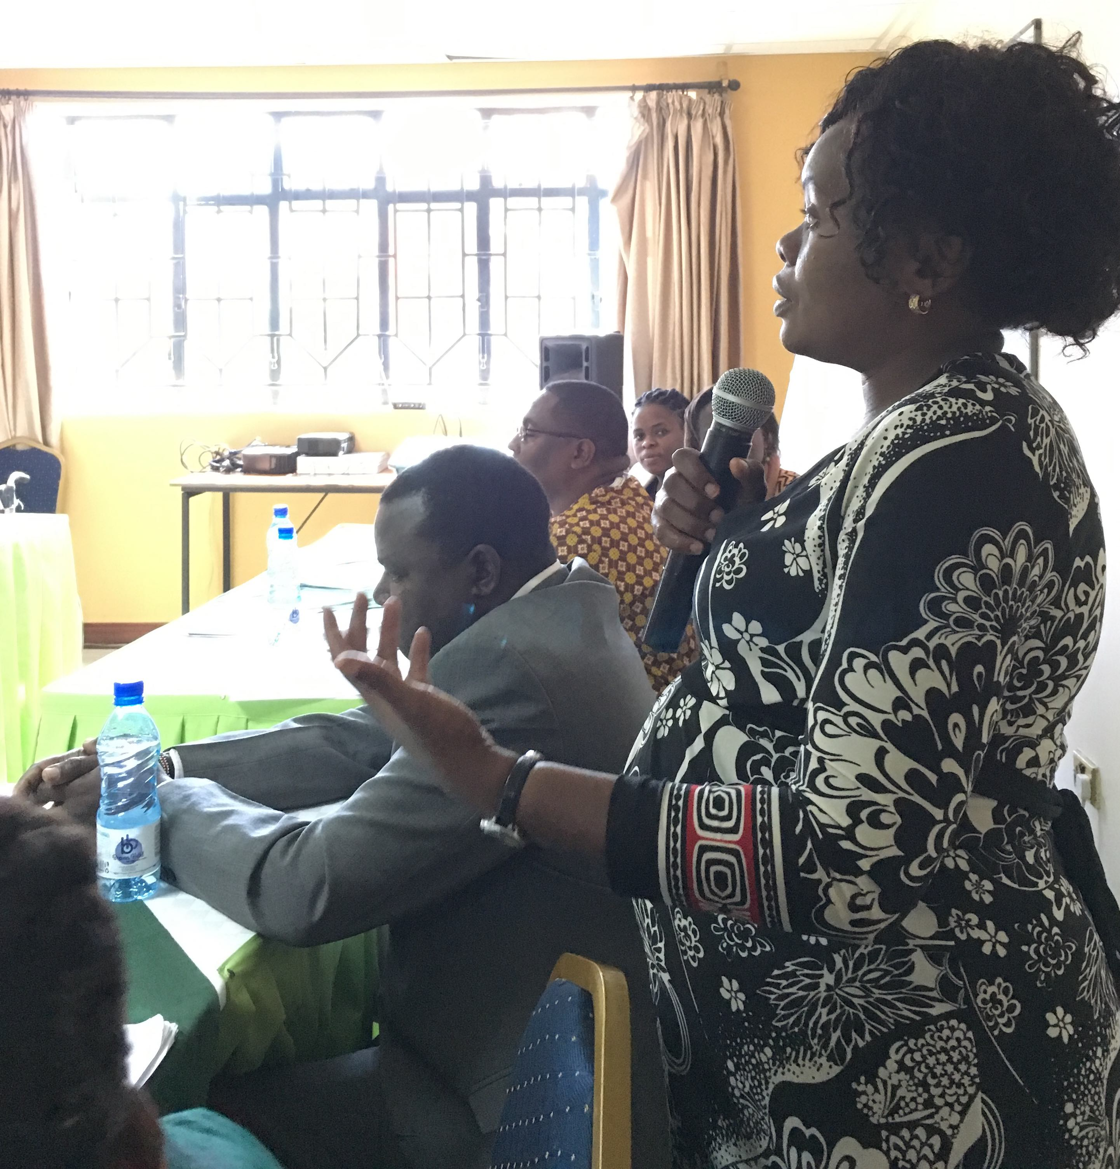
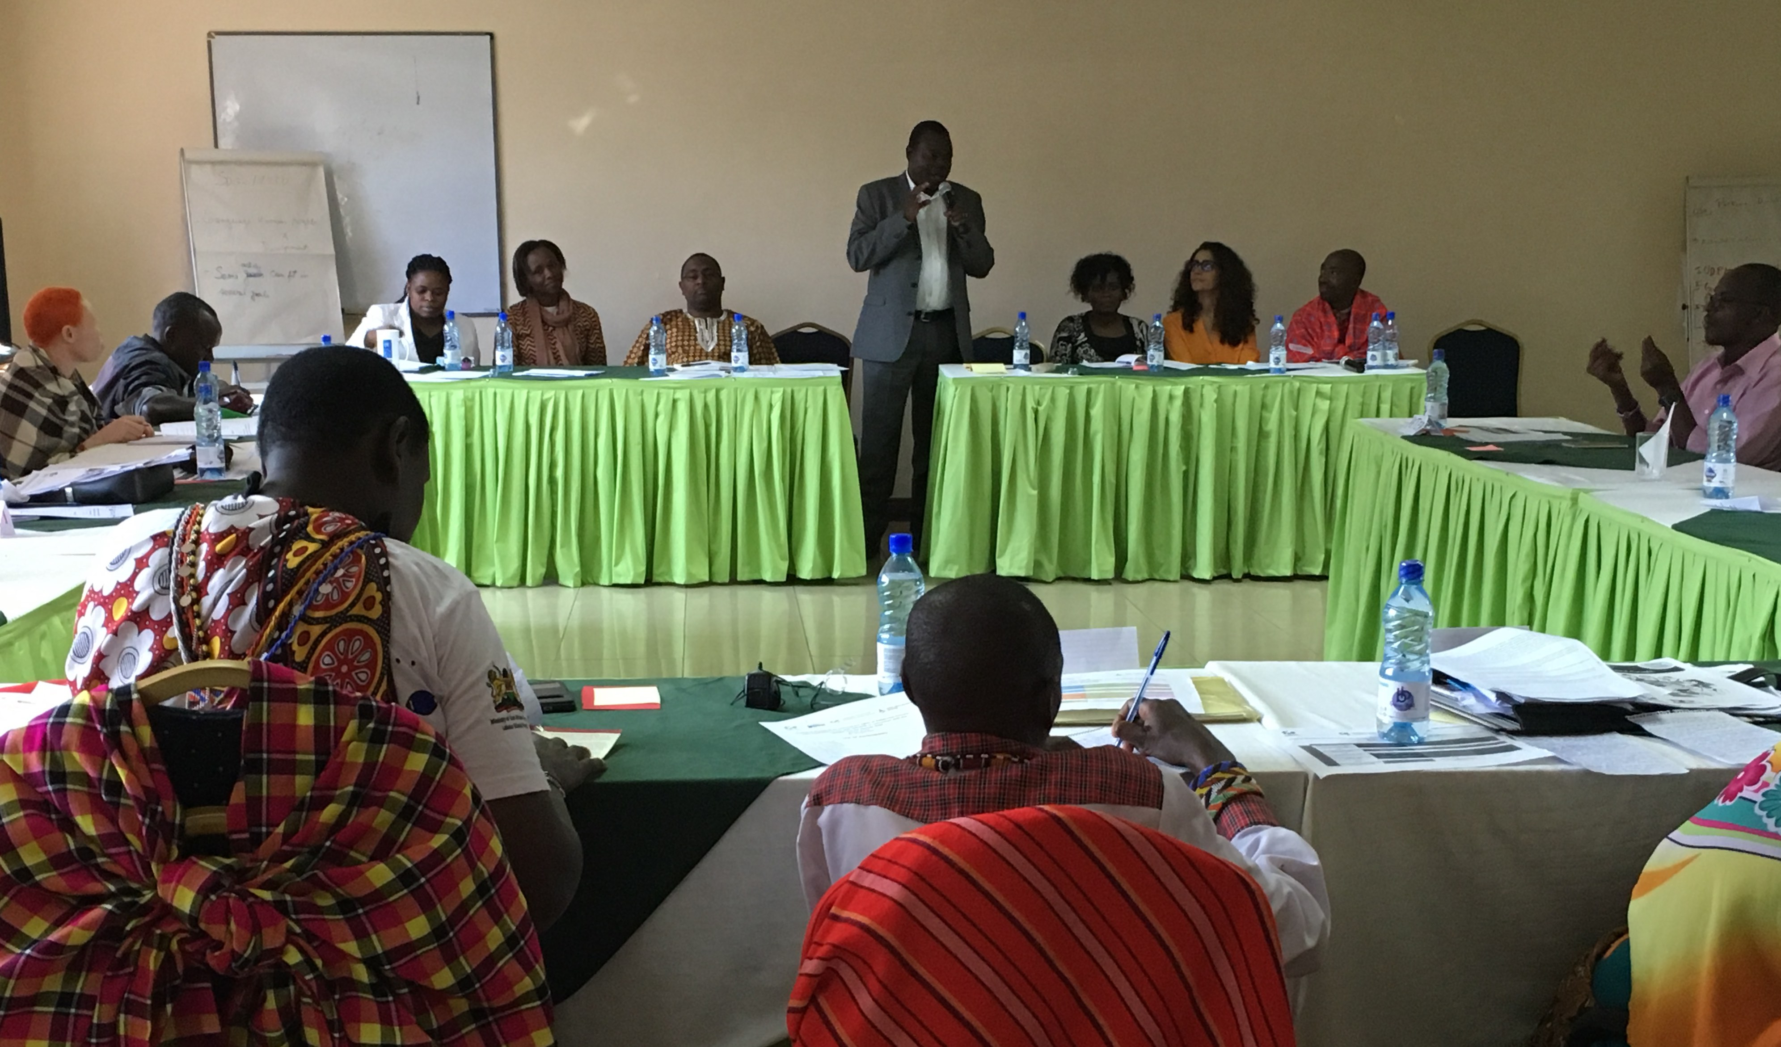

These remarks were followed by a brief presentation of each invited stakeholders, namely Anderson GITONGA, Chief Executive Officer of the United Disabled Persons of Kenya (UDPK), Elizabeth SHIAKAMIRI, Leonard Cheshire, Peter MUSAKHI, Director of the Department of Social Protection, Pensions and Senior Citizens; Ministry of Labour and Social Protection, and Shathika CHIVUSIA, Commissioner in the Kenya National Commission on Human Rights (KNCHR).

Following the presentation by each invited stakeholder, the participants were divided into 4 groups, being:

Group 1 – DPO representative - UDPK
Group 2 – Government representative and Commissioner of the KNCHR
Group 3 – IDDC member – Leonard Cheshire
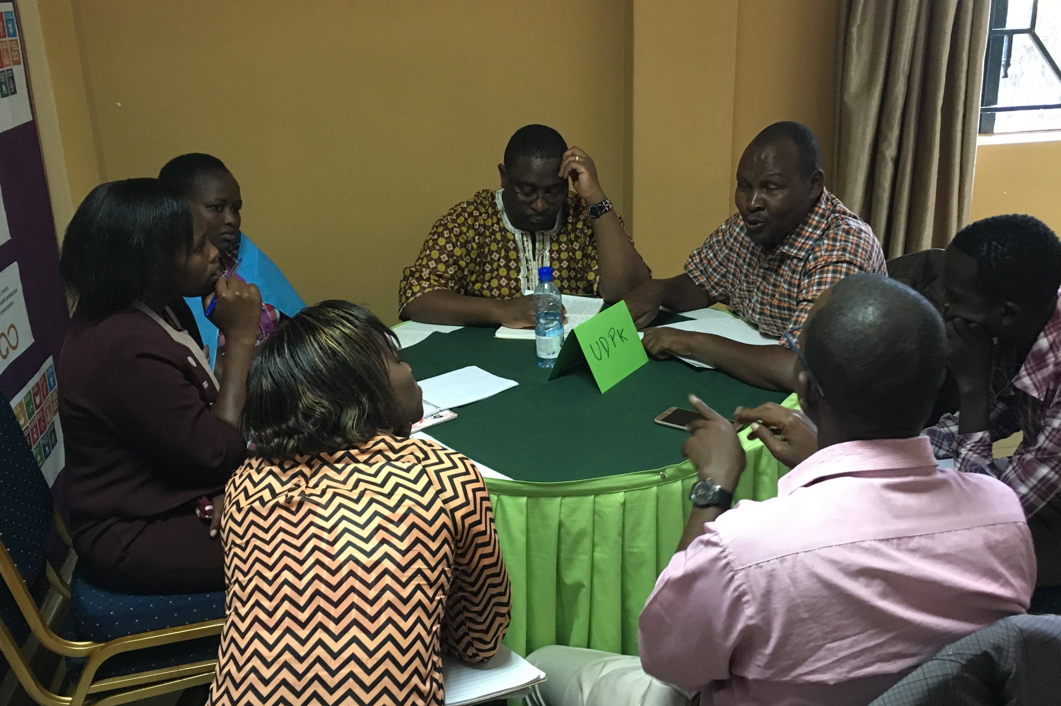
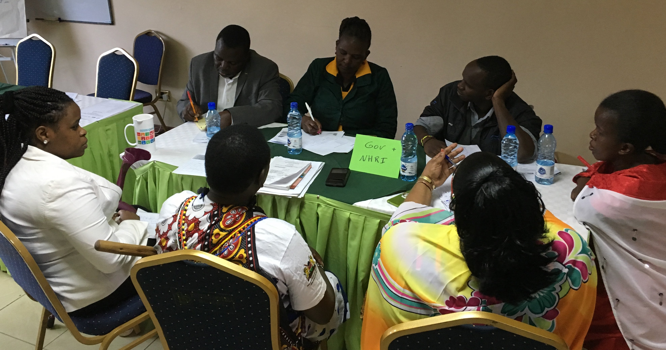
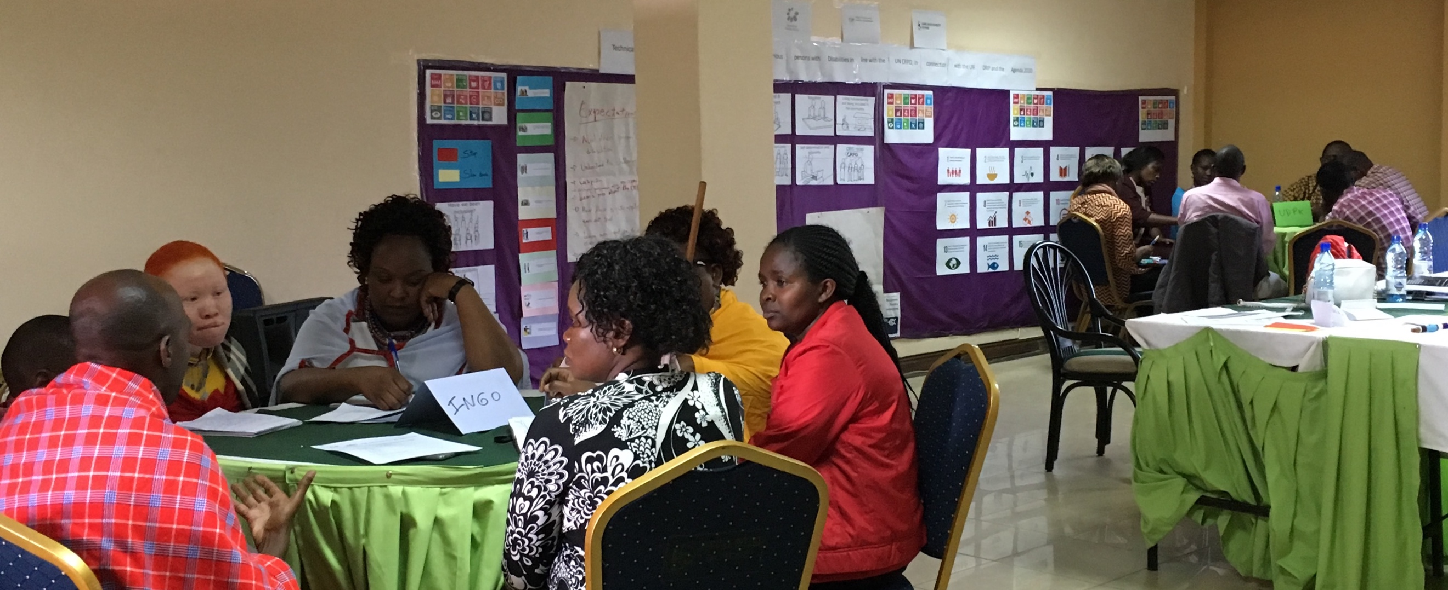

Indigenous leaders with disabilities presented, in their respective groups, the work they are implementing related to the CRPD and the SDGs either at local or county level. The round of presentation was followed by an informal discussion on how stakeholders are involving indigenous persons with disabilities in their work and, if not, they jointly explored how to make that possible.

Furthermore, the group discussed about the importance and opportunity to collect data on indigenous persons with disabilities, and whether and how their budget included indigenous persons with disabilities including women and children with disabilities. In general, the discussions covered the following points:

Group 1 – Meeting with UDPK
- UDPK agreed to increase work with indigenous persons with disabilities
- Importance to ensure regional balance
- Follow up: Indigenous group will register with the UDPK, and UDPK will involve indigenous representatives at their current training at counties level, include a representative of the indigenous leaders in the DPOs WhatsApp group, and have a focal point identified among the indigenous representatives

Group 2 – Meeting with Ministry of Labour and Social Security, and the KNCHR
- Discussed about cash transfer being more accessible
- Expand support to accessibility efforts more inclusive of all
- Ensuring that at least 5% of the public procurement is respected
- Follow up: Ensure that the design of the upcoming census is inclusive of persons with disabilities; and that a focal point among the indigenous representatives is stipulated

Group 3 – Meeting with Leonard Cheshire (IDDC member)
- The office in Kenya covers education, data collection, trainings on monitoring and reporting and data collection on the upcoming census, in partnership with UDPK
- Established partnership with UDPK and constant work with persons with disabilities, but not yet with indigenous persons with disabilities
- Work with children on education and livelihoods
- Follow up: Interest to work with indigenous persons with disabilities, but there is a need to be registered under UDPK.

After the lunch with different stakeholders and the group picture, the afternoon session was dedicated to a de-briefing discussion only with the indigenous leaders. Main feedback from the leaders on the informal discussions with stakeholders was:

- The preparation the previous day was very important as they were able to:
- get prepared to go directly into the discussions,
- to address main areas that were missing in the presentation,
- to get more confidence during the discussions.

- Regarding the meeting with stakeholders was:
- the set up was very nice,
- leaders were able to express themselves freely and in confidence,
- enough time allowed for interactions and views exchange,
- excellent format,
- great opportunity to share,
- important role from sign language interpreter.
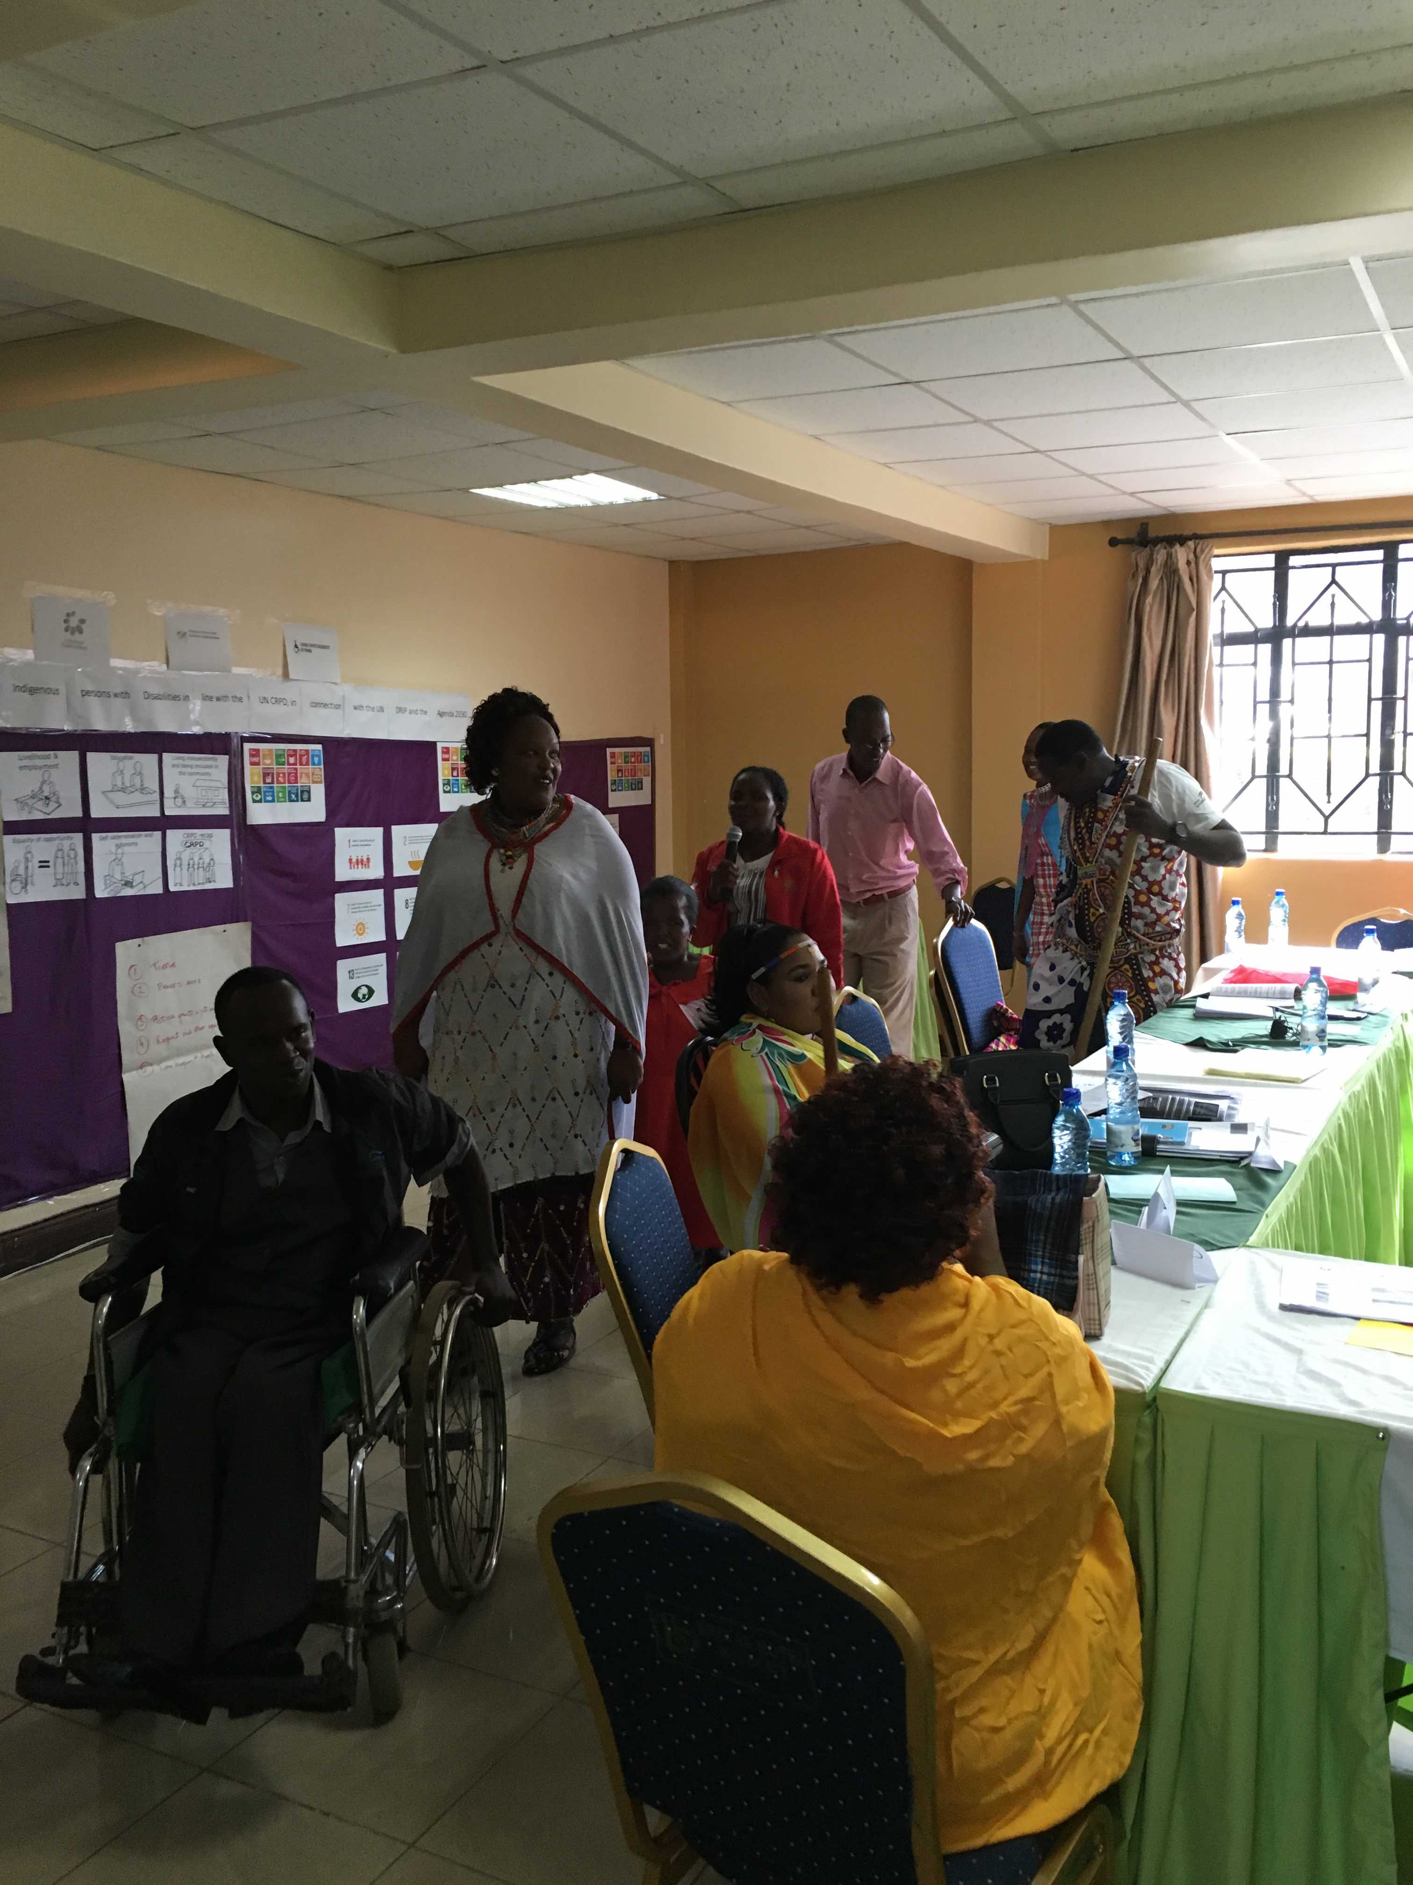
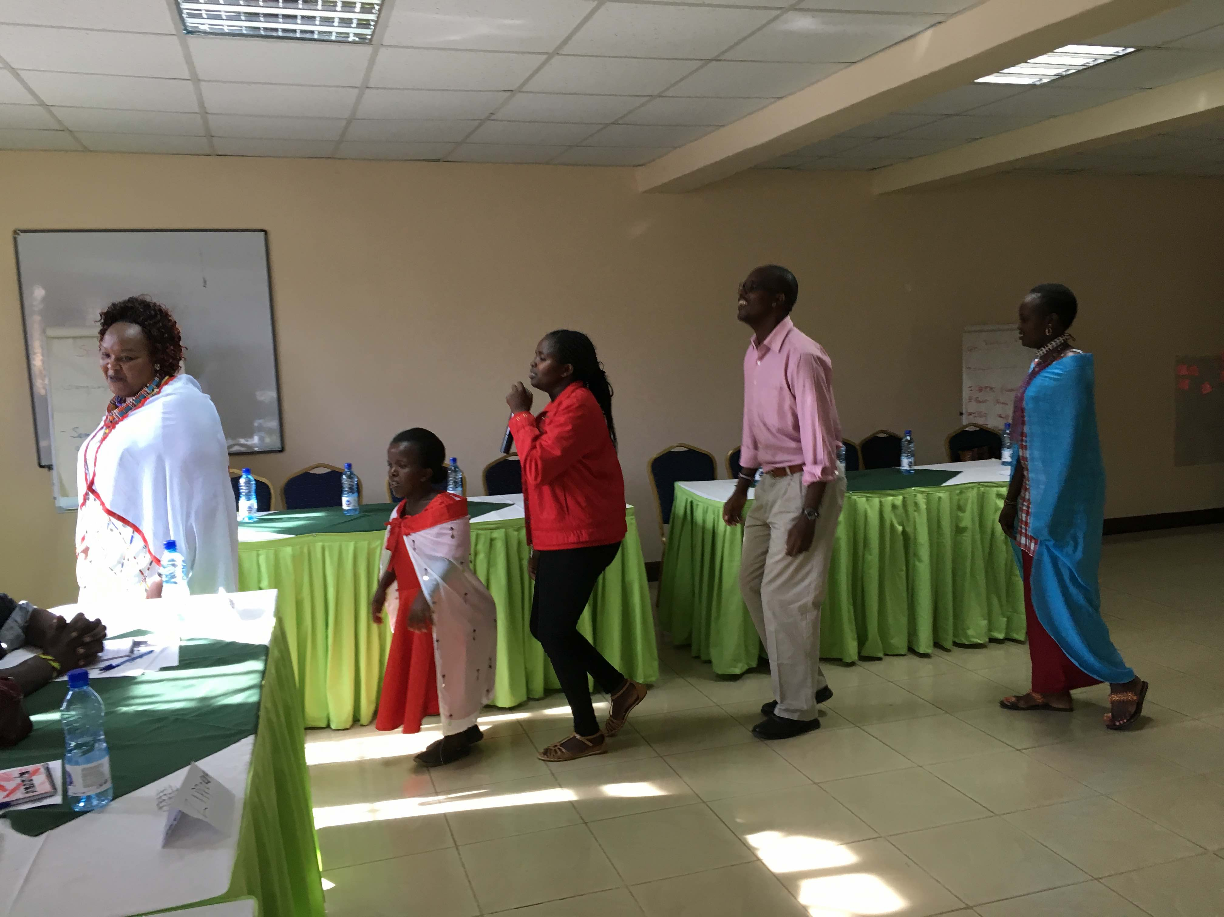
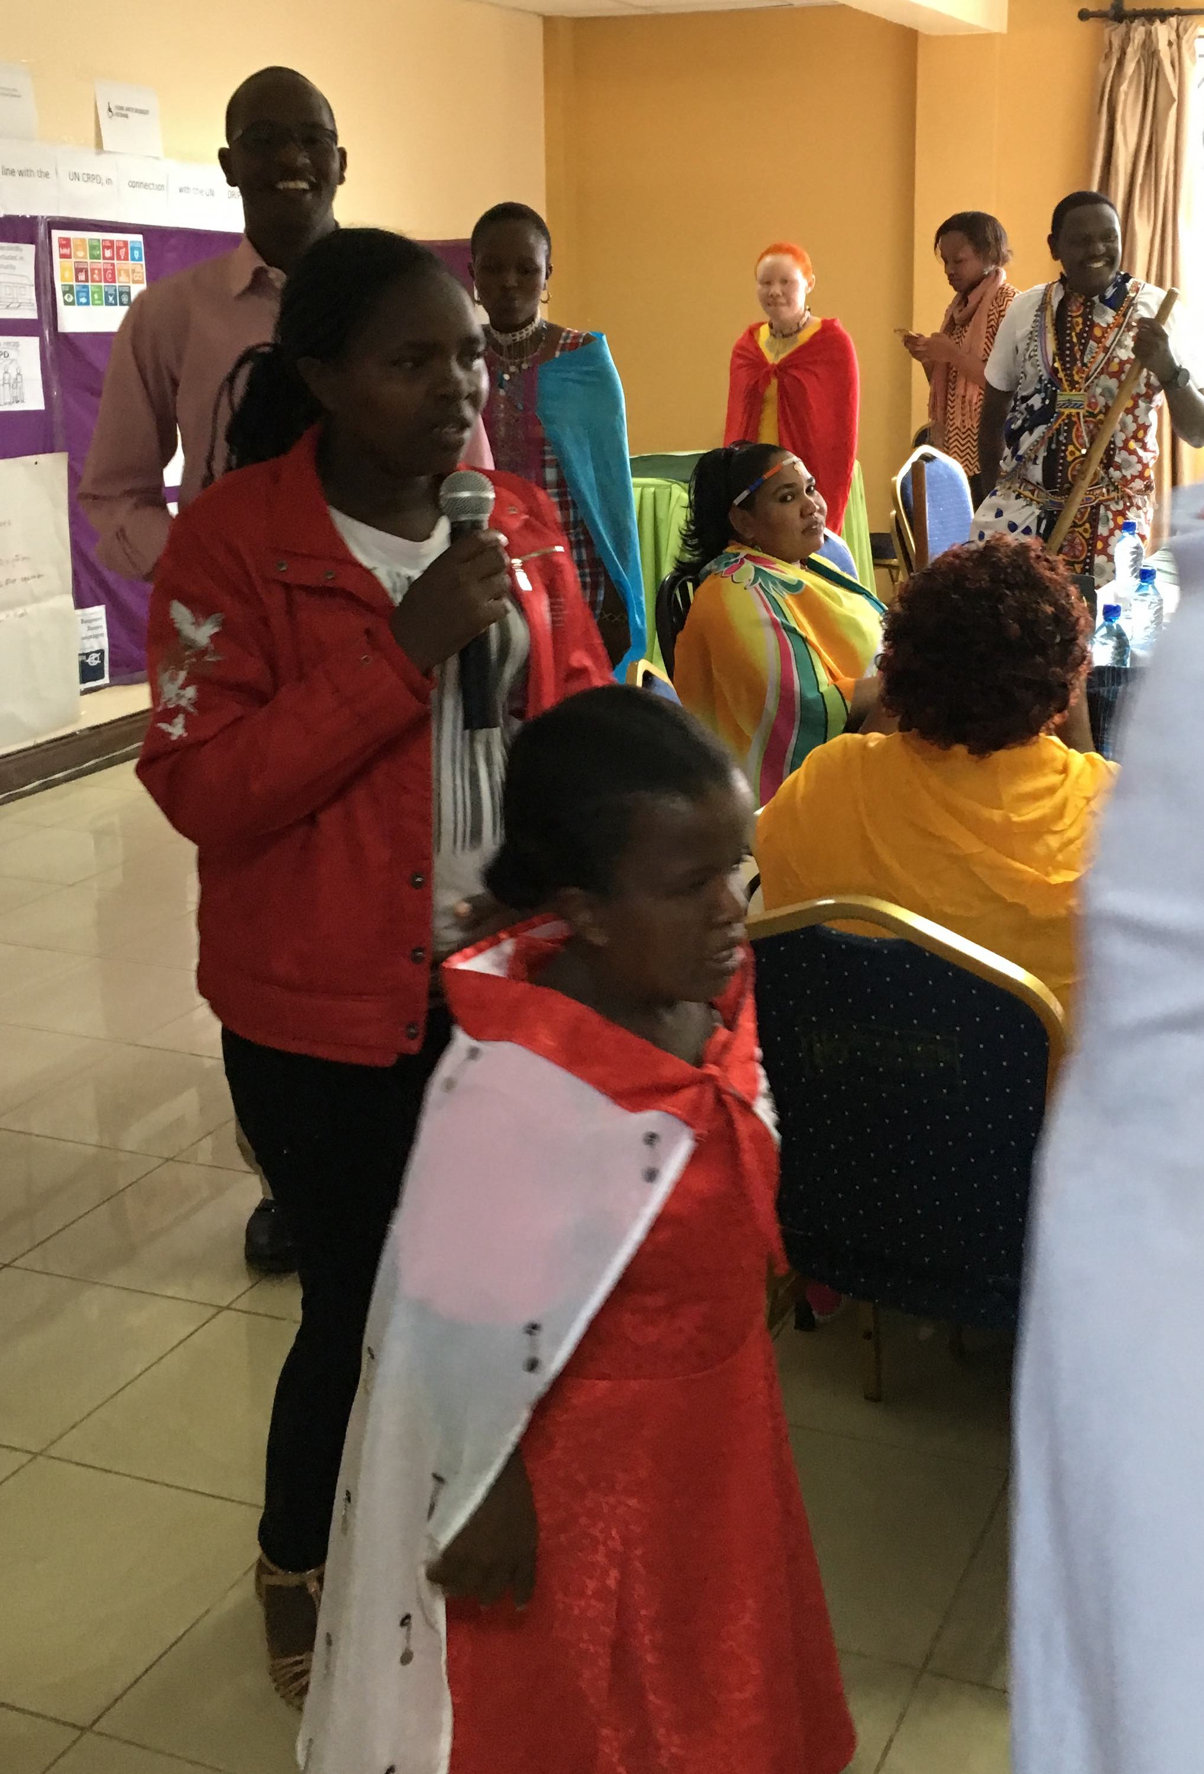

In the last session of the day, the indigenous leaders discussed about the role and evolution of the indigenous persons with disabilities within the movement of persons with disabilities and indigenous peoples in Kenya.

The day was concluded with a traditional song and dance with participants and facilitators.

Once again, the “Moodometer” was very positive.

Fourth day

The day was opened with a plenary session on follow up actions considering different stakeholder, as following:

Group 1 – Follow up towards the disability and indigenous movements
- Get involved in their work on capacity building,
- Strengthen advocacy together with UDPK toward government and organisations of persons with disabilities bringing the indigenous identity,
- Actively participate in decision making processes.

Group 2 – Follow up towards the Government and the KNCHR
- Creating awareness on indigenous people with disabilities towards government at national, county and local levels,
- Reinforce grass-roots organisations of indigenous persons with disabilities and their advocacy,
- Resource mobilization (financial, human, infrastructure and in kind resources).

Group 3 – Follow up towards IDDC members and other international NGOs
- Contact different IDDC members and Civil Society Organisations on issues related to capacity building, advocacy, awareness raising and participation,
- Partnership to strengthen organisations of indigenous peoples with disabilities with other organisations working on human rights, development, disabilities, indigenous and women’s rights,
- Seek support from CSOs regarding resources (financial, material, on infrastructure and human),
- Foster active collaboration, both at county, but also at national levels.

The session was followed by an informal discussion on how to strengthen the IPWDGN in Kenya. A video was shared with all participants on the meeting held by members of the IPWDGN in Geneva in 2017, during the Expert Mechanism on the Rights of Indigenous Peoples (EMRIP).

The day was concluded by a session evaluating the training, which was very positive and can be summarised as following:

- It was important to have reflected at the same time as a person with disabilities, but recognising its very nature as indigenous person,
- Important to see indigenous persons with disabilities representing themselves, which is not often,
- Learnt on how to network towards government and other organisations,
- Learnt about inclusive facilitation and how to use the shared materials in future trainings,
- Importance to link with other organisations,
- Learnt a lot about right that even didn’t know about,
- The training exceeded expectations; will share with others on what they learnt,
- It was a great opportunity to know that we are so many and now we will be in contact,
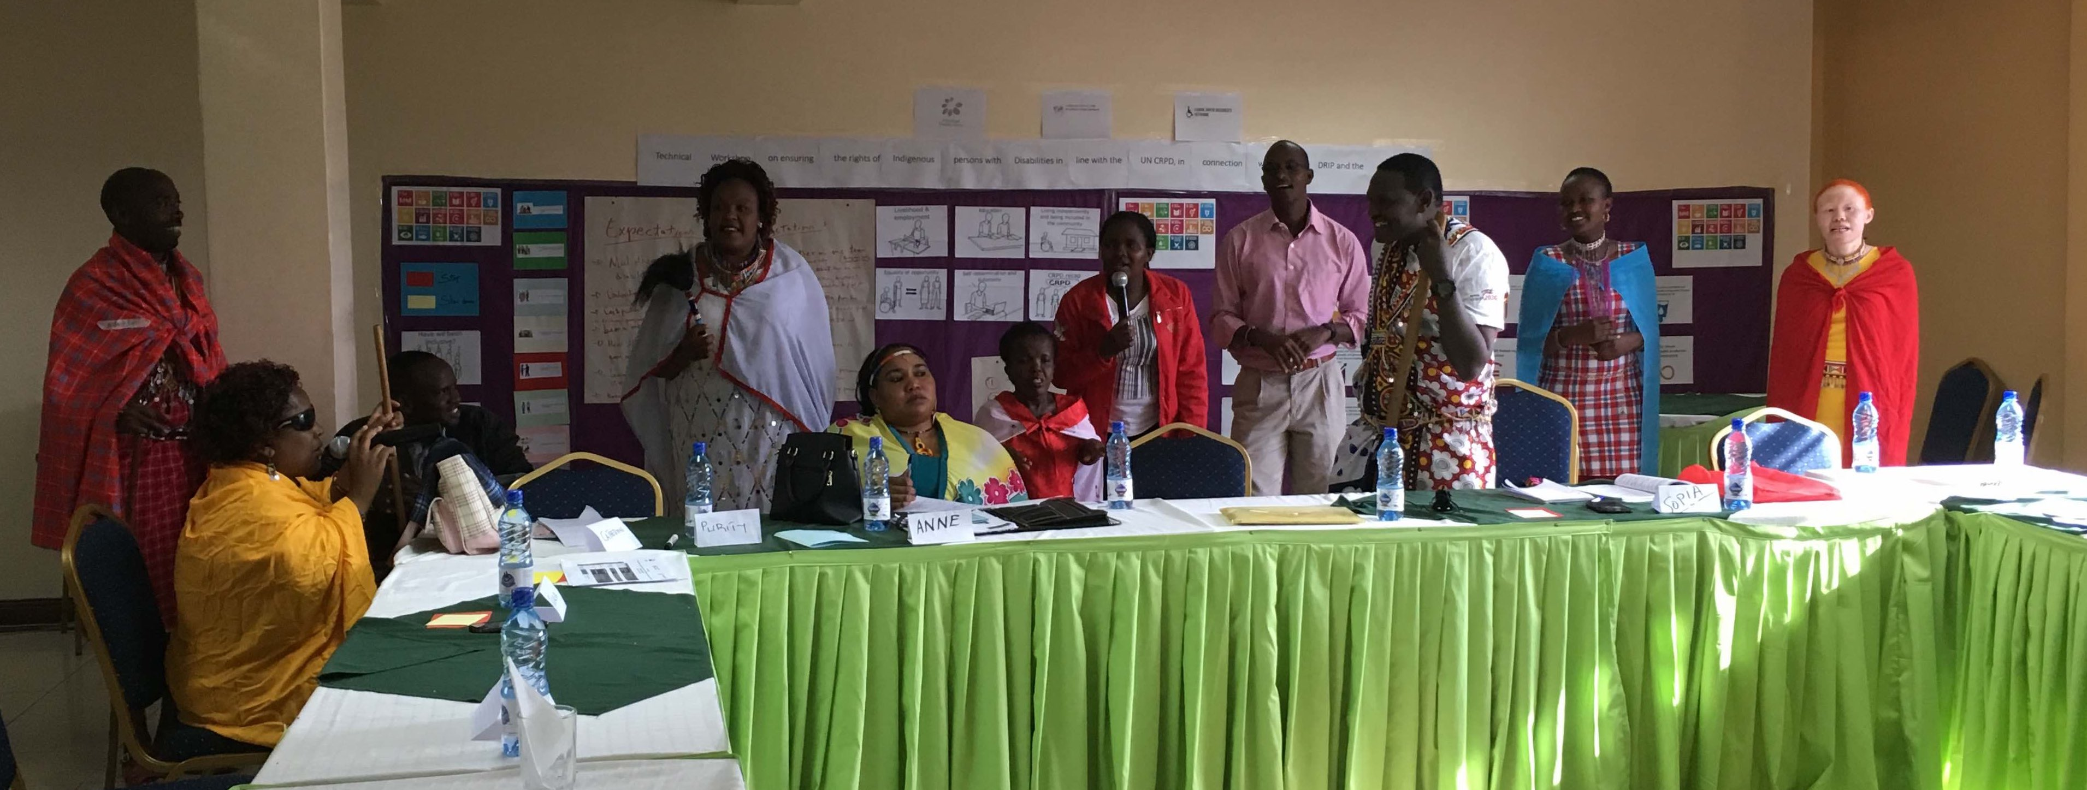
- Will organise the women movement of indigenous women with disabilities in Kenya,
- Expect other trainings to their indigenous fellows as more capacity building is needed.

Testimonials

Anderson Gitonga, Chief Executive Officer, United Disabled Persons of Kenya and Board of East Africa Federation of the Disabled

“This is a landmark meeting. UDPK is committed to work with indigenous people with disabilities as well as persons with psychosocial disabilities and intellectual disabilities. These groups cannot be left behind. It is important that indigenous persons with disabilities are involved in the work of Disabled Persons Organizations (DPOs). There is need to come up with a close coalition which would be important to advance the rights of indigenous persons with disabilities and it is a good thing that already they have come together under the Narok South Disability Network to receive training on the CRPD, SDGs and UNDRIP. This engagement with participants in this workshop has been key in reminding us, the umbrella organization, that often time indigenous persons with disabilities may be left out in the work of DPOs.

Awareness raising and advocacy on advancing the rights of the indigenous persons with disabilities is important and even as a big responsibility to advance their rights does fall on their shoulders because they bring their own, rich diverse experiences as indigenous people, as the umbrella organization we shall continue to work with them and all persons with disabilities in Kenya to advance our rights.”

Elizabeth Shiakamiri, Leonard Cheshire Disability
“As human beings, we have different identities and engaging with indigenous persons with disability in this workshop has been very important to show the intersectionality between indigenous persons and disability. Discrimination happens based on our different identities and being an indigenous person with disability would expose individuals to multiple forms of discrimination.

As a development organization, we realize that there is still an information gap and sometimes we may not reach out to all people and this workshop has opened the way for us to ensure that indigenous persons with disabilities are meaningfully involved in our programs.

Going forward it is critical that all development partners are deliberate about reaching out to marginalized groups whereby indigenous persons with disabilities fall.”

Manaseh Ntutu, Chairman of the Narok South Disability Network
“It is the very first time we organise a meeting for, by and with indigenous persons with disabilities in Kenya. I am glad of its success. A step has been made towards reaching unreached communities. And what better way than to learn about the CRPD, SDGs and UNDRIP? The focus is to leave no one behind!

Due to limited resources, poor infrastructure, limited education, access to information among other barriers, most indigenous communities and more so those with disabilities may be negatively affected. For us, coming to meet the people in these rural and remote areas is very critical because it is also supporting our government in many ways.

The government is keen on public participation of people in policy development among others, but how can communities participate if they have no information? Therefore, it was important that the indigenous persons with disabilities get the information. This is a resource that is very important for us.

The workshop has indeed supported us and will help us in our advocacy in ensuring that we are advocating for inclusion in our communities. There is continued need to build synergies between government and the people and this is one way of doing it and we are happy that we received the support from international partners to carry out the training.”

Peter Musakhi, State Department of Social Protection, Pensions and Senior Citizens; Ministry of Labour and Social Protection
“There is increasing need to focus on rural areas as we continue to implement the Convention on the Rights of Persons with Disabilities in Kenya. Building the capacity of all persons with disabilities is crucial because with information on their human rights, all persons with disabilities including those from the indigenous communities will be in a position to demand these rights.

Capacity building is also important because as the state we must consult with persons with disabilities to inform our policies and programing. We acknowledge that we may not have all the information and the people with disabilities are crucial to help us and working to ensure inclusion means that we exchange knowledge gained through our lived experiences but also that we gain through such trainings as this one that has been carried out with indigenous persons with disabilities.

It is important to acknowledge that some people in view of years of discrimination, they have been left behind in development. There are communities that apply their culture in doing things and it is important to recognize traditions and identity. We appreciate all cultures and it is important to mainstream disability in the view of cultural differences. As such we shall continue to work with all persons with disabilities including those from indigenous communities.”

Shathika Chivusia, Kenya National Commission on Human Rights
“As the Commission, we have worked before with indigenous persons and also with persons with disabilities. However, we have not worked with indigenous persons with disabilities. This has been an eye opener for us who are the designated national monitoring agency under Article 33.2 of the CRPD. Interacting with the participants has brought to the fore key concerns such as the need to expand social protection measures for indigenous persons with disabilities. Issues were also raised of not obtaining ID cards where parents do not register their children with disabilities as they are not seen to be of value.

As such, this engagement of the Commission with the indigenous persons with disabilities has been informative and interesting and going forward we realize that there is need to equip indigenous persons with disabilities. This will be through protection of their rights particularly in regard to their inclusion in decision making and non-discrimination.

It is also important to continue to improve their social and economic conditions by ensuring that they have access to employment and inclusive education. This can be achieved though holding forums and conducting trainings organized by various stakeholders and national human rights institutions on the rights of indigenous persons with disabilities and how to claim them. As such it is important that the International Disability Alliance and the Indigenous persons with disabilities in Kenya have partnered to hold this training.”

Sopia Paul
“I am a teacher and a social worker. I am also a trainer and I founded a Disabled Persons Organization (DPO). I have worked for many years with persons with disabilities and I appreciate that this training on the CRPD, the SDGs and UNDRIP has added to my knowledge and given me new insights on how I do my advocacy. During these four days, I learnt a lot about rights of persons with disabilities and knowledge of the CRPD has given me the strength to understand that both locally and globally, there is space for us to engage with our governments and here in my community also engage with the county government.

Meeting government and development stakeholders was very important for me as they reaffirmed that they have opened their doors to engage with us indigenous persons with disabilities. Something important for me, among the new things I learnt was on advocacy. How to do advocacy in different ways. For example, most of us persons with disabilities having gone through an education that segregates us, we have often felt happy with it. But I realized that special education in no way makes us special rather it isolates us from the community. For that, my advocacy skills have been strengthened especially on advocating for inclusive education and also that all teachers have skills to train learners with disabilities.”

Zipporah Mereso Ntininie
“I am 26-year-old and my career is in human resource management. As a young woman, who is indigenous, and has albinism, this training was timely for me and also new because I had not been introduced to the CRPD before. So, to learn and understand my rights and also to understand that my government has a duty to fulfil my rights was very meaningful for me.

I also learnt that through DPOs we can advance our rights which has given me an impetus to make sure that other youth with albinism are also members of DPOs. As an indigenous person now I have been equipped with skills that I can also pass to other people especially the youth with disability.

Speaking with a development partner from an international agency was also important for me. I used to think that I could only engage with the National Council for Persons with Disabilities but I have learnt that as I am a member of my community, I should be able to engage with all organizations that work not only for disability but also in development.”

Anne Siodi
“I am 26 years old and work as a teacher. As a deaf woman, this training has exposed me to the rights of all persons with disabilities and I am glad to have been involved because it is not something that happens all the time. I will use the opportunity to also share the knowledge with other persons in my community.”

Anne Nakunyinyi Thomas, Loitoktok Association for the Disabled
“My greatest learning was about the UNCRPD, SDG and UNDRIP and how to use these three instruments to achieve inclusion of indigenous persons with disabilities. During the workshop, I met key people from entities like Kenya National Human Rights Commission and Ministry of Labor and Social Protection. I felt privileged engaging them on matters that affects indigenous persons with disabilities. I also learnt more about the umbrella bodies of persons with disabilities and how to engage them.

I am more focused on leading my grassroots organization to lobby and to advocate for the rights of indigenous persons with disabilities by utilizing the knowledge that I gained as I learned that it is upon DPO’s to claim rights for indigenous persons with disabilities.”

Kool Tiampati John, Narok South Disability Network
“My greatest learnings were more information on UNCRPD, SDG and UNDRIP. The meaning of CRPD principles was very insightful to me. As a leader and through my DPO, I have the role of passing information to other organizations of indigenous persons with disabilities and to do more awareness raising in community. Interacting with a representative from INGO was beneficial for me. I learnt how to cooperate with different stakeholders.”

