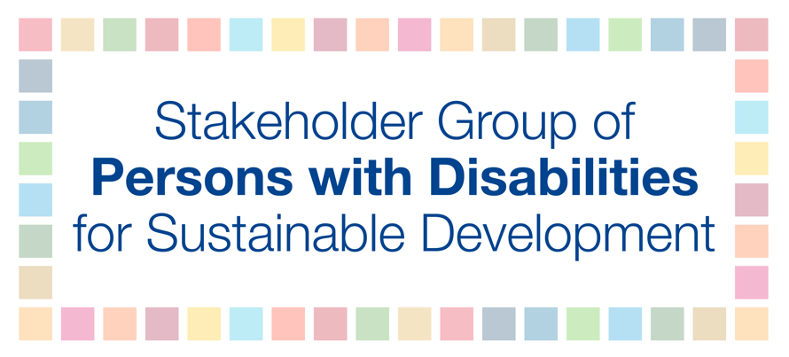

HLPF 2019

Official session: Progress, gaps and obstacles: are we on track for leaving no one behind?
Tuesday, July 9th
10:00 AM – 1:00 PM

George Khoury – official discussant

Persons with disabilities experience compounding social, economic and political inequality, which is exacerbated when disability intersects with other forms of discrimination, including on the basis of gender, age, ethnicity, and other factors. We are over-represented among people living in poverty and among those most left behind. Despite this, persons with disabilities have not been included in SDG implementation thus far. And there is a consequence to this as there are economic costs of exclusion that can affect all of a society leading to a loss of 3 to 7 percent of Gross Domestic Product (GDP) if persons with disabilities do not participate fully in their communities and countries.

Redressing these many inequalities requires dedicated resources. Yet available evidence suggests that in practice, although there have been some pockets of progress, such resources are rarely available. Gaps exist in critical areas, including in inclusive education for children with disabilities; sign language interpretation for deaf people seeking to access health facilities; and essential support services that would enable persons with disabilities to live independently, to name a few examples.

Regardless of constraints governments face due to inequalities, they still have a duty to align national-level fiscal policies with their human rights obligations, paying particular attention to the rights of marginalized groups. Furthermore, in order to be included we need Member States to produce targeted action-oriented steps with commitments across all ministries and across central, subnational and local government to realize inclusion.

Specifically, we recommend:
- Concrete actions to reach the furthest behind, including those most marginalized within the disability community;
- Data collection and disaggregation of data by disability to inform policy makers of gaps and challenges that must be addressed;
- System-wide resource allocation and commitments on disability spending;
- Accessibility as a precondition to enable persons with disabilities to actively participate on an equal basis with others; and
- Full and equal participation of persons with disabilities in all aspects of society.

We, as persons with disabilities have as much of an obligation to leave no one behind as we expect from others. We must ask, isn’t it better, as persons with disabilities in partnership with Member States, to begin taking steps toward this goal by embodying the spirit of the global agenda, by being proactive and visible advocates and partners of transformative change? We all know inclusion is a two-way process, and we must all apply the principles for which we advocate.

Thank you.

