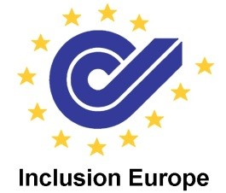
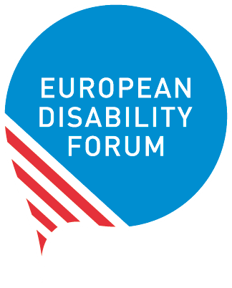
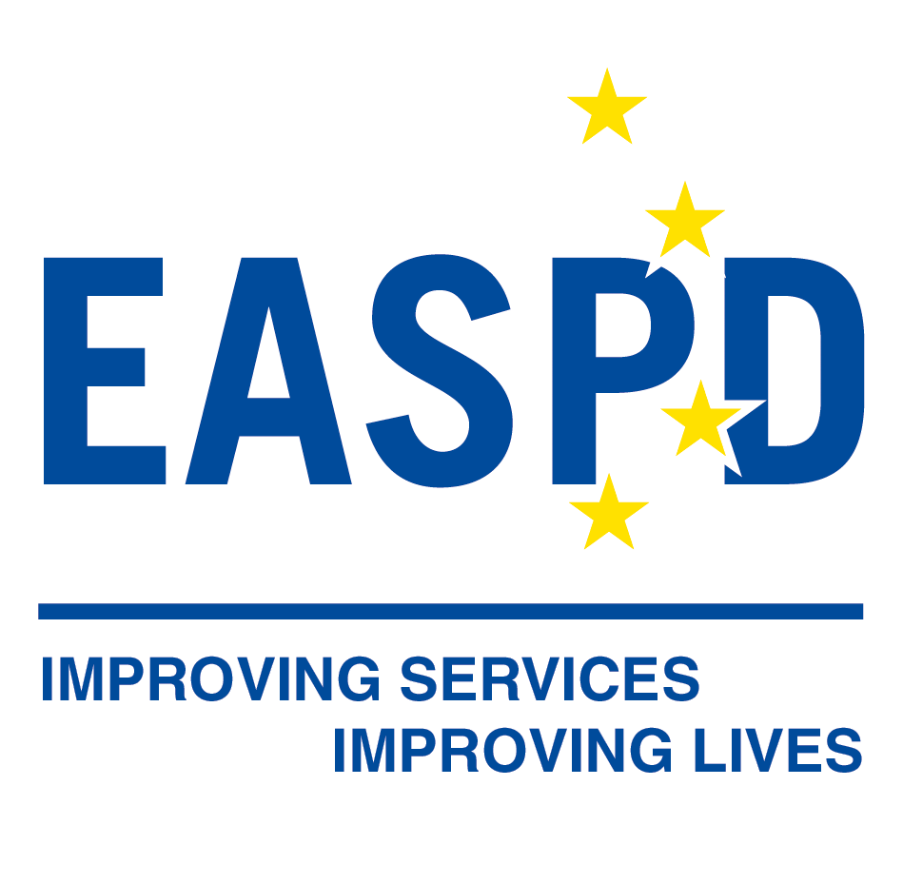
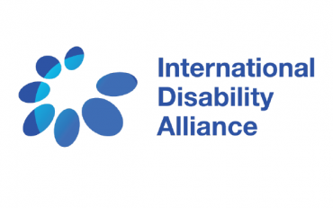
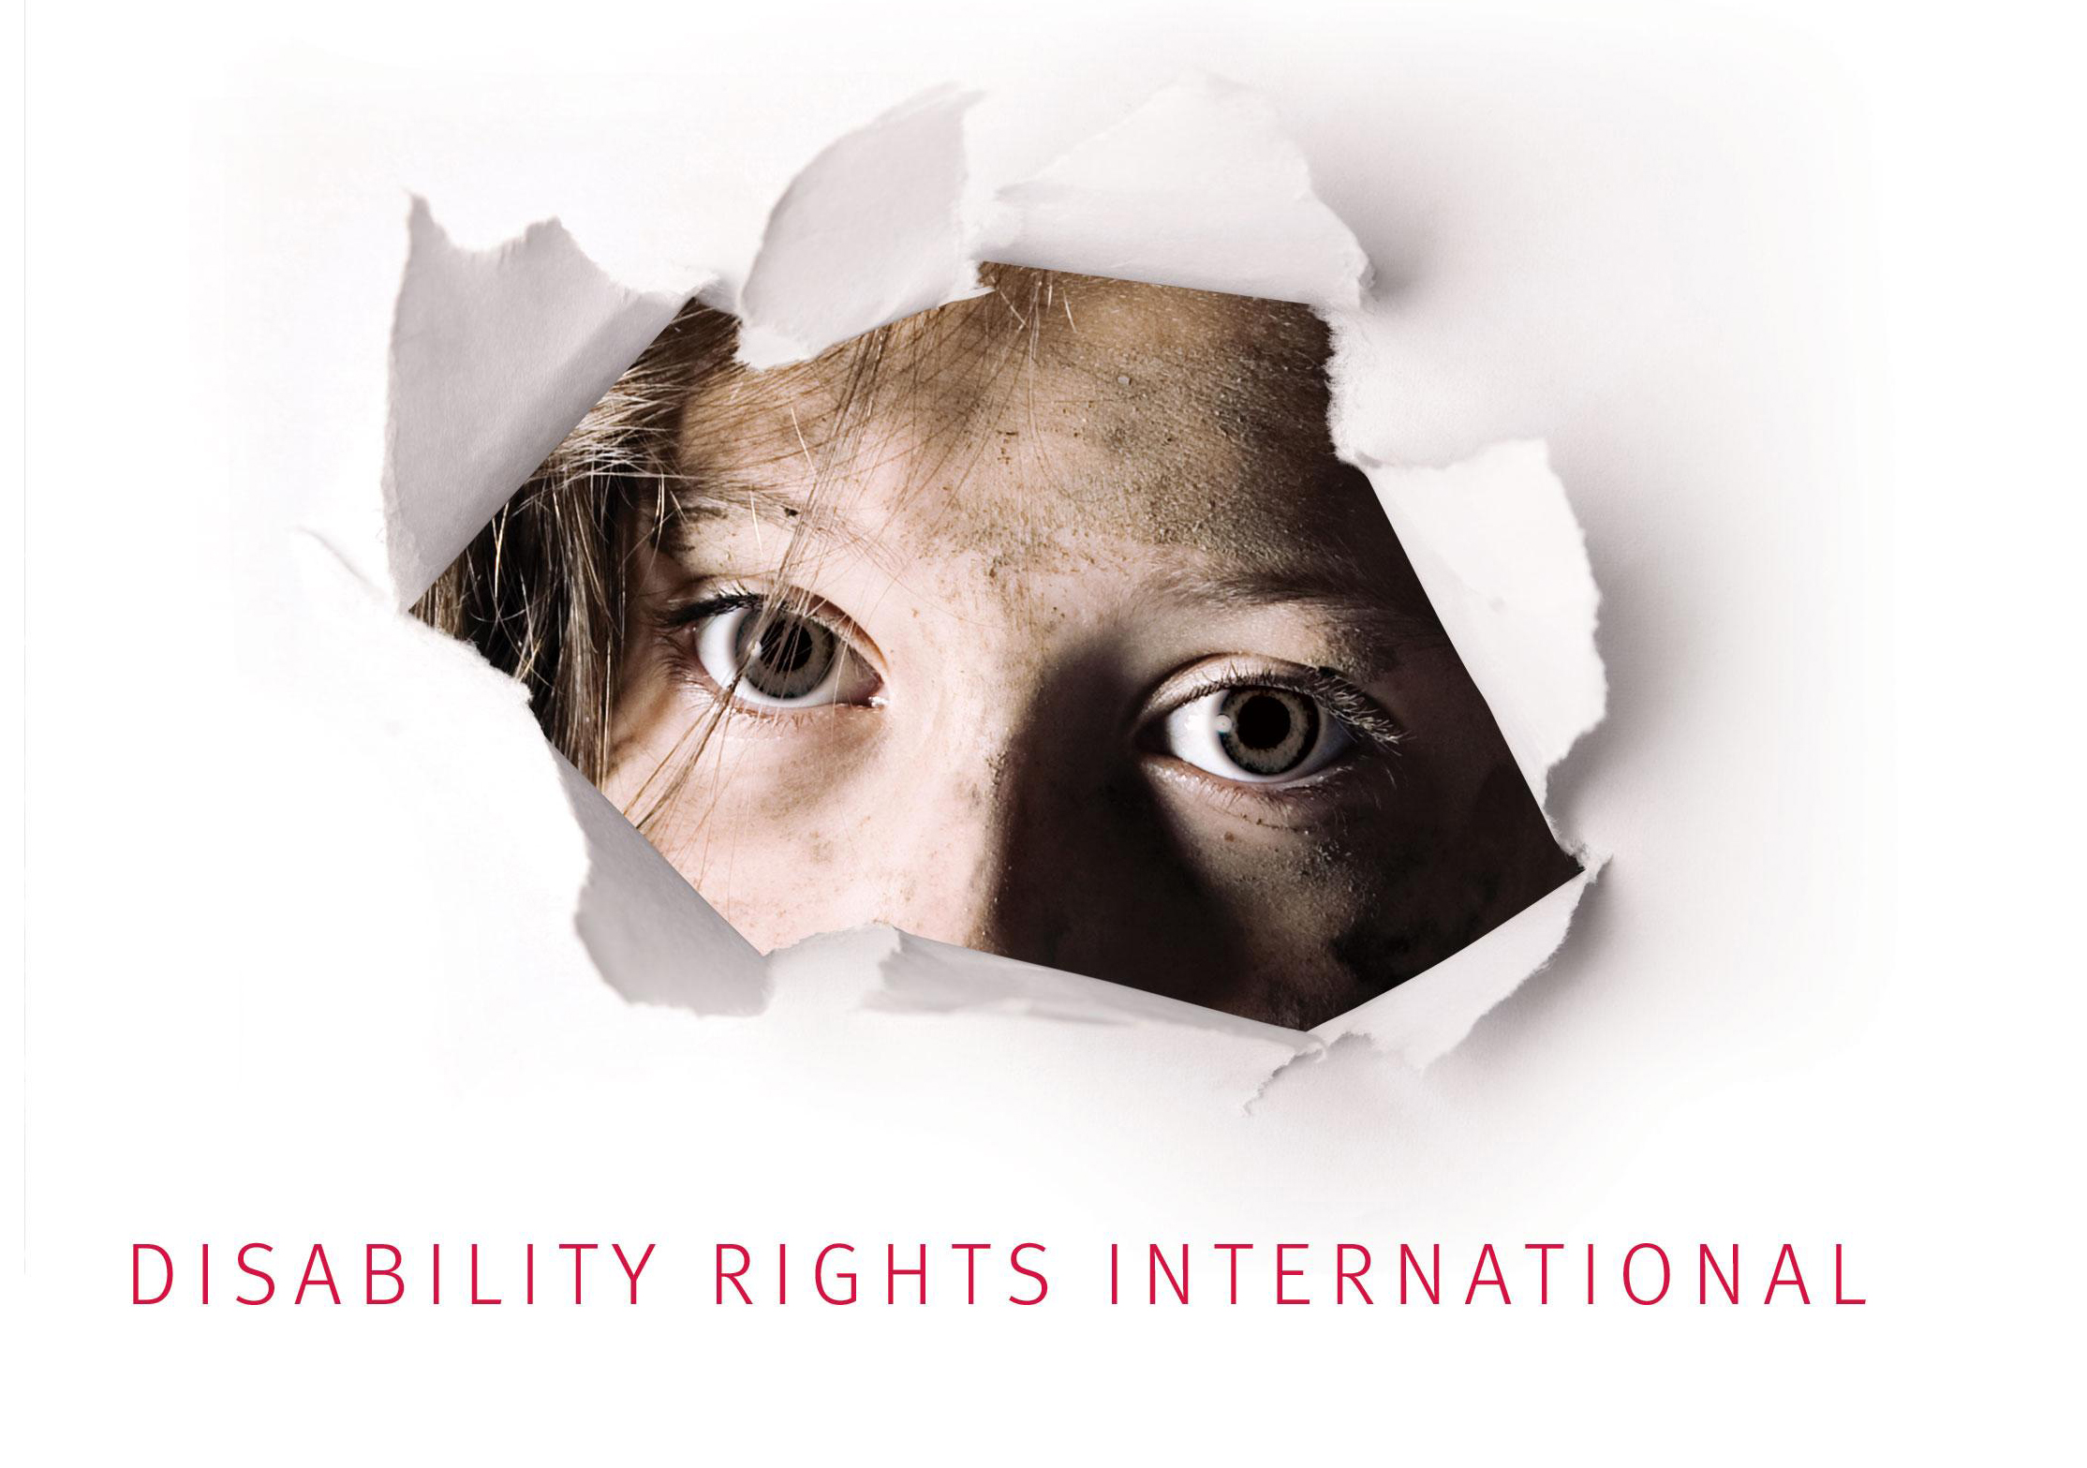

#WITHDRAWOVIEDO

FORCED TREATMENT AND PLACEMENT VIOLATE RIGHTS OF PEOPLE WITH DISABILITIES AND THE UN CONVENTION ON THE RIGHTS OF PERSONS WITH DISABILITIES

Since 2014, under the mandate received from member states of the Council of Europe, the DH-BIO Committee of the Council of Europe has been working on a draft additional protocol to the Oviedo Convention concerning the protection of human rights and dignity of “persons with mental disorders”.

If adopted, this protocol would greatly undermine the rights of persons with disabilities:

- Its text and spirit violate the UN Convention on the Rights of Persons with Disabilities (CRPD), that has been ratified by 46 of the 47 Member States of the Council of Europe, including all the Member States of the European Union (see statement of the experts of the UN Committee on the Rights of Persons with Disabilities attached).

- It would lead to further institutionalisation and forced treatment. These practices are condemned by the UN Committee on the Rights of Persons with Disabilities and the UN Special Rapporteur on the Rights of Persons with Disabilities.

- It would create a legal conflict between the obligations of States at the regional level (Council of Europe) and at the international level (United Nations).

We, organisations of persons with disabilities, call for the immediate withdrawal of the draft additional protocol to the Oviedo Convention. We urge States to focus on and develop alternative measures to forced treatment and institutionalisation, in collaboration with organisations of persons with disabilities.
Our opposition to the draft additional protocol is supported by international experts, such as:

- Commissioner of Human Rights of the Council of Europe
- Parliamentary Assembly of the Council of Europe
- UN Committee on the Rights of Persons with Disabilities
- UN Special Rapporteur on the right to health
- UN Special Rapporteur on the rights of persons with disabilities
- UN Working Group on Arbitrary Detention

We welcome the opposition expressed by the States of Bulgaria, Portugal and the Former Yugoslav Republic of Macedonia and remain available to provide further information to Council of Europe member states on the discriminatory nature of this draft protocol and the many alternatives possible in compliance with the CRPD.

Autism-Europe
Disability Rights International
European Disability Forum
European Network of (ex)-Users and Survivors of Psychiatry
European Association of Service Providers for Persons with Disabilities
Inclusion Europe
International Disability Alliance
Mental Health Europe
Validity

More information is available on our websites:

Autism-Europe: http://www.autismeurope.org/what-we-do/rights-promotion/withdraw-the-additional-protocol-to-the-oviedo-convention/

European Disability Forum: http://www.edf-feph.org/withdraw-additional-protocol-oviedo-convention

European Network of (ex)-Users and Survivors of Psychiatry: http://enusp.org/2018/04/18/enusp-started-campaign-against-the-draft-additional-protocol-to-the-oviedo-convention/

Inclusion Europe: http://inclusion-europe.eu/?p=6848

Mental Health Europe: https://mhe-sme.org/drop-draft-oviedo-convention/

Committee on the Rights of Persons with Disabilities (CRPD)
Statement

Statement by the Committee on the Rights of Persons with Disabilities calling States parties to oppose the draft Additional Protocol to the Oviedo Convention

Adopted during the Committee’s 20th session, held, from 27 August 21 September 2018 in Geneva

The Committee calls upon States parties of the United Nations Convention on the Rights of Persons with Disabilities to oppose the draft Additional Protocol to the Council of Europe in relation to the Additional Protocol to the Council of Europe Convention for the Protection of Human Rights and Dignity of the Human Being with regard to the Application of Biology and Medicine: Convention on Human Rights and Biomedicine (ETS No 164) (herein referred as the ‘Additional Protocol to the Oviedo Convention’).
The draft Additional Protocol, which purportedly aims at protecting the rights of all persons with “mental disorders” with regard to the use of involuntary placement and involuntary treatment blatantly conflicts with the human rights of persons with disabilities recognised by the Convention on the Rights of Persons with Disabilities. It violates particularly article 5 on equality and non-discrimination in conjunction with articles 12 on the right of equal recognition before the law, article 14 on the right to liberty and security, article 17 on the right to physical and mental integrity, and article 25 on the right to health.
Article 12 of the Convention on the Rights of Persons with Disabilities states that all persons with disabilities, including those with psychosocial disabilities, have the right to equal recognition before the law and should enjoy legal capacity on an equal basis with others. It sets forth two positive aspects of personal autonomy: the respect for one's own choices shaped by individual will and preferences, and the promotion of personal autonomy through supported decision-making. In this regard, States parties have an obligation not to deprive persons with disabilities of the right to make and pursue their own decisions, nor to permit substitute decision-makers to provide consent on their behalf. Instead, States parties must provide persons with disabilities with access to different forms of support arrangements for the exercise of their legal capacity, including the provision of consent.
Article 14 of the Convention on the Rights of Persons with Disabilities prohibits all unlawful or arbitrary deprivation of liberty of persons with disabilities, clarifying that the existence of impairment cannot justify a deprivation of liberty. Prevalent mental health laws nowadays justify detention on the grounds of actual or perceived mental impairment, or based on potential dangerousness to themselves or others. While the criteria purport to be objective and reasonable, in practice they have the effect of targeting persons with disabilities, in particular persons with psychosocial and persons with intellectual disabilities who are commonly considered as being dangerous and in need of treatment or care. Hence, such measures are discriminatory and in contradiction of the prohibition of deprivation of liberty on the grounds of impairment, and the right to liberty on an equal basis with others prescribed by article 14. States have an obligation to replace the use of coercive psychiatry with support in decision making on health related matters and alternative service models that are respectful of the will and preferences of the person.
Persons with intellectual or psychosocial impairments are frequently considered dangerous to themselves and others when they do not consent to and/or resist medical or therapeutic treatment. All persons, including those with disabilities, have a duty to do no harm. Legal systems based on the rule of law have criminal and other laws in place to deal with the breach of this obligation. Persons with disabilities are frequently denied equal protection under these laws by being diverted to a separate track of law, including through mental health laws. This situation would be perpetuated by the Additional Protocol to the Oviedo Convention. These laws and procedures commonly have a lower standard when it comes to human rights protection, particularly the right to due process and fair trial, and are incompatible with article 13 in conjunction with article 14 of the Convention.
Article 25 of the Convention on the Rights of Persons with Disabilities expressly requires States to provide health care to persons with disabilities on the basis of free and informed consent. Health professionals are therefore obliged to ensure that consent is always provided before any medical intervention can be performed. On the basis of respect for a person’s consent, people are also entitled to refuse treatment, even when there is ground to believe that treatment would benefit their health. Persons with psychosocial disabilities should be treated no differently, and as a result, they enjoy the same right to accept or refuse medical treatment.
Furthermore, involuntary placement and treatment represent also a threat to the right to physical integrity, as recognised by article 17 of the Convention on the Rights of Persons with Disabilities. In practice, these non-consensual interventions entail the use of force, chemical or physical restraints, isolation, seclusion, or sedation. Such practices exceed the scope of the right to health and may amount to torture or cruel, inhuman or degrading treatment.
The Committee recalls that despite these concerns being expressed to the Secretary-General of the Council of Europe in a joint letter dated 29 September 2017 by the Working Group on Arbitrary Detention, the Chair of the Committee on the Rights of Persons with Disabilities, the Special Rapporteur on the rights of persons with disabilities, and the Special Rapporteur on the right of everyone to the enjoyment of the highest attainable standard of physical and mental health, and to the Committee on Bioethics of the Council of Europe in submissions from other stakeholders, alternatives to the Additional Protocol that would comply with the human rights of persons with disabilities have not been discussed.
The Committee strongly recommends that all States parties to the Convention on the Rights of Persons with Disabilities who are members of the Council of Europe explicitly oppose the adoption of the Additional Protocol to the Oviedo Convention. The Committee also welcomes the opposition already expressed by the States of Portugal, Bulgaria and the Former Yugoslav Republic of Macedonia, and encourages them to raise their views before the Committee on Bioethics of the Council of Europe.

*****

See Committee’s General Comment No 1 of 2014 (CRPD/C/CG/1)
See the Committee’s Guidelines on article 14 of the Convention on the Rights of Persons with Disabilities, paragraph 6. See also A/HRC/34/32, para. 29 to 32.
See A/HRC/34/58, paragraph 85 and A/HRC/35/21, paragraph 29.
See the Committee’s Guidelines on article 14 of the Convention on the Rights of Persons with Disabilities, (para. 14) – see also A/HRC/34/32, paragraphs 29 to 32
See E/CN.4/2006/120, paragraph. 82
See A/63/175, paragraphs 55 and 56

