Advocacy on the margins

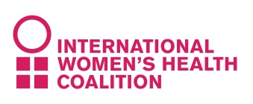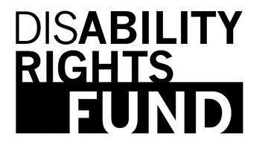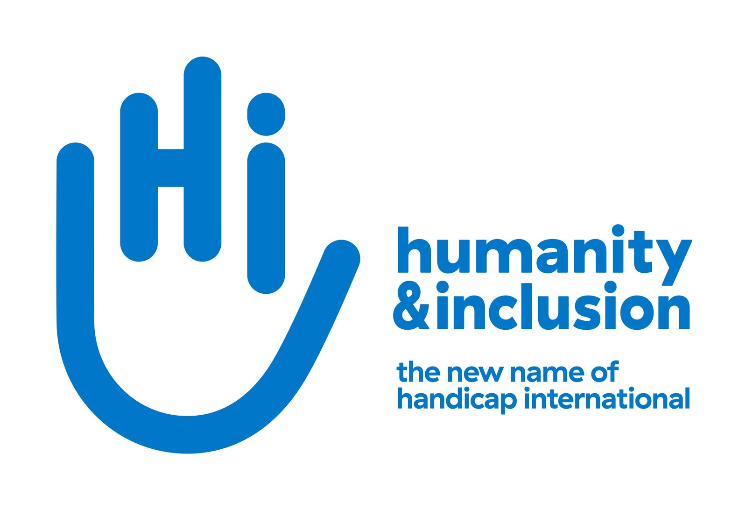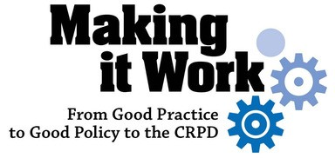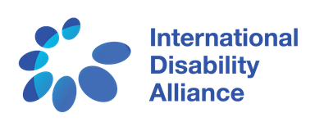WOMEN WITH DISABILITIES ADDRESSING THE VIOLENCE AT THE GRASSROOTS LEVEL

Parallel event  
NGO CSW62 Forum

MARCH 22, 2018 – 4:30 PM

CHURCH CENTER FOR THE UNITED NATIONS  
TENTH FLOOR

777 UNITED NATIONS PLAZA, NEW YORK

International sign language interpretation provided

Please RSVP to LAdams@disabilityrightsfund.org before 15th of March

