International Disability Alliance (IDA)
+1 646 776 0822 | 205 East 42nd Street
New York, NY 10017
Hlpf participants’ GUIDE TO NYC
Accommodation, transportation, health and safety, etc. in regards to accessibility
Introduction

Welcome, HLPF Participants, to New York City. The following guide includes information on transportation, accommodation, notable venues, dining, medical services, entertainment and more, in accordance with any accessibility needs you may encounter in the duration of your trip. For any questions, or points of interest that are not addressed in this guide, please contact the International Disability Alliance at <email>.

For further information on accessibility in NYC: http://www.nyc.gov/html/mopd/downloads/pdf/accessibility_guide.pdf

Important Phone Numbers to Remember
• Emergencies (police, fire or ambulance): 911
• NYC government agencies (nonemergency): 311 or 212-NEWYORK (639-9675)
• Directory assistance: 411
• Multilingual Visitor Information Counselors: 212-484-1222
• Printed NYC Literature: 800-NYCVISIT (692-8474) or 212- 397-8222

Transportation
Whether it’s by subway or bus, taxi or bicycle, being able to get around NYC is essential. The MTA remains the recommended method for travel, particularly in regards to both affordability and accessibility, however other options are available.
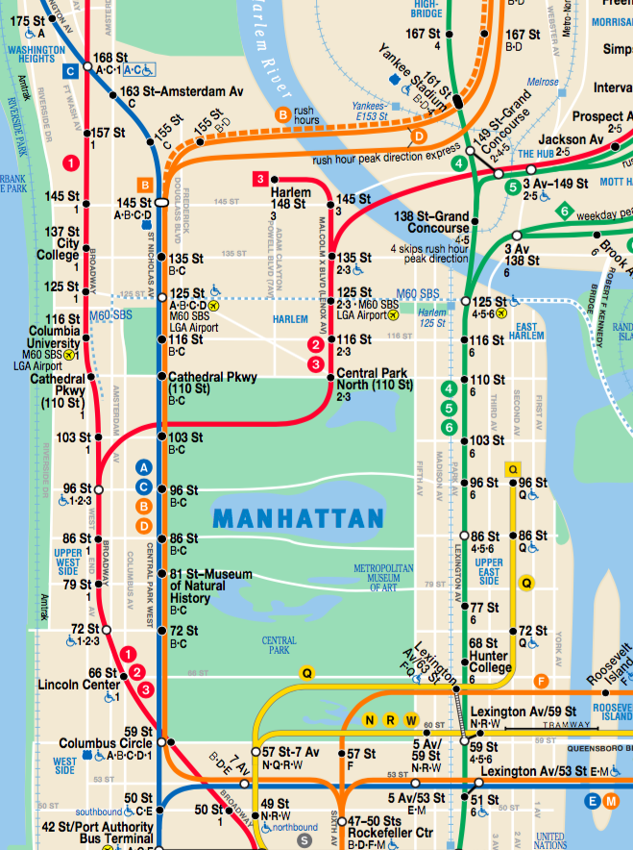

Image of NYC subway map, showing wheelchair accessible stops in upper Manhattan.
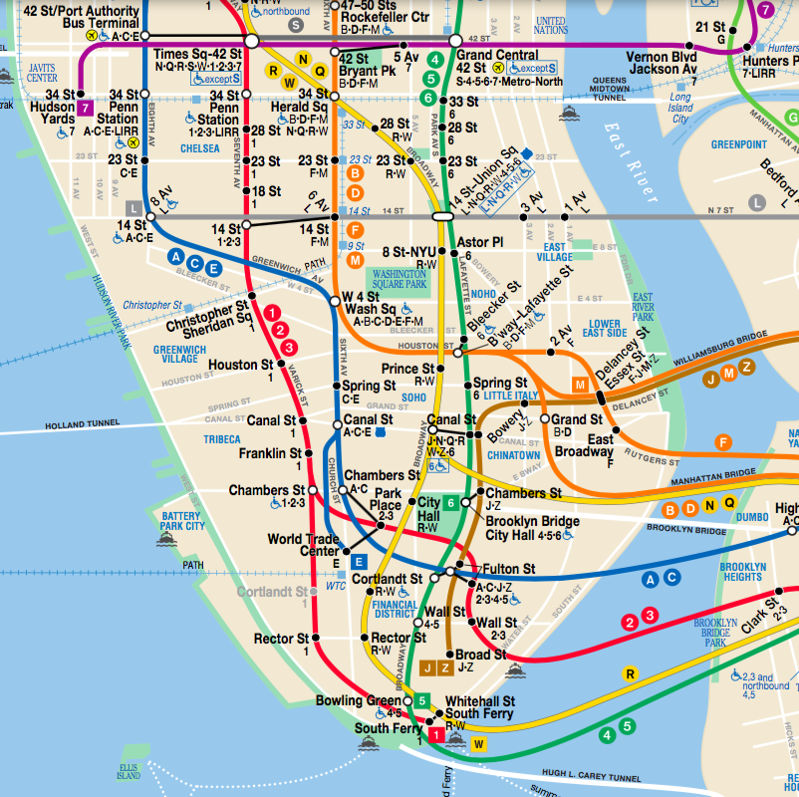

Image of NYC subway map, showing accessible stops in lower Manhattan

**The blue wheelchair symbol next to the station indicates whether or not it is accessible

TOOLS FOR MTA TRAVEL

- Further MTA accessibility information: http://web.mta.info/accessibility/

- Stations with out of service elevators/escalators:
http://advisory.mtanyct.info/EEoutage/

SUPER SHUTTLE AND
WHEELCHAIR ACCESSIBLE CAR SERVICES

- Super Shuttle
- Wheelchair-accessible buses and vans between all hotels and private residences in Manhattan and JFK, LaGuardia and Newark airports.
- 24 hours a day, 7 days a week
- Customers who need a lift-equipped vehicle call 24 hours in advance to schedule.
- 212-258-3826 or www.supershuttle.com.

- Wheelchair Accessible Cars

Accessible Dispatch
- Request a wheelchair-accessible taxi from anywhere in the city
- Call: 646-599-9999
- Book online: accessibledispatch.com

Vega Transportation
- Luxury transport
- Call: 718-507-0500

Access-A-Ride
- MTA Service that provides paratransit service throughout the city
- Application: http://web.mta.info/nyct/paratran/access_application.pdf
- More information: http://web.mta.info/nyct/paratran/guide.htm
- Call: 877-337-2017 from NYC area codes

- Lyft

- Lyft allows customers with accessibility requirements to enable ‘access mode.’
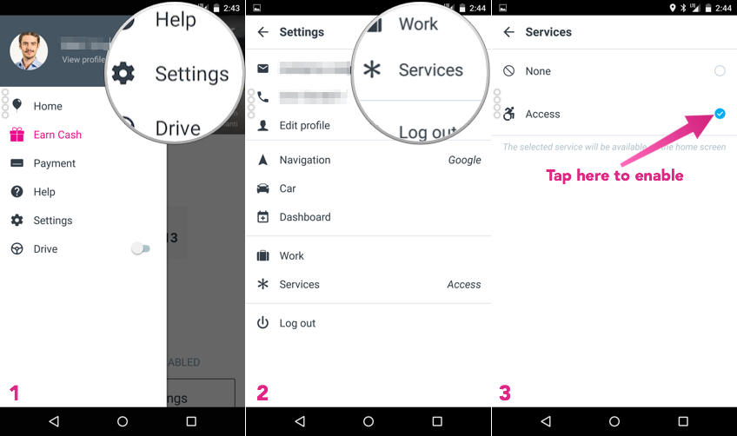
Image showing how to enable access mode on the Lyft app. Directions: Press the ‘settings’ button, then press the ‘service’ button and check the ‘access’ icon to turn on access mode.

WHEELCHAIR SERVICES

- Wheelchair Rental/Repair

Big Apple Mobility
- Address: 241 W 37th St, Between Times Sq. and Penn Station
- Call: 212-278-8100
- Hours: Mon- Fri: 9 AM – 6 PM, Sat: 9 AM – 4 PM, Sun: 9 AM – 3 PM
- $115-$215/5 days, +$10 for each additional day
- Delivery and Pickup services available for $20

Carnegie Hill Pharmacy Broadway
- Address: 1721 Broadway
- Call: 212-246-0020
- Hours: Mon- Fri: 8:30 AM-8:30 PM, Sat-Sun: 10 AM- 6 PM

Solano Medical Equipment
- Call: 1-800-986-5091
- Open 24 hours

After Hours Repair Service
- Call: 917-374-2323
- 2 PM- 10 PM

SUBWAY ROUTES FROM AIRPORTS

JFK INTERNATIONAL AIRPORT to GRAND CENTRAL TERMINAL

- JFK AIRTRAIN—take the Jamaica Station bound Air Train, get off at Jamaica Station (877-JFK-AirTrain (877-535-2478))
- From SUTPHIN BLVD-ARCHER AV., take the World Trade Center bound E train, get off at Court Sq-23rd St. Station
- Follow the signs and transfer to the 34th St. Hudson Yards bound 7 train, get off at 42nd St.—Grand Central
MTA New York City Transit/Bus—JFK Terminal 5
Queens: Q3 to 165th Street at Jamaica Bus Terminal, Q10 from Kew Gardens and 80th Road along Lefferts Boulevard.
Brooklyn: B15 to Marcus Garvey Boulevard and Broadway, along New Lots Avenue.

NEWARK LIBERTY INTERNATIONAL AIRPORT to GRAND CENTRAL TERMINAL

- Take the Air Train from your terminal to Newark Airport Railway Station
- Take the New York Penn Station bound NJ Transit train, get off at New York Penn Station
- From 34th STREET – PENN STATION, take the 241st Wakefield bound 2 train, get off at 42nd St.—Times Sq.
- Transfer to Main St-Flushing bound 7 train, get off at 42nd St—Grand Central

Accommodation

Manhattan serves as NYC’s most wheelchair-accessible borough. Their prices range from moderate ($$) to high-end ($$$$).

Millenium Hilton: 55 Church St.
- Call: 212-693-2001
- Accessible Rooms: 29
- Pricing: $$$$

Four Seasons Hotel New York: 57 E 57th St.
- Call: 212-758-5700
- Accessible Rooms: 12
- Pricing: $$$$

The London NYC: 151 W 54th St.
- Call: 212-307-5000
- Accessible Rooms: 28
- Pricing: $$$$

InterContinental The Barclay New York: 111 E 48th St.
- Call: 212-644-0079
- Accessible Rooms: 19
- Pricing: $$$

Renaissance New York Hotel Times Sq.: 2 Times Sq.
- Call: 212-765-7676
- Accessible Rooms: 15
- Pricing: $$$

New York Marriott Downtown: 85 West St.
- Call: 212-385-4900
- Accessible rooms: 31, an accessible suite
- Pricing: $$$

Sheraton Manhattan Hotel at Times Sq.: 790 Seventh Ave.
- Call: 212-581-3300
- Accessible Rooms: 32
- Pricing: $$$

Comfort Inn Convention Center: 442 W 36th St.
- Call: 212-714-6699
- Accessible Rooms: 3
- Pricing: $$

DoubleTree Metropolitan Hotel: 569 Lexington Ave at 51st St.
- Call: 212-752-7000
- Accessible Rooms: 37
- Pricing: $$

Holiday Inn Express Fifth Avenue: 15 W 45th St.
- Call: 212-302-9088
- Accessible Rooms: 7
- Pricing: $$

Skyline Hotel: 725 10th Ave at 49th St.
- Call: 212-586-3400
- Accessible Rooms: 12
- Pricing: $$

Medical Information
Medical Information

Med
Medical Information
ical Information

Pharmacies and Medical Services are dispersed throughout the city. The following are listed based on convenience, hours and proximity to the United Nations Headquarters.

Pharmacies
*Most general drugs can be obtained without prescription

CVS Pharmacy: (150 E 42nd Street) Open 24 hours, 7 days a week. (many other locations)

Walgreens: (1000 2nd Ave) Open 24 hours, 7 days a week. (many other locations)

Duane Reade: (852 2nd Avenue) Mon-Fri: 08:00—21:00, Sat: 09:00—18:00, Sun: 10:00—17:00

UN Plaza Pharmacy: (800 2nd Avenue D) Mon-Fri: 08:00—20:00, Sat: 09:00-19:00, CLOSED SUNDAYS

Hospitals/Urgent Care

NY Hotel Urgent Medical Services: 952 5th Ave #1D, New York, NY 10075 (24 HRS)

CityMD: 1150 3rd Avenue, New York, NY 10065 (DEPENDS ON COVERAGE)

NYU Langone Medical Center: 550 1st Ave

New York Presbyterian Weill Cornell Medical Center: 1300 York Avenue, New York, NY 10065
Dress Code for UN

The weather in New York is much like New Yorkers themselves: unpredictable. It ranges between 75º F/23º C to 95º F/35º C with fairly regular rainfall. Typical attire for July in NYC is entirely informal, even when going to the theaters or walking around the city.

However, despite the warm temperatures, the dress code in the United Nation is formal. The UN is also very air-conditioned, so despite the warm weather outside, it would be beneficial to wear layers when attending the HLPF.

Typical attire for the UN includes:
- Dresses
- Longer skirts and blouses
- Suits/ button-downs
- Formal trousers
- Closed-toe shoes

The following is a list of venues compiled based on relevance to HLPF and IDA’s events. All are located within a few blocks of each other, and visual presentations have been provided for your convenience.
Notable Venues

UN Headquarters: 1st Ave, between 42nd Street and 48th St. Delegate entrance on 42nd Street, CS entrance on 46th Street.

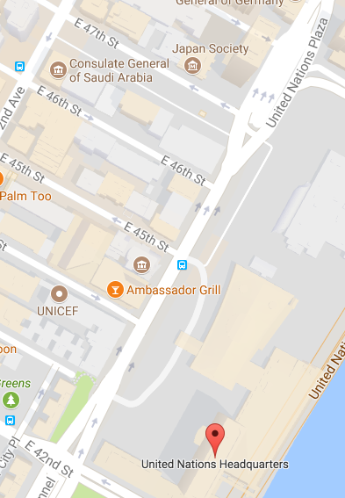
Delegate Entrance
CS/Visitors’ Entrance
Image of a map showing the CS/Visitors’ Entrance to the UN at 46th Street, and the Delegate Entrance at 42nd Street.

One UN Plaza Hotel: One UN Plaza, 1 United Nations Plaza, New York, NY 10017

Church Center of the United Nations: 777 United Nations Plaza, New York, NY 10017

UN Pass Office: 320 E 45th St, New York, NY, 10017. For UN Pass Pickup: Enter through 45th St. If accompanying someone picking up their UN pass, wear yours while on the premises. Bring the necessary letter and paperwork, wait in the appropriate lines, and follow instructions given by UN employees.

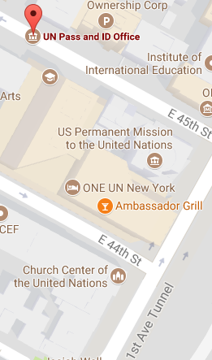
ONE UN New York Hotel
UN Pass and ID Office
Church Center of the United Nations
Image of a map showing the locations of the UN Pass and ID Office (45th St.), The ONE UN New York Hotel (44th St.) and the Church Center of the United Nations (44th St.).

IDA Office: 205 E 42nd Street, New York, NY 10017. Telephone: +1 646 776 0822

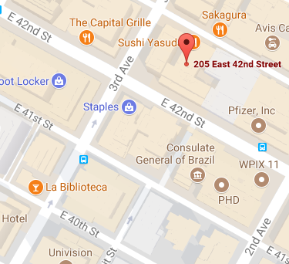
International Disability Alliance Office, 16th Floor
Image of a map showing the location of the IDA office on 42nd St. between 2nd and 3rd Aves.

Food & Dining

Locating affordable food in Manhattan, particularly around the United Nations headquarters, is no easy task.

In UN Headquarters

https://unitednations.catertrax.com/upload/UNDiningServicesMap1.pdf?intOrderID=&intCustomerID=

LEVEL 4:
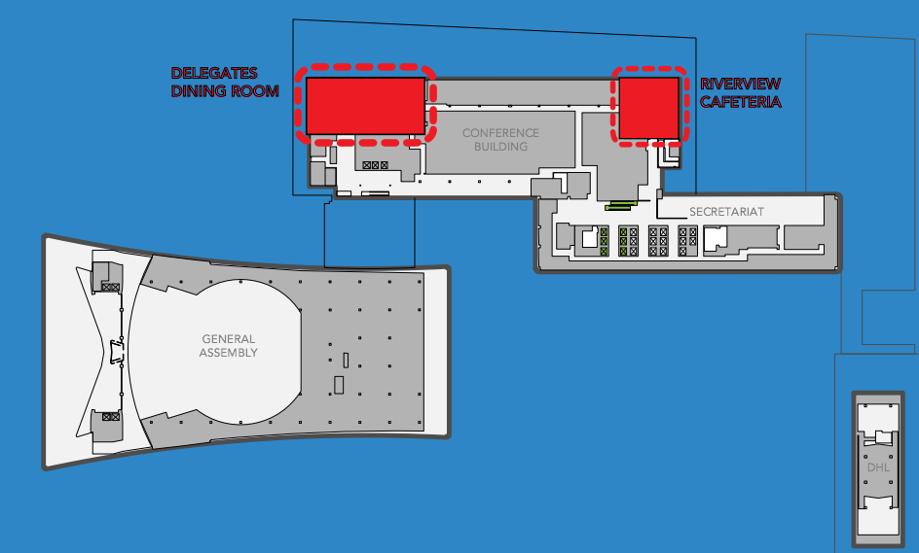
Image of a map showing level 4 of the United Nations headquarters.

Delegates Dining Room

- Reservation only; 3 course prix-fix meal.
- Hours: Mon-Fri, 11:30 AM – 2:30 PM
- Public: $39.99, Badge-holders: $29.99

Riverview Cafeteria

- Offers vegetarian, vegan and gluten-free options
- Hours: Mon-Fri, 8 AM – 3 PM

LEVEL 1B:
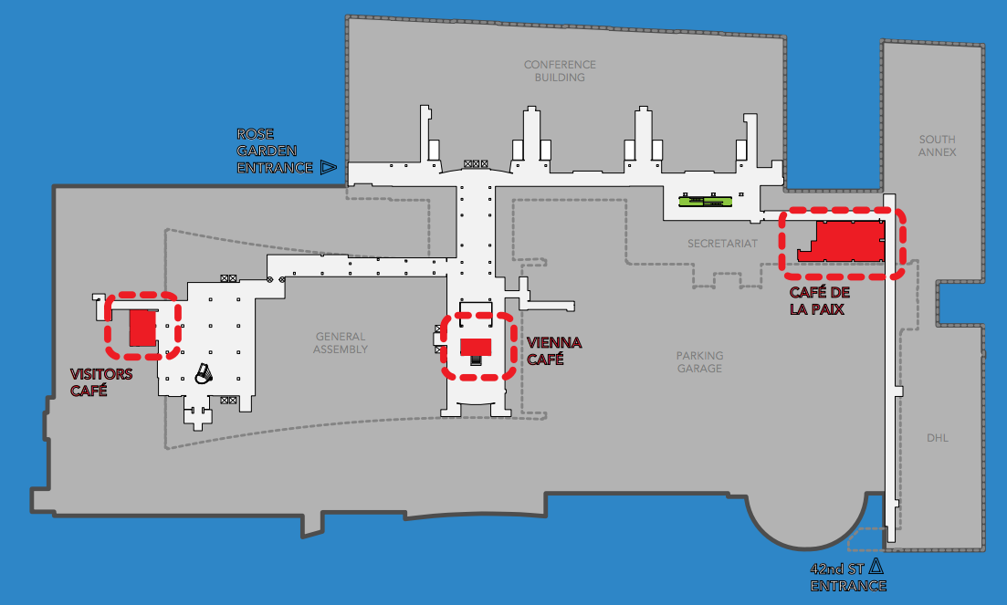
Image of a map showing Level 1b of the United Nations headquarters.

Vienna Café

- Situated in between Conference Rooms
- Hours: Mon-Fri, 8 AM – 6 PM

Visitors’ Café

- Hours: Mon-Fri, 9 AM – 6 PM, Sat, 9 AM – 5 PM

Café de la paix

- Hours: Mon-Fri, 11:30 AM – 4 PM

LEVEL 1:
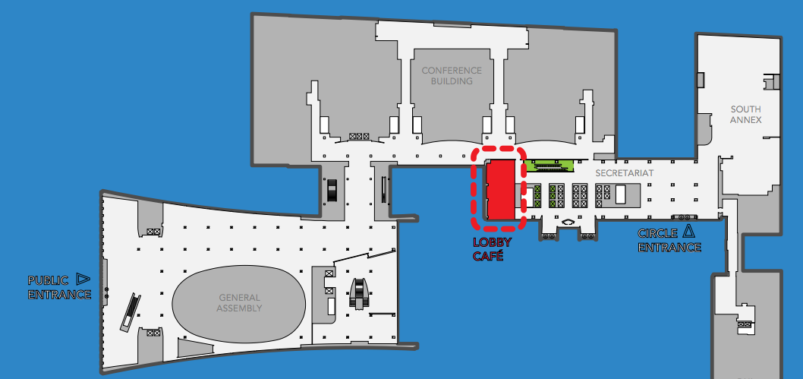
Image of a map showing Level 1 of the United Nations headquarters.

Lobby Café

- Hours: Mon-Fri, 8 AM- 5 PM

Near UN Headquarters

*Most restaurants/coffee shops will have free Wifi. Ask for username/password.

$$: Le Pain Quotidien UN Plaza (Belgian): 937 2nd Ave

$$: Sakagura (Japanese): 211 E 43rd St

$$$: Alcala (Spanish): 246 E 44th St

$: John’s (Diner): 823 2nd Ave

$: Pret A Manger: 205 E 42nd St

$: Patsy’s Pizzeria: 801 2nd Ave

NYC hosts a variety of activities for visitors to get involved with. This includes anything for Broadway shows to museums all around the city. Some of the highlights are listed below.
Entertainment/Attractions

- Broadway

To purchase tickets for Broadway shows, helpful resources are:
- livebroadway.com
- offbroadway.org
- timessquarebid.org

- Museum Mile

8 different museum run from 5th Ave and 82nd St-104th St, including:
- Metropolitan Museum of Art (82nd)
- Goethe-Institut New York (83rd)
- National Academy Museum (88th)
- Guggenheim Museum, Solomon R. (89th)
- Cooper-Hewitt, National Design Museum (91st)
- The Jewish Museum (92nd)
- Museum of the City of New York (103rd)
- El Museo del Barrio (104th)

- Central Park

From 59th St to 110th St, 5th Ave to 8th Ave. Includes:
- Zoo
- Nature trails
- SummerStage (daytime and nighttime summer concerts) - www.cityparksfoundation.org/summerstage

- Bronx Zoo

At Bronx River Pkwy. and Fordham Rd. – www.bronxzoo.com

- New York Botanical Garden

200th and Southern Boulevard, Bronx. – www.nybg.org

- Coney Island

Accessible by D, N, F, Q trains to Stillwell Avenue. Includes:
- Theme park with rides.
- Boardwalk/beach
- Fireworks every Friday at 9:30 PM
- http://www.coneyisland.com/tourist-information

