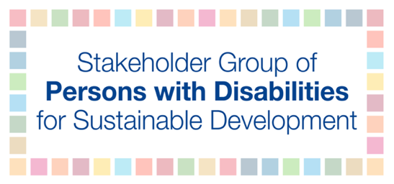
High-level Political Forum 2020
Official side event of the Stakeholder Group of Persons with Disabilities

Title of the event: Will the SDGs be Still Relevant After the Pandemic for Persons with Disabilities?
Date and time: Wednesday July 8, 2020, 12:00pm-1:30pm EDT
Register: https://zoom.us/meeting/register/tJUodeCtqTktG9biu8xd3ZozCvX7moWbRDwA.

Rationale and key messages:
Since the adoption of the UN Convention on the Rights of Persons with Disabilities (CRPD), followed by the adoption of the 2030 Agenda for Sustainable Development and its Sustainable Development Goals (SDGs), there has been a positive development and change in the lives of persons with disabilities. Slowly societies have begun to transition from the traditional charity and medical model approaches to inclusion into a social and human rights approach granting persons with disabilities more rights than ever before.
When the COVID-19 pandemic hit, it removed the curtain and in many ways the lives of persons with disabilities spiraled back to pre-CRPD and SDGs times. Historical inequalities have resurfaced, stronger than ever, discrimination has significantly increased and the fight for inclusion has become increasingly more challenging. Today governments are deliberating how to restart the economy, open up society and are looking to their neighbors to build on lessons learned. Dialogues around leave no one behind, reach the furthest behind first, and inclusion in the era of social (physical) distancing have been neglected and gone backward. This poses the fundamental question for persons with disabilities: is it still important to advocate to achieve the Sustainable Development Goals? In addition, will the Goals and targets be instrumental to build a better, more inclusive and equal world for all?
The Stakeholder Group of Persons with Disabilities is dedicating its side event to explore answers to these questions.
The event is focusing on three main messages:
- The role of multilateralism and action-oriented political leadership to ensure that the response to the pandemic and the rebuilding of societies will follow a rights-based approach and ensure the inclusion of persons with disabilities;
- Reducing inequalities, addressing discrimination and eliminating barriers, through consultation and partnership by taking an intersectional approach and allocating proper consideration to include in the dialogue underrepresented groups, which will contribute to reaching the furthest behind first; and
- The vital role of OPDs and critical contribution to the pandemic response; this once again highlights that persons with disabilities must become active leaders and participants in all decision-making processes to ensure that we are building back a better and more inclusive future for all.

Tentative Agenda:
Moderation: Mr. Dominic Haslam, chair, the International Disability and Development Consortium
Opening remarks: TBC
This event includes three main sections:
- Multilateralism: the lost key in leaving no person with a disability behind in pandemic response and recovery
Presenters:
IDA representative: TBC
Government representative: TBC
Objectives:
- What kind of multilateral system is necessary to effectively face the multi-layered crisis exposed and further triggered by the COVID-19 pandemic and how can persons with disabilities be included?
- How to strengthen human rights, the implementation of the CRPD, 2030 Agenda and reaffirm principles and modalities for democratic participation of rights-holders such as persons with disabilities at global, regional, national and local levels?

- Reach the Furthest Behind First: experiences from underrepresented groups of persons with disabilities
Presenters:
Representatives from some underrepresented groups of persons with disabilities:
Women with disabilities: Ms. Dorothy Nakato Mubezi, Uganda
Indigenous persons with disabilities: TBC
Persons with intellectual disabilities: TBC
Autistic persons: Ms. Fernanda Sanata, Brazil
Youth with disabilities: Mr. Kibe Yohana, Kenya
Objectives:
- Highlight the multiple and intersectional forms of discrimination experienced by different groups of persons with disabilities during the global pandemic;
- Explore ways to “reach the furthest behind first” through prioritizing inclusion of the underrepresented groups of persons with disabilities

- The meaningful engagement of OPDs in all decision-making processes at all levels to ensure building back better inclusive societies for all.
Objectives:
- How have the roles of OPDs changed during the pandemic?; What are the lessons learned?;
- The critical next steps to ensure that OPDs are at the table when the societies are rebuilt.
Presenters:
OPD representative: Dr. Mohammed Ali Loutfy, Alternate Representative of the Stakeholder Group of Persons with Disabilities
Civil Society Representative: Dr. Mary Keogh, CBM Global
Government representative: TBC

The side event will provide Live Captioning and International Sign
Updated information on the event will be available on IDA webpage: http://www.internationaldisabilityalliance.org/hlpf2020-side-event

