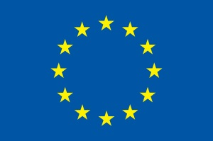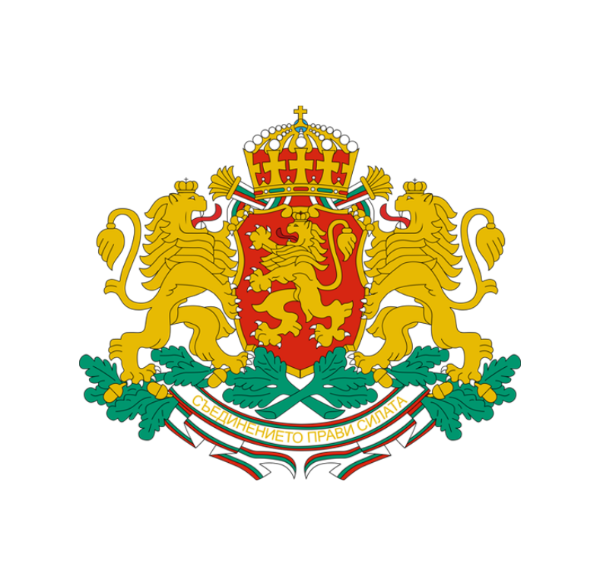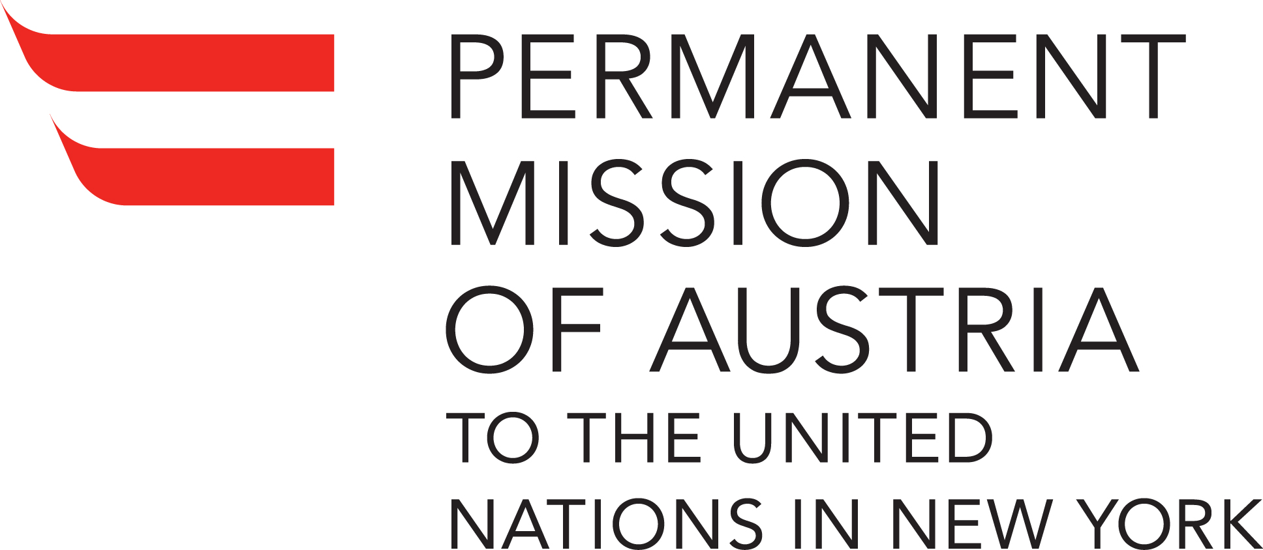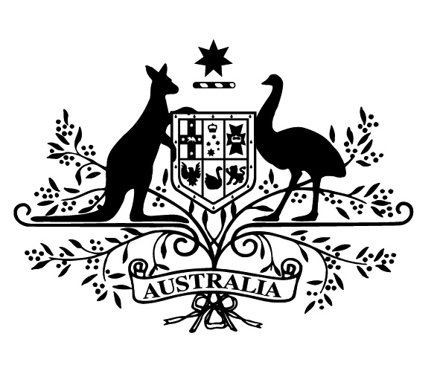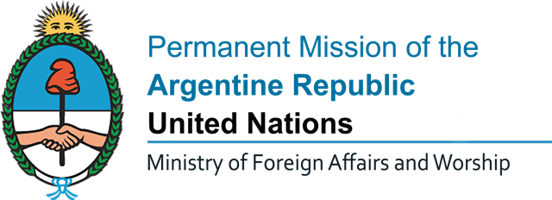**Co-sponsored by:**

../../../../../Desktop/Lithuania.jpg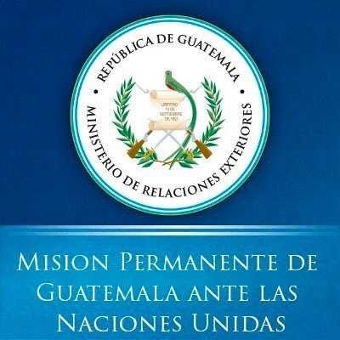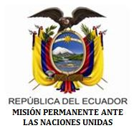

/Users/idacommunications/Desktop/NGOCSD-NY Logo 2017.pdf

*Invitation to a side event during the High-Level Political Forum 2017*

**Sharing national experiences of persons with disabilities regarding multiple & cross-cutting discrimination as core issues contributing to poverty**

**Date & Time:** Thursday, 13 July 2017, 1:15 pm- 2:30 pm

**Location:** Conference Room 5, UN Headquarters

**OPENING REMARKS:**

**H. E. Mr. Georgi Panayotov,** PermanentRepresentative of Bulgaria to the United Nations

**H. E. Mr. Jan Kickert,** Permanent Representative of Austria to the United Nations

**Moderated by: Mr. Vladimir Cuk,** Stakeholder Group of Persons with Disabilities

**Speakers Include:**

**Thorkild Olesen,** Denmark

**Judith Umoh,** Nigeria

**Jose Maria Viera,** Argentina

**Eeva Tupi,** Finland

**CLOSING REMARKS:**

**Mr. Cormac Ebken**, Deputy Head, 2030 Agenda for Sustainable Development Reducing poverty and inequality, Federal Ministry for Economic Cooperation and Development, Germany

CART and Sign Interpretation available. Lunch will be provided.