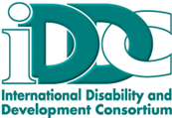
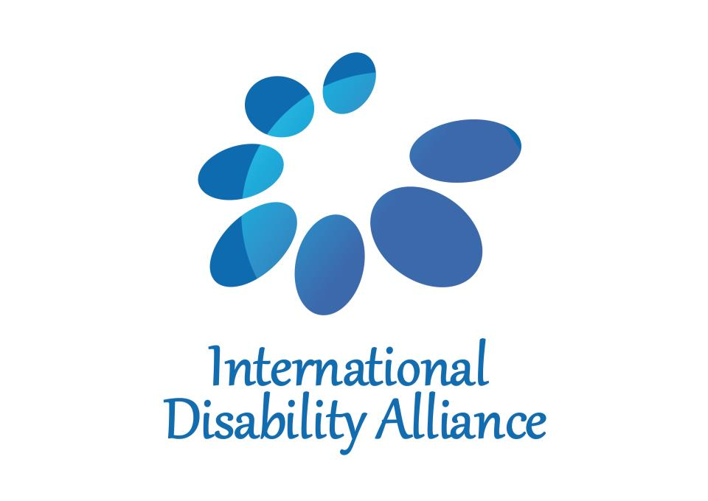

IDA and IDDC Statement for IATF Briefing on October 27, 2017

I am speaking on behalf of persons with disabilities. As a member, we align with the CSO FfD Group statement. And on behalf of persons with disabilities we would like to encourage more space for dialogue to contribute to the Inter-agency Task Force report and Financing for Development processes.

We would like to address one urgent issue, that the cost of exclusion is higher than the cost of inclusion of persons with disabilities.

World leaders committed to achieve the Sustainable Development Goals for all, leaving no one behind. Persons with disabilities were explicitly referenced 11 times in the 2030 Agenda and 6 times in the Addis Ababa Action Agenda. However, the financial aspects of realizing the commitment for persons with disabilities have rarely been addressed. To achieve this commitment, Member States and the UN system will have to find dedicated domestic and international resources and uphold commitments of the UN Convention on the Rights of Persons with Disabilities.

We are calling on the Inter-agency Task Force to draw on existing budgetary and fiscal policies and to make recommendations on how to systematically address resource allocation for the inclusion of persons with disabilities.

