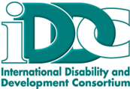
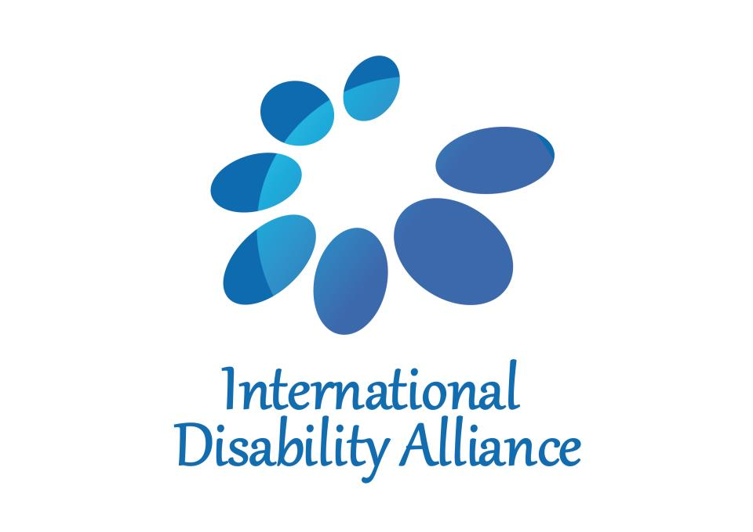

International Disability Alliance and International Disability and Development Consortium inputs on inclusive development for persons with disabilities

Persons with disabilities comprise an estimated 15 percent of the world’s population and are overrepresented among the poorest in the world: the 2030 Agenda states that more than 80 per cent of persons with disabilities lives in poverty. Persons with disabilities face widespread exclusion from all areas of economic, political, social, civil and cultural life, including employment, education and health care. Persons with disabilities, including those with leprosy-related disabilities, experience higher rates of poverty and deprivation and lower levels of income than the general population. This stems from pervasive discrimination and stigma, unequal opportunities, and physical and attitudinal barriers. And these same factors also mean that the rights of persons with disabilities are not adequately addressed in poverty-reduction programmes, social protection floors or development programmes and funds.

Globally political momentum around disability has been growing for some years; beginning with the UN Convention on the Rights of Persons with Disabilities (CRPD) in 2006, the World Report on Disability in 2011, and the subsequent High-level Meeting on Disability and Development in 2013, the Sendai Framework for Disaster Risk Reduction in 2015 and the significant mobilisation of the global disability community through the post-2015 negotiations that led to the inclusion of persons with disabilities in the Sustainable Development Goals (SDGs).

The commitment to delivering disability inclusive development must be strengthened and deepened if the global community is to deliver against these ambitious global agendas. The inclusion of persons with disabilities in Agenda 2030 is a huge opportunity however, concrete and systematic change needs to take place to make sure they are not left behind by the SDGs.

Accessibility is a human right, a core principle of development, the key to inclusive cities, and an essential condition to realize the SDGs, the Sendai Framework for Disaster Risk Reduction, World Humanitarian Summit outcome document and Charter on Inclusion of Persons with Disabilities in Humanitarian Action? and the CRPD. This is especially important since more than half of all persons with disabilities now live in towns and cities and by 2030 this number is estimated to swell to between 750,000 and 1 billion. As such, accessibility must be meaningfully and fully integrated in inclusive development.

Persons with disabilities are at increased risk from disasters due to inaccessible shelters, relief distribution, inaccessible warning systems and inappropriate response actions, but also because of underlying factors such as poverty and low levels of employment. Consequently, programmes must target and engage persons with disabilities, giving particular focus to the inclusion of girls and women with disabilities, agree to the minimum standards for disability-inclusive programmes, provide training to workers, and include disability audits in evaluations. Crucially, persons with disabilities must be able to engage with the bodies responsible for decision-making at local, national and international levels.

Internationally and nationally, there is a lack of data on disability and weak data collection systems that often grossly under-estimate the prevalence of disability. This makes it all too easy for the rights of persons with disabilities, their families and communities to be ignored. If we are to deliver the vision of the 2030 Agenda in leaving no one behind to reduce poverty globally, we must ensure the global community commits to the collection of data disaggregated by disability.

All Member States must commit to collecting and using comparable data on disability by using the Short Set of Questions developed by the Washington Group. We would also encourage National Statistical Offices to drive better data collection on disability at a national level to inform appropriate and inclusive national planning, resource allocation, and monitoring of the SDGs. Moreover, disability-inclusive development must be systematically embedded into global policies and national frameworks.

IDA and IDDC suggests that the following policy actions are taken at both an international and national level in order to fully implement the 2030 Agenda:

International

- National governments, multilateral organisations, civil society and organizations of persons with disabilities (DPOs) must work in partnership at an international and national level to progress inclusive development in implementing the 2030 Agenda.
- Internationally we need to strengthen and deepen the global commitment to delivering inclusive development as part of the 2030 Agenda by ensuring that persons with disabilities have a right to participate and engage in international development forums and policy dialogues.
- At an international level, we would encourage multilateral agencies to promote the use of appropriate methodologies to collect data on disability including the Washington Group short set of questions and work to support Member States to build the capacity of National Statistical Offices to collect data on disability to inform resource allocation, and effectively monitor the implementation of the SDGs.
- Disability inclusion has been long-under prioritised and as a result under-resourced. A key component of increasing resource is to systematically track and report on at national and global levels of financing for disability inclusion. Efforts are ongoing to introduce a policy marker into the OECD DAC system, but non-OECD donors and others actors must also introduce measures to track and monitor resources.
National

- Member States need to prioritise persons with disabilities by developing coherent and measurable approaches for ensuring disability inclusion, e.g. national governments develop policies or action plans to ensure disability inclusion is embedded into the next National Development Plan, and any long-term plans around SDG implementation.
- Many initiatives to promote the rights of persons with disabilities are never implemented because they are not part of the budgetary decision-making processes of governments. This must change. Budgets need to be responsive to the needs and rights of persons with disabilities or we will not meet the ambition of the 2030 Agenda. Member States must ensure disability inclusion is embedded into budgeting processes.
- Member States need to support DPOs to form coalitions and participate in reporting of relevant national reports to the CRPD, or wider initiatives including Voluntary National Reviews and SDG monitoring.

Transforming Our World: the 2030 Agenda for Sustainable Development, paragraph 23.
S. Mitra, A. Posarac and B. Vick. (2011). Disability and Poverty in Developing Countries: a Snapshot from the World Health Survey: http://siteresources.worldbank.org/SOCIALPROTECTION/Resources/SP-Discussion-papers/Disability-DP/1109.pdf
WHO (2011) World Report on Disability http://www.who.int/disabilities/world_report/2011/report.pdf
World Enabled and CBM (2016). The Inclusion Imperative: Towards Disability-inclusive and Accessible Urban Development - Key Recommendations for an Inclusive Urban Agenda. From: https://www.cbm.org/article/downloads/54741/The_Inclusion_Imperative__Towards_Disability-Inclusive_Development_and_Accessible_Urban_Development.pdf
Utilizing 5 billion urban dwellers, we calculated that 15 to 20% of these would be persons with disabilities. Our data sources were derived from: WHO and World Bank (2011). “World Report on Disability”, WHO Press, Geneva, and “Urbanization | UNFPA - United Nations Population Fund.” from: http://www.unfpa.org/urbanization.
DRRA and Sightsavers. (2015). Disability, disasters and empowerment. https://www.sightsavers.org/wp-content/uploads/2017/09/sightsavers-disability-disasters-and-empowerment-summary.pdf

